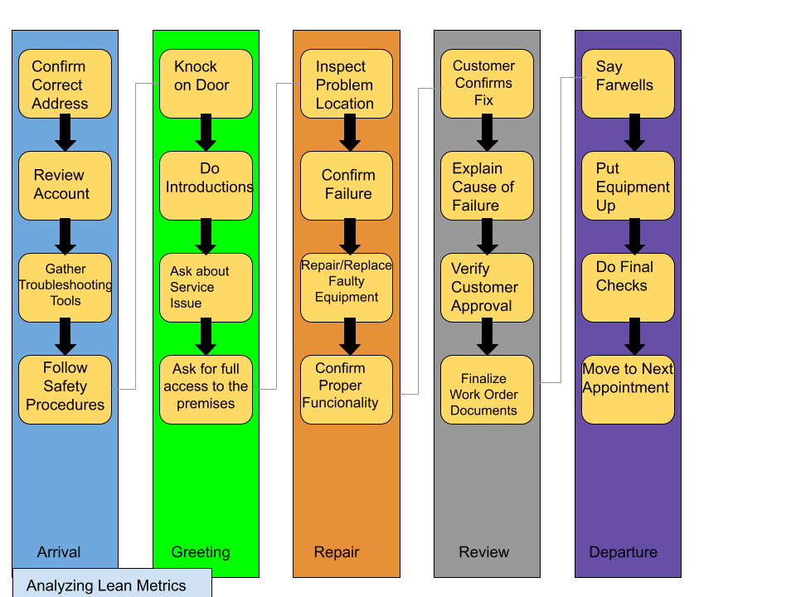

Estimated Average Flow Time

|  |  |
| --- | --- |
| Arrival | 10min |
| Greeting | 30min |
| Repair | 2hrs |
| Review | 30min |
| Departure | 10min |

Estimated Time Cycle: 3hrs 20min

Optimize Service Call Routine:

This is my finalized routine for service calls. I have eliminated many extra steps to get it down to these 20 steps. I believe the only way to optimize this flow further would be to gain the experience to cut down on analysis and repair.

Workflow Orchestration:

Many times, by the time we are in the Greet phase the problem is already apparent, and many steps can be avoided all together. This cuts a lot of precious time out of the equation, making more room for the rest of the day.

Governance Model:

There may be times when tools or locations could be left allowing for theft or accidents. These can be minimized by blocking off the area or making fewer trips.