Analysis of Algorithms
Taylor Roberts
CS 221-03

Algorithm 1: Find
Section 1: Preliminary Analysis
The java file Find.java begins with a for loop, adding an increment of 1 right off the bat. It is not certain how many cycles the for loop will go through. This particular test finds an int out of a randomly sorted array. The for loop goes through the whole array until it finds the the specified value. I’m thinking that on average the for loop will cycle through about half of the array’s length. The int could be anywhere, whether that be in the front of the list or the back, so I’m giving a 50/50 chance of both. Also note I am making a for loop for every test size. In this loop, I will find all the values that are possibly stored within the array, say from 1 to 1000, then take the total number of statements decided by the test size number to get a solid average. All that being said, I’m adding one increment for the process of the for loop, then n (length of array) decided by 2 for the 50/50 odds. There is an if statement check for the correct value matching the array location, so I’ll times the n/2 by 2, making 2(n/2). If the if statement is true, there is a return statement, so I’m adding 2 increments for the running of the if statement and the return statement. Not sure if a return statement counts, but I’m leaning on yes. There is also a return statement for NOT finding the value, but because I am specifically only looking for values that I know are in the array, this will never be called.

Values: n = length of the array

for loop check: +1

process of for loop + if statement check: +2(n/2)

if statement process: +2

T(n) = 1+2+2(n/2) Simplified => T(n) = 3 + n

Since n is the dominant variable, I’m predicting this Algorithm’s bigOh type is linear, or O(n)

BigOhPropertyPrediction: O(n)

Section 2: Collected Data
size statements
1000 1004
10000 10004
20000 20004
30000 30005
40000 40004
50000 50004

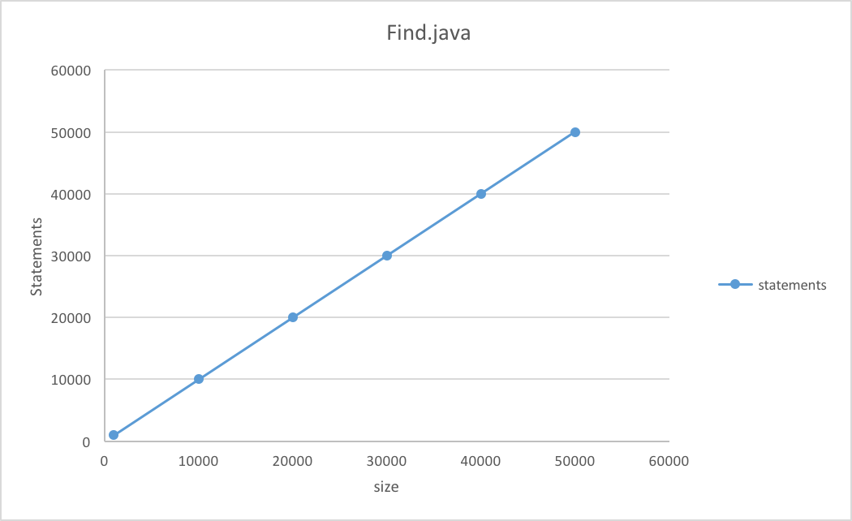

Section 3: Final Analysis
It seems that my prediction was right in calculating O(n) as the bigOh property. As you can see the size equals the number of statements almost exactly. Even though I ran an average of 1000 to 50000 tests depending on the test size, there is still room for error, although of course very little. This seems to be why some of the statement counts have an additional 4 and some have an additional 5. At this point I am not sure if it is my calculations of +3 that are off, or if there is indeed another statement that I am not seeing a connection with the find constructor. That being said I am very pleased with my results.

Algorithm 2: Order

Section 1: Preliminary Analysis
The constructor order() starts with a for loop that goes through once for every index that is in the array. is amount of calls represents the array size, which is also the value for ’n’. Within the for loop are 3 values, two created, and one changed. There is also a while loop check. So far, for the for loop alone, we have +1 for the for loop check, +5 for running the for loop, initializing two variables, changing one, and checking the while loop. This totals to +6 multiplied by n. We get 6n. The while loop within the for loop has a total of 3 statements overtime it is ran. The while loop itself running, an index swap, and an increment. The amount of times the while loop runs depends on probability and size of the array, or ’n’. The whole algorithm checks the current value it is on based on the for loops count position, going through 1 - n. If the number currently being checked is less than the number ahead of it (index -1) the while loop comes into play and copies the larger number in front over the value, goes to the next value, and if still larger, copies that number over the original previous larger number that was in from of the value. This keeps going on until the value is greater than the current index’s value. In which case the original of the two copies of the last larger number is overwritten with the current value. This ends the loop and then the next value is checked. All that being said, The odds of the number being less than or greater the previous number is about a 50% because for 1, there is a 100% that all the numbers are greater, and vise versa, with ’n’ there is a 100% chance that all numbers are less than its value. 50% is the middle ground average. For example, say the loop was on the 60th value. Its only going to go through the first 60 numbers, and the odds of it being the last verses the first in ascending order is about a 50% chance. It could not move at all, or it could move all the way to the front from the back. Now if you take this into consideration, and you know that 60, 800, or 9 still have a 50% chance of going through all of the numbers or none of them, you get something like n/2 +n-1/2 + n-2/2 + n-3/2 + n-4/2 + … etc all the way to ((n-n) + 1)/2. Of course you can’t have half a statement. This averages out to ((1/2)n) / (2) for the while loop statements. Saying that, all of the while loop statements should be multiplied by ’n’ because it is nested within a for loop.

Values n = length of array

for loop = 6n

while loop = n(((1/2)n) / (2))

T(n) = 6n + n(((1/2)n) / (2)) simplified => T(n) = 6n + n^2/4

Since n^2 is the dominant variable, I’m predicting this Algorithm’s bigOh type is quadratic, or

O(n^2)

BigOhPropertyPrediction: O(n^2)

Section 2: Collected Data
size statements
1000 763726
10000 74975923
20000 299135766
30000 674123003
40000 1195596055
50000 1874107569

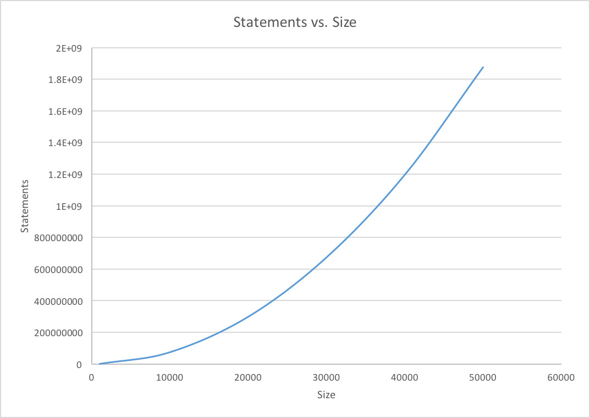

Section 3: Final Analysis
From what I am getting from the statement totals, it does not seem like this is an n^2 but rather an exponential function, O(C^x). Plotting the graph shows a very fast ascending curve, so definitely not a lot function. Both quadratic and exponential functions have similar looking curves depending on the scaling of the graph. Instead of comparing graphs, I simply took the n values square roots, then compared there values to the values I had obtained. They are linearly similar for the most part. The qualities of an exponential function tend to jump significantly up in multiplication after every additional number up for ’n’ compared to any quadratic. This is not the case for this function. All in all data shows that the function is indeed a quadratic one.
Final verdict, O(n^2)

