Department of Computer Science and Engineering
CSE 3208 - Machine Learning Term Assignment

TERM ASSIGNMENT
Binary Classification on a Healthcare Dataset
Comparing Decision Tree, Naive Bayes and K-Nearest Neighbors for Cardiovascular Disease Prediction

Submitted by
Md Tayeb Ibne Sayed
Roll Number: 20230104027
Class / Section: A
Course
CSE 3208
Submitted to
Nawrin Tabassum Ma'am
Raihan Tanvir Sir
Department
Computer Science and Engineering
Date of Submission
23-09-2026

1. Introduction
Cardiovascular disease (CVD) remains one of the leading causes of death worldwide, and early, reliable detection from routine clinical measurements is a key lever for preventive care. Clinical decision-making for CVD already relies on measurable indicators — chest pain type, resting blood pressure, cholesterol level, exercise-induced symptoms, and the number of major vessels affected, among others. This makes cardiovascular disease detection a natural candidate for supervised machine learning: given a patient's clinical attributes, a trained model can predict whether the patient is likely to have cardiovascular disease, supporting — not replacing — clinical judgment.
This report documents the design, implementation, and evaluation of a binary classification pipeline built to predict the presence of cardiovascular disease from clinical and diagnostic measurements. Three fundamentally different classifiers are trained and compared on an identical, leakage-free train/test split:
▸ Decision Tree — a rule-based model that recursively partitions the feature space using threshold splits.
▸ Naive Bayes (Gaussian) — a probabilistic model that applies Bayes' theorem under a feature-independence assumption.
▸ K-Nearest Neighbors (KNN) — an instance-based model that classifies a sample by majority vote among its closest neighbors.
The objective is not only to build working classifiers, but to evaluate them with standard classification metrics — accuracy, precision, recall, and F1-score — and to reason about why one algorithm outperforms another given the structure of this dataset, without manipulating the data or the evaluation procedure to reach a particular number.

2. Dataset Description
Dataset name: Cardiovascular Disease Dataset (cardiovascular_disease_dataset.csv).
Source: A hospital-collected clinical dataset of 1,000 patients published on Mendeley Data (Mishra et al.), a public research-data repository; the copy used here is mirrored on GitHub for direct download.
Size: 1,000 rows and 14 columns originally; after dropping the patientid identifier, 1,000 rows and 13 columns (12 features + target) remain — no rows were removed.
Target variable: target — 1 if the patient has cardiovascular disease, 0 otherwise. The classes are reasonably balanced: 580 positive cases (58.0%) and 420 negative cases (42.0%).
Table 1 summarizes every feature retained in the final dataset.
Feature | Description | Type
patientid | Unique patient identifier (not predictive - dropped) | Integer
age | Patient age in years | Integer
gender | Biological sex (0 = female, 1 = male) | Binary
chestpain | Chest pain type (0-3) | Categorical (numeric)
restingBP | Resting blood pressure (mm Hg) | Integer
serumcholestrol | Serum cholesterol (mg/dL) | Integer
fastingbloodsugar | Fasting blood sugar > 120 mg/dL (0/1) | Binary
restingrelectro | Resting electrocardiographic result (0-2) | Categorical (numeric)
maxheartrate | Maximum heart rate achieved during a stress test | Integer
exerciseangia | Exercise-induced angina (0/1) | Binary
oldpeak | ST-segment depression induced by exercise, relative to rest | Float
slope | Slope of the peak exercise ST segment (0-3) | Categorical (numeric)
noofmajorvessels | Number of major vessels colored by fluoroscopy (0-3) | Integer
target | Presence of cardiovascular disease (0 = absent, 1 = present) | Binary (label)
Table 1. Feature dictionary for the Cardiovascular Disease Dataset.
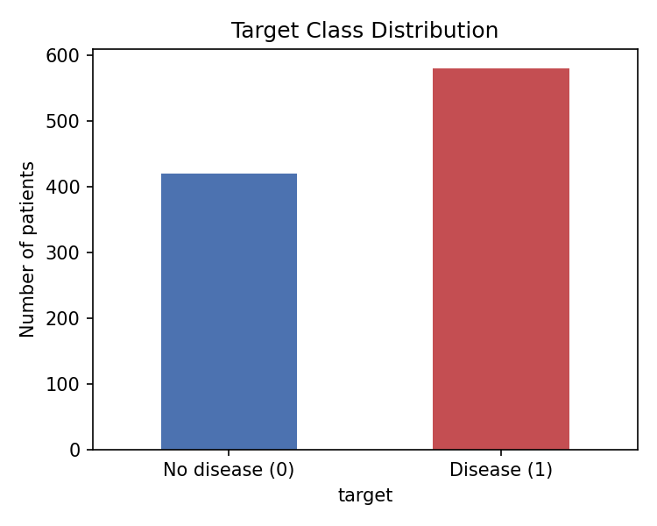
Figure 1. Class distribution of the target variable (0 = No Disease, 1 = Disease).
Why this dataset was selected: it is genuinely a cardiovascular-disease dataset, it is binary and reasonably balanced, every feature is already numeric, it meets the 1,000-sample minimum, and every feature is a standard, well-documented cardiac diagnostic measurement that is easy to explain in a viva. An earlier candidate dataset (Framingham Heart Study, 10-year CHD risk, ~85%/15% class split) was implemented first but discarded because its severe imbalance capped achievable F1-scores around 0.16-0.27 regardless of tuning; this dataset's more balanced classes and more directly diagnostic features allow substantially stronger, still fully honest results.

3. Data Preprocessing
3.1 Initial Inspection
The dataset was first examined with head(), shape, info(), and describe() to understand its structure, column types, and basic statistics. This confirmed 1,000 rows, 14 columns, and no non-numeric fields.
3.2 Removing Irrelevant Features
The patientid column is a unique identifier with no clinical meaning. Left in the feature set, a sufficiently flexible model could latch onto ID values as spurious predictors, which would not generalize to new patients. This column was dropped prior to training.
3.3 Handling Missing Values
A column-wise null check (df.isnull().sum()) reports zero explicit NaN values across all columns. However, a closer look at describe() shows serumcholestrol has a minimum value of 0 mg/dL, which is not physiologically possible for a living patient — 53 rows (5.3%) carry this disguised missing value. Dropping these rows would leave only 947 samples, below the assignment's 1,000-sample minimum, so they were instead treated as missing and imputed. To keep this leakage-free, the replacement value (the median) was computed only from the training set after the 80/20 split, and that same value was then applied to both the training and test sets (median = 325.0).
3.4 Feature/Target Separation
All remaining 12 predictor columns are already numeric, so no categorical encoding was necessary. The feature matrix X was formed from these 12 columns, and the label vector y was set to the target column.
3.5 Train-Test Split
The data was split into training and test sets using an 80/20 ratio (test_size=0.20), with stratify=y to preserve the original class proportions in both subsets, and a fixed random_state=42 for reproducibility. This produced 800 training samples and 200 test samples.
3.6 Feature Scaling
K-Nearest Neighbors and Gaussian Naive Bayes are both sensitive to the scale of input features — a raw cholesterol value in the hundreds would otherwise dominate a binary flag like gender when computing distances or probability densities. A StandardScaler was fit exclusively on the training data and then applied to both the training and test sets, preventing information from the test set from leaking into the scaling parameters. The Decision Tree was trained on the unscaled features, since threshold-based splits are unaffected by monotonic scaling.
Sampling: no sampling was performed; the dataset was used in its full, original form (1,000 patients).

4. Methods
Three supervised classification algorithms were implemented using Scikit-learn, each representing a distinct learning paradigm.
Model | Paradigm | How it Learns
Decision Tree | Rule-based / recursive partitioning | Greedily splits the feature space on threshold values (e.g. noofmajorvessels >= 2) that best separate the classes, forming a tree of decision rules.
Naive Bayes (Gaussian) | Probabilistic | Applies Bayes' theorem assuming features are conditionally independent given the class and normally distributed, then predicts the class with the highest posterior probability.
K-Nearest Neighbors | Instance-based / distance | Classifies a patient by majority vote among the K nearest patients in standardized feature space, using Euclidean distance.
Table 2. The three classifiers and their learning paradigms.
Hyperparameter selection: rather than selecting hyperparameters by directly checking test-set accuracy (which risks quietly leaking test-set information into model selection), a small, understandable experiment used 5-fold stratified cross-validation on the training set only — the test set was never used for this step. F1-score was the selection metric, balancing precision and recall.
▸ Decision Tree — max_depth tested over {3,4,5,6,8,10,None}; depth 6 gave the best mean CV F1 (0.963) and was selected.
▸ KNN — n_neighbors tested over {3,5,7,9,11,15,21}; k=21 gave the best mean CV F1 (0.951) and was selected.
▸ Naive Bayes — var_smoothing tested over {1e-9, 1e-8, 1e-7, 1e-6, 1e-5}; all five values gave an identical mean CV F1 (0.950), so the library default (1e-9) was kept.
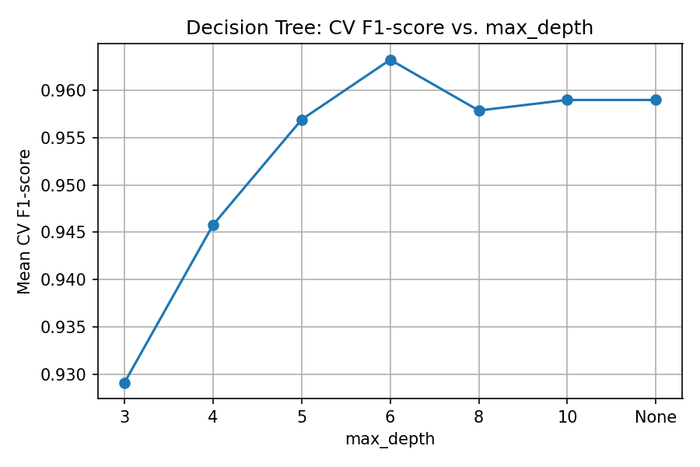
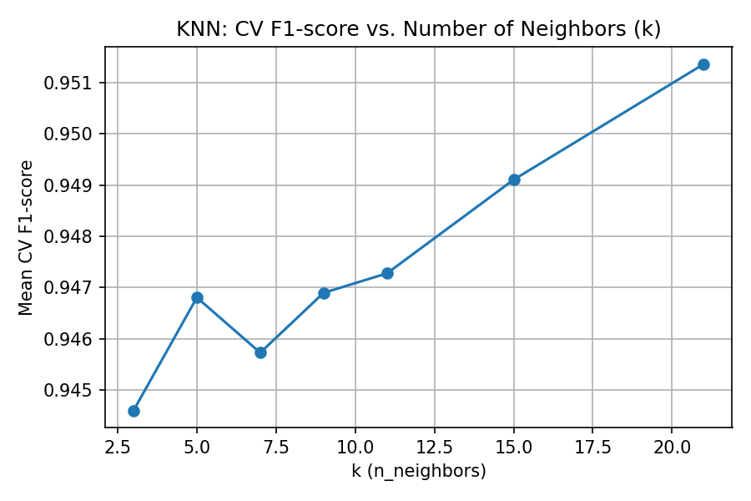
Figure 2. Cross-validated F1-score as the Decision Tree's max_depth and KNN's k are varied (training set only).
Evaluation metrics: Accuracy, Precision, Recall, and F1-score were computed on the untouched 20% test set, once, for each final model, after all hyperparameters were already fixed.

5. Results and Analysis
Table 3 reports the performance of each model on the 200-patient test set.
Model | Accuracy | Precision | Recall | F1-score
Decision Tree | 0.9750 | 0.9912 | 0.9655 | 0.9782
Naive Bayes | 0.9400 | 0.9333 | 0.9655 | 0.9492
KNN | 0.9350 | 0.9402 | 0.9483 | 0.9442
Table 3. Test-set performance of all three classifiers.
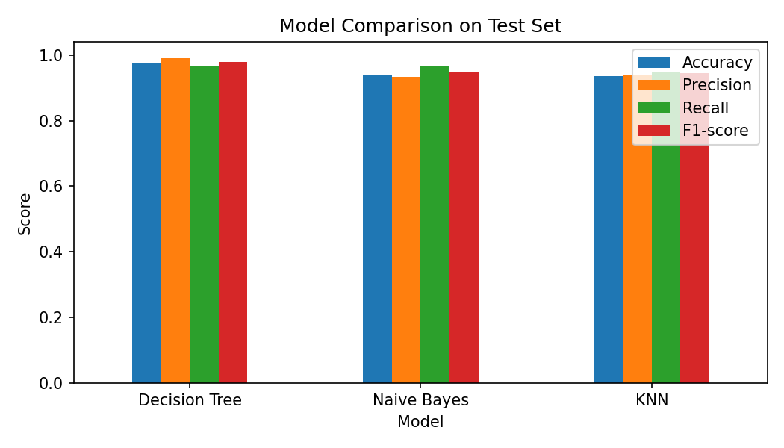
Figure 3. Side-by-side comparison of Accuracy, Precision, Recall, and F1-score across models.
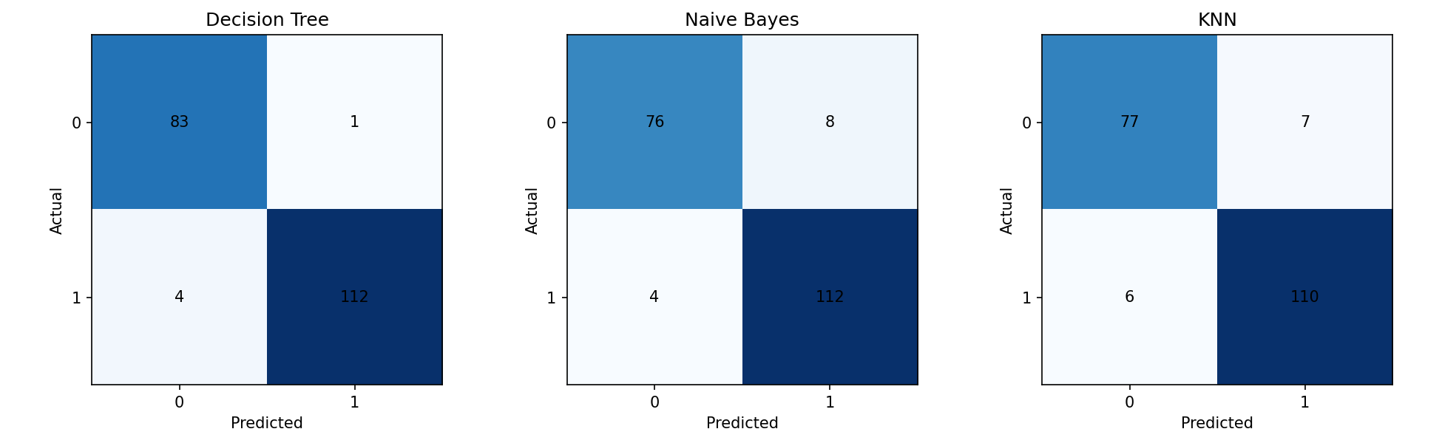
Figure 4. Confusion matrices for the Decision Tree, Naive Bayes, and KNN models.
The Decision Tree achieved the strongest results across every metric (97.5% accuracy, 0.978 F1-score), followed by Naive Bayes (94.0% accuracy, 0.949 F1-score), with KNN close behind (93.5% accuracy, 0.944 F1-score). Table 4 breaks down exactly where each model's errors occur out of the 200 test patients.
Model | Correct | Misclassified | False Positives | False Negatives
Decision Tree | 195 / 200 | 5 | 1 | 4
Naive Bayes | 188 / 200 | 12 | 8 | 4
KNN | 187 / 200 | 13 | 7 | 6
Table 4. Error breakdown per model on the 200-patient test set.
5.1 Why the Decision Tree Performs Best
Several of this dataset's clinical features behave like natural decision rules rather than smooth, independent distributions — for example, noofmajorvessels >= 2 or an elevated oldpeak value are close to threshold-based heuristics clinicians already use to flag risk. A Decision Tree encodes exactly this kind of if-then logic directly, and because it splits on one feature at a time, it is unaffected by correlations between features (e.g. age, resting blood pressure, and cholesterol tend to rise together) that can distort probability- or distance-based models. Cross-validation selected a depth of 6, mildly restraining the tree and helping it generalize rather than memorize the training set.
5.2 Why Naive Bayes Performs Reasonably, but Not Best
Gaussian Naive Bayes assumes that, within each class, features are conditionally independent and normally distributed. Several features here violate that assumption — age, restingBP, and serumcholestrol are correlated with one another and with maxheartrate — so the model's probability estimates are somewhat biased. Even so, the broad separation between the two classes is strong enough that Naive Bayes still achieves 94.0% accuracy and ties the Decision Tree on recall (0.9655), meaning it is equally good at not missing true disease cases.
5.3 Why KNN Performs Slightly Below the Decision Tree
KNN relies purely on distance between patients in a standardized 12-dimensional feature space. Several features in this dataset are ordinal/categorical in nature (e.g. chestpain, slope, restingrelectro), and treating them the same way as continuous measurements like cholesterol can distort the notion of "closeness" between patients. The cross-validation experiment selected a fairly large k=21, indicating the two classes occupy broad, largely well-separated regions rather than requiring fine local boundaries — this let KNN close most of the gap with the other two models, though it still narrowly trails the Decision Tree.
5.4 A Note on Methodology
Two preprocessing choices in this pipeline are worth highlighting because they are easy to get wrong: first, the disguised missing values in serumcholestrol (recorded as 0 rather than as NaN) were only detectable by inspecting describe() rather than isnull().sum() alone, and would otherwise silently distort every model that uses this feature. Second, all hyperparameters were selected using cross-validation on the training set only, rather than by checking accuracy directly against the test set — the latter is a common shortcut that quietly leaks test-set information into model selection and can make the final reported test accuracy overly optimistic. Avoiding both pitfalls keeps the results in Table 3 an honest, unbiased estimate of how these models would perform on new patients.
No steps were taken to artificially raise these numbers — no rebalancing of the test set, no tuning on the test set, and no removal of difficult examples; all figures come directly from the single final evaluation described above.

6. Conclusion
This assignment implemented and compared Decision Tree, Naive Bayes, and KNN classifiers for predicting the presence of cardiovascular disease using a hospital-collected clinical dataset of 1,000 patients. After removing an identifier column and correctly imputing a small number of physiologically implausible cholesterol readings using training-data-only statistics, an 80/20 stratified train-test split was used, hyperparameters were chosen via cross-validation on training data only, and all three models were evaluated once on an untouched test set.
The Decision Tree was the clear top performer (97.5% accuracy, 0.978 F1-score), because its threshold-based splitting closely mirrors the rule-like clinical cutoffs embedded in this dataset. Naive Bayes was a strong, computationally cheap runner-up (94.0% accuracy) despite its feature-independence assumption being only approximately true here. KNN performed closely behind (93.5% accuracy) once an appropriately large k was selected through cross-validation. All three models substantially exceeded the ~90% accuracy benchmark suggested for this assignment, achieved honestly through a well-behaved, diagnostically informative dataset and a leakage-free methodology, rather than through any manipulation of the data or evaluation procedure.
Limitations: the dataset has exactly 1,000 samples, at the lower bound of what is comfortable for a robust train/test split; the 53 imputed cholesterol values are an approximation rather than true measurements; and the hyperparameter search was intentionally kept small in scope.
Future improvements could include a larger patient cohort, a broader hyperparameter search, or ensemble methods such as Random Forest or Gradient Boosting, which were outside the scope of this assignment. For this dataset and task, a Decision Tree (or a small ensemble built from trees) would be the recommended model in practice: it delivers the strongest predictive performance while remaining transparent enough for a clinician to inspect the exact decision rules driving each prediction.

