

|  |
| --- |
| JustPrototype |
| 02/08/18 14:30 |
| **Author:** John Doe  **File name:** JustPrototype.vp  **Version** 1.0 |

|  |
| --- |
| Site Map |
|  |

|  |
| --- |
|  |

01. Site Map / JustPrototype 

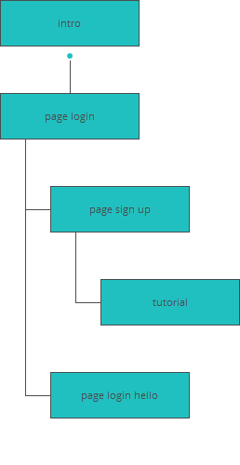

|  |
| --- |
| Screens |
|  |

|  |
| --- |
|  |

02. Screens / JustPrototype 

intro

|  |
| --- |
|  |

Interactions

|  |  |
| --- | --- |
| 1 | **on Page Load:** goes to 'page login' with effect: fade 🡪 |

02. Screens / JustPrototype 

page login

|  |
| --- |
|  |

Interactions

|  |  |
| --- | --- |
| 2 | **on Click:** goes to 'page sign up' with effect: slide and fade 🡪 |
| 3 | **on Click:** goes to 'page login hello' with effect: fade 🡪 |

02. Screens / JustPrototype 

page login hello

|  |
| --- |
|  |

02. Screens / JustPrototype 

page sign up

|  |
| --- |
|  |

Interactions

|  |  |
| --- | --- |
| 4 | **on Click:** goes to 'page login' with effect: fade 🡪 |
| 5 | **on Click:** goes to 'tutorial' with effect: fade 🡪 |

02. Screens / JustPrototype 

page my profile

|  |
| --- |
|  |

02. Screens / JustPrototype 

tutorial

|  |
| --- |
|  |

02. Screens / tutorial 

Other states

|  |  |
| --- | --- |
|  |  |
|  |  |

|  |
| --- |
| Templates |
|  |

|  |
| --- |
|  |

03. Templates / JustPrototype 

background

|  |
| --- |
|  |

|  |
| --- |
| Scenarios |
|  |

|  |
| --- |
|  |

04. Scenarios / JustPrototype 

default

|  |
| --- |
|  |