**INVESTIGATING THE EFFECTIVENESS OF DIVERSIFICATION STRATEGIES BASED ON ALTERNATIVE RISK MEASURES**

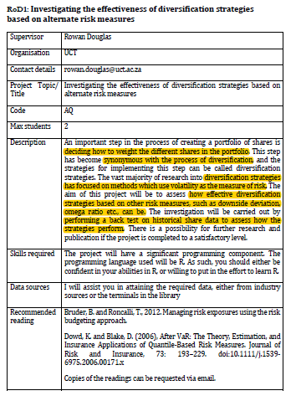

**To consider:**

* What alternative risk measures will we be using (characteristics, limitations, estimation, application)
  + Downside variation
  + Omega ratio
  + QBRMs
* Diversification strategies on these other risk measures, and how to assess their efficacy
* Back-test on historical share data to assess how the strategies perform

**LIT REVIEW**

1. **After VaR: The Theory, Estimation, and Insurance Applications of Quantile-Based Risk Measures (Dowd, K. & Blake, D., 2006)**

* VaR is flawed
* Financial risk management (FRM)
* New risk-measures
  + Coherent measures
  + Distortion risk measures
* Increased interest in risk measures also due to
  + “Impact of financial engineering...especially in emerging area of alternative risk transfer (ART)”-p194
  + “Increasing securitisation of insurance-related risks”
  + “Increasing use of risk measures in regulatory capital and solvency requirements”
  + “Trend toward convergence between insurance, banking, and securities markets”
  + “Growth of enterprise-wide risk management (ERM)”
* There are many QBRMs better than VaR
  + Should be relatively easy to upgrade from VaR to the better risk measures
* QBRMs
  + VaR
    - Maximum likely (generally 95% CI) loss over time-period t
    - Different t, CI, estimation methodology
    - Has favourable characteristics
      * “Provides common measure of risk across different positions and risk factors” - p196
        + Ie can be applied to any portfolio and so can compare different portfolios
        + Duration applies only to fixed-income positions
        + Greek measures only to derivative positions
        + MPT only to equity and similar positions
      * Aggregates the risk of position taken
      * “Holistic” - takes account of all driving risk factors in the complete portfolio
        + As opposed to one at a time or by making simplifying assumptions
      * Is probabilistic (giving info on likelihood of certain loss amounts)
      * Easy to understand unit of measure - “lost money”
    - Limitations
      * Fails to fully describe tail losses
        + This may contradict logical and rational risk-return analysis if the tail loss is extremely large
      * Moral hazard
        + “The fact that VaR does not take account of what happens in “bad” states can distort incentives and encourage traders to “game” a VaR target (and/or a VaR-defined remuneration package) to promote their own interests at the expense of the institutions that employ them.“ - p.197
      * Not sub-additive (see below). Thus, VaR is fundamentally merely a quantile, not a risk measure
      * Does not meet increasingness property (see conditions that the risk spectrum function must meet st M is coherent - p203)
  + Coherent risk measures (Artzner et al., 1997, 1999).
    - Risk-measure axioms (axioms of coherence) - see p.198

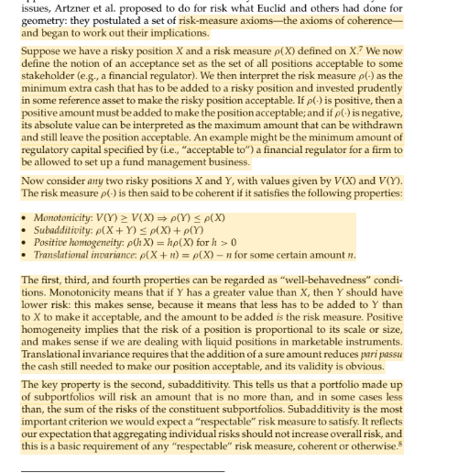p198

* + Expected Shortfall
    - The average worst case scenario (given a CI)
    - No consistent use of nomenclature (Conditional Tail Expectation, Tail VaR, Expected Tail Loss, Tail Conditional Expectation, Conditional VaR, Tail Conditional VaR, Worst Conditional Expectation)
    - Two variations
      * ES - “defined ito a probability threshold”
      * “Average of losses exceeding VaR”
  + Spectral Risk Measures
    - “Relates coherent risk measures to a user’s risk aversion” - p.202
    - Gives us p(.)=M_thi=integral(0,1)thi(p)q_pdp

p202

* + - “Weighted averages of the quantiles of our loss distribution”
    - Function thi(.), aka the risk spectrum or risk-aversion function, needs to be determined. Must meet certain conditions so that M_thi is coherent
    - ES is special case of M_thi

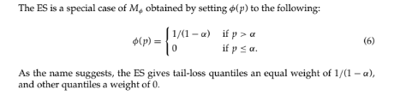p202

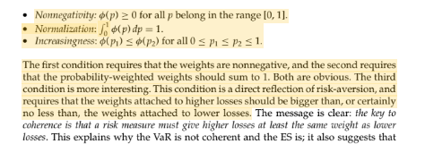p203

* + - “The key to coherence is that a risk measure must give higher losses at least the same weight as lower losses” - p.203
    - “If a user has a “well-behaved” risk-aversion function, then the weights will rise smoothly, and the more risk-averse the user, the more rapidly the weights will rise” - p.203
    - Choice of user’s risk-aversion function is subjective
    - ES and VaR can be argued to be bad measures to use for the risk-averse user:
      * VaR: No value given to loss exceeding a certain point ⇒ risk-loving in tail loss region\
      * ES: all losses in tail region have the same weight (see p.202 equation (6)) ⇒ risk-neutral attitude to risk between tail-region outcomes
  + Distortion Risk Measures
    - “Closely related to coherent measures” - p.204

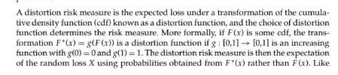p204

* + - Like coherent risk measures, share some properties
      * Monotonicity
      * Positive homogeneity
      * Translational invariance
    - Like spectral risk measures
      * Property of comonotonic additivity
    - We need to choose a good distortion function. Some qualities to look out for:
      * Continuity (necessary and sufficient for it to be coherent)
      * Concavity (sufficient for it to be coherent)
      * Diffible
  + Other Risk Measures
    - Convex risk measures
    - Dynamic risk measures
    - Comonotonicity approaches
    - Markov bounds approaches
    - “Best practices” risk measures
  + There are many different types of risk measures, and it’s generally not quickly identifiable which one is the best for the particular situation
  + VaR does not have good theoretical properties
* Estimation methods
  + “The costs of upgrading from VaR to more sophisticated risk measures are very low” - p208
  + See p.208 - 212 - will probably come in handy when doing the actual modelling
  + 1) Parametric methods
    - Assumes that loss dbn takes on a particular parametric form
    - Choice of dbn informed by “informal diagnostics” or also “theoretical considerations” or “past experience” - p209
    - Would “have to take account of any conditionality in the loss process: losses might follow a temporal pattern, or might be driven off some other rv”
    - After choosing dbn, must “look up that dbn’s quantile formula”
      * Has unknown parameterns that need estimating, which can be done using
        + MLE
        + OLS
        + Method of moments
    - “Suited to risk measurement problems where the dbns concerned are known or reliably estimated” p.210
      * Not met normally - esp small sample sizes
      * Only appropes for relatively “simple” risk measurement problems
  + 2) Nonparametric methods
    - Without strong assumptions regarding the dbn under consideration
    - “Estimate risk measures from the empirical dbn” - p210
    - “Avoid danger of misspecifying the dbn”
    - Assume that the near future will be similar to the recent past, which is justification for using recent historical data
    - Can be imprecise - especially towards the tails
    - “Can also extend nonparametric methods to include nonhistorical scenarios” (ie “hypothetical scenarios) - p211
  + 3) stochastic (monte carlo) simulation methods
    - “Simulate the loss dbn using a random number simulation engine, and they are much more powerful and flexible than the earlier methods” - p211
* Complicating factors in insurance risk measurement problems
  + “These will often necessitate that we use stochastic simulation methods” - p212
  + Valuation problems
  + “Badly behaved” and heterogenous risk factors
  + Nonlinearity
  + Optionality
  + Parameter and model risk
  + Long horizons
  + Others . . .
* Didn’t read pages 212 - 220 (didn’t seem all that relevant - but may have to come back to them)
* Conclusion
  + Good summary of what we’ve done - may be good to look at briefly

1. **Managing Risk Exposures using the Risk Budgeting Approach (Bruder, B. & Roncalli, T., 2012)**

* Risk budgeting
  + “Investor only chooses the risk repartition between assets of the portfolio, without any considerations of returns” - p2
  + Equal risk contribution (ERC) portfolio
    - “Is located between minimum variance and equally-weighted portfolios” - p2
  + Analysis of the risk budgeting approach
    - See defn on p3
    - “Managing risk exposures with VaR or ES risk measures is the equivalent to managing risk exposures with the volatility in a Gaussian world.” -p3
  + “The right specification of the RB portfolios”
    - RB techniqus usd to create diversified portfolios
    - “If some assets have a negative risk contribution implies that the risk is highly concentrated in the other assets of the portfolio”
    - In the below:
      * X is the vector of weights
      * B is the vector of risk budgets

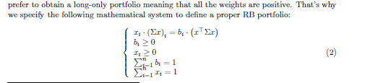p4

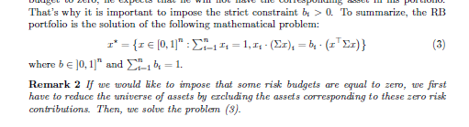p5

* + RB portfolio properties
    - The RB portfolio always exists and is unique
    - Optimality
      * “Like the ERC portfolio, the risk budgeting approach is a heuristic asset allocation method” -p10
  + Generalisation
    - “We could show that the previous results are valid to convex risk measures R that satisfy the Euler decomposition, because it suffices to replace the the marginal volatility by the marginal risk in the mathematical proofs.” - p13

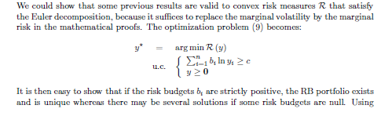p13

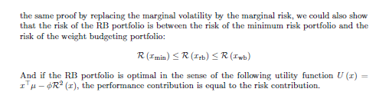p14

* + Comparison with MPT
    - “MPT tends to maximise effects of errors in the input assumption” - p15 (Michaud, 1989)
  + Risk Parity Funds
    - Optimising the MPT - faces that asset allocation puzzle (Campbell and Viciera, 2002): describes a gap between theory of this diversification method, and the practical point of view
      * Main criticisms:
        + “The allocation of diversified funds is very static and does not justify the high level of management fees” - p19
    - This has lead to an alternative diversification technique: “a risk parity (RP) fund is an ERC strategy on multi-assets classes:
      * “Diversify, but diversify by risk not by dollars - that is, take a similar amount of risk in equities and in bonds” (Asness et al., 2012)
      * For example, if we had a portfolio consisting of bonds and equities, we would diversify by rebuilding the portfolio such that the risk of the bond assets is equal to the risk of the equity assets
        + “The leverage RP fund has a volatility similar to the balanced fund, but a better performance” - read p20-21 again for better explanation of what they did
  + “Risk-based indexation’
    - “More recently, risk-budgeting techniques have been considered to build alternative benchmarks to market-cap indexes. These last ones have been particularly criticized by academics and market professionals and we observe a growing interest by sophisticated institutional investors.” - p23
    - Equity indexation
      * capitalisation -weighted indexation
        + “Most common way to gain access to broad equity market performance” - p24
        + “Backed by results of MPT because it is assimilated to the market portfolio”
        + Main advantages

Simple to manage (low turnover and transaction costs)

Easy to understand and replicate

* + - * + Drawbacks

“By definition a trend-following strategy where momentum bias leads to bubble risk exposure as weights of best performers increase”

“Absence of portfolio construction rules leads to concentration issues (in terms of sectors or stocks)”

* + - * Thus, this lead to alternative-weighted indexation
        + Fundamental

“Defines the weights as a function of economic metrics like dividends and earnings”

* + - * + Risk-based

“Defines the weights as a function of individual and common risks”

The ERC method belongs to this form of alternative-weighted indexation

See Eurostoxx 50 NR index vs ERC Eurozone index on p24

Same universe of stocks

ERC rebalanced every month (according to ERC method)

ERC has smaller volatility

ERC has smaller drawdown

ERC outperforms

* + - Bond indexation
      * “Weights are generally defined by the notional amount of debt, implying that asset management industry is dominated by the debt-weighted indexation.” - p26
      * “The simplicity of this approach and the recognition of a capitalisation-weighted index as the market portfolio has contributed to the success of the methodology. Yet, intuitively, it is easy to note a basic flaw in this allocation scheme, since it gives higher index weightings to the most indebted countries, regardless of their capacity to service their debt. A country facing financial hardship and trapped in a debt spiral to remain solvent would see its index weight increase until the whole mechanism collapses and an exclusion from the index occurs. Depending on the index, exclusion can be triggered by specific events, such as a downgrade or, in the worst case, a default.” - (Bruder et al, 2011)
      * ….becomes less relevant I think since it’s the bond market and we will be looking to diversify stocks….can back to this (p.26-29)
* Conclusion - p29
  + “Risk budgeting portfolio is a generalisation of the ERC portfolio presented in Maillard et al. (2010) when the risk budgets are not necessarily the same.”-p29
  + “It is also an heuristic method like equally-weighted or minimum-variance portfolios, because there is no financial theory that promotes the RB portfolio as an optimal portfolio.”
  + “There are few results about the theoretical behaviour of such portfolios”
  + “We have shown that the volatility of the risk budgeting portfolio is located between those of minimum variance and weight budgeting portfolios”
  + Applications
    - Risk parity funds
    - Strategic asset allocation
    - Equity indexes
    - Sovereign bonds benchmarks
  + Issues
    - “To understand what type of performance we could expect”
    - “Simulations and back tests show that it could deliver better performance than other portfolio methods”

1. **First additional reading**
2. **Chen et al 2011**
3. **Chow et al 2011**

* 2 types of investment strategies
  + Heuristic-based weighting
    - Ad hoc weightings establish on rules
    - Includes
      * Equal weighting
      * Risk-cluster equal weighting
      * Cap weighting blended with equal weighting
      * Weighting by historical financial variables
  + Optimisation-based
    - “Subject to practical investment constraints.”
    - Includes
      * Minimum variance strategies
      * Variety of maximum sharpe ratio portfolios based on various expected return assumptions

1. **Fourth additional reading**
2. **5th**
3. **6th**
4. **7th**
5. **8th**
6. **9th**
7. **10th**

1. **Further readings - also see highlights above for this**

* Maillard et al. (2010) - for further look at equal risk contribution (ERC) portfolios (risk-budgeting)
* 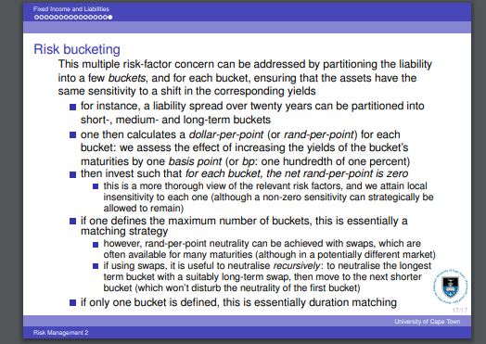
* Risk budgeting readings
  + Rahl (2000)
  + Grinold and Kahn (2000)
  + Meucci (2005)
  + Scherer (2007)
  + Michaud (1989) - for evaluation of MPT optimisation
* 