Taha Taylan Ceylan B1910.033015

Hamza Şafak Çavuş B1910.033045

# Graduation Project Documentation

## Spirit of Sinners – a 2D Action Platformer Game

Introduction: Spirit of Sinners is a 2d action platformer game. The main focus of the game is a combat between player and enemies. Player’s objective is eliminating enemies through his path and reach the end of the level.

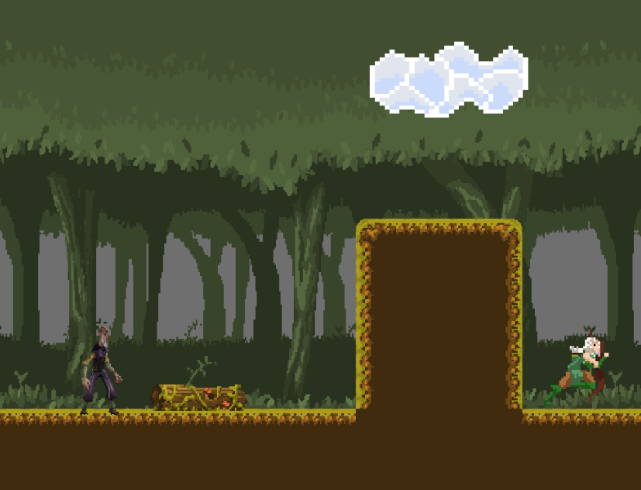

Player Abilities: The player can do multiple movements such as running, jumping, sliding on wall and crouch. The player also has two combat action. These are magic ball attack and melee attack.

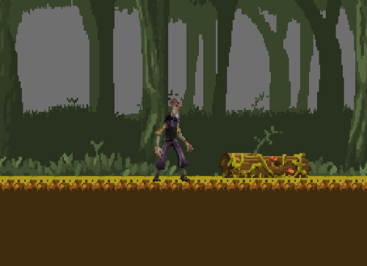

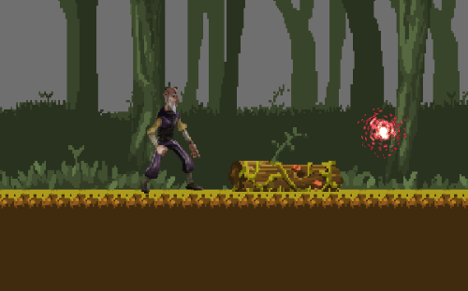

Enemies: We have 4 unique enemy types in our game. These are skeleton, gunslinger, bulldozer and bomberman.

Skeleton: Skeleton is a basic enemy type. It patrols along the platform and when the player is in its range, it attacks the with an axe player.

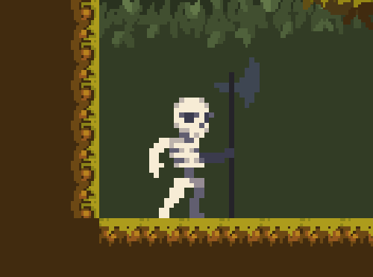

Gunslinger: Gunslinger is a ranged enemy type. It patrols along the platform and if the player is in attack range, it uses its bow to attack the player.

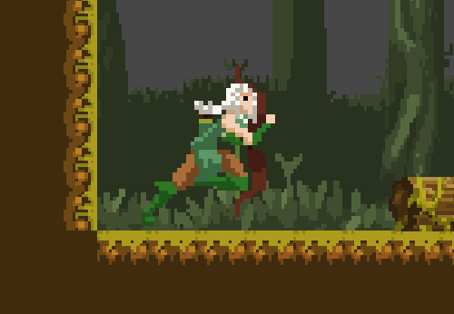

Bulldozer: Bulldozer is a heavy enemy type. It idles on its position unless it sees the player. If it sees the player, it rushes to the player and attacks.

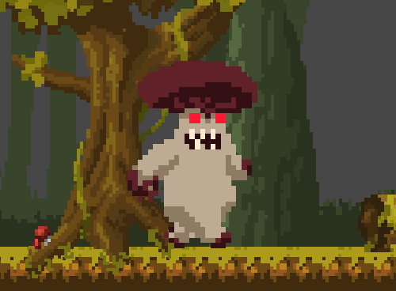

Bomberman: Bomberman is a ranged type of an enemy. It flies along the platform. It throws a grenade to the player if the player is in attack range.

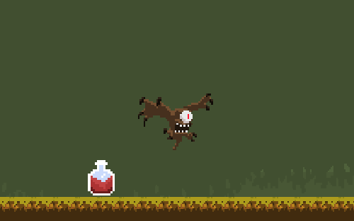

Game Systems: We have multiple game systems such as shop system, health potion system, moving cloud system, and flamethrowers.

Shop System: In our shop system the player can buy health potion or health upgrade for itself in exchange with coins.

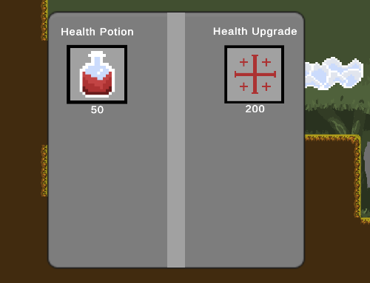

Moving Clouds: In our game we have moving clouds that moves between declared positions. The player can use them to access the higher platforms.



Flamethrowers: Flamethrowers are the traps to deal damage to the player.

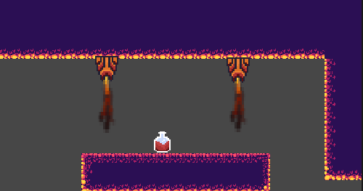

HUD: We have hud that displays player health and player coins.

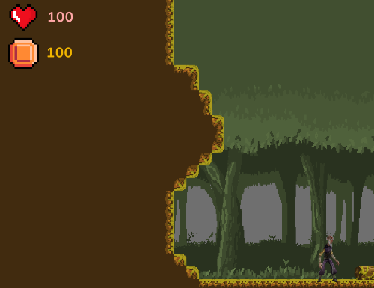

Levels: We have 2 levels in our game. These are heaven and hell.

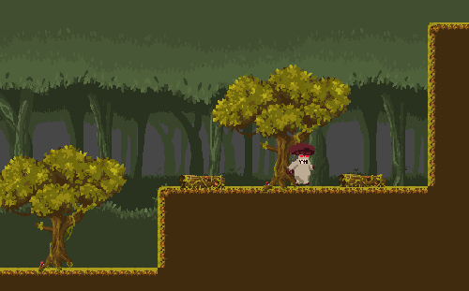

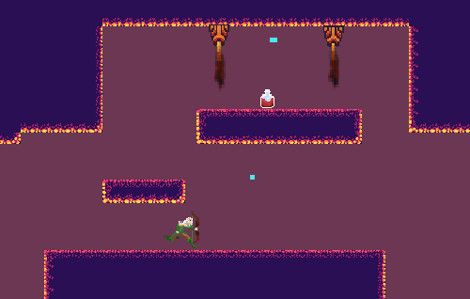

Prerequisites For Players: Spirit of Sinners is very user-friendly game. That means any kind of player can easily adapt to the game and enjoy it. They can read the control schema in the main menu. The game is not hard for the non veteran players.

Prerequisites For Developers: In order to understand the core code, you need to have C# knowledge and be familiar how to use Unity game engine.

You can use the Unity documentation link below to understand the concepts.

<https://docs.unity3d.com/2020.3/Documentation/Manual/index.html>

Black-Box View:

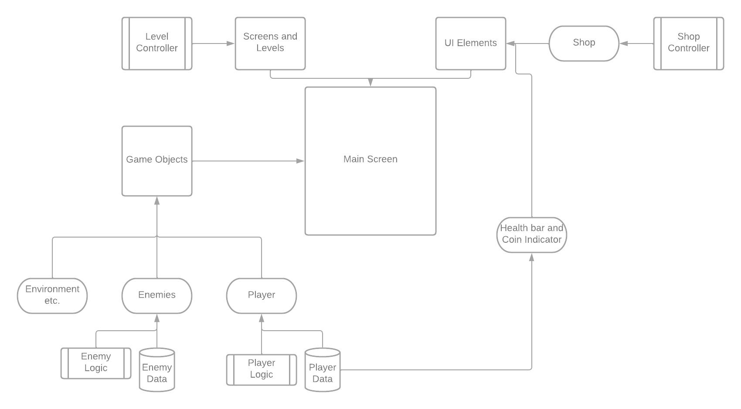

Coding Guideline:

|  |  |
| --- | --- |
| Tools | Resources |
| C# | <https://www.w3schools.com/cs/index.php> |
| Unity | [Unity Documentation](https://docs.unity3d.com/2020.3/Documentation/Manual/index.html) |

Technical Constraints:

|  |  |
| --- | --- |
| Constraint Name | Description |
| Unity Engine | The game made with unity. You can not use any different kinds of game engine for this Project. |

|  |  |
| --- | --- |
| Constraint Name | Description |
| Entity Animation Controller | You can not implement new animation controller logic due to Project architecture. |

User Interface Diagram:

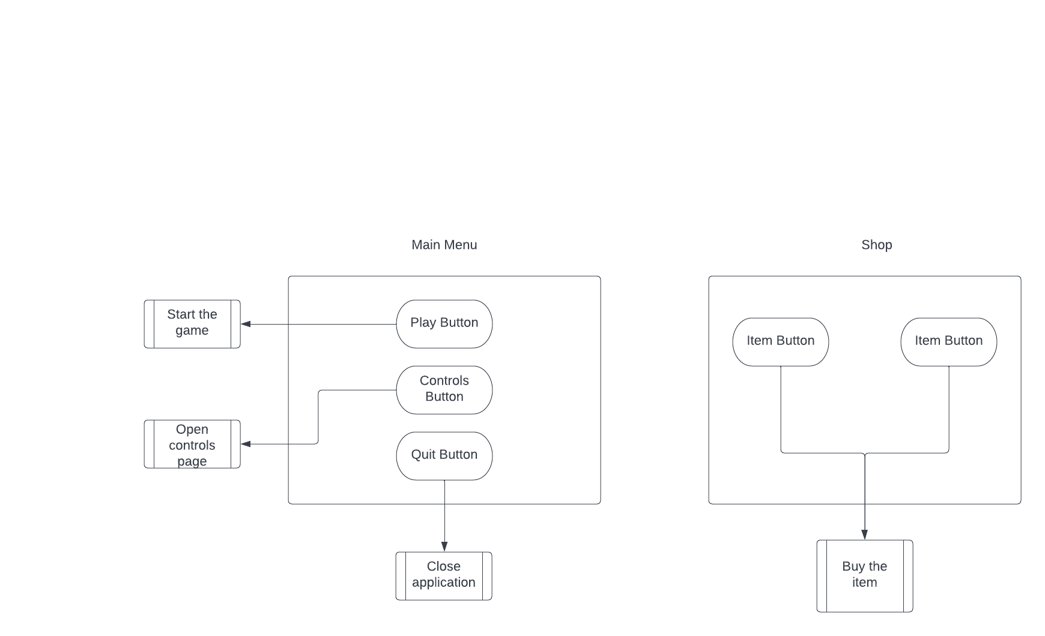

## Installing and Starting The Game: You can download the game files and after clicking the game exe you can start the game.

Solution Strategy: Our solution strategy is developing the core game concept first such as prototyping the bare-bone game and after the prototype part, we focus to polishing the game code and implement clean code principles.

Runtime Diagram:

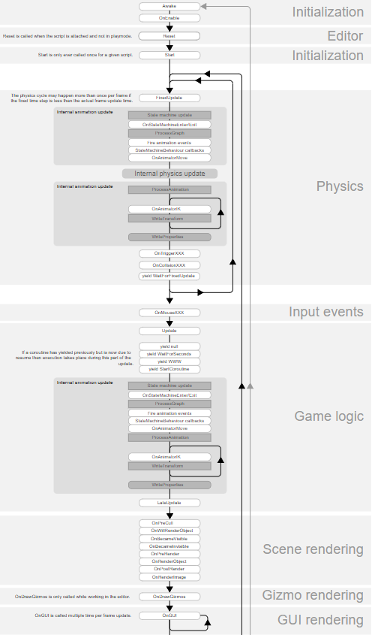

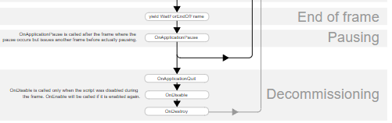

Source: <https://docs.unity3d.com/Manual/ExecutionOrder.html>

Libraries and Softwares used in this Project:

|  |
| --- |
| Unity Engine |
| Unity Package Manager |
| Unity UI Elements |
| Unity Scene Manager |
| Blender |
| Aseprite |