**Runtime Analysis**

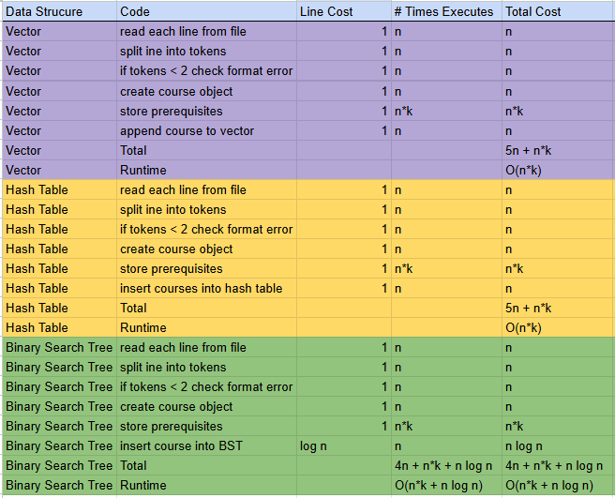

Although vectors are easy to implement and preserve insertion order, their linear-time lookups and precondition handling make them inefficient for large datasets. Although they don't retain order and require more complicated setup, hash tables are perfect for organizing several courses and prerequisites since they provide the highest efficiency for insertions and lookups. Binary search trees are more complicated and slower than hash tables because of their log n operations and possible imbalance, but they offer ordered data and faster searches than vectors.