Population Size: 5  
Mutation Rate: .005  
Selection Rate: .02  
Generations: 50

Highest score: 12

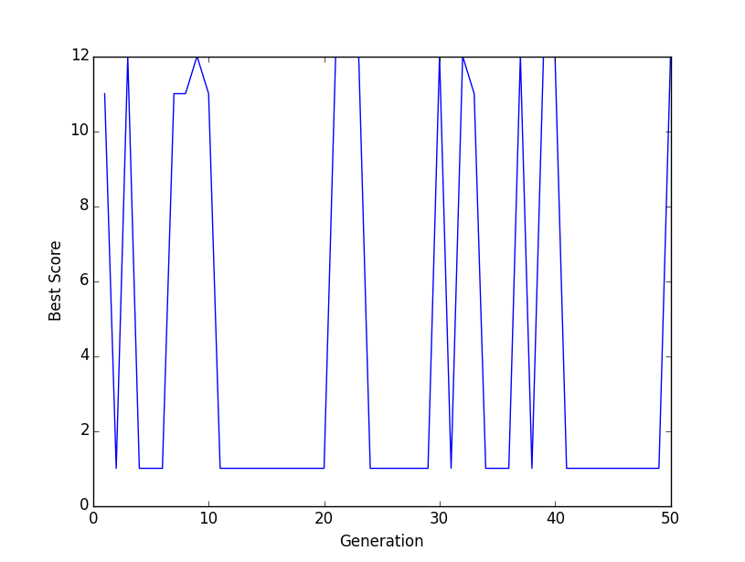

Population Size: 5  
Mutation Rate: .5  
Selection Rate: .02  
Generations: 50  
Highest score: 347

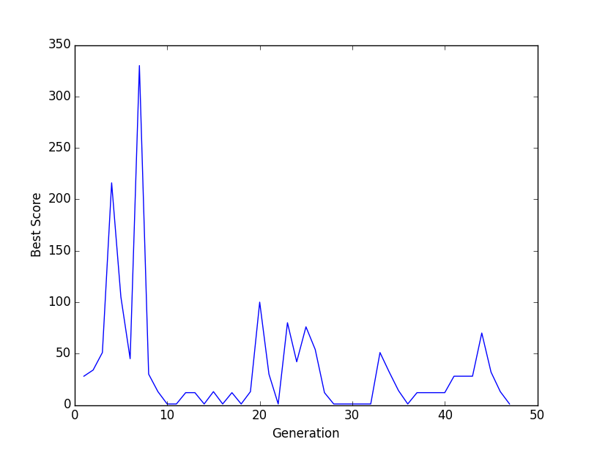

Population Size: 10  
Mutation Rate: .05  
Selection Rate: .02  
Generations: 50  
Highest score: 47

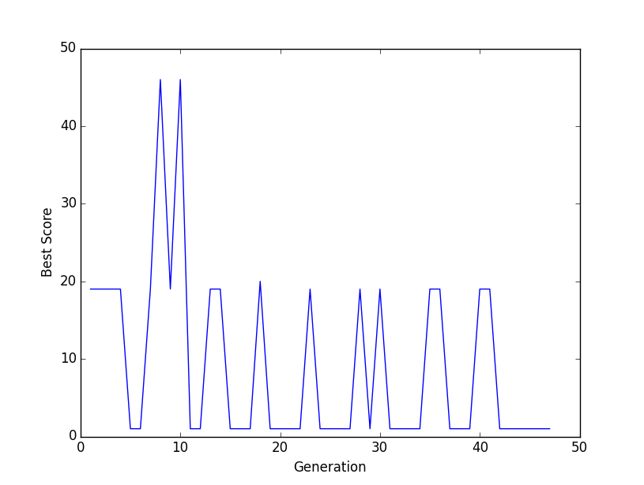

Population Size: 10  
Mutation Rate: .5  
Selection Rate: .02  
Generations: 50  
Highest score: 333

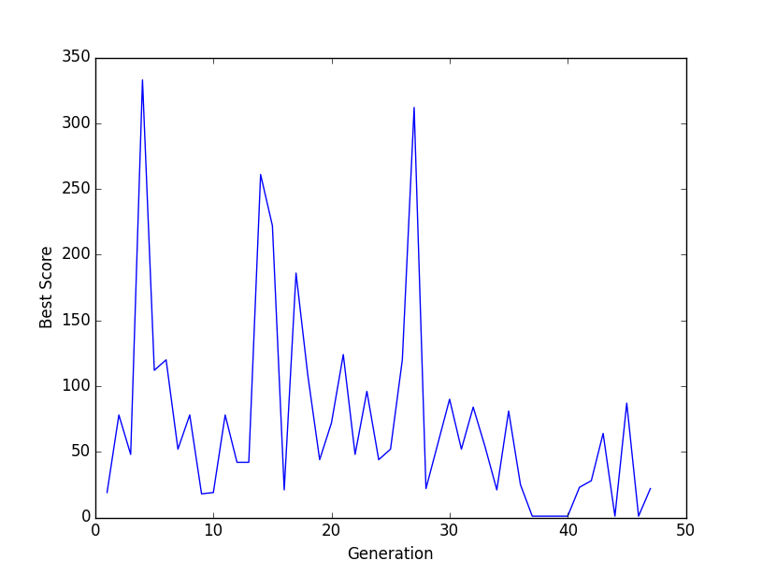

Population Size: 15  
Mutation Rate: .005  
Selection Rate: .02  
Generations: 50  
Highest score: 178

