SEN-36005Configuration
- Connect sensor to CAN adapter
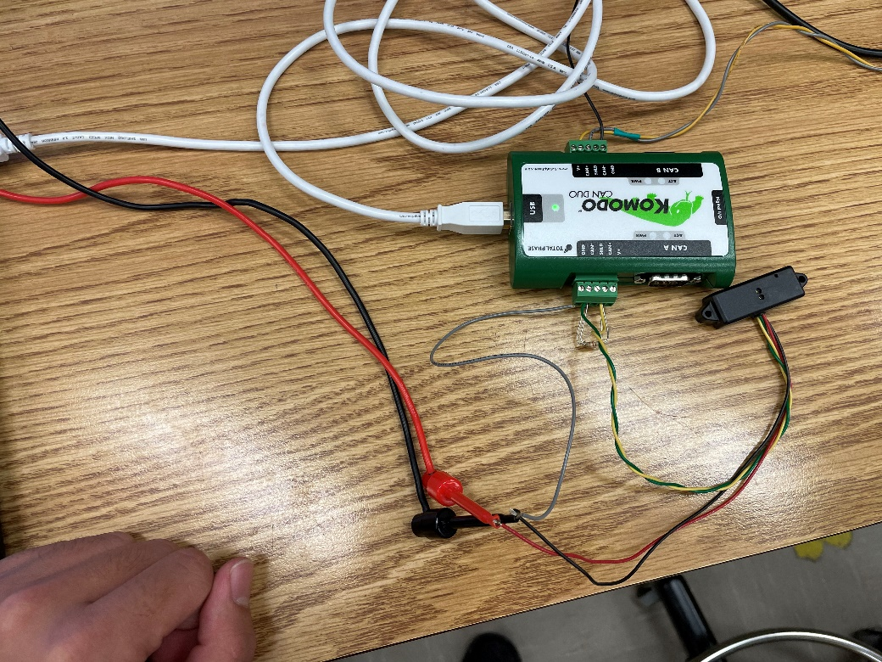
Red: Power: +7V -- +16V
Black: Ground
Yellow: CAN-High
Green: CAN-Low
- Run Komodo GUI
  - Connect port
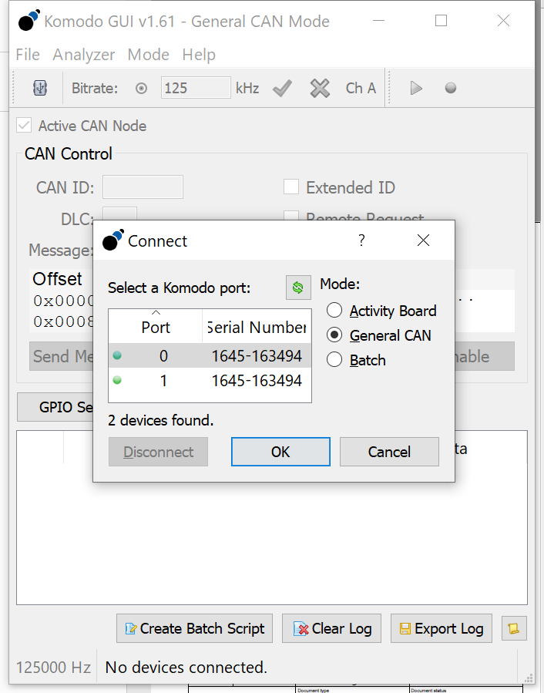
  - Set bitrate or auto bitrate if the sensor is running and should change to 1000 kHz
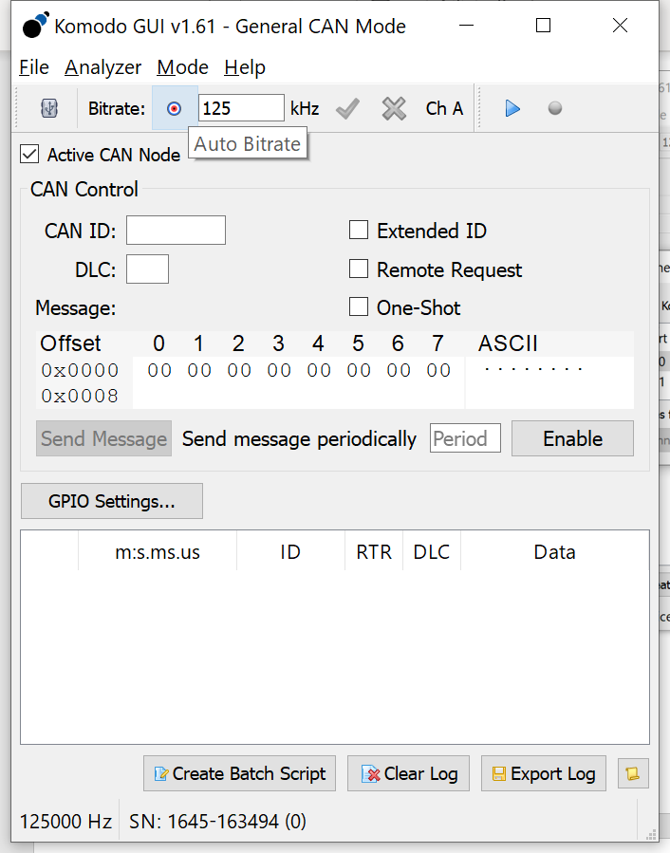
  - Choose channel A or B
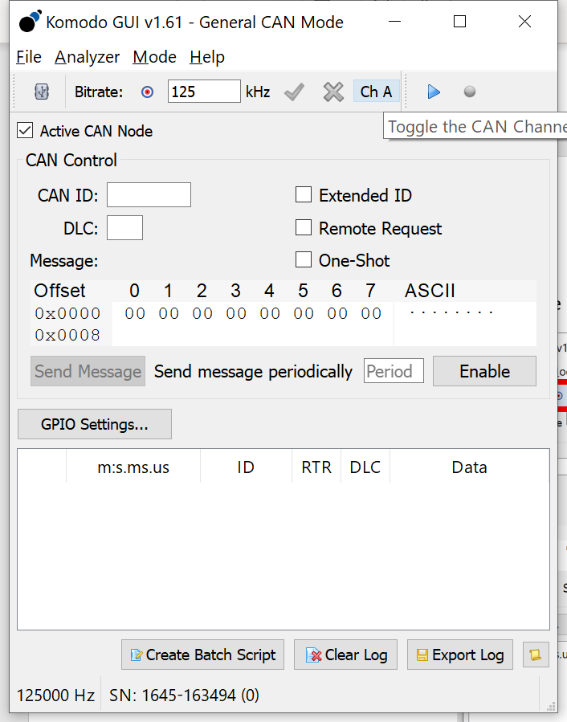

  - Run
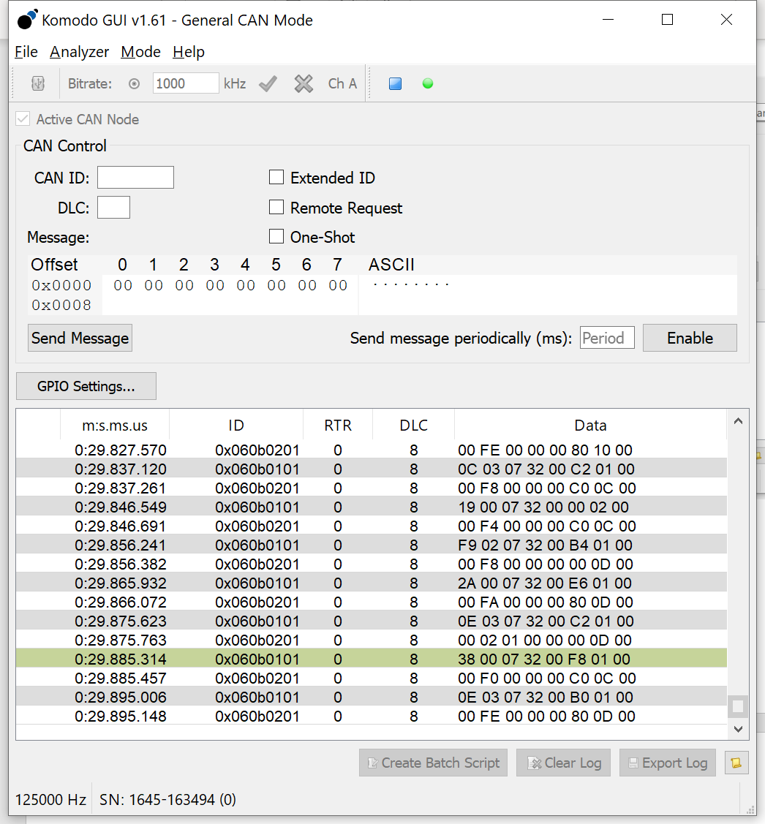
- Get Hardware Serial Number
Find the heartbeat message(1Hz) of message ID 0x1F0B01FF(FF is 00 for default, and 01 in this example)
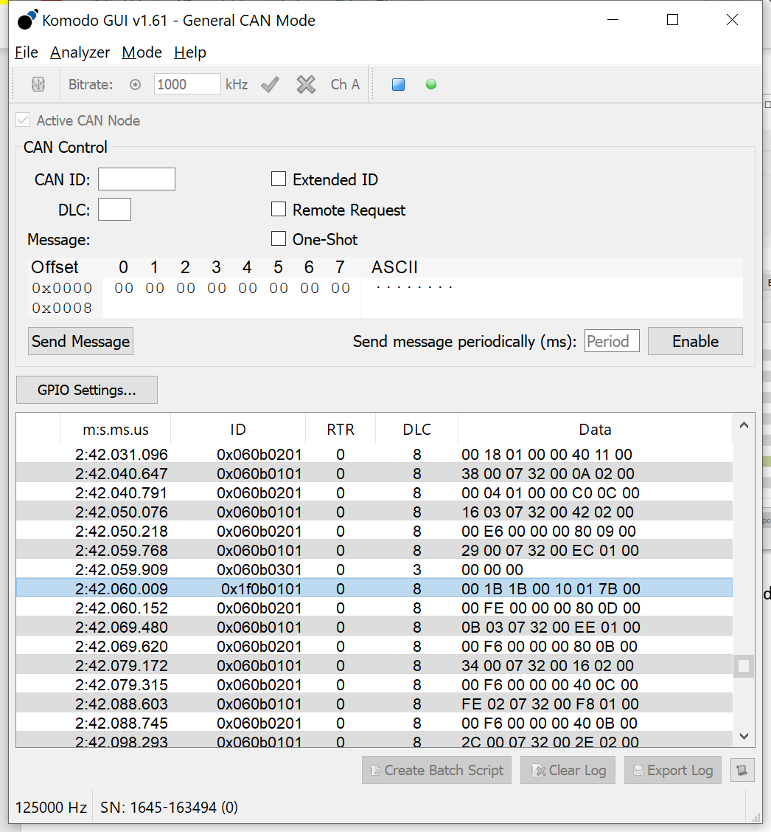
The Hardware Serial Number is byte 1-3, in this example [1B 1B 00]
- Send the message to the sensor to rename the device ID
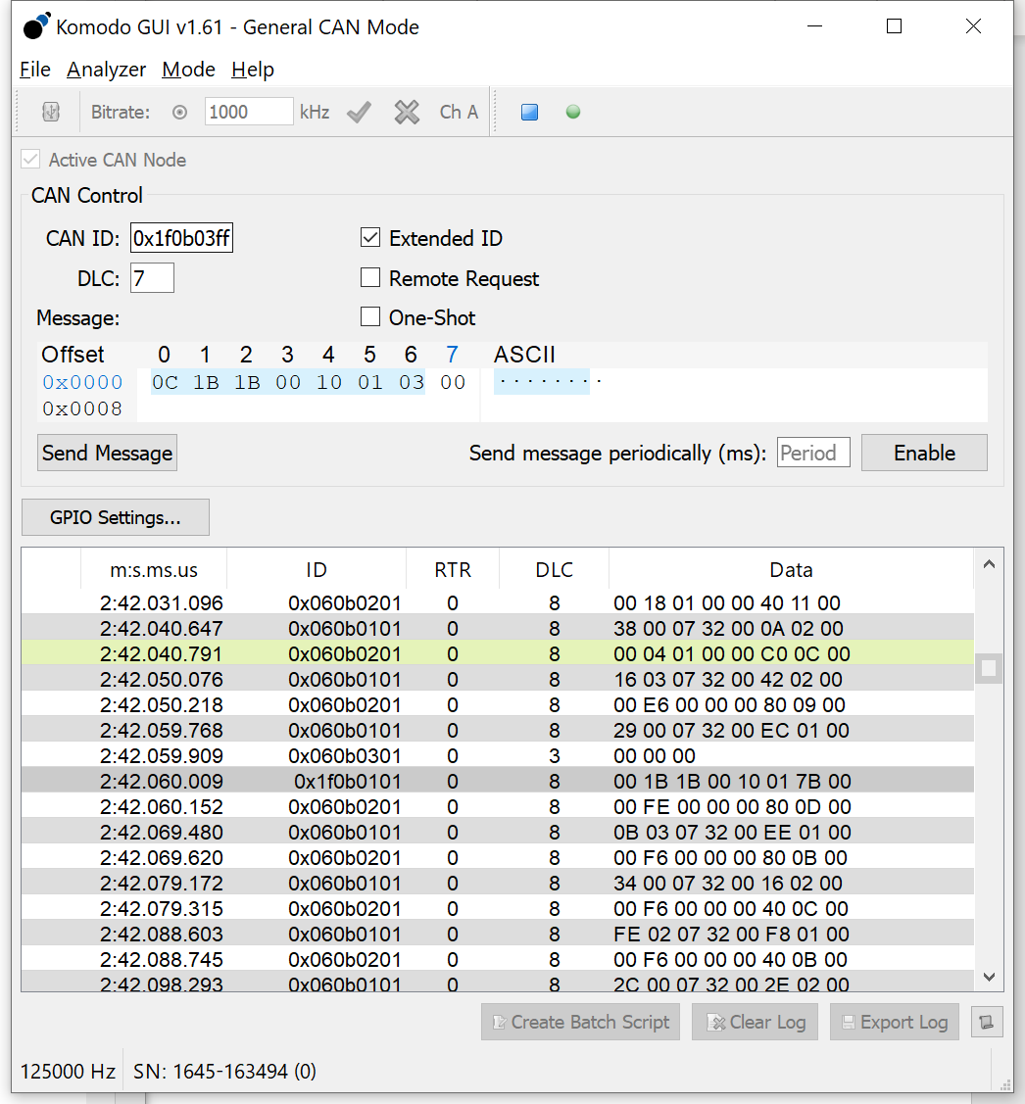

CAN ID: 0x1f0b03ff
DLC(data length):7
Extended ID(29bit): yes
Data: 0C 1B 1B 00 10 01 03
Change to your hardware serial number
Change to your new device ID
After you send the message, the sensor message ID end with 03(your new device name)
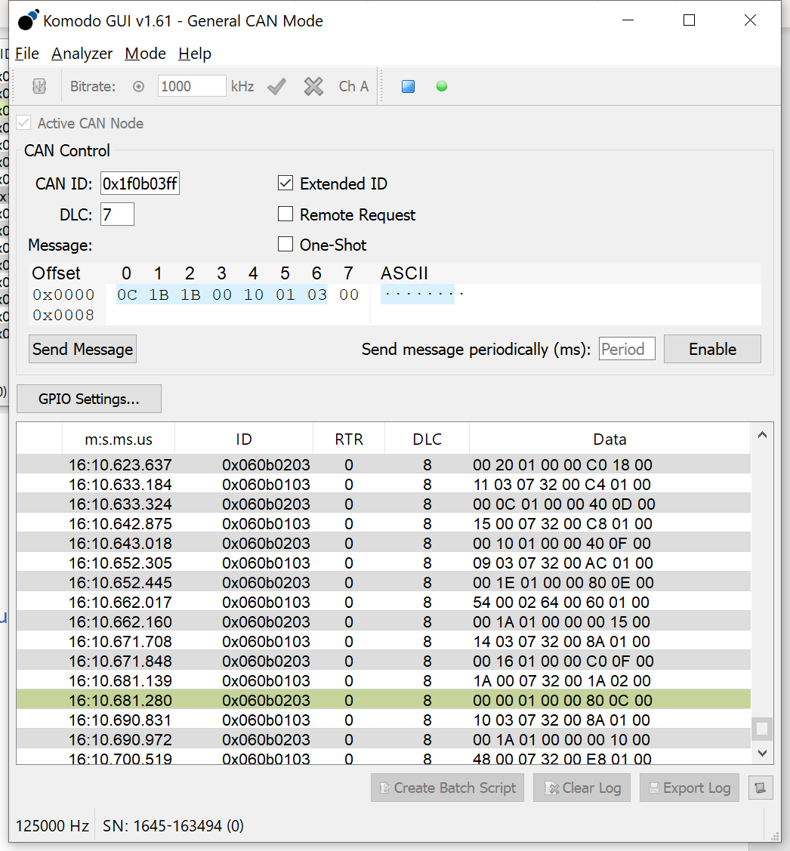

- Ranging, sample time configuration (optional, 1.4m short range by default)
Send a message, similar to step 4

CAN ID: 0x060b04ss(your device ID)
DLC(data length):8
Extended ID(29bit): yes
To Send 50ms is 32Hex
Data: 00 32 00 00 00 00 0F 0F
Range mode: 00: short mode 1.4m(default)
01: medium mode
02: long mode 4m (only in dark)
(The longer mode used, the darker environment should be)
Sample time(ms): 10-1000, (default 10ms)
DataSheet says minimum sample rate is 24 but it is actually 10ms.

