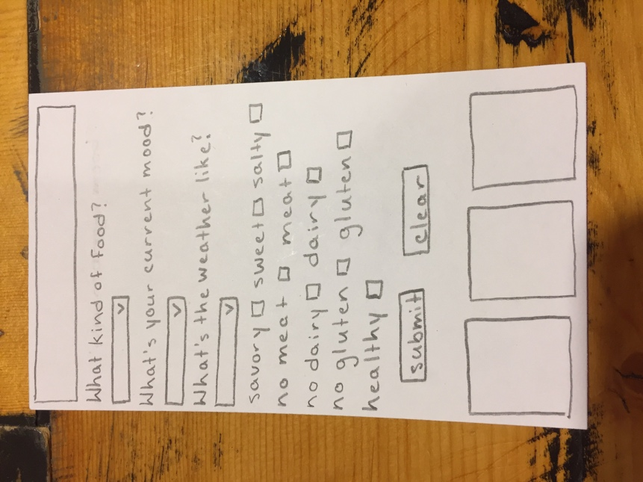

For project 1 I want to create an app that can help you decide what kind of food you want to eat. I will ask the user a series of questions and they can answer as many of them as they want, but the more answers they give the more refined their food choices are going to be. There are a lot of apps out there that help people choose where to eat or help people decide what to eat based off what they have in their pantry, not many choose an actual dish for you based of a quick questionnaire.

In my research I found a lot of similar apps to my idea, but none of them were exactly what I’m going for. One app closely related to my app is called MealGame, it gives you suggestions based on your location. Another one is called Entrée, which is basically tinder for food choices. You can swipe left or right on different kinds of food and it gives you suggestions based on your preferences. There’s another app that reads your facial expressions and will suggest food to improve your mood. After my research I still confident that my app is different enough to pursue.

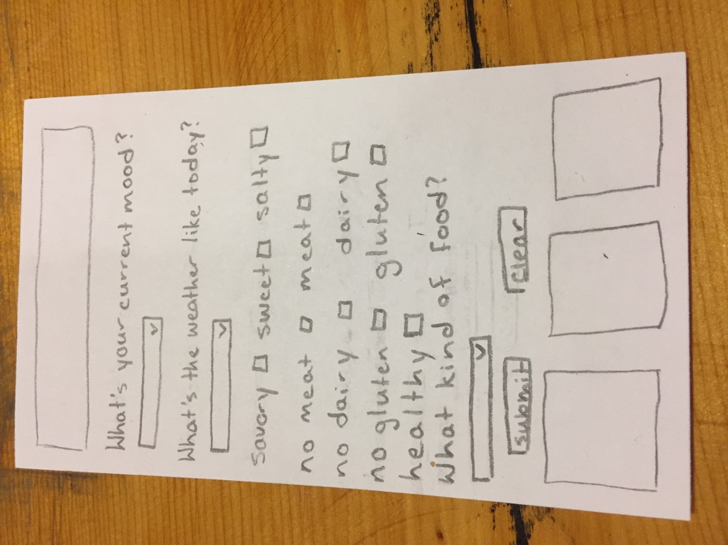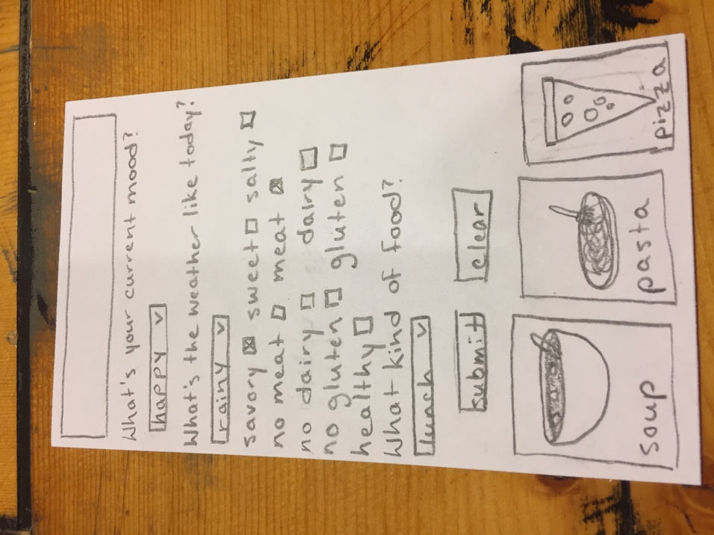

The hardest part of making this app is going to be the algorithm that decides what food to suggest the user. I’m not quite sure how I’m going to do it yet, maybe make different categories of food for each answer and then go through and see what foods appear in every category to give suggestions. My main goal of this app is to make a properly functioning app, which will probably mean spending less time on the food picking algorithm. My choices will be limited, but I want to have at least three suggestions based on the users choices.