Project 1 Milestone 2

So far what I have for project 1 is a rough idea of what I want my layout to look like and a list of options my users can choose from. From these options I’ve started a list of food and I listed what options can result in that food. Since milestone 1 I have dramatically reduced the amount of options available so my app doesn’t become overly complicated. I’ve also taken away the check boxes and the drop down menus, because as you pointed out Xcode doesn’t have those. I replaced them with segmented control because now that I have less options to choose from I want my users to give me a value for each option.

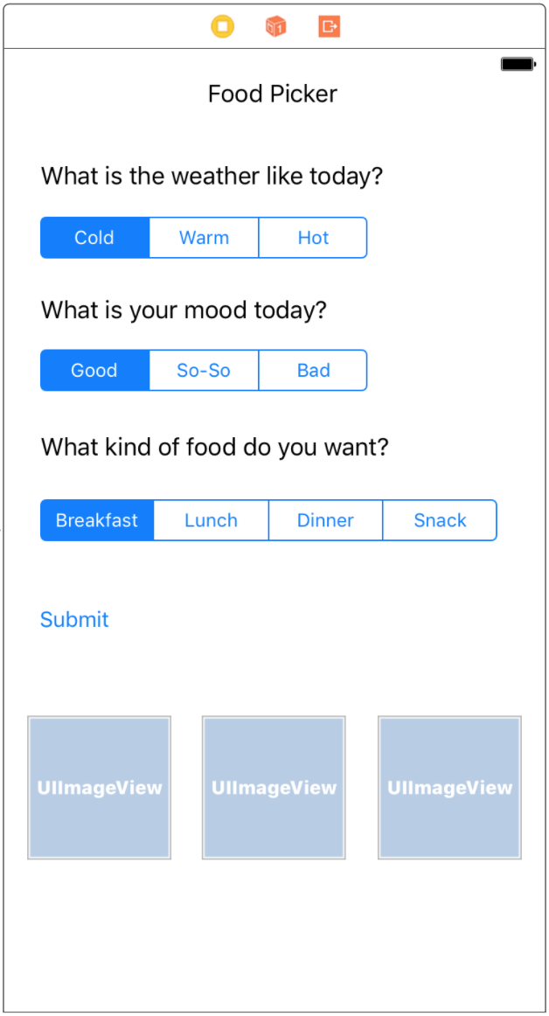

What is the weather like today?

1 - Cold

2 - Warm

3 - Hot

What is your mood right now?

1 - Happy

2 - So-So

3 - Bad

What kind of food do you want?

1 - Breakfast

2 - Lunch

3 - Dinner

4 – Snack

Food Choices

Pizza {1/2,1/2,2/3}

Soup {1,2/3,2/3}

Chicken Pot Pie {1,2/3,2/3}

Salad {2/3,1/2,2/3}

Yogurt {2/3.1/2,4}

Corn Dog {1/2,1/2,2/4}

Ice Cream {2/3,1/2/3,4}

Chocolate {2/3,3/2,4}

Burrito {1/2,1/2,2/3}

Breakfast Burrito {1/2/3,1/2,1}

Breakfast Sandwich {1/2,1/2/3,1}

Bagel {2/3,1/2/3,1}

Waffles {1/2,1/2,1]

Steak {1/2,1/2,3}

Granola Bar {2/3,1/2,4}

Popcorn {1/2/3,1/2/3,4}