Project 2 Milestone 2

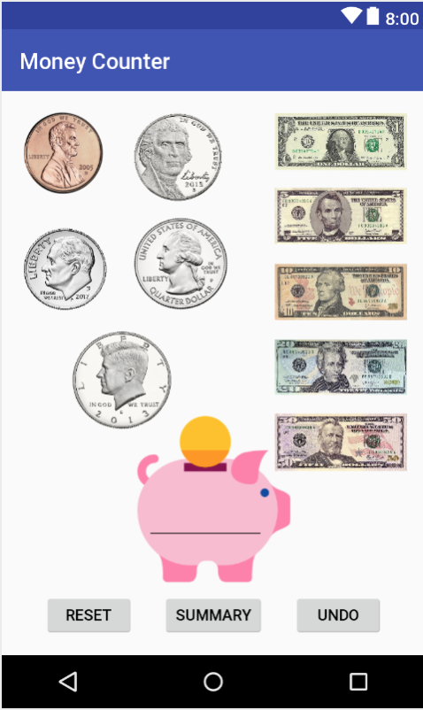

So far I am focused mainly on the first activity, and if I allow myself enough time I would really like to create a second activity that shows how many times you clicked on each picture of money and a break down of the totals. Another thing I would like to add if time permits is if you click on a button it will flash the amount then return to the coin. For example, if you click on the penny right as you click it the picture turns to show a grey background and a “1¢”.

Code:

Private int total;

Private int penny;

Private int nickel;

Private int dime;

Private int quarter;

Private int dollarcoin;

Private int dollar;

Private int fivedollar;

Private int tendollar;

Private int twentydollar;

Private int fiftydollar;

Public void undo;

Public void reset;

Public void calculatetotal;

Public void returntotal;