**1) Narrative summary**

The core narrative of this project is that everyday purchases at a local retail store can tell about American society and its place in global trade three centuries ago. It does so by reconstructing consumer actions of men and women— wealthy and poor, free and enslaved, in various ages and occupations—and detailing that behavior in terms accessible and inviting to scholars and the general public. In essence, it uses an online shopping, a common and comfortable behavior of modern American shoppers, to draw them into another world.

The ledger of William Ramsay records common purchases for everyday life as well as luxury items from a colonial merchant in Alexandria Virginia. The ledger provides a treasure trove of data which we've transcribed into a csv database to facilitate analysis of the sales. However, neither the ledger itself nor the database present the information in a format that is interesting to a general audience. This website presents the book’s historical evidence as it might be encountered as a contemporary e-commerce shopping site. In this effort, currently at a proof of concept stage ([https://ramsay.arthistory.wisc.edu](https://ramsay.arthistory.wisc.edu/)), the user can study what purchases customers make, see them as real objects rather than unfamiliar words, and finally, evaluate a range of options, a modern cost comparison, and a cohort of other items purchased by a customer. We've also released our robust and curated data sets on the website in order to foster scholarly collaboration. Thus our digital humanities project serves myriad new audiences. A larger public will be able to connect historic period consumer goods to their own lives. Scholars can integrate the original data into their own economic and material culture studies, as well as draw on the e-commerce website for students. Museums and historical archaeologists can utilize our work for their interpretive needs.

**2) User experience**

The website is built around offering various levels of interpretation for the information found in the ledger. The main feature for the public audience is in the object entries found sorted by department under the “Shop by Department” tab. This innovative feature allows users to experience unfamiliar objects in a relatable manor. For the casual user, this feature can be used on its own to explore how these everyday colonial objects were used, what they cost, and where they were made. The further features on the site help build a larger cultural framework around the objects and the world they represent. For those who are interested in the historical context or the methods used for our website, the “about” page offers more detailed information. The customer profiles provide a further lens to interpret the objects in the context of the community they were sold and used in. Data visualizations will eventually map relationships between the sales to highlight larger social issues such as spending habits by gender, peek sales periods, foot traffic within the store, or how payment methods reflect social structure. Finally, the documents provide raw data for further analysis by users who wish to engage with the materials on a deeper level or contribute to the project.

**Site Structure and Navigation:**

The primary mode of navigation is through the menu which is present on every page of the website. In the proof of concept version of the website, the tabs each lead to a specific page and further navigation is done through hyperlinks on each page. In the website rebuild, we will maintain these pages while also offering dropdown menus and “next” and “previous” buttons for quicker navigation. Another key feature which we will add in the rebuild is a search field to allow customers to pinpoint the information they want quicker.

The following site map represents the basic structure of the website. Due to space constraints in this document this visualization only reflects a sampling of the individual object entries under each department.

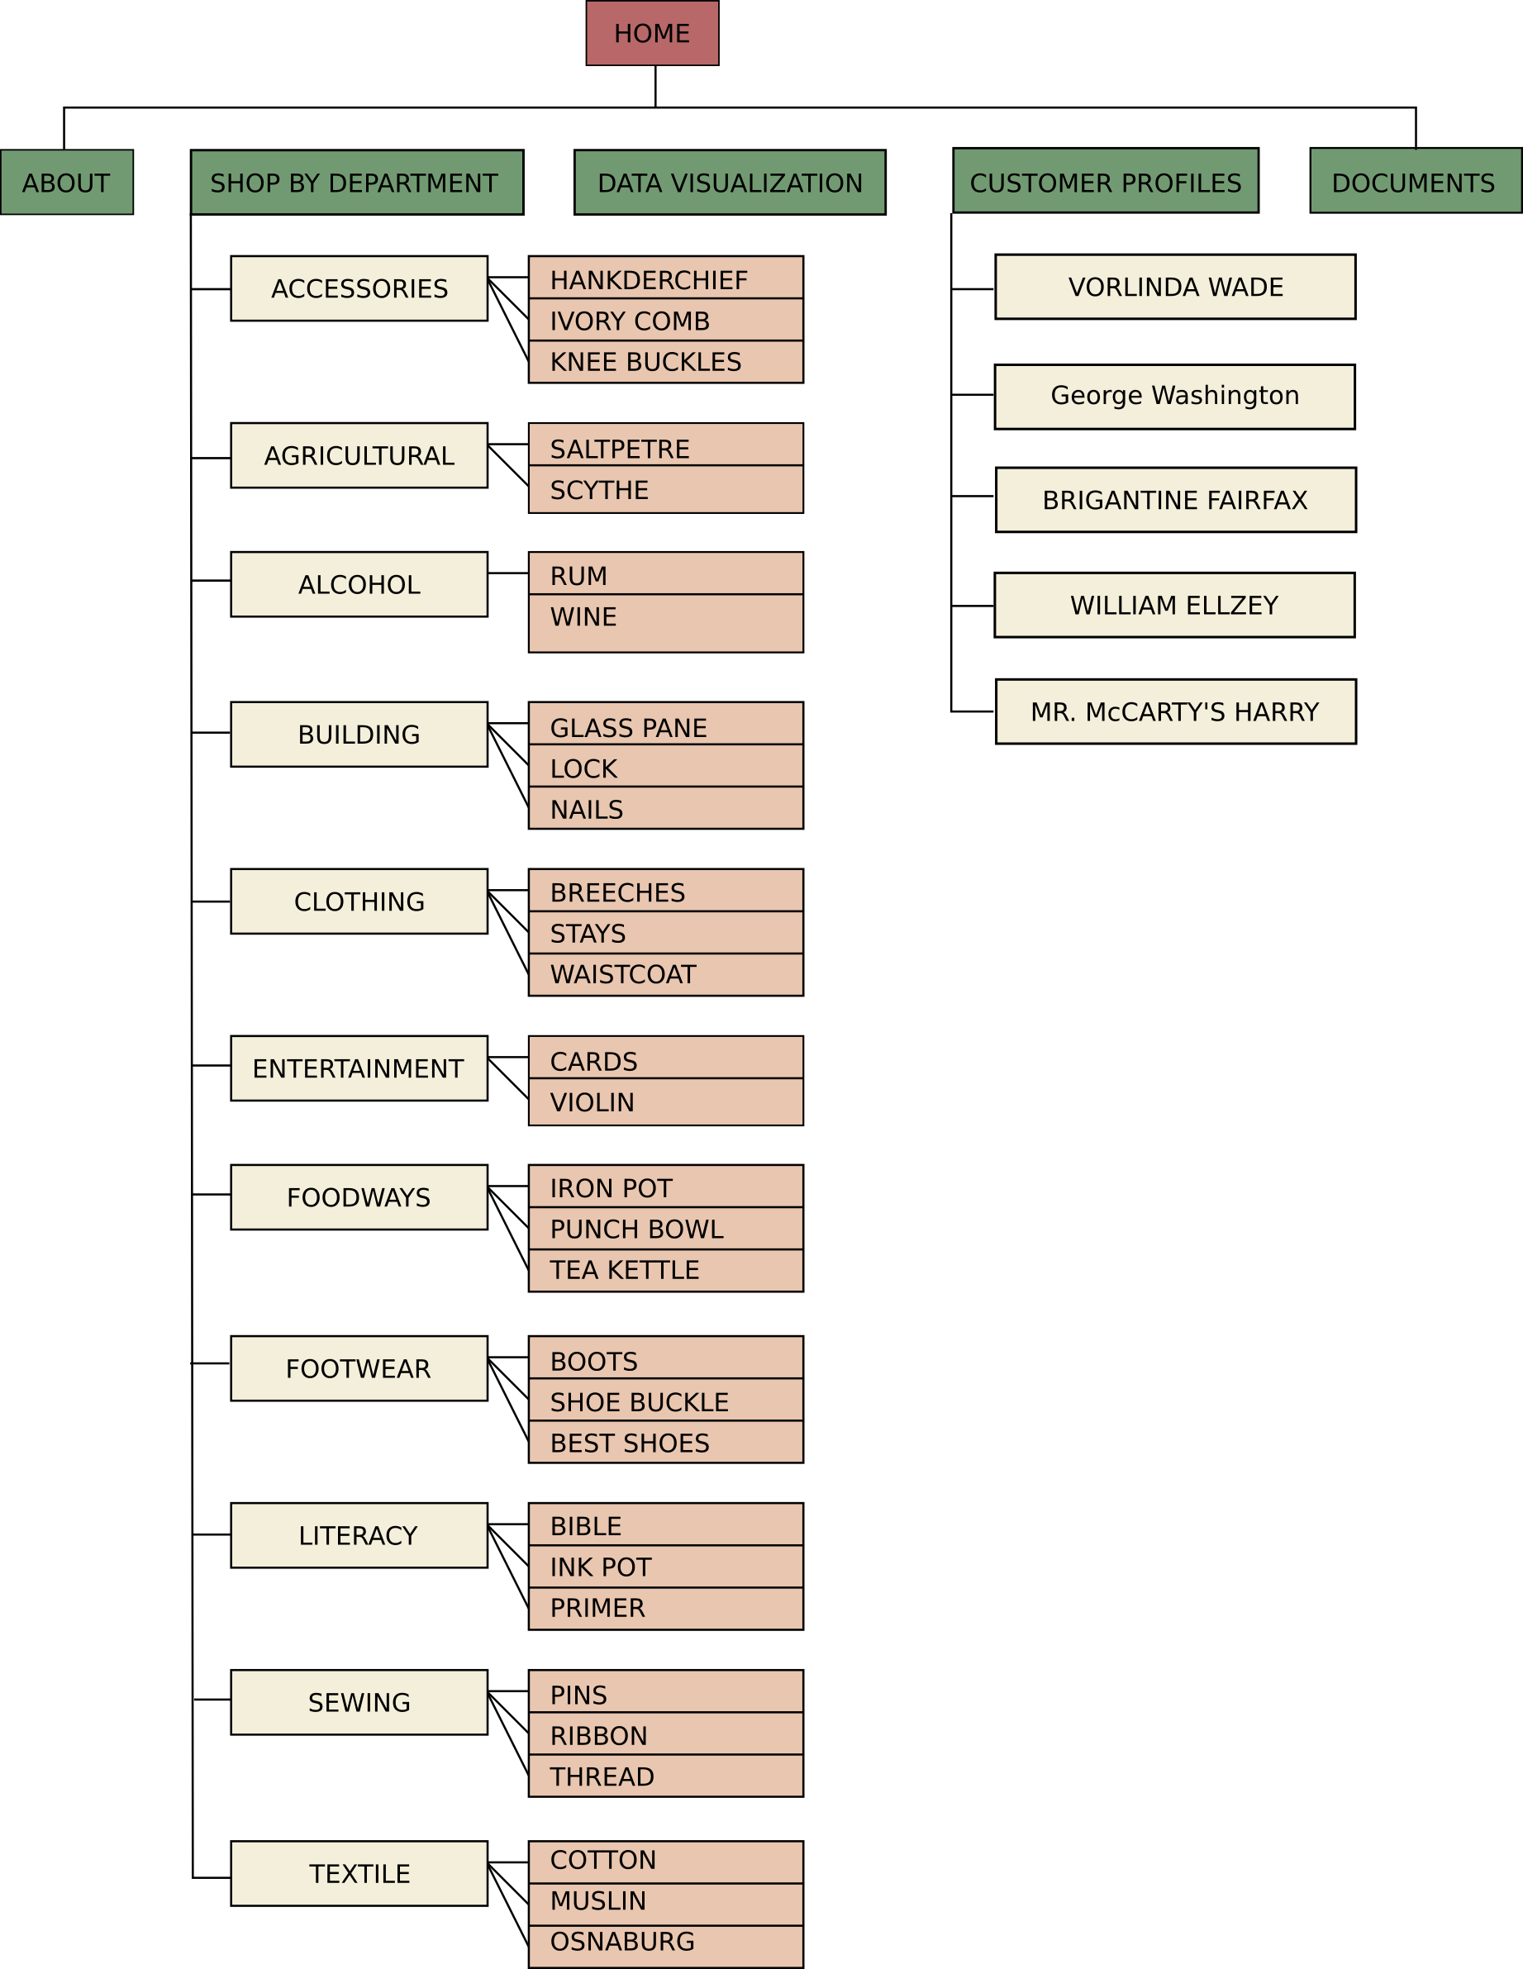

**Home (**[**https://ramsay.arthistory.wisc.edu/**](https://ramsay.arthistory.wisc.edu/)**):**

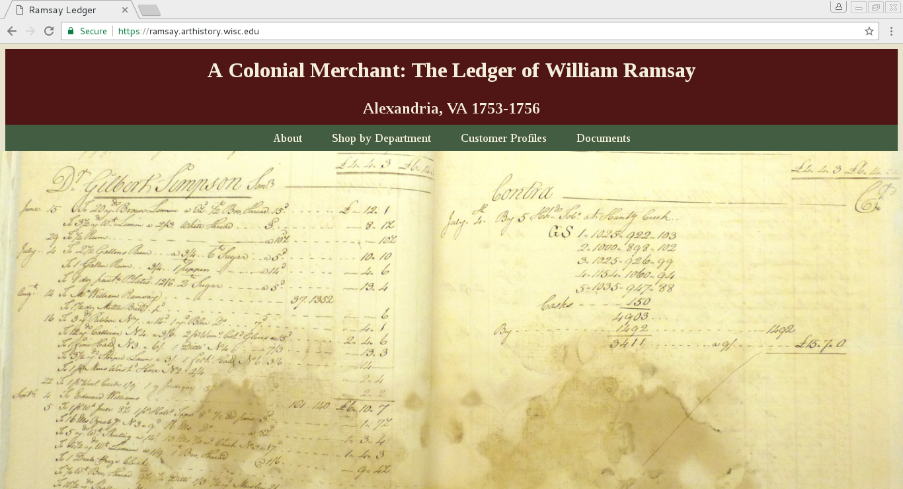 We made a design decision to keep the home page for this site neutral. When a user first approaches the site, they see the header followed by a high resolution image of a page from the ledger. The header is persistent on every page of the site and identifies the project as “A Colonial Merchant: the Ledger of William Ramsay” as well as the geographical context and date range of the ledger. The navigation bar offers the options of “About,” “Shop by Department,” Customer Profiles,” and “Documents.” This screenshot is from our proof of concept website which does not yet have all of the planned features. The final design will include a tab for “Data Visualization” as well as a search function in the header.

**About (**[**https://ramsay.arthistory.wisc.edu/about/**](https://ramsay.arthistory.wisc.edu/about/)**):**

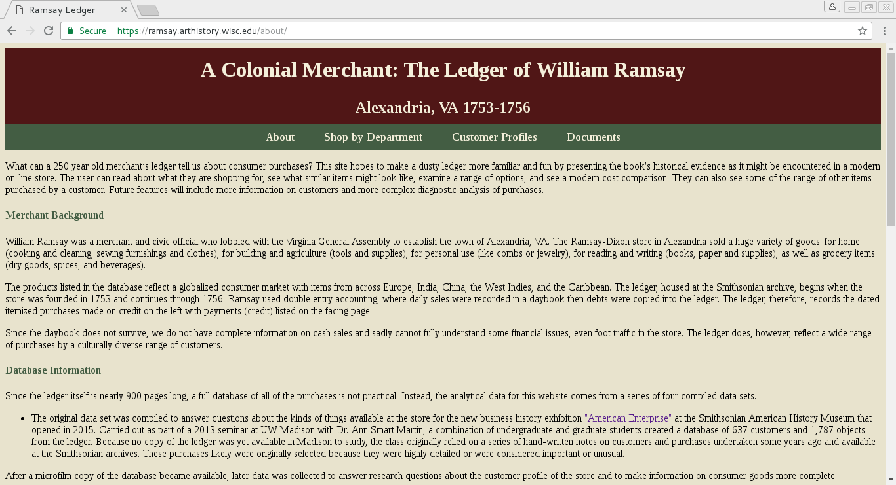 We want to maintain the illusion of the e-retail store for the main object entries, so this page includes an abundance of clarifying information that would otherwise distract the user. On this page, the user will gain a wealth of information about the project. This includes a brief description of the project's goals, the historical background of William Ramsay's store, information about how we collected the data used to generate the site, the navigation and layout of the website, image licensing, features of the site, an explanation of currency conversion, information on how to participate in the project, and funding history. Since this page contains a large amount text it has proven a bit overwhelming to users, therefore, when we rebuild the site we will add an index at the top of the page that will take the user to a particular section of the text.

**Shop by Department (**[**https://ramsay.arthistory.wisc.edu/departments/**](https://ramsay.arthistory.wisc.edu/departments/)**):**

This page organizes the individual object entries into discrete departments 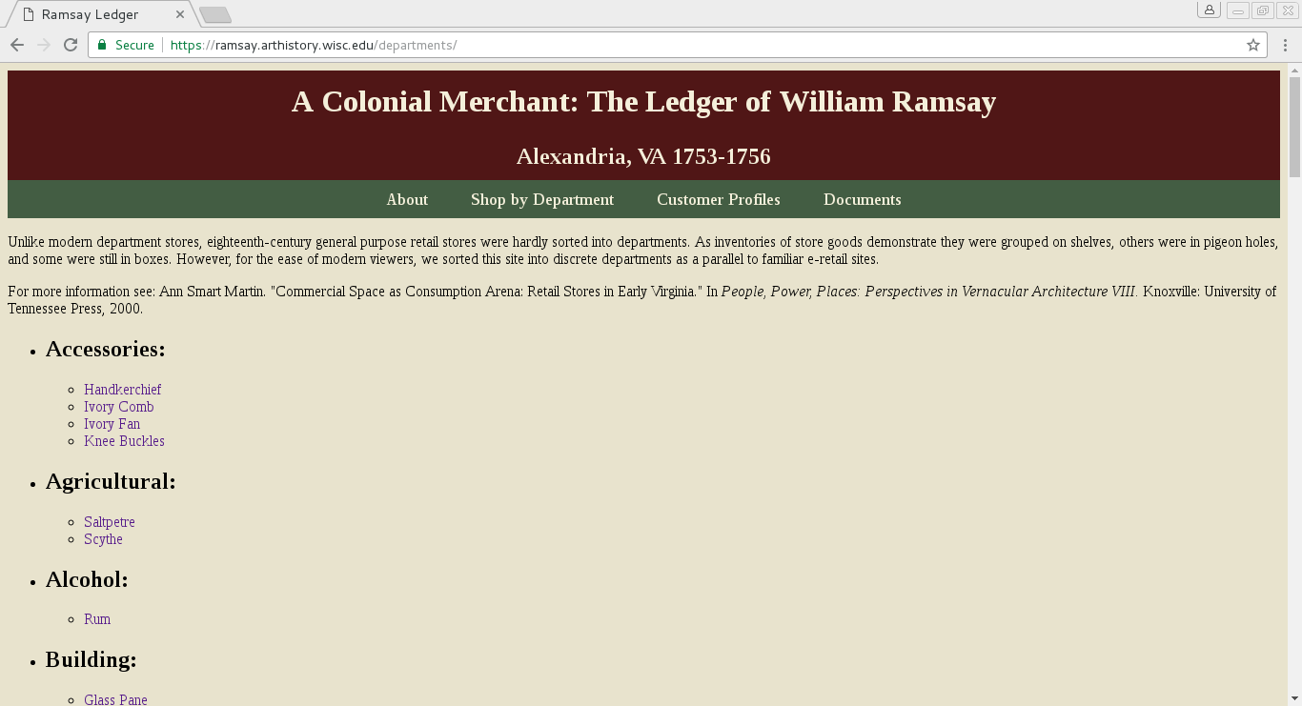for the ease of modern viewers as a parallel to familiar e-retail sites. Although many of the objects may be foreign to our users, sorting them into departments assigns them basic functions that are easily comprehensible. We do, however, acknowledge at the top of the page that objects in eighteenth-century general purpose retail stores were not divided in this way. Some objects were grouped on shelves, others were in pigeon holes, and some were still in boxes. In this way we hope to facilitate easy comprehension of the objects for users as well as explain the historical context of the retail experience.

**Object Entries (**[**https://ramsay.arthistory.wisc.edu/Doll/**](https://ramsay.arthistory.wisc.edu/Doll/)**):**

Each object has an entry presented as if it were for sale on an e-retail site. Our goal is to blend the data gleaned from the ledger with historical background and artifacts from roughly contemporary contexts to present the material culture of Colonial America in a recognizable format. In order to do this, we need to create an illusion of cohesion that does not survive. We do not have the actual artifacts that William Ramsay sold in his store, nor do we have retail information from objects that survive in museum collections. In order to acknowledge this discrepancy without shattering the illusion, 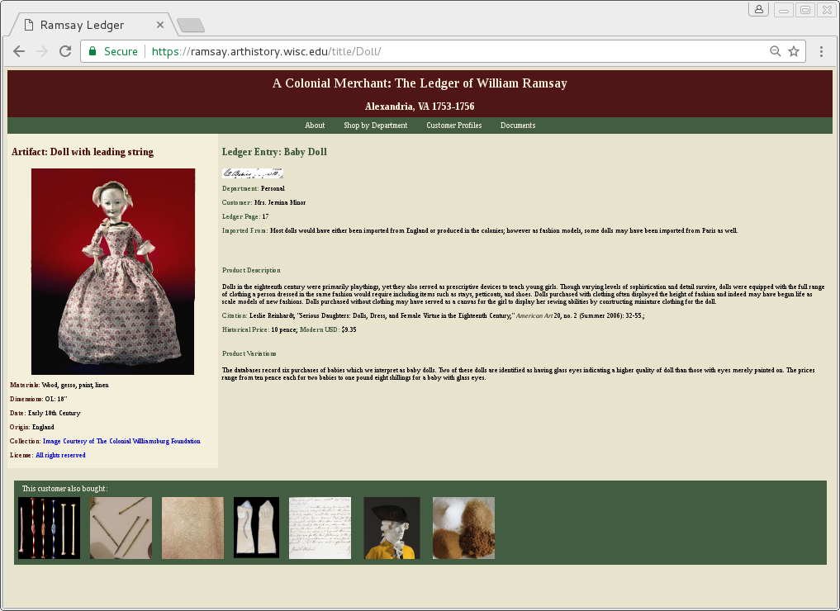each of the object entries is divided into two categories under separate headings of “Artifact” and “Ledger Entry”.

To the left there is an image of a surviving object that roughly fits the description of an purchase in the ledger. This section of the page is differentiated by a lighter background in order to highlight information related specifically to the object. Below the image is pertinent information including the materials, dimensions, date, and the origin/provenance. Since we are utilizing objects from a variety of collections, each of which have their own image licensing procedures, we also include hypertext links to the collection the object or image is from and the licensing agreement that pertains to the image.

To the right is information about the product listed in the database along with general information about the type of object. For each object entry, we choose one representative purchase in the ledger and include an image of the entry from the ledger, the customer's name, the page in the ledger, and the price with an estimated equivalent in modern US dollars. In the re-build of the website, we will use higher-resolution color images from the ledger which were unavailable to us when we were creating the proof of concept website. For deeper context, we will also provide information about where the object was likely imported from and a description of the object and how it was used. Since most of the object types reflected on the website appear multiple times in the ledger, we will also include an explanation of product variations including the various materials, qualifiers, and types represented in the ledger.

The final feature of the object entry is thumbnails with links to other objects that the customer purchased. Instead of the complex algorithms utilized by e-retailers to suggest products based on related sales, we simply highlight other objects that were purchased by the customer highlighted in this sale. Where possible, we use objects that were purchased on the same day, but given the variable shopping patterns of the customers this is not always possible.

**Customer Profiles (**[**https://ramsay.arthistory.wisc.edu/wishlists/**](https://ramsay.arthistory.wisc.edu/wishlists/)** 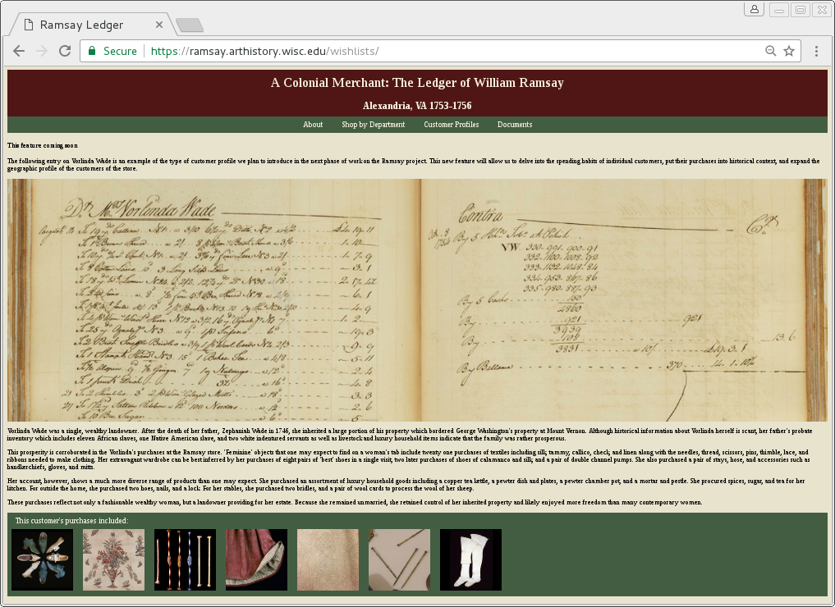):**

In our proof of concept website we have only one profile for Vorlinda Wade which serves as a placeholder. In the website rebuild, when the user clicks on the “Customer Profile” tab, they will see a list of customers with hyperlinks similar to what appears on the “Shop by Department” page. Each customer profile will include an image of their purchases from the ledger, including the contra page which indicates payments made. The profile will include, where possible, bibliographic information about the customer as well as historical context. It will also include an analysis of the customer's spending habits as well as a comparison of the customer's purchases compared to the overall sales in the ledger. We will choose a range of customers who were influential in regional or national history, customers with interesting spending habits, and customers who were marginalized in society to explore the social geography of the community. In the footer are a sampling of objects that the customer purchased. We will also add hyperlinks to the customer names in the object entries for customers who have profiles.

**Documents (**[**https://ramsay.arthistory.wisc.edu/documents/**](https://ramsay.arthistory.wisc.edu/documents/)**):**

The documents page is a repository for information and data relevant to the project for scholars and the public to explore and expand on our research. We will release our csv databases as well as reports on the numbers and types of objects sold, customers who appear in the databases, and useful documents for users who are interested in contributing to the project. These documents are released under a [CC BY-NC-SA 4.0](https://creativecommons.org/licenses/by-nc-sa/4.0/) 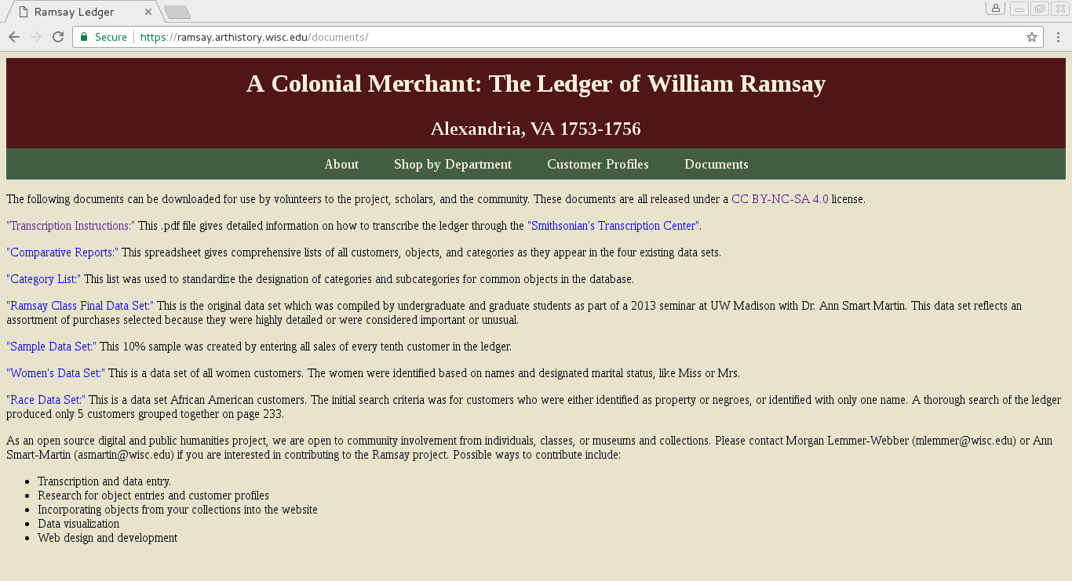license to promote open access to research materials.

**Data Visualizations**

Once we have completed the full database of one book of the ledger, and therefore have a more statistically significant data set, we plan to use Gephi to create data visualizations. This will allow us to emphasize points of interest such as the global market, customer spending habits, and the volume of sales in various seasons or years. Consultant [Carrie Roy](http://www.carrieroy.com/), who specializes in computational analysis of data in the humanities and attendant innovative visual, material, and artistic development will further use the historical data set in new digital humanities formats.

**3) Technical specifications**

The current iteration of the website was built using python and Jinja2 templates to generate dynamic pages from a csv database. This effort enabled the adaption of the database in ways that were simple to accomplish in a spreadsheet, without requiring the manual editing of over a hundred pages of static code. We then used requests in a virtual environment to generate static files for each object entry. At present, updates to the site are made possible by editing the csv database and running a python program to re-export the new static files. Nonetheless, problems remain as this method requires the use of legacy code that will be difficult for someone with little or no programming experience to maintain. We will therefore re-build the website using Drupal, an open-source content management system which, once it has been developed, can be easily maintained by scholars who have little or no programming skills. The website will continue to be hosted through the University of Wisconsin Department of It (DoIt) Shared Web Hosting.

The code used in the current stage of web development has been released under the GPL version 3.0 and can be found on Github (<https://github.com/mlemmer/ramsay-ledger>). Since we will be utilizing a CMS, we do not foresee much software development in the next stage of this venture, but whatever code is developed with grant funds will likewise be released under GPL version 3.0 and uploaded to Github. In addition to the Github repository, the database for the website will be stored in a MySQL database provided by the DoIT.

While this project is open to participation from the public, all updates to the website will be managed by the administrators. Lacking a comments section or forum, we do not foresee the need to filter obscene, libelous, indecent, or defamatory content.

**4) Sustainability plan**

The benefit of re-building the website using the Drupal CMS is that after the initial development, the site will be able to be maintained and updated by Ann Smart Martin and her students with support from the L&S Learning Support Services and the DoIt. This will, however, transform the site from static to dynamic. The website will continue to be hosted through the DoIt Shared Web Hosting at the University of Wisconsin, Madison. The hosting fee for a dynamic website will be twenty five dollars per month, this cost will be covered through the standing budget for the Material Culture program made possible by the Chipstone Foundation of Milwaukee Wisconsin.