B.Sc. Computing Stage 1 2016/17  
Activity Led Learning Project  
Semester 2 – Navigation System

**Group Details**

**Group Name: Group 3**

**Group Members:**

7541788 Kyle Speke

6932053 Shivani Sharma

7166765 Alexander Tanev

7126194 Taylor Southorn

7041565 Miltion Hajdini

There is another guy but we don’t know his full name. (cause he did nothing)

**Submission Notes:**

Do not edit this Section

* Your submission must be uploaded to Moodle **by 23:55 on Thursday 30st March 2017.** The submission point will appear in the ECU177 – Computing Moodle Page.
* Place this report in a directory **alongside all the code needed to run your navigation system**. Compress it to a zip folder and upload the zip to Moodle.
* If we need to run code in Codio to host the website ensure all the necessary instructions are provided in this report.
* Your game will be tested using a tablet of the same make and model as given to you at the start of the year. So ensure it looks good on this.
* **You submit only one report and one folder of code per group**. All team members should agree on the final submission.
* Each report section has a maximum word count. **Any words over the maximum will not be marked**. You need not write up to the limit.

***User Documentation (max 500 words)***

Go to URL: http://89.19.29.154:6800 (We double checked with Reda on hosting it on raspberry pi, and David had also said we could host it on raspberry pi), Kyle has hosted it on his home internet. He is using apache web services to host the database and index. Html

On load you will have a navigation bar on the left side of the screen, and in the bottom right you have the map controls i.e.; zoom, street view, and your location button.

On the navigation bar you have three icons; menu, search, directions.

On click of menu you are faced with links to key and favorite’s;

1. Key takes you to a separate site with lists of buildings shops etc.
2. Buildings has a pullout menu which overlaps the map with a few key places i.e., hub library.

Search bar opens up a small text field which allows you to put a marker on the map of a place of your choosing.

Directions allows you to plot the quickest route to a destination of your choice.

You can also find your location in the bottom right to insert a pin to your exact position. This allows the user to have a precise indication of where they are, and therefore the distance from their destination.

The

# ***Usability Tests (max 1000 words)***

**First Usability Test**

We used all the above points when we did the first usability test. We did this as it was felt it would give us a good basis to learn and improve our navigation system. The second round of usability testing conduct was done under the approach of correcting any errors we learned from the first test and to apply improvements.

The group took an empathetic approach when they discussed on how to conduct the tests. They thought that all individuals who would test the paper prototype would be looking for two main things “Where are the webpage links” and “Search bar”.

Our first usability test involved testing the paper prototype. By using the paper prototype, it gave us an indication of how we wanted our website to look. We wanted to know which features the website should contain and the overall functionality of the navigation system.

The data that was being collected within our usability test was at how long it takes for the users to navigate to certain pages by using a stopwatch or by counting the number of clicks test users did to get to the designated buildings. We decided to keep the tests simple, and had asked our users to try to search for the Lanchester Library on our paper prototypes.

The results from the usability test was analysed using a histogram. It was felt that this was the best method as it showed the findings in a clear way. By using a histogram, we could decide how effective our paper prototype would be. From our results we had discovered that longer the time in finding the Lanchester Library or the more clicks done by that test users showed us that that they struggled with the set task and that the paper prototype needed to change.

The findings showed most our test users found the home page for the navigation system, very helpful, and liked the use of a key page that consists of relevant places where students will frequently go.

**The number of clicks it took for our users to find Lanchester Library**

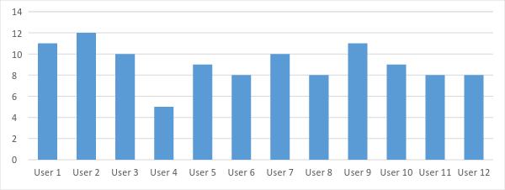

**Users who had taken part in testing our navigation system**

However, some of the test users had found it confusing, as it took them three minutes to identify the “Drop Down Menu” on the side. They had commented on the menu begin “too small”, furthermore they found they did not understand what the page was about and what the map was showing.

As a result of our first usability test, we were able to change the design of our homepage which would suit the needs of our users. Overall helping us to create a much better home page paper prototype.

Another usability test for the index page was done. We again tested the length of time it took for the test users to go on a certain site. We measured the success of this page at how well they understood the context of the page. Four of our five testers successfully understood what this page consisted of.

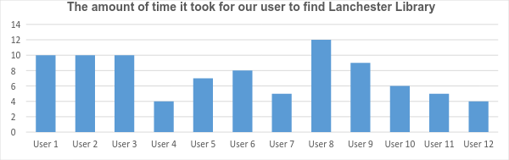

**Users who had taken part in testing our navigation system**

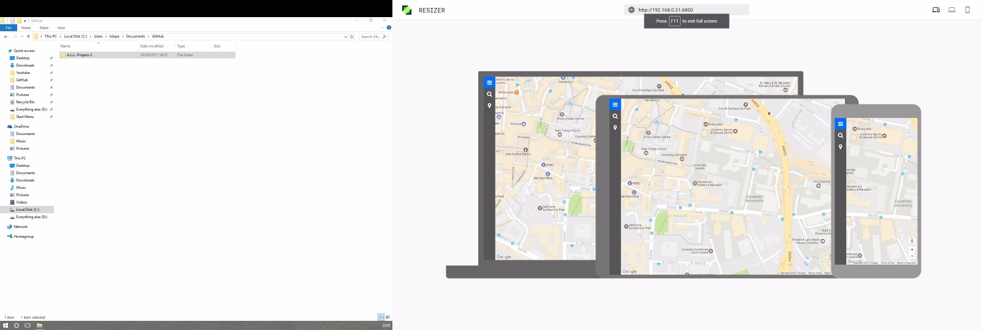

We used the Resizer feature on Material.io in order to check that our website was compatible on all 3 devices as this was a requirement. This unique design allowed for a great overview of what the final website will look like, and what users will experience on each device. It also contained the margin regions for each device so we could keep in mind this data when using css.

**Second Usability Test**

Our second usability test was more successful, it involved a set of specific users to test the prototype navigation system. In total we had a variety of usability testers. They were six males and six females, furthermore we had also insured that they were all different, in terms of age, ethnicity, and if they had a disability. This was done to ensure valid results that we could use to help us gain an understanding to what more could be done to improve our website navigation system.

We had conducted the tests by asking our specific users on the University Campus to "Try Out Our Website" as well as requesting our users to go on the navigation system on our tablets. We applied the metrics from the first usability test and again asked them to find a specific building or street. As they were doing this we again counted the number of clicks and how long it took them to find the designated location. In this case, it was the HUB.

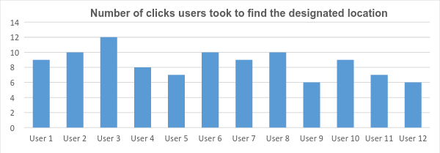

**Users who had taken part in testing our navigation system**

Throughout our analysis our findings showed that some users had found the "Search Bar" was too small. The group decided that it made more sense to incorporate it within the 'Drop Down Menu'. This would give our users a quicker and more efficient access to what they need to find.

The group also found that a few of the web page names were confusing they did not correlate to the content inside of the page. This affected our project in moving forward as the users clicked the wrong page which wasted time.

**Before Usability Test After usability test**

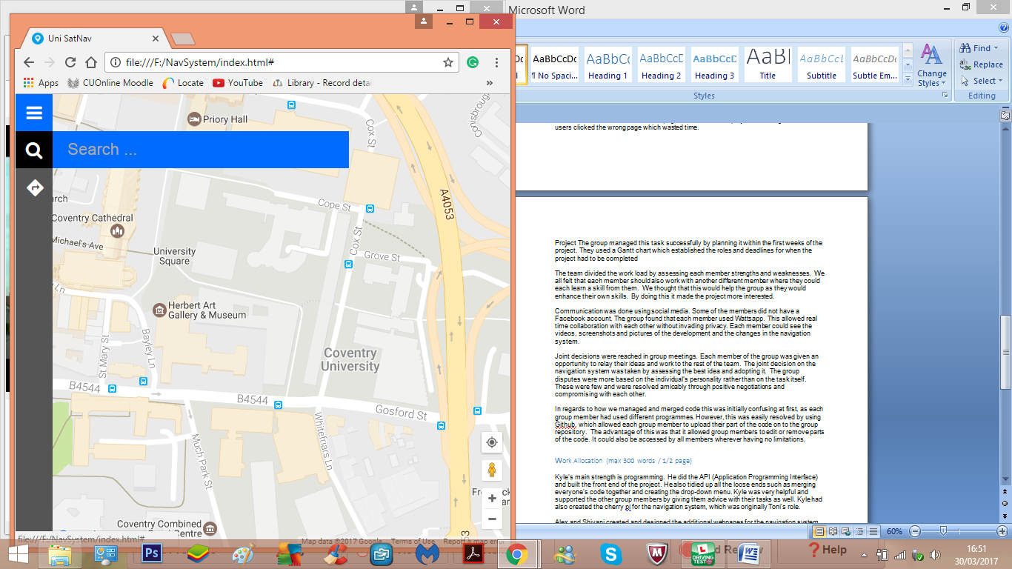

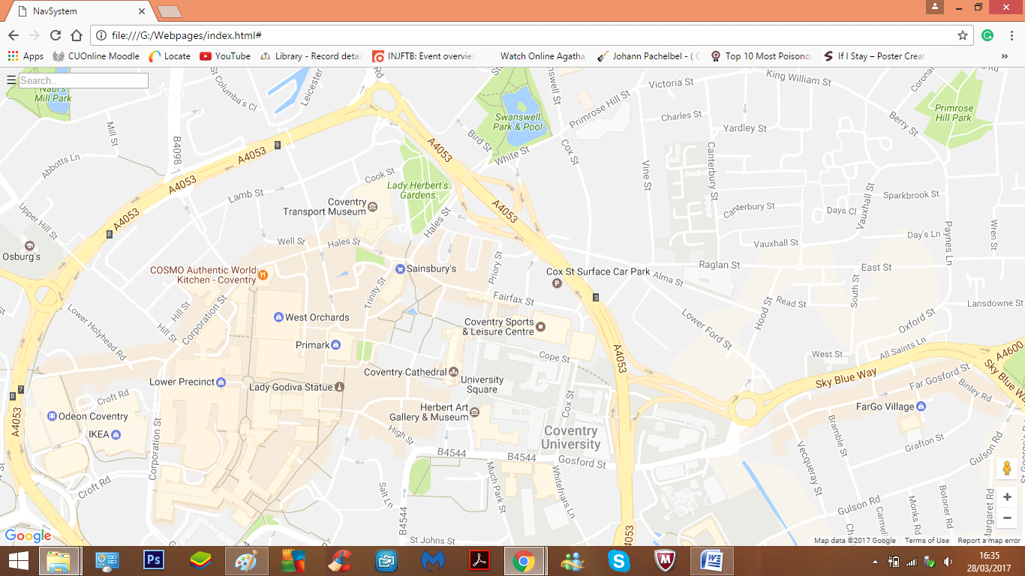

From doing this usability test, we were able to upgrade, and create a much more user friendly design and navigation system, for our users. As the search bar is more visible and eye appealing to our users, hence allowing users in spending more time using the search bar, rather than finding it.

The second graph shows the amount of time it took for each user to find the building or address we asked them to find. We had run this test by using a stopwatch from the moment they were started the task. During this test the users were not told they were going to be timed, this is because it may have compromised the results.

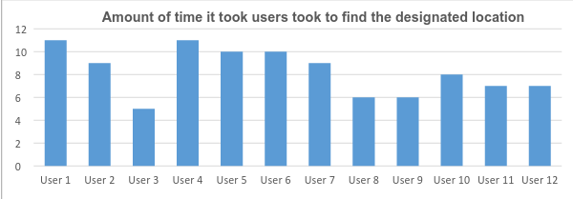

**Users Who Had Taken Part in Testing Our Navigation System**

Overall these findings from our second usability test, was much more successful. The findings helped us move forward with our navigation system as the group discovered how accessible the users found it and at how we could improve it.

# Project management

Project The group managed this task successfully by planning it within the first weeks of the project. They used a Gantt chart which established the roles and deadlines for when the project had to be completed

The team divided the work load by assessing each member strengths and weaknesses. We all felt that each member should also work with another different member where they could each learn a skill from them. We thought that this would help the group as they would enhance their own skills. By doing this it made the project more interested.

Communication was done using social media. Some of the members did not have a Facebook account. The group found that each member used Whatsapp. This allowed real time collaboration with each other without invading privacy. Each member could see the videos, screenshots and pictures of the development and the changes in the navigation system.

Joint decisions were reached in group meetings. Each member of the group was given an opportunity to relay their ideas and work to the rest of the team. The joint decision on the navigation system was taken by assessing the best idea and adopting it. The group disputes were more based on the individual’s personality rather than on the task itself. These were few and were resolved amicably through positive negotiations and compromising with each other.

In regards to how we managed and merged code this was initially confusing at first, as each group member had used different programmes. However, this was easily resolved by using Github, which allowed each group member to upload their part of the code on to the group repository. The advantage of this was that it allowed group members to edit or remove parts of the code. It could also be accessed by all members wherever having no limitations.

## Work Allocation (max 300 words / 1/2 page)

Kyle's main strength is programming. He did the API (Application Programming Interface) and built the front end of the project. He also tidied up all the loose ends such as merging everyone's code together and creating the drop-down menu. Kyle was very helpful and supported the other group members by giving them advice with their tasks as well. Kyle had also created the cherrypy for the navigation system.

Tony did his own website and tried to help connecting the database with the website by making a function which every time the user presses one of the buildings it would place a marker on the map on that point but could not find a way how to achieve that.

Alex and Shivani created and designed the additional webpages for the navigation system such as the buildings and key page. At first they had created separate webpages for each one. These were then merged into one existing page. They also carried out the usability tests by asking students what they thought about the website. Alex and Shivani additionally constructed the paper prototypes. Shivani’s other contribution to this project was in preparing and writing this report.

Taylor's main strength was creating the operating system (the database) which resulted in four successfully working tables (one for cars parks, ATM’s, buildings and shops). Taylor also created a unique primary key which allowed us to identify each field’s data, name and coordinates. His other contributions included developing the group repository on GitHub as well as helping to merge the first attempt of the code. Having a database complete means that data can be stored and then pulled once the user types in a matching name as long as it’s in the database. Furthermore, he created the database using Python, being able to enter new data into tables, and pull relevant data for example the coordinates of buildings to be used on the website when a link is clicked, plotting a marker.