Taylor Smith, Christian Williams

Rob Frohne

ENGR 454

5/2/23

Dynamic Test (Hanging Down Test):

For our dynamic tests we took the hover copter arm from the top position and dropped it, recording the output from the angle encoder as it went to rest completely hanging down. Below are our results from the physical measurements:

Dynamic Test Simulations:

After we obtained our physical measurements, we simulated the expected response for our hover copter. Using our physical measurements, we began to adjust our simulated model to account for the damping factor so that it closely matched our physically measured results. We obtained the best results when using a damping factor between 0.5 – 0.7. The results of our data are not the same as the simulated, but it is close. Below are the simulated results.

No Damping:

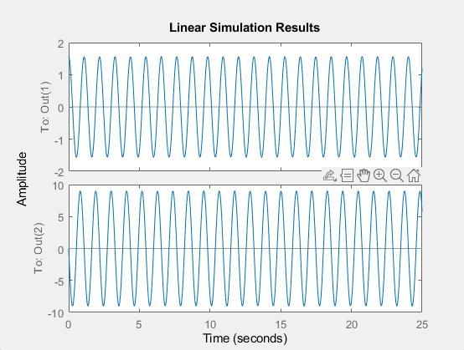

More Below ->

With a Damping Factor of 0.6:

