York Pirates! Instruction Manual

Controls

|  |  |
| --- | --- |
| **Key** | **Control** |
| Up Arrow / W | Enable forward movement |
| Down Arrow / S | Stop forward movement |
| Left Arrow / A | Turn left |
| Right Arrow / D | Turn right |
| F | Interact with islands |
| Esc | Exit menus |
| LMB | Select button |
| P | Save game |
| T | Toggle FPS and coordinate display |

Gameplay

Sailing:

During sailing mode you can use your ship to move between islands. You can also randomly encounter enemy colleges’ ships if you sail around in their territory (the territory you are currently in is displayed at the top of the screen). If you sail to a college’s island you can challenge their boss ship. If you successfully defeat a college’s boss you will take over their territory and will no longer encounter hostile ships there. You will also be able to heal at that college’s island (for a cost).

Some islands house departments rather than colleges. These islands are neutral and so can always be used to repair or even apply unique upgrades to your ship. Occasionally, you may come across a sea monster in your travels. You should stay away from these where possible as if you get too close they will chase you and try to deal damage to your ship.

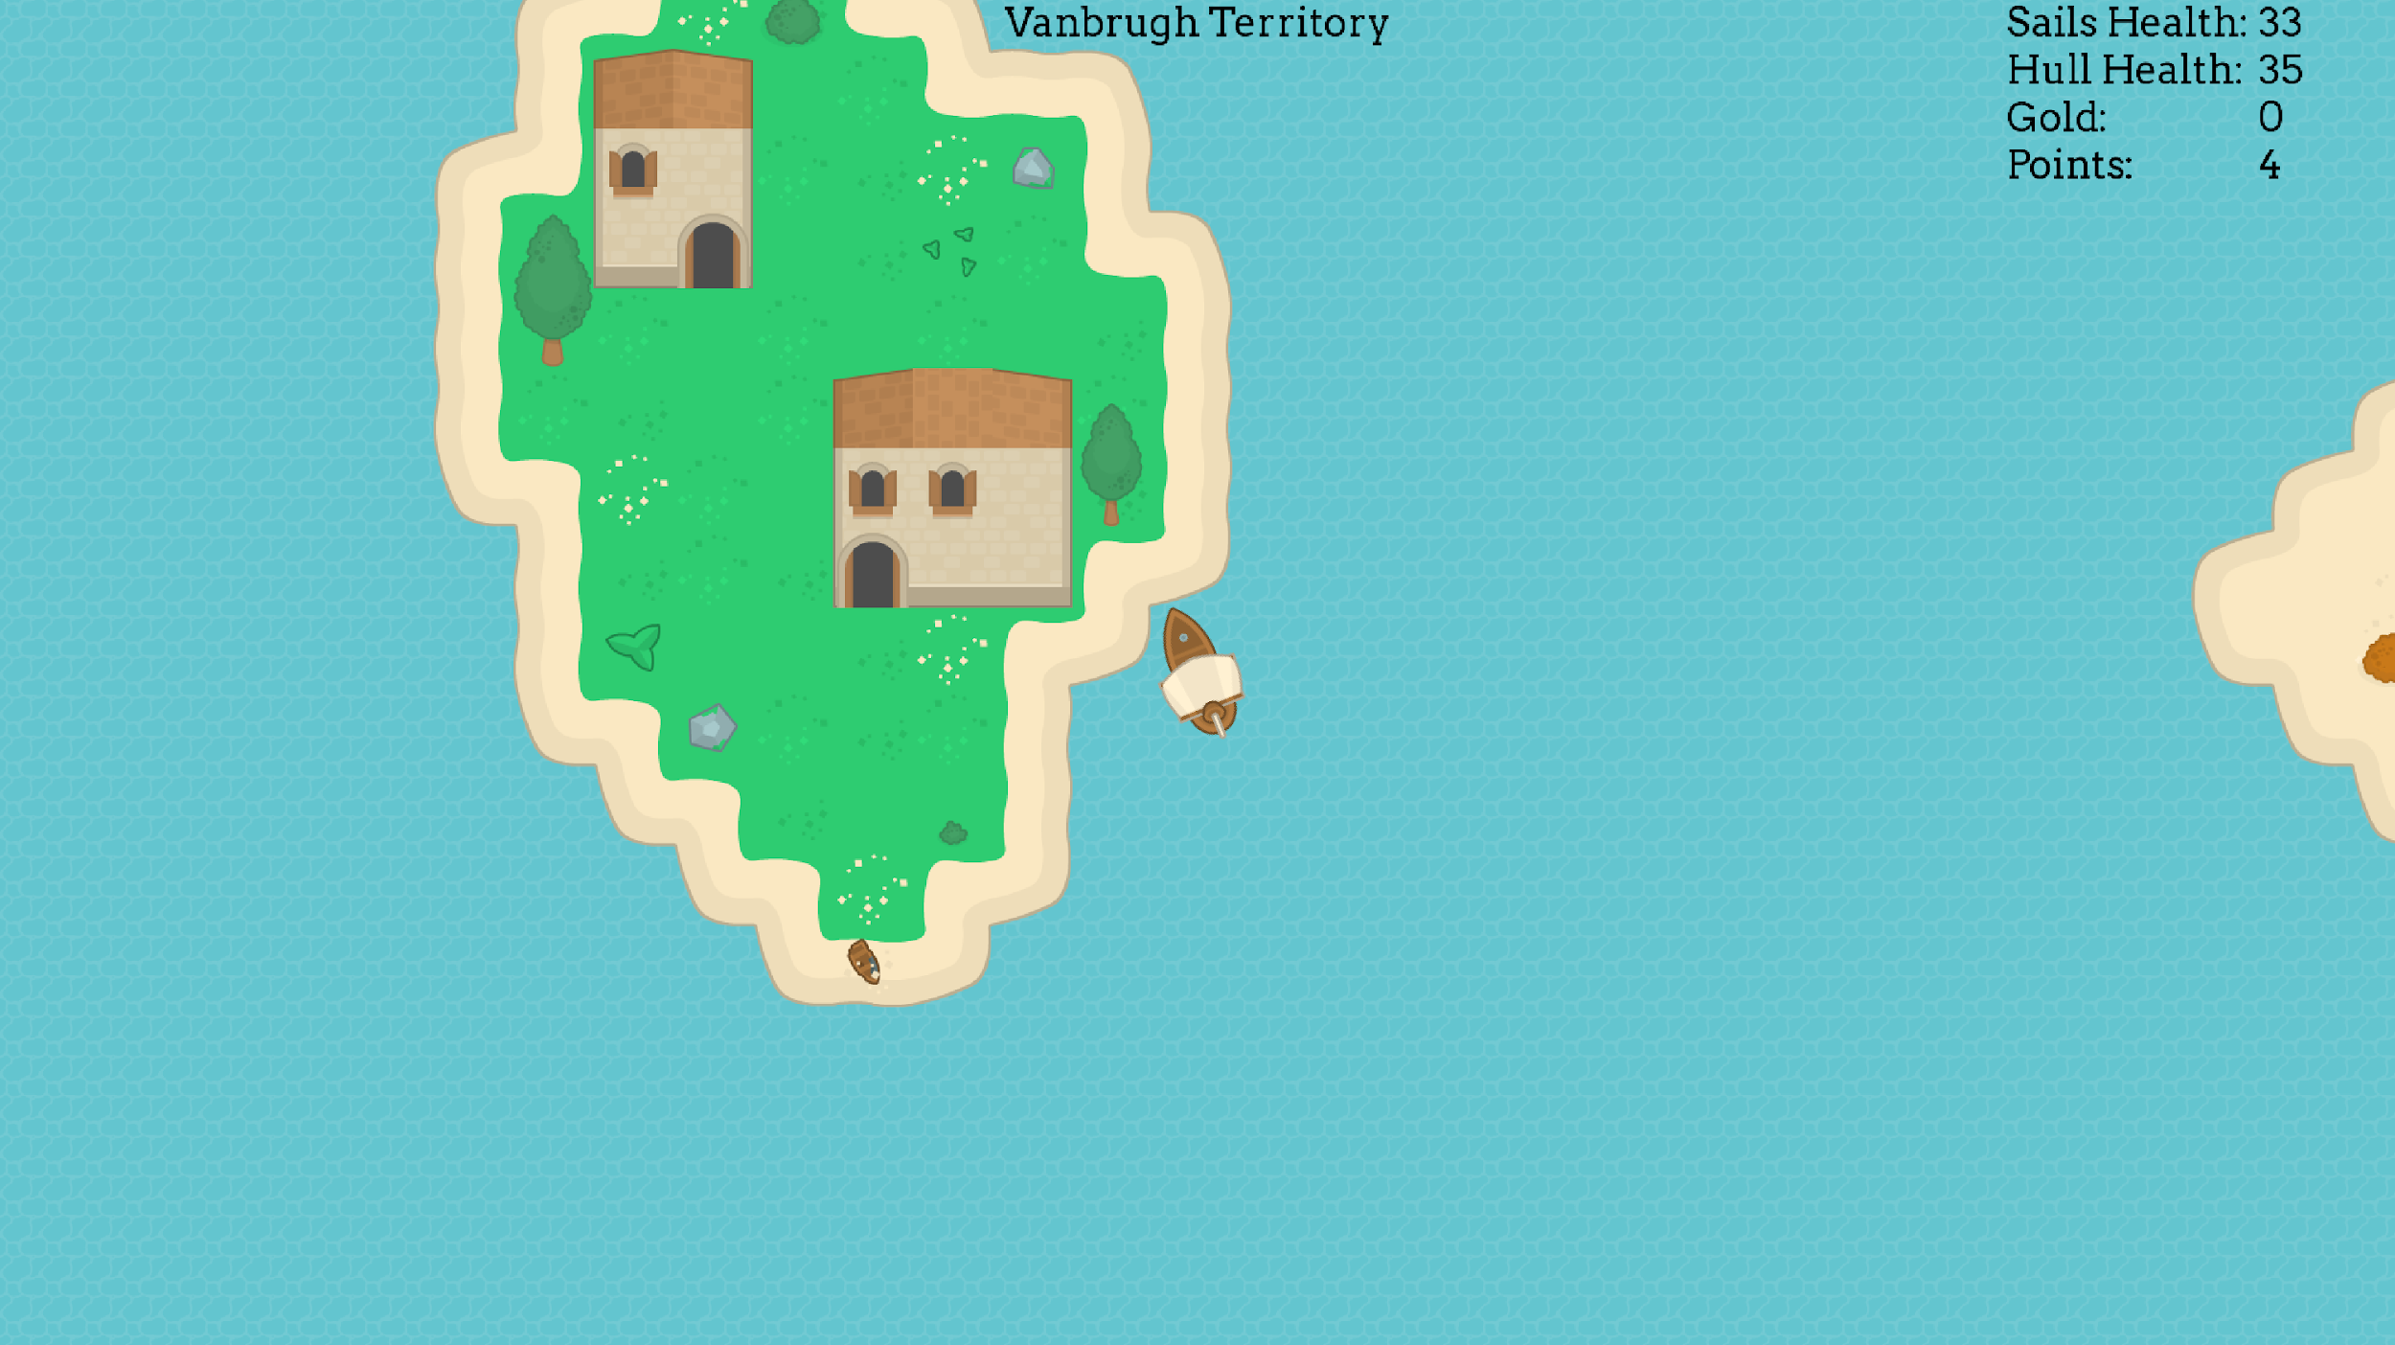

Combat:

During combat mode you are able to select attacks to use against the enemy ship in order to defeat them. You can also flee if you feel you are unable to defeat the enemy. Successfully defeating an enemy ship will reward you with some points and gold. The overall goal of the game is to attack the islands of the other colleges around the map and defeat their bosses in combat. Each time you defeat a boss, you will receive a random upgrade which can range from a cash bonus to a new crew member who can increase things like your ships speed or damage output. Once you have defeated the bosses of all the other colleges, you have beaten the game.

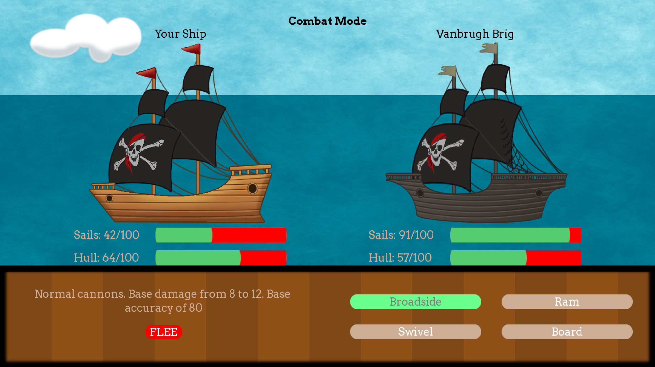

Minigame:

You can start the minigame at an allied college’s island. Winning the minigame will give you 100 points. In the mini game, you control a pirate and your goal is to get out of the maze whilst avoiding being caught by the ghosts. The controls are the same as the main game (WASD/arrow keys for up, down, left, right).

