Nimbus IO

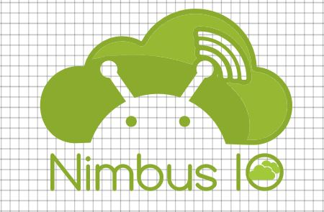

Add to wishlistMacintosh HD:Users:scott:Desktop:Screen Shot 2016-12-03 at 11.08.36 PM.png

Rate our App



Nimbus IO is an Android Application designed to offer Cloud Services. Users can manage configuring hardware and software options. Currently users can

* Select servers

* Add servers

* Customize servers

* Check balance

VERSION : 1

Initial Release

Requires Andriod 6 and Up

Developer : NIMBUS.IO

More features are coming soon. Stay tuned.

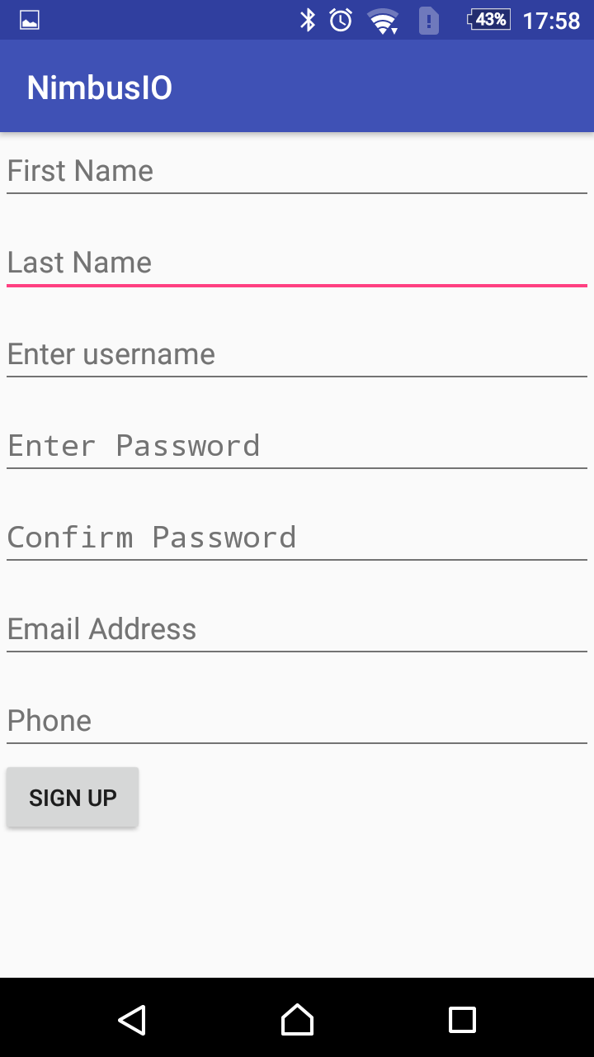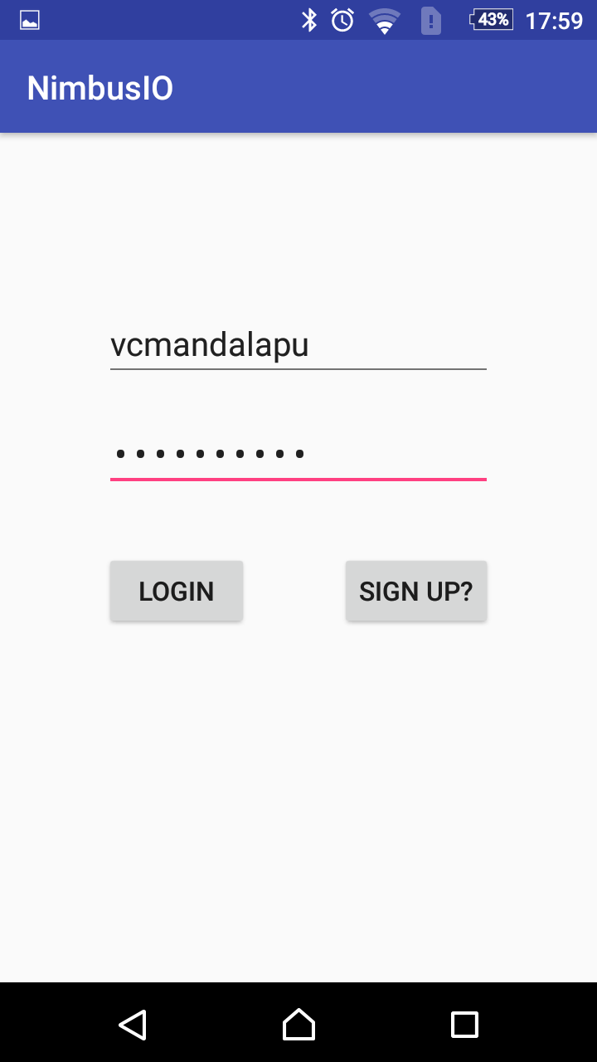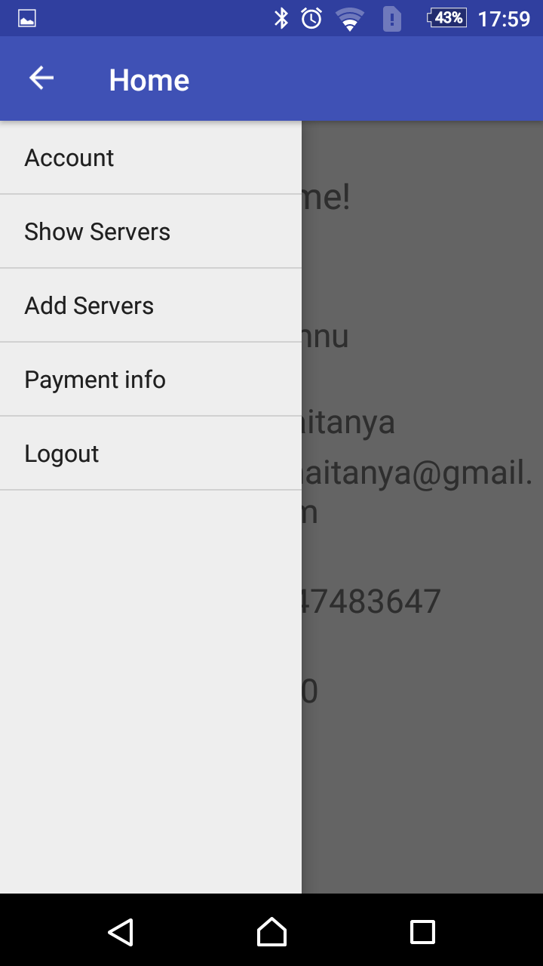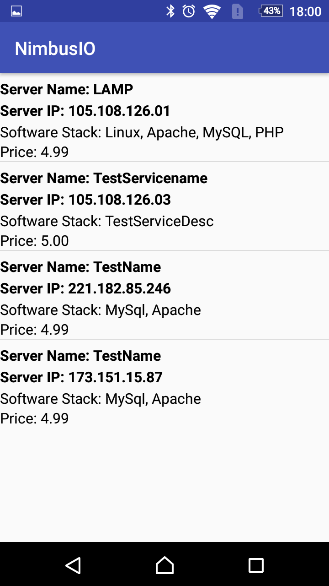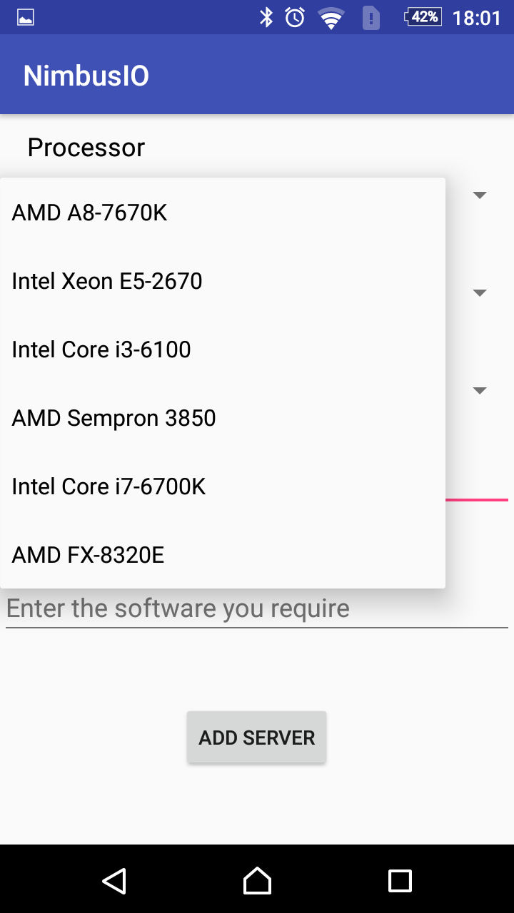

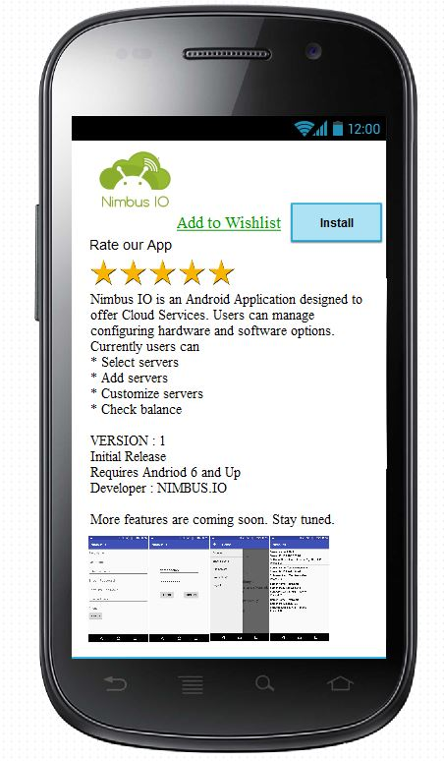

Instructions for ‘Update Database’

These instructions are for the administrator of the system ONLY

1. Open a web browser of your choice:

In the navigation bar type the following URL:

<http://104.236.47.53/phpmyadmin>

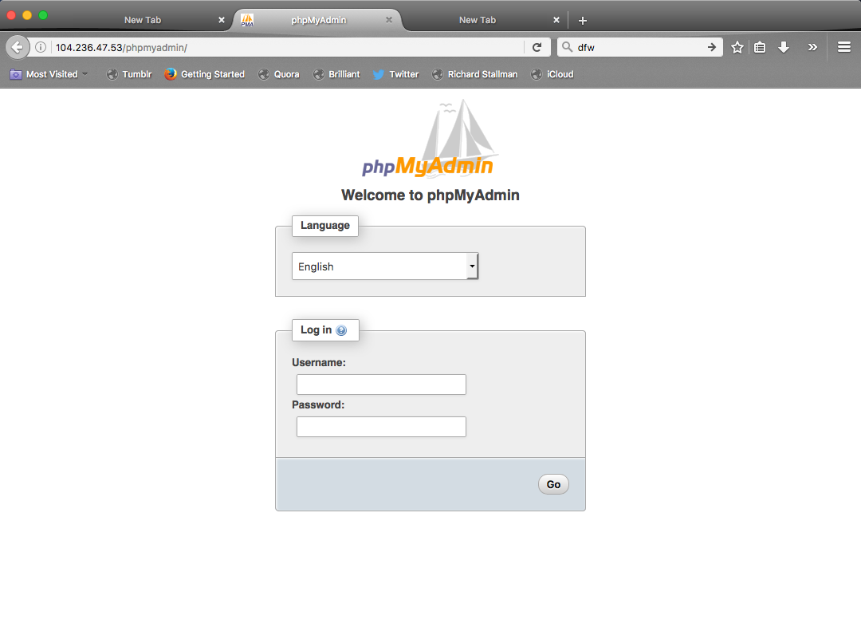

1. For the username: ‘nimbus_android’

For the password: ‘nimbus.io’

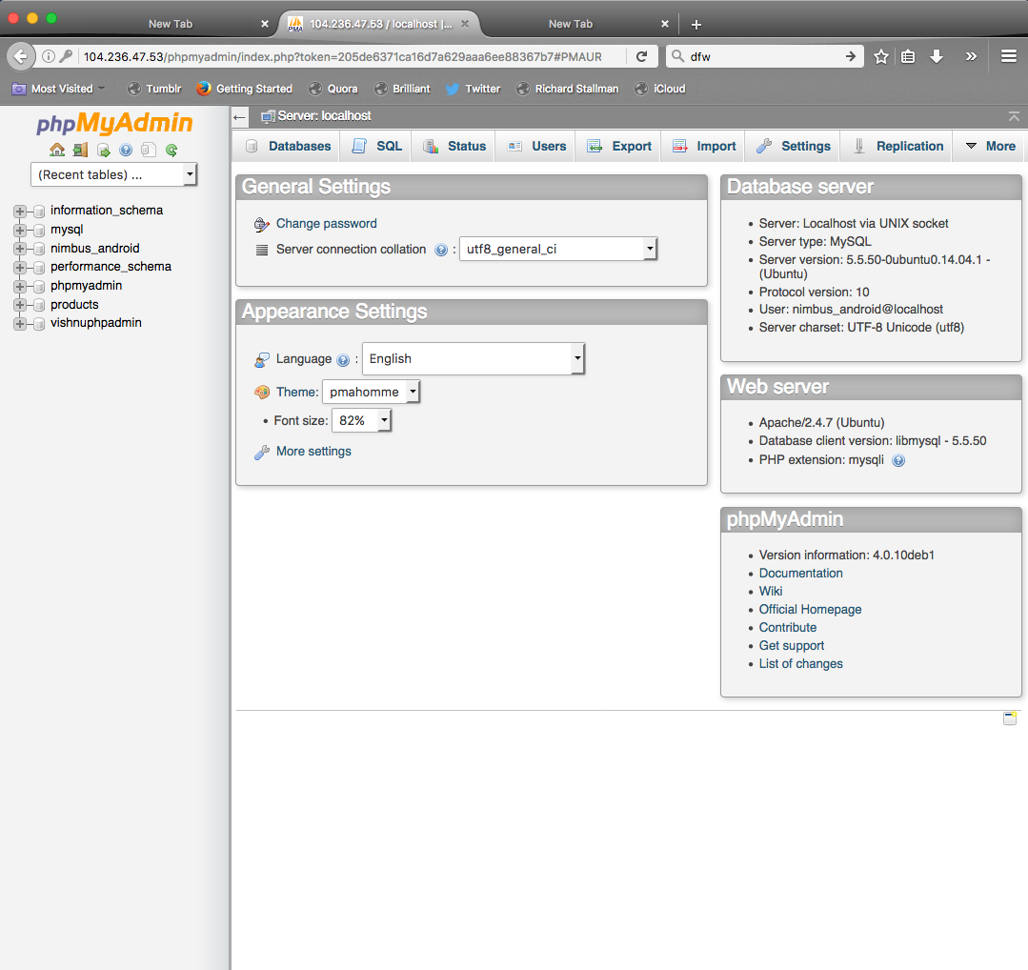

1. On the home screen, Select the ‘nimbus_andorid’

Database.

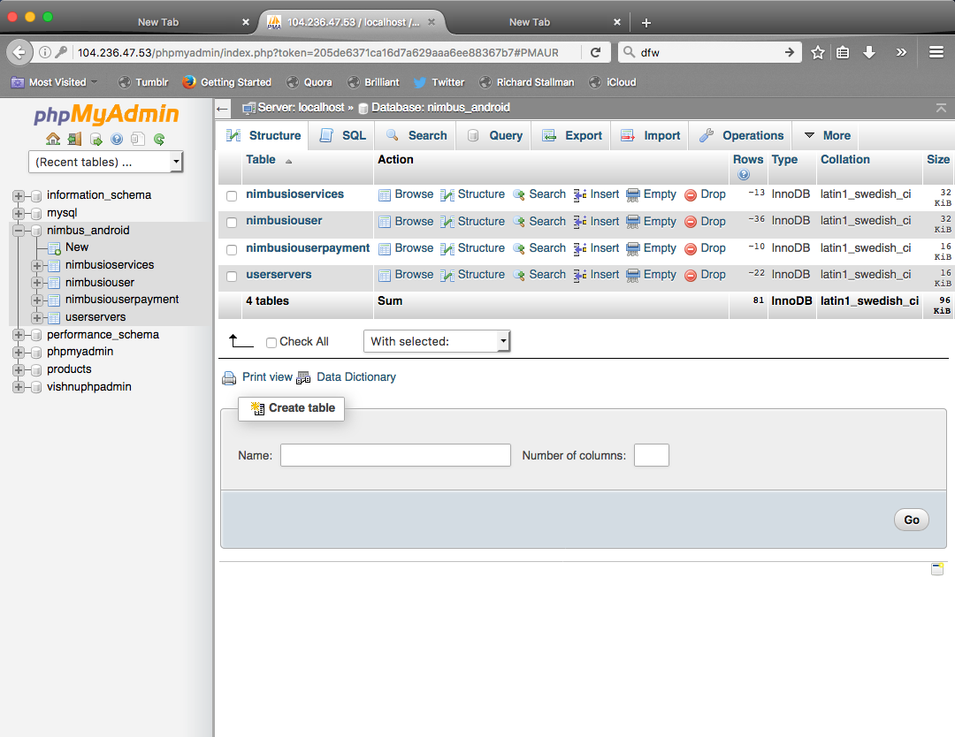

1. Edit tables or accounts as needed. BE CAREFUL, any damages you cause to the system are your own responsibility. Keep backups.
2. Log out of PHPmyadmin, close your browser.