**CMPS 5153 Software Engineering**

**Monday, November 7, 2016**

**Group: Cloud-MSU**

**Scott Gordon, Taylor Kirk, Vishnu Mandalapu, Tejaswi Singam, Mounika Mannam**

*User Interface Navigation*

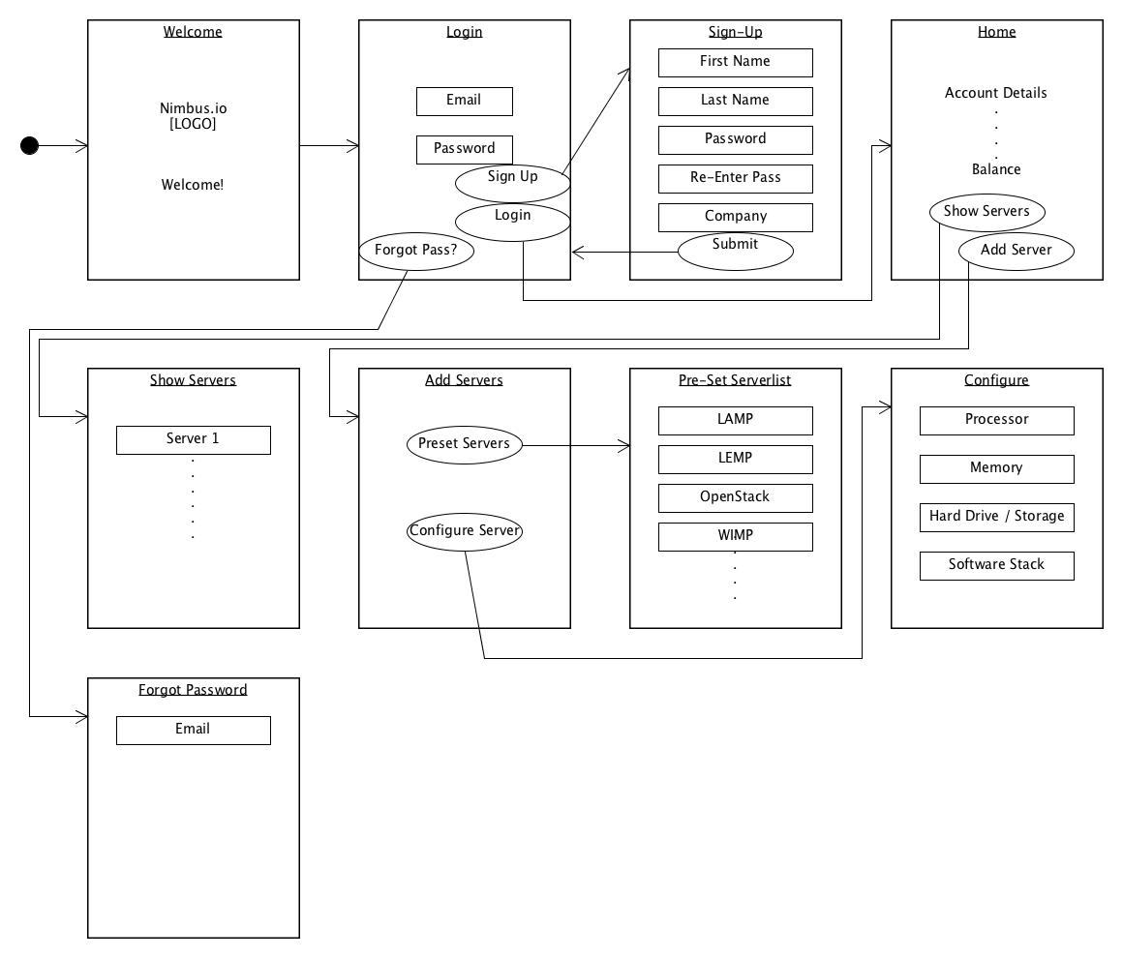

*Class Diagram*

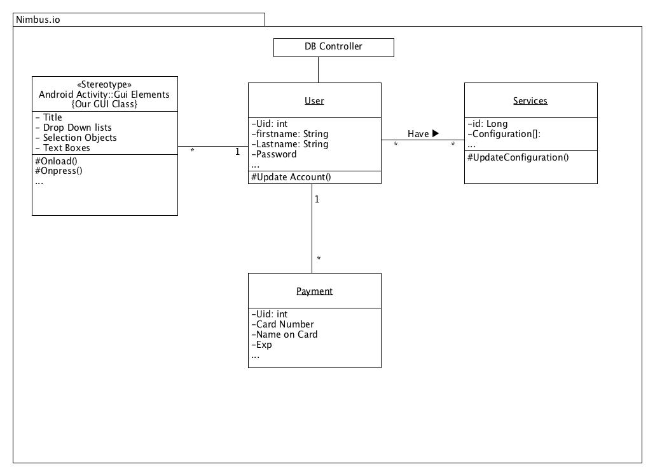

*Database Structure*

