**CMPS 5153 Software Engineering**

**Monday, November 7, 2016**

**Group: Cloud-MSU**

**Scott Gordon, Taylor Kirk, Vishnu Mandalapu, Tejaswi Singam, Mounika Mannam**

**Final Report**

**1 Introduction**

*The following document will contain two sections, one known as the project section, containing open issues involving our system, Nimbus.IO. It will also discuss some of the problems we encountered during the course of the project as well as how we solved these problems. We will discuss any deviations from original specifications and any open issues with the system. The second section, known as the Team Section, will discuss what we would do if we had more time, and weather or not we would change anything, given the chance. The document will close with a discussion of some of the lessons learned as a team.*

**2 Project Section**

*This section will discuss any problems we encountered and our solutions to them. It will also describe any deviations from our specifications and will briefly discuss some of the known, unresolved outstanding issues.*

***Outstanding Issues***

*There also happen to be several known bugs, which exist in the software, which were uncovered by our testing cycle. One of these has to do with user information; several user-provided fields erroneously allow for numbers or special characters to be entered into the database. This causes a plethora of strange behavior, including no display of user information. We have several planned mitigations to this and other outstanding issues, which are outlined in the Test Report.*

***Deviations From Specifications***

*One of the major issues with the system involved our underestimation of the complexity required of our database. The team originally envisioned a simple database with clearly defined relations. System Testing uncovered undeniable issues with this design, and work was required to correct it. The changes were made to the database quickly in the hopes of getting a working application; further increments would likely require additional revision to the database. This unexpected event caused a large*

*delay in our progress.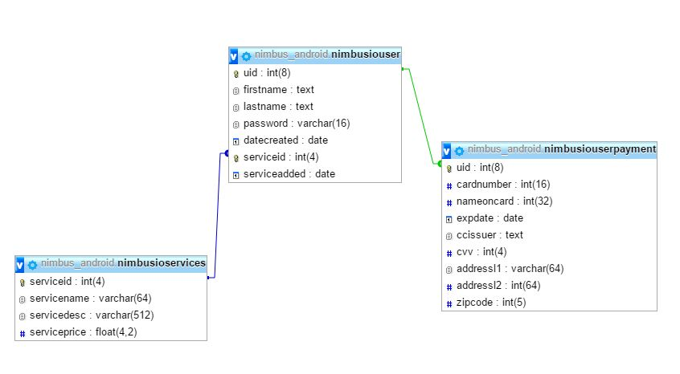*

*Original DB Design (Figure 1)*

*The elimination of some direct relations has little effect on the application in real-time. However the modified design allows for a very low number of calls into the database from our mobile system. The userservers table was created to assist references to and from other tables in the DB.*

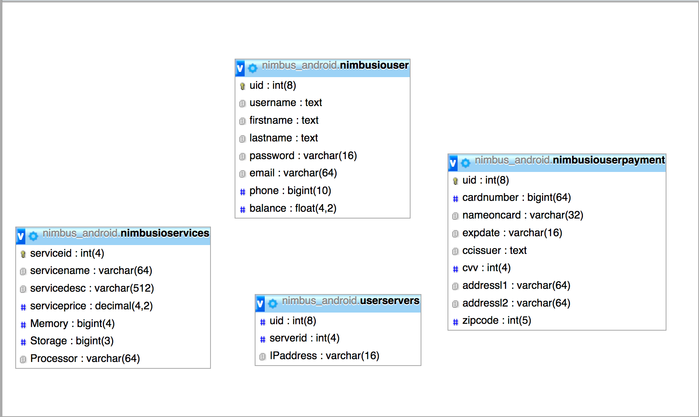

*Modified DB Design (Figure 2)*

*Another deviation from original specifications center on a particular set of use cases known as ‘notify’ and ‘Retrieve Password’ Original product documents outlined a set of use cases in which the system notified the user or the administrator in case of a particular event as well as a use case for password recovery. During the implementation phase it was decided that the notify use case was superfluous to the core functionality of the system. During design phase it was determined that the ‘Retrieve Password’ use case contained several security loopholes. Therefore, that those times it was decided, to leave these cases unimplemented in this increment of the system. Any future increment of the system should implement these features. This is illustrated in Figures 3 & 4*

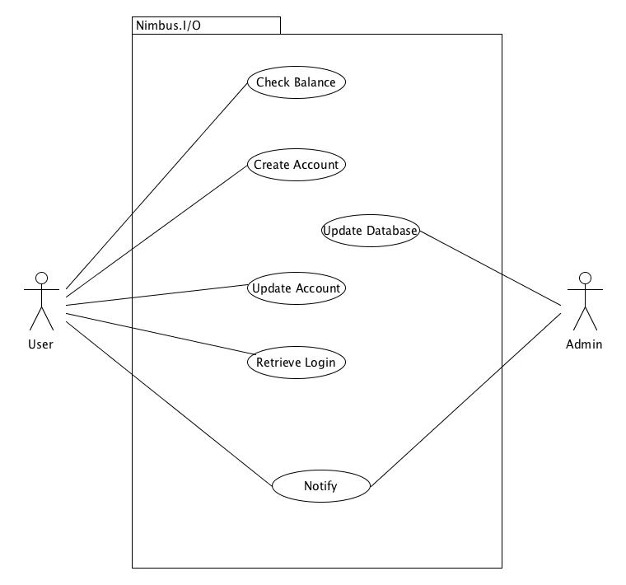

*Original Use Case Diagram (Figure 3)*

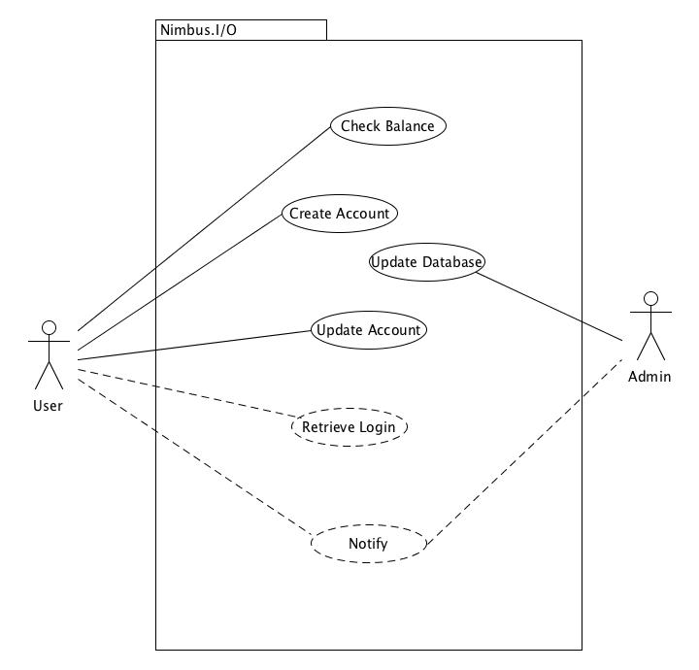

*Modified, Use Case Diagram: Increment 1 (Figure 4)*

**3 Team Section**

*The following section will host an informal discussion about several questions which are relevant to the project at hand, namely “What would we do if we had more time?” and “What we would do differently if we had to do it all over again?” We close with a discussion of what we learned as a group.*

**What we would do if we had more time?**

*Obviously, We would correct the outstanding issues, as well as implementing some of the remaining features. Beyond that what we would focus on overall “look and feel” which is an area where the app is lacking. We would work to put more information on the screen while keeping its clean and uncluttered style. Additionally we could plan for another increment, where ideas that didn’t make it into the first increment could implemented, such as tying the system to a payment services platform like PayPal, or encryption of the database.*

**What we would do differently if we had to do it all over again?**

*Based on our level of satisfaction with the overall product, this is a difficult question. Perhaps we would take more time when designing the database. This turned out to be a sticky thorn in the side of the group, which had the potential for disaster. We would also have focused on ‘look and feel’ to aid during demos. Without question, one thing we would have done differently was, we would schedule a larger time for implementation phases. Overall the form and the function of the team would not change.*

**What we learned**

*As a team, we learned that our differences were actually strengths, once we started working together. Different ideas and opinions coupled with open and friendly discussion, as well as friendly interaction outside of the project made working for Cloud MSU a pleasure for all of the members. There have been no reports of conflict or incidents of any kind. A Happy demeanor all semester, we discovered each other’s wide range of strengths, such as Mounika’s strength in design, or Taylor’s intuitive understanding of Database applications. Vishnu’s smart and disarming leadership kept the team calm and on track even when problems arose. Overall these were powerful boons for our team, which could not have anticipated, that paid large dividends.*

**4 Summary**

*This document served two purposes, namely was to provide a final report on the status of the project, Nimbus.IO. Which we did by discussing any problems we encountered and our solutions to them, we also described our database deviations as well as some of deviations from specifications and we briefly discuss some of the known, unresolved outstanding issues.*

*The Second purpose was to provide a final report on the status of the Team at large, Cloud MSU. We accomplished this by*

*hosting an informal discussion about several questions which were relevant to the project, namely “What would we do if we had more time?” and “What we would do differently if we had to do it all over again?” We closed with a discussion of what we learned as a group.*

*Team Cloud MSU Thanks you for your interest in our project Nimbus.IO developed for Android!*