**Nimbus I/O Project Plan**

**CMPS 5153 Software Engineering**

**Monday, September 12, 2016**

**Group: Cloud-MSU**

**Scott Gordon, Taylor Kirk, Vishnu Mandalapu, Tejaswi Singam, Mounika Mannam**

**Table of Contents**

1. **Introduction** 
   1. *Purpose*
   2. *Scope and Objectives*
      1. *Statement of Scope*
      2. *Major Functions*
      3. *Performance Issues*
      4. *Constraints*
2. **Project Organization**
   1. *Team Structure*
   2. *Reporting & Communication*
   3. *Process Model*
3. **Risk Management**
   1. *Risks*
   2. *Risks Management Plan*
4. **Resources**
   1. *People*
   2. *Hardware and Software*
5. **Schedule**
   1. *Time Line*
6. **Tracking and Control Mechanics**
7. **Glossary**

**1. Introduction**

*This Document describes the**engineering plan for* *Nimbus.I/O***,** *a mobile order processing system designed for cloud services.*

* 1. **Purpose of Plan**

*This document details the Project Plan for Nimbus I/O, which Software Engineering Group Cloud-MSU will develop to provide a Real Time Transaction based processing system, or RTTPS based around providing cloud services. The plan outlines the steps necessary to complete the project, describes some of the resources needed, and defines how the team is organized. The plan also highlights some of the risks involved with the project. Also, a brief description of testing methodology as well a glossary of terms is provided.*

* 1. **Project Scope and Objectives.**

*We wish to provide a RTTPS for cloud based service providers. The system will run natively on the most current stable android build (Currently, Android 6 “Marshmallow.”) Since the system will be built on Android, our programming language of choice is Java. For our development and testing purposes we will use Android Studio, which is the official Android integrated development environment, or IDE, built on Android’s Software development kit, or SDK. Along with Android Studio, we will use Github for source code management as well as WhatsApp for team communication and coordination. We intend on delivering the software as defined in this and other documents.*

**A. Statement of Scope**

*The software will also have the ability to email customers or administrators as required. This will work together to form a cohesive, mobile, real-time transaction processing system application centered on android that will provide an easy method for customers to select and purchase cloud based hardware and software.*

*Although our software will have the ability to receive a customer’s credit card information, no systems will be in place to process the information. Likewise, a customers credit and personal information will be stored and transmitted without encryption. Also, although we will be providing functionality to facilitate sales of cloud services, no actual services will be supplied.*

**B. Major Functions**

*Using our platform, customers will be able to select a wide configuration of hardware and software options. These selections correspond with various cloud-based solutions of hardware infrastructure, or IAAS (Infrastructure as a service) or software platforms, or PAAS (Platforms as a service), which are available for purchase from cloud based service providers.*

**C. Performance Issues**

*The application must be able to retrieve records from the database in a timely manner. Additionally, the activities should be responsive so that the customer is not kept waiting for a needlessly long period.*

*Other performance issues include the storing of data. The software must maintain the database and save data entries in a manner such that if failure in power, hardware, or the software is experienced, the data will not be lost. Likewise when a user is logging back into the software for the second or third time, data should not be lost.*

**D. Constraints**

*We have set the deadline of Tuesday, December 13 as the deadline for project completion*. *This is the main constraint. Other constraints include the requirement that the application be deployed in an* *android environment, as well as the fact the system must be designed using object oriented programming, and furthermore in java. We also require that all members of Cloud-MSU contribute to the task, in order to maintain a sensible timeline for completion. This demands an even distribution of tasks among members.*

**2.** **Project Organization**

*The Software Engineering Cloud-MSU has decided to develop Nimbus-I/O, as a RTTPS built on top of android, from start to finish. Therefore The group has organized itself in such a manner as to help bring focus to the different parts of the project.*

*The team consists of five members:*

**Mounika Mannam - Graduate**

**Scott Gordon – Graduate**

**Taylor Kirk - Undergraduate**

**Tejaswi Singam -Graduate**

**Vishnu Mandalapu –Graduate**

**2.1 Team Structure**

*Cloud-MSU has established a democratic decentralized structure. The Group has chosen Vishnu Mandalapu our elected leader. His role is to oversee that tasks are completed as planned and on schedule. The team will meet every Thursday in Bolin Science Hall, 320, and on Sundays at a designated time. Also, the team may also meet at other times as necessary. The leader will guide the group through discussion and assist in problem solving. Overall the team will act democratically for all appropriate matters.*

**2.2 Reporting & Communication**

*Mounika Mannam will act as meeting clerk and document meeting discussions as well as post the minutes to the repo. Team members will report progress to the group via the WhatsApp chat Group as well as through emails and face to face meetings. The team will follow as the leader directs the meetings. The clerk will maintain the minutes and other relevant documentation.*

**2.3 Process Model**

*For this project we have chosen the incremental process model of development. We believe this will satisfy our needs for thorough requirements and documentation while also providing a quick delivery of an initial working product. We will focus on adding the core of our functionality to the first increment. We also believe that the extensive planning involved in this model will help us mitigate risk factors which will be mentioned in the next section.*

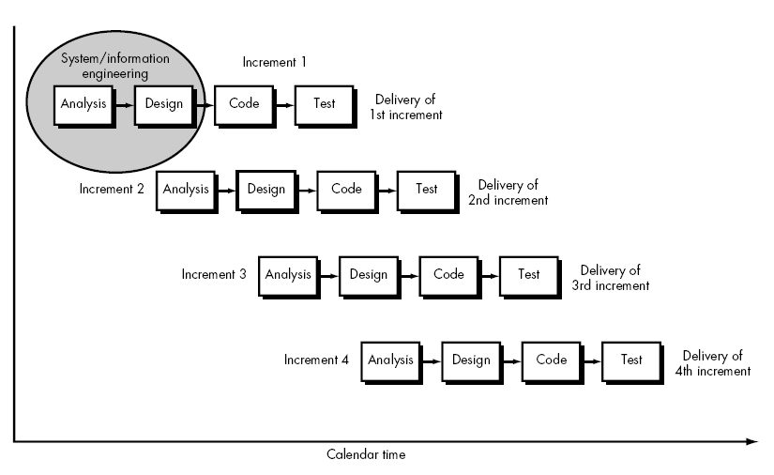

*The Incremental Process Model*

**3. Risk Management**

*The software development process involves several risks. These risks should be analyzed and a method of correction should be designed. Project risks include, learning curves, requirements alterations, changes in specifications, size underestimation and resource availability.*

* 1. **Risks**

*Because java is a high level programming language and because Android Studio has many advanced features, we have identified a learning curve associated with the languages and tools the team has chosen. Additionally, the requirements previously set forth could unexpectedly change if the client sees a problem with the current requirements during design or prototype phases. Another risk is that the specification as determined by the team may change during the project development process.*

*The team needs to carefully analyze the complexity of the project else, risk of the project scope being underestimated. It is critical that resources are identified during design in order to ensure that they are available. It is the responsibility of the team to make certain that all deliverables happen on schedule, else the project could be adversely affected.*

**3.2 Risk Management Plan**

*The team has a plan to minimize the effects of these risks. This plan is a simple model of communication, which shows how the team monitors potential sources of risk and communicates to manage the issue before it affects the cost and time of the project.*

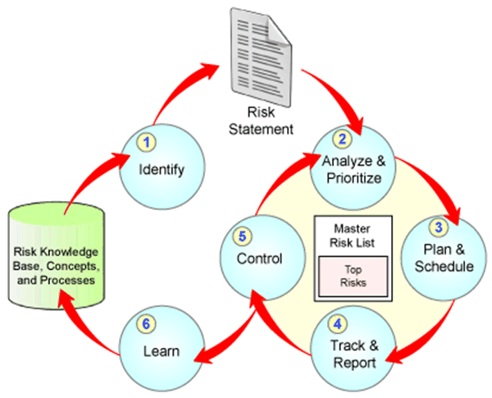

*Risk Management Strateg*y

**4. Resources**

*The project requires several resources; such resources include people, hardware, and software. Beyond basic knowledge of programming, group members may find themselves in need of assistance from other members and should therefore maintain steady communication.*

**4.1 People**

*Cloud-MSU consists of five members who are all listed in a previous section of this plan. Team personnel have committed themselves to this project until its completion. The members are also responsible for participating in the development of the project in their respective roles.*

**4.2 Hardware and Software**

*The project will require hardware and software from users. The group must also have knowledge of the hardware and software being used. If the group or a group member does not have working knowledge of the resource being used, it is his or her own responsibility to learn.*

**A. Hardware**

*The users will own an Android device* *on the most current stable android build (Currently, Android 6 “Marshmallow.”), We will provide the customer a remote server which contains the Database.*

**B. Software**

*The Current Android build, Android Studio, A LAMP server, PHPMyAdmin For the Database, UMLET for software modeling*

**5. Schedule**

*The schedule for the project will outline tasks to be completed and the individual milestones that the group needs to reach. It also describes the team member responsible for a given task.*

* 1. **Time Line**

*The time line divides the project into tasks, with specific time and designated group member for each one. The group has drafted a schedule using Microsoft Project, which includes a Gantt charts and calendar. Additionally, the project schedule and Task Network Diagram is provided below.*

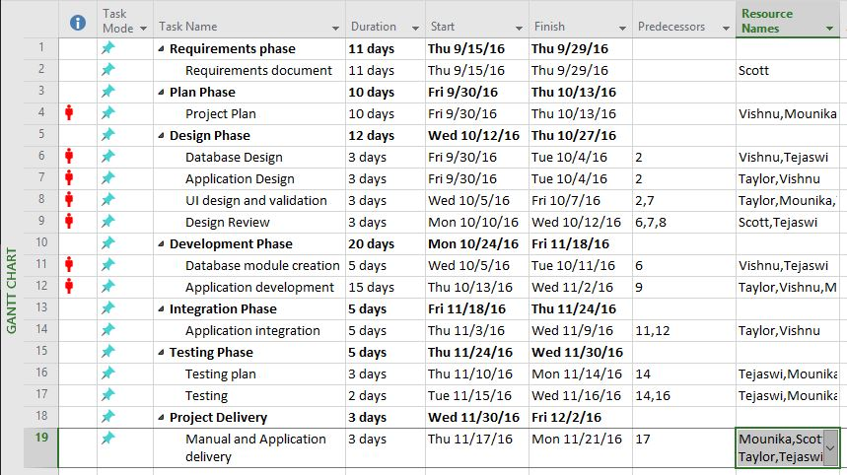

*Gantt Chart*

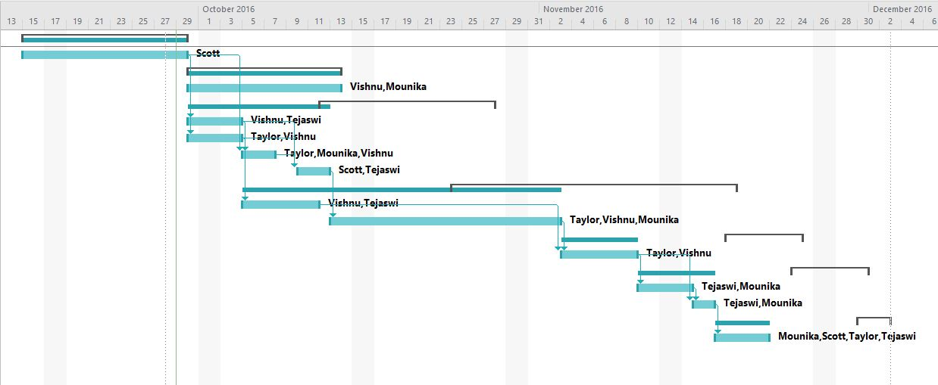

*Time Line*

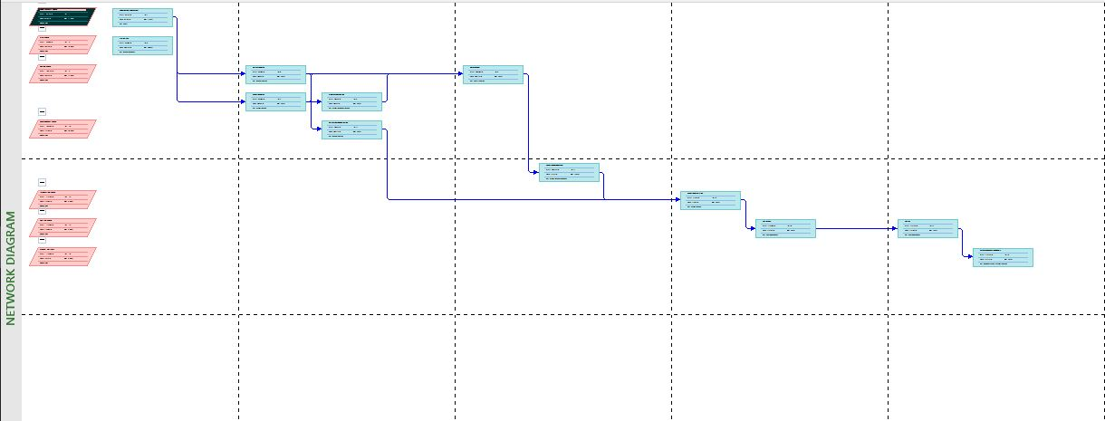

Task Network Diagram

**6. Tracking and Control Mechanics**

*A single team member will ensure that a working iteration of the code is available to be built at all times, To achieve this goal we will use Github which is a website to host git repositories. Along with this a weekly code review will be performed at one of the weekly meetings. Also an objective grading sheet will provide a metric for evaluation of team member’s individual contributions.*

*A Test plan will be be developed and included with this documentation. We will utilize the test plan to ensure that all errors are identified before the project has reached a release candidate.*

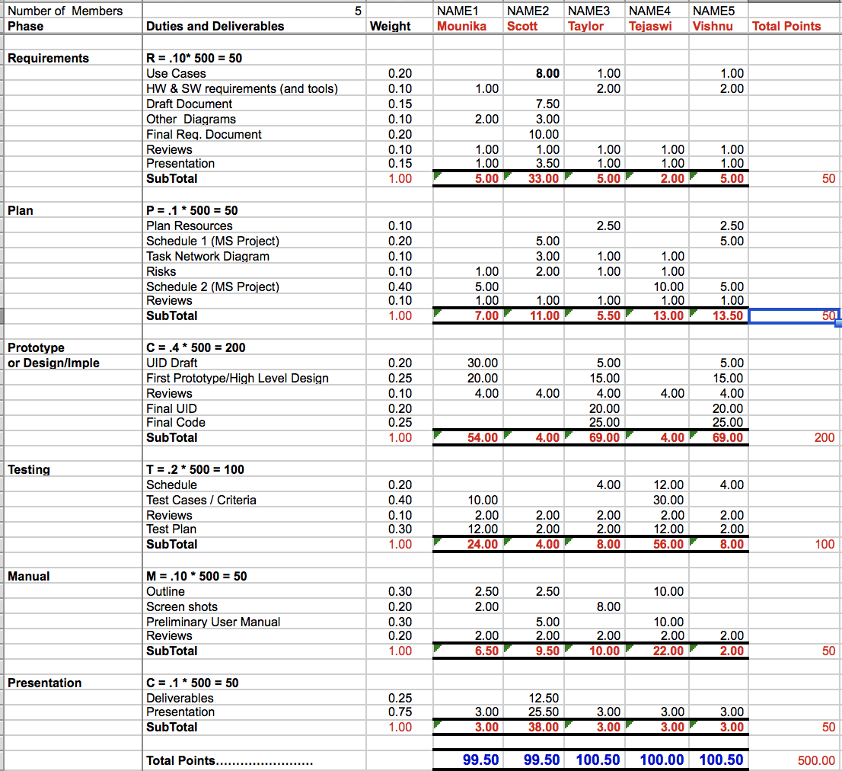

*Objective Grading Sheet*

**7. Glossary**

**Database** – *The file or server containing the collection of data for the software.*

**Democratic Decentralized** – *A system of government with a figure head as leader, but where all have equal option.*

**Requirements Document** – *An abstract system definition to help the client understand what the software will do.*

**Server** – *a computer that provides services to another computer.*

**SQL** – *Structured Query Language, a standard language used to manipulate databases.*

**MySQL** *– A specific implementation of SQL, which is open source*

**Time line** – *schedule detailing a chronological sequence of events.*

**IAAS** *- Infrastructure as a service, cloud-based solutions of hardware infrastructure,*

**PAAS** *- Platforms as a service, cloud-based solutions of or software platforms*

**Android Studio** *- the official android IDE buit on Android’s SDK., built on Android’s*

**SDK** *- Software development kit*

**IDE** *- integrated development environment*