**Scott Gordon, Taylor Kirk, Vishnu Mandalapu, Tejaswi Singam, Mounika Mannam**

*Working closely with our Programmers, our designer Mounika Mannam has created a non-functional ‘wireframe’ of our project using Pencil 3.0. Pencil is an open source Graphical User Interface, or GUI, prototyping tool. Using Pencil, we have modeled the individual Android pages, also known as Activities, which will need to be implemented. These activities will be arranged in their logical order; however, because of the event driven nature of Android, it is possible they may executed in a slightly different order. These Wireframes are for analysis and design purposes only and do not represent a finished product. We reserve the right to make additional changes to any release candidates.*

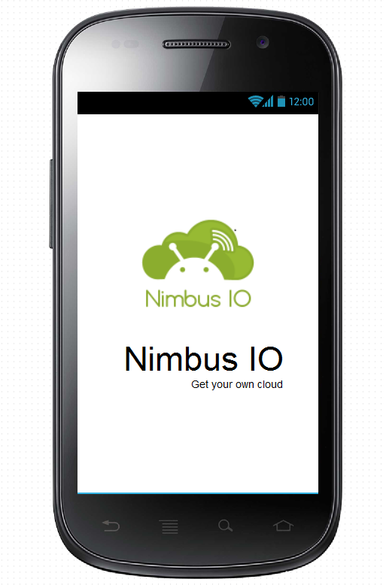

“Welcome”

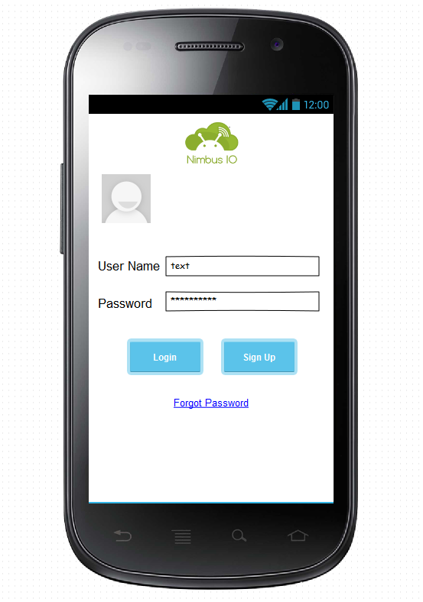

“Login”

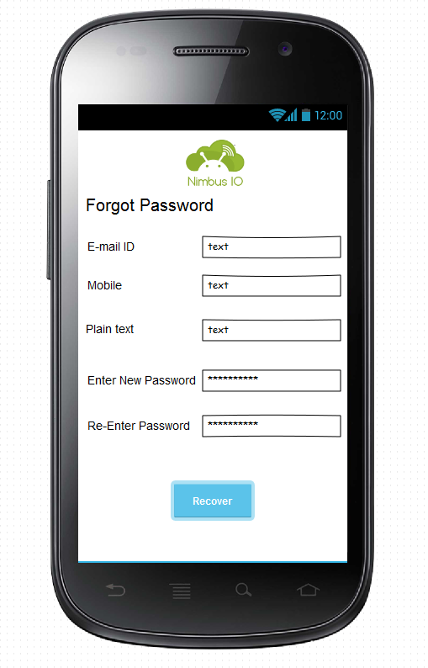

“Forgot Password”

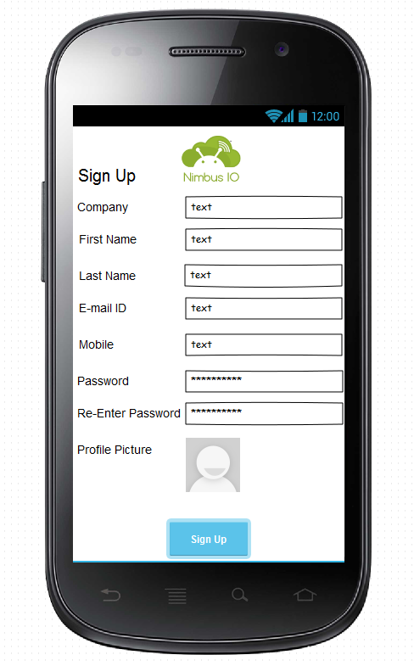

“Sign Up”

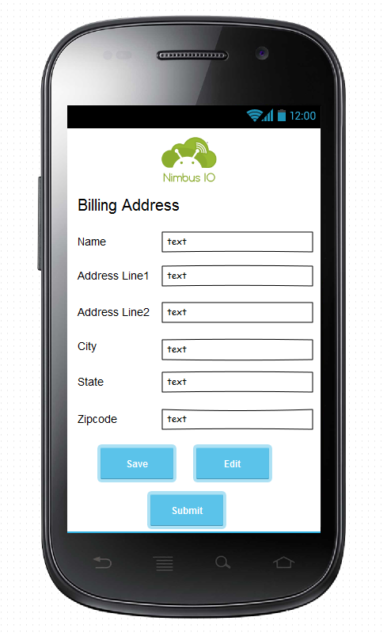

“Billing Information”

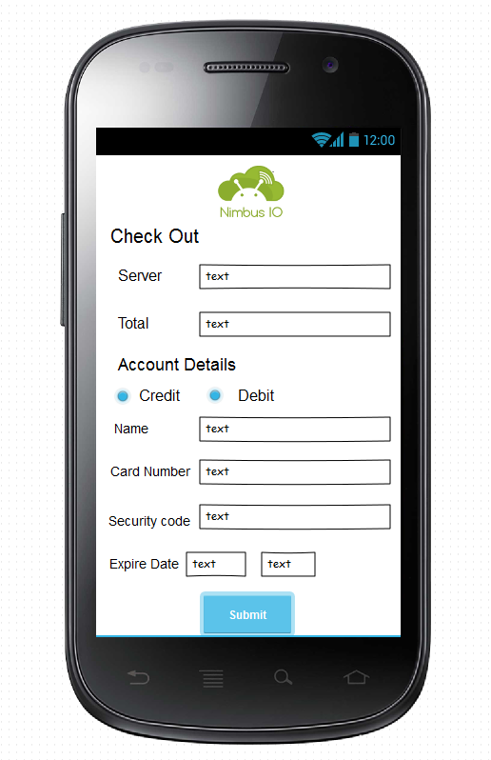

“Check Out”

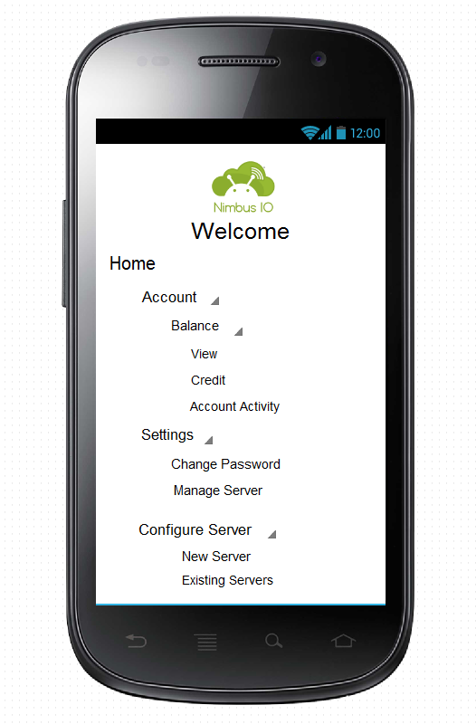

“Home”

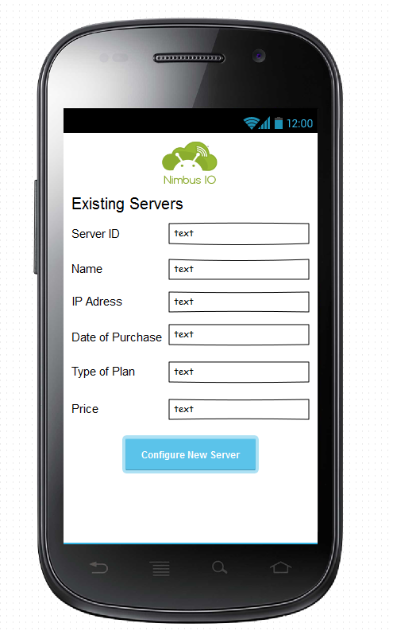

“Existing Servers”

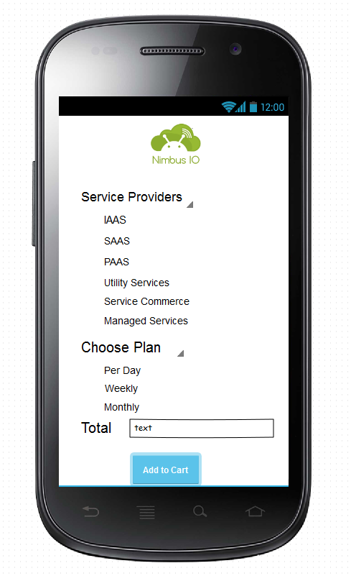

“Configure New”