UML DIAGRAMS
UseCase Diagram:
Use cases are used during requirements elicitation and analysis To represent the functionality of the system.Use cases focus on the behaviour of the system from the external point of view.The actor are Outside the boundary of the system, whereas the use cases are inside the boundary of the system.
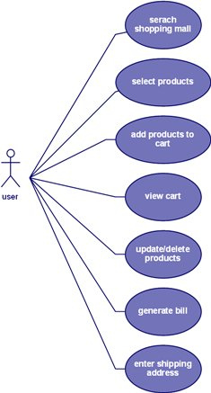

Sequence Diagram:
Sequence diagrams are used to formalize the behaviour of the system and to visualize the communication among objects. They are useful for identifying additional objects that participate in the use cases. A Sequence diagram represents the interaction that take place among these objects.
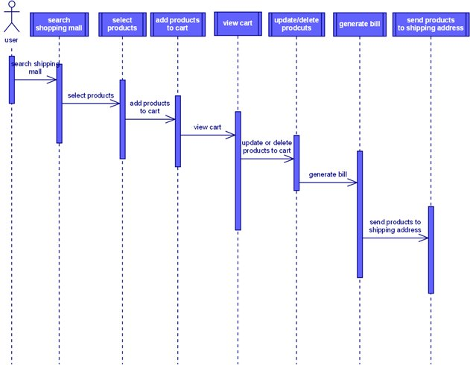

Activity Diagram:
An activity diagram describes a system in terms of activities. Activities are states that represents the execution of a set of operations. Activity diagrams are similar to flowchart diagram and data
ACTIVITY DIAGRAM

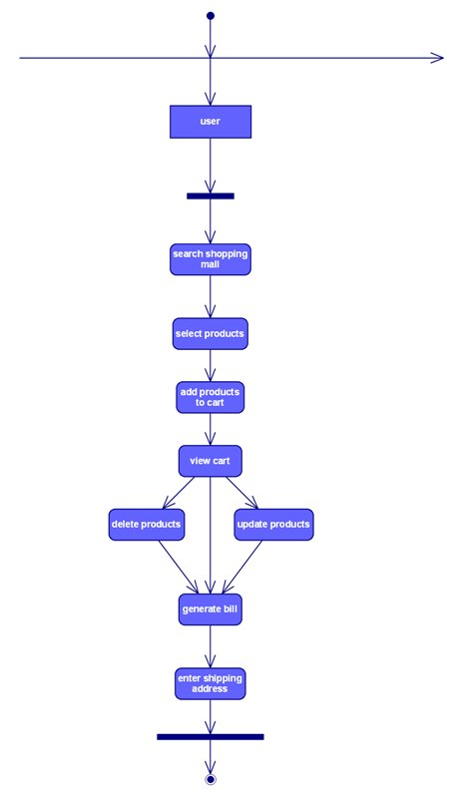
Class Diagram:
Class diagrams to describe the structure of the system. Classes Are abstraction that specify the common structure and behaviour of a set Class diagrams describe the system in terms of objects, classes, attributes, operations and their associations.

Class diagram

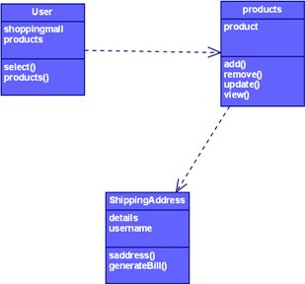

State Chart Diagram:

State chart diagrams describe the behaviour of an individual object as a number of states and transitions between these states. A state represents a particular set of values for an object. The sequence diagram focuses on the messages exchanged between objects, the state chart diagrams focuses on the transition between states.
State chart diagram server

