NBA Game Prediction System Using Neural/Tabular Machine Learning Models

Taylor Beuke | Evan Scara
MSBC-5190 Modern AI: Introduction to AI for Business
Professor Liu Liu Spring 2026

Abstract
This project develops an AI-based system for predicting NBA game outcomes and point spreads using historical player and team box-score data. The main objective is to estimate both the probability that the home team wins and the expected home-team scoring margin. The system uses player-level box-score data from the 2021-22 through 2025-26 NBA seasons, aggregates those records into team-game observations, engineers rolling pre-game features, and trains multiple supervised learning models. To avoid data leakage, all rolling statistics are shifted so that each prediction uses only information available before the game being predicted.
The final system includes two major model families: a dense neural network implemented in Keras and a tabular machine learning model. The tabular model is designed to use TabPFN when available, with a HistGradientBoosting fallback when TabPFN is unavailable. The neural network and tabular model are trained for two related tasks: binary win/loss classification and spread regression. Model performance is evaluated on a chronological holdout test set containing 1,179 games. The Dense Neural Network achieved 65.7% classification accuracy, 0.721 ROC AUC, 11.36 point spread MAE, and 14.55 point RMSE. The HistGradientBoosting fallback achieved 65.6% classification accuracy, 0.705 ROC AUC, 11.66 point spread MAE, and 14.78 point RMSE.
The project also includes a matchup prediction interface and an odds-market comparison prototype. These outputs translate model predictions into interpretable game-level summaries, including home win probability, predicted spread, predicted winner, and potential differences between model estimates and sportsbook lines. Overall, the project demonstrates how modern AI and tabular machine learning can be applied to sports analytics, while also showing the limits of prediction in a high-variance domain like professional basketball.

1 Introduction

The National Basketball Association produces volumes of structured data across game metrics, making it a strong application area for modern prediction and machine learning methods. The market for sports analytics overall is an area that is increasingly growing and changing, and technology advancements for data collection during games allow for vast amounts of analytics capabilities across sectors. Teams, analysts, fantasy platforms, media broadcasters, and fans all leverage prediction models to succeed and benefit from better ways to transform raw data into usable predictive platforms. The 2018 legalization of online sports betting in the United States has also transformed the need and accessibility for these structures, with normal fans and everyday thrill seekers benefiting from the power of accurate predictive analysis.
The goal of this project is to build a machine learning system that predicts two outcomes for NBA matchups, win probability and expected point spread. Win prediction is defined as the probability that the home team in the game will win. Points spread is defined as the model's prediction for how many points the home team will win or lose by, with positive values indicating a win and negatives a loss. This prediction system ingests raw historical csv data dating back the past 5 NBA seasons, performs feature engineering, trains supervised machine learning models, providing reusable predictive systems for new matchups and the full slates of games. The second part of this project then looks to compare this model performance to overall betting market odds derived from the Odds API.
The main research question is: can 6 tabular datasets be used to predict NBA game winners and point spreads with performance better than simple baselines? The baseline classification accuracy on this test set was 55.3%, which corresponds roughly to always predicting the more common class. The best model achieved approximately 65.7% accuracy, indicating that the engineered features and learning algorithms capture real predictive structure.

2 Related Work
This project builds on two main streams of related work: sports outcome prediction and modern tabular machine learning. A closely related sports analytics study is He and Choi’s (2025) work on NBA game outcome prediction using stacked ensemble models. He and Choi apply a range of machine learning methods to NBA prediction, including multilayer perceptrons, logistic regression, K-nearest neighbors, decision trees, AdaBoost, XGBoost, and stacked ensembles, and report that a stacking ensemble with an MLP meta-learner outperforms any individual base classifier [1]. Their results demonstrate the effectiveness of multiple model families rather than a single algorithm, since different algorithms tend to capture different nonlinear relationships in basketball data.
This project follows a similar line of thinking by comparing a neural network against a tabular learning model and averaging their outputs in the matchup predictor. It differs from He and Choi, however, in its emphasis on pre-game rolling features and leakage prevention. Rather than using statistics from the game being predicted, the model shifts rolling averages by one game so that each row reflects only information available before tipoff.
The second relevant area is modern foundation models for tabular data. Hollmann et al. (2025) introduced TabPFN, a tabular foundation model that achieves strong predictive performance on small- to medium-sized tabular datasets in a single forward pass, outperforming tuned gradient boosted trees on datasets with up to 10,000 samples. TabPFN is relevant here because this project’s final matchup dataset contains 5,891 games and 23 model features, which fits squarely in the structured tabular prediction regime TabPFN targets. The notebook attempts to use TabPFN when available and falls back to scikit-learn’s HistGradientBoosting models when it is not, so the pipeline remains runnable and reproducible across environments.

3 Data
The model uses historical NBA data stored in four CSV files: box_scores.csv, player_advanced.csv, player_pergame.csv, and team_standings.csv. This data is derived from the NBA API, an API client to access NBA.com APIs (see Appendix A). The raw box-score dataset is player-level, meaning each row represents one player's performance in one game. Since the prediction target is game-level, the first major preprocessing step aggregates player rows into team-game rows.
The data covers five NBA seasons: 2021-22, 2022-23, 2023-24, 2024-25, and 2025-26. After aggregation, the model produced 12,300 team-game rows and 6,150 unique games (see Appendix B). After rolling-feature cleanup and matchup construction, the final modeling dataset contained 5,891 games.

4 Feature Engineering

4.1 Team-Game Aggregation
The model first groups box-score data by GAME_ID, TEAM, and SEASON. It sums team statistics such as field goals made and attempted, three-point makes and attempts, free throws, rebounds, assists, steals, blocks, turnovers, and points. It also keeps game context fields such as home team, away team, home points, and away points.
From these values, the notebook calculates shooting efficiency metrics such as field goal percentage, three-point percentage, free throw percentage, and two-point percentage. The model also creates game outcome indicators, including whether the team was at home and whether it won the game.

4.2 Rolling Pre-Game Features
The model creates rolling averages over each team's previous 10 games. This is crucial because a prediction model should only use information available before the game. The model handles this correctly by applying .shift() before calculating rolling averages.
This prevents data leakage. Without this shift, the model would use the current game's statistics to predict the current game, which would artificially inflate performance.
The rolling features include points, field goals, field goal attempts, shooting percentages, rebounds, assists, steals, blocks, turnovers, and last-10 win count. These features represent recent team strength and form.

4.3 Missing Player Impact
The model approximates player availability by identifying regular and key players. A player is treated as relevant if they appeared in at least 15 games. A key player is one who meets either of these thresholds: usage percentage of at least 18.0 or points per game of at least 12.0.
For each team-game, the notebook compares the team's regular roster to the players who actually appeared in the box score. If regular players did not appear, the model calculates missing-player impact features: MISSING_USG, MISSING_PPG, and MISSING_KEY_COUNT. These features approximate the offensive importance of absent players. The output showed 8,457 team-games with key players missing and an average missing usage value of 1.2 when a key player was out.

4.4 Matchup Dataset
The model then merges the home-team row and away-team row for each game. For every feature, it computes a differential: home feature minus away feature. For example, D_R_PTS equals home rolling points minus away rolling points. The final model uses differential features plus a home advantage indicator. The final feature matrix contains 5,891 games and 23 model features. The target variables are HOME_WIN for classification and SPREAD for regression.

5 Methods
The project trains models for two prediction tasks. The classification task predicts HOME_WIN, producing a probability that the home team wins. The regression task predicts SPREAD, producing the expected home scoring margin.

5.1 Train, Validation, and Test Split
The model uses a chronological split rather than a random split. This is appropriate for sports prediction because future games should be predicted from past games. Random splitting could allow information from later seasons to indirectly influence predictions for earlier seasons (Appendix B).
The model also creates baseline models. The baseline classification accuracy was 55.3%, and the baseline spread MAE was 13.05 points. These baselines show whether the AI models add predictive value beyond simple heuristics.

5.2 Dense Neural Network
The Dense Neural Network is implemented in Keras. It takes the 23 scaled input features and passes them through three hidden layers with 96, 48, and 24 units (Appendix D). The classification model uses a sigmoid output because the target is binary. The regression model uses a linear output because spread can be positive or negative.
The architecture includes batch normalization, swish activation, dropout regularization, L2 regularization, early stopping, and learning-rate reduction. Batch normalization stabilizes training, dropout reduces overfitting, and L2 regularization discourages overly large weights. Early stopping prevents the model from training too long after validation performance stops improving. The neural network has approximately 8,833 total parameters.

5.3 Tabular Model
The second model family is designed to use TabPFN, a modern tabular foundation model [2]. TabPFN is attractive for this project because NBA game prediction is a structured tabular problem with a moderate number of samples and features, which is the regime where TabPFN has been shown to outperform tuned tree-based baselines. The notebook also includes a fallback model using HistGradientBoostingClassifier and HistGradientBoostingRegressor for environments where TabPFN is unavailable. In the recorded notebook output, the fallback model was used rather than TabPFN, so the final evaluation table compares the Dense Neural Network with the HistGradientBoosting fallback.

5.4 Ensemble Matchup Predictor
The model includes a predict_matchup() function that turns trained models into a usable prediction tool. For a given home and away team, the function finds each team's most recent rolling features, computes home-minus-away feature differentials, scales the features for the neural network, obtains predictions from both model families, and averages the outputs into an ensemble prediction. The
ensemble outputs home win probability, predicted spread, and predicted winner.

6 Results (Appendix E)
The Dense Neural Network achieved 65.7% classification accuracy and 0.721 ROC AUC, while the fallback tabular model achieved 65.6% accuracy and 0.705 ROC AUC. Both models substantially outperformed the 55.3% baseline, indicating that rolling team statistics, recent form, home-court information, and missing-player features carry meaningful predictive signals.
The Dense Neural Network also performed best on spread regression, with an MAE of 11.36 points, RMSE of 14.55 points, and R2 of 0.208. The spread baseline MAE was 13.05 points, so the Dense Neural Network reduced average spread error by approximately 1.69 points. This is meaningful in the context of NBA spread prediction, where outcomes are noisy and margins are affected by random variation, injuries, and game context.
6.1 Example Matchup Predictions
The predict_slate() function demonstrates how the model can be used on a list of matchups. These predictions are easy to interpret. For example, the model predicts that Boston has a 59.5% chance to beat Miami at home and is expected to win by about 4 points. The predicted spread is not the betting spread; it is the model's estimate of the actual scoring margin.

8 Odds Market Integration
The notebook also includes an Odds API integration. This section pulls current NBA moneyline and spread odds, maps full team names to team abbreviations, and compares sportsbook odds with model predictions. The odds data includes home team, away team, best home moneyline, best away moneyline, market home spread, and sportsbook name.
The model converts American odds into implied probabilities and compares model probability against market implied probability. A positive probability edge means the model thinks the team is more likely to win than the market implies. The system also computes a spread edge and recommends possible moneyline or spread positions when the edge passes a threshold.
This part should be interpreted as a prototype rather than a production betting system. Sportsbook spread signs require careful handling, market odds move quickly, and any real betting application would require additional validation against closing lines. The report should therefore frame this section as an example of decision-support analytics, not as wagering advice.

9 Discussion
The results show that the model successfully learns useful patterns from historical NBA data. The best model improves classification accuracy from the 55.3% baseline to 65.7%, and it improves spread MAE from 13.05 points to 11.36 points. The Dense Neural Network slightly outperforms the tabular fallback model across all major metrics.
The strongest part of the system is its feature engineering. Rather than using season averages or post-game statistics, the model constructs rolling pre-game performance indicators that reflect the information an analyst would actually have before tipoff. The use of shifted rolling averages is especially important, since it is what prevents target leakage from the game being predicted.
The model also demonstrates practical usability. Rather than ending with abstract evaluation metrics, the notebook includes functions for predicting individual matchups, predicting a full slate, saving trained models, and comparing model outputs to market odds. This makes the project a complete development-track system rather than only an experiment.
However, there are several limitations. The missing-player impact feature is only an approximation. It infers missing players from box-score participation, but it does not know whether a player was injured, resting, traded, suspended, or simply out of the rotation. The model also does not include schedule context such as back-to-back games, rest days, travel distance, altitude, or playoff versus regular-season setting. Betting-market comparison also requires additional care because odds move quickly and spread sign conventions must be handled consistently.

10 Social and Managerial Implications
From a managerial perspective, this type of model can support decision-making in sports analytics, media, fantasy sports, and fan engagement. Teams could use similar models to evaluate matchup risk, broadcasters could use them to enrich pre-game analysis, and sports platforms could use them to generate explainable predictions for users.
From a business perspective, predictive models can create value by turning raw sports data into decision-ready outputs. The model's probability estimates and spread predictions are easier for nontechnical users to understand than raw box-score tables. This makes the system useful as a communication tool as well as a prediction engine.
However, there are important ethical and social implications. Because the model includes betting-market comparisons, it should not be presented as a tool that guarantees profitable wagering. Sports betting carries real financial and behavioral risks, particularly when users misinterpret probabilistic predictions as certainties. A responsible implementation should include uncertainty estimates, clear disclaimers, and safeguards against overconfident recommendations.

11 Conclusion
This project developed an end-to-end NBA game prediction system using historical box-score data, rolling pre-game features, neural networks, and tabular machine learning. The system predicts both home-team win probability and expected scoring margin.
The best model, a Dense Neural Network, achieved 65.7% classification accuracy, 0.721 ROC AUC, 11.36 point spread MAE, and 14.55 point RMSE on a chronological test set. These results outperform simple baselines and show that recent team performance, efficiency statistics, home-court context, and missing-player proxies provide useful predictive signal.
The project also demonstrates a practical prediction workflow through matchup prediction, full-slate prediction, model saving, and odds-market comparison. Future improvements could include official injury reports, rest-day features, travel distance, player-level lineup projections, betting-line movement, team Elo ratings, and model explainability tools such as SHAP. A more advanced version could also train separate models by season phase, such as regular season versus playoffs, or compare predictions against closing betting lines to measure real-world calibration.
Overall, the project shows how modern AI can transform structured sports data into interpretable predictions while also highlighting the uncertainty and responsibility involved in predictive sports analytics.

References
[1] G. He and H. S. Choi, “Stacked ensemble model for NBA game outcome prediction analysis,” Scientific Reports, vol. 15, p. 29983, 2025. doi:10.1038/s41598-025-13657-1.

[2] N. Hollmann et al., “Accurate predictions on small data with a tabular foundation model,” Nature, vol. 637, pp. 319–326, 2025. doi:10.1038/s41586-024-08328-6.

Appendix

Appendix A: Data Source

A.1 NBA Data API

Game-level and team-level data used in this project were obtained through the NBA API (nba_api Python package), which provides programmatic access to official NBA statistics.

A.2
Dataset | Rows
Player box scores | 131,292
Player advanced stats | 2,867
Player per-game stats | 2,867
Team standings | 150

A.3
Stage | Count
Team-game rows | 12,300
Unique games | 6,150
Rows after rolling-feature cleanup | 11,850
Final matchup rows | 5,891

B
Split | Games
Fit/training set | 4,123
Validation set | 589
Train + validation set | 4,712
Test set | 1,179

C
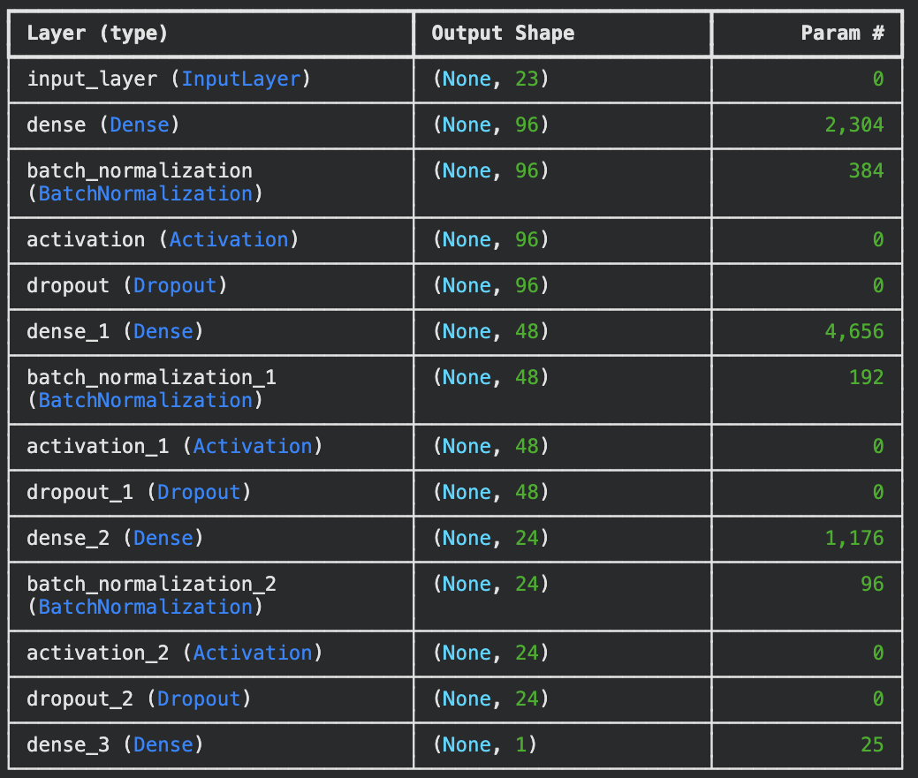

Appendix E: Results
E.1

Model | Classification Accuracy | ROC AUC | Spread MAE | Spread RMSE | Spread R2
Dense NN | 0.6573 | 0.7207 | 11.3609 | 14.5540 | 0.2079
HistGradientBoosting fallback | 0.6565 | 0.7050 | 11.6568 | 14.7837 | 0.1827
E.2
Home | Away | Ensemble Home Win Probability | Ensemble Spread | Predicted Winner
BOS | MIA | 59.5% | +4.0 | BOS
LAL | GSW | 70.5% | +7.2 | LAL
NYK | PHI | 64.9% | +7.6 | NYK
DEN | MIN | 70.8% | +6.5 | DEN
OKC | DAL | 71.0% | +6.4 | OKC

E.3
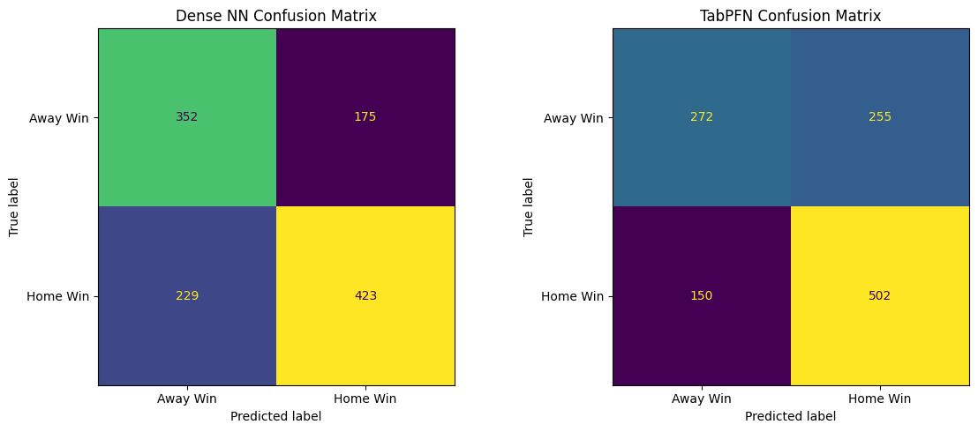
E.4
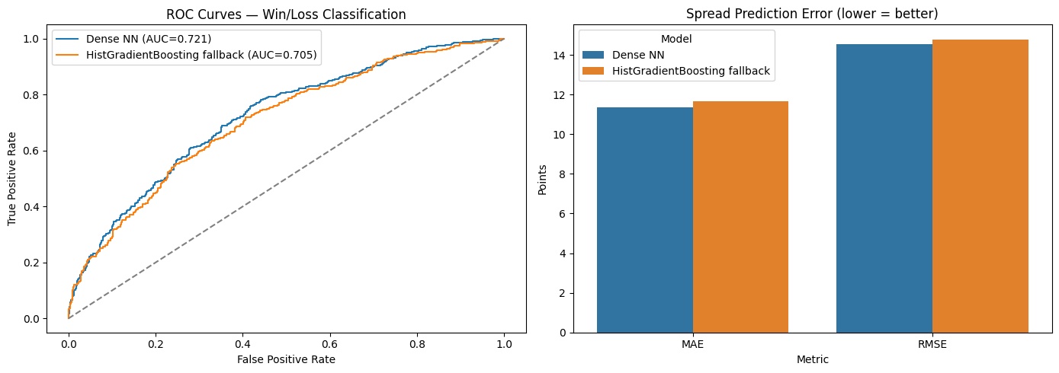

E.5
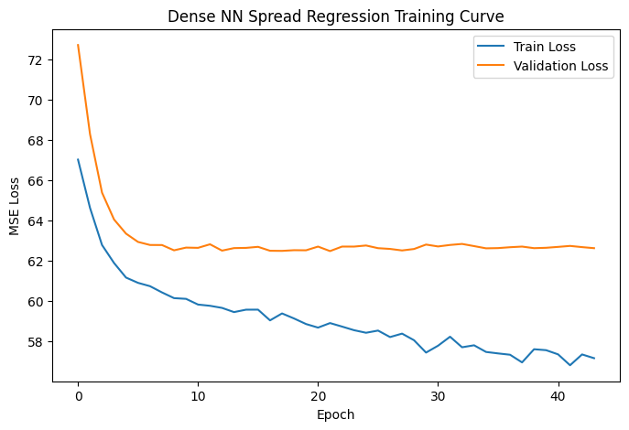

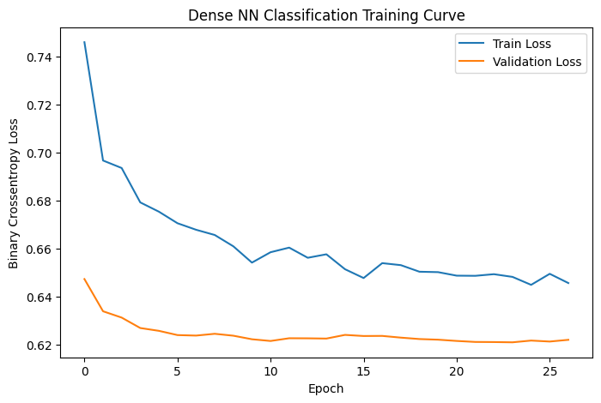

E.6
​​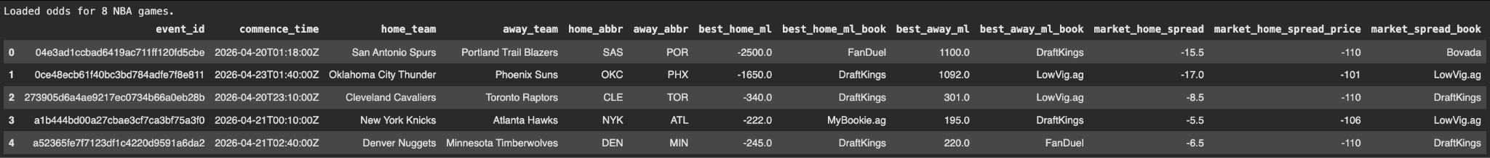

E.7
