Bài tập stack:  
https://leetcode.com/problems/valid-parentheses/description/  
<https://leetcode.com/problems/next-greater-element-ii/>

<https://leetcode.com/problems/largest-rectangle-in-histogram/>

Bài tập queue:

Bài 1:  
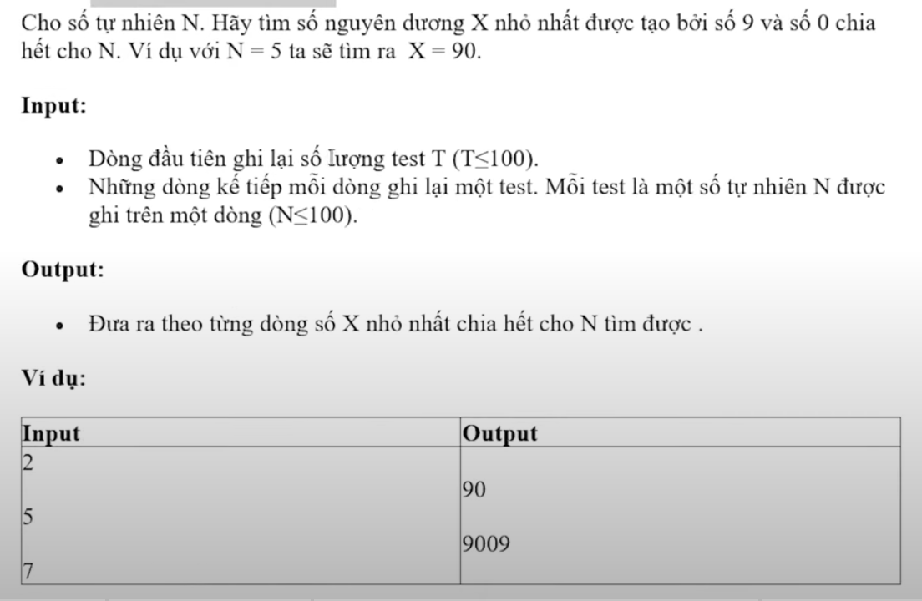

Bài 2:

