Software Requirements Specification

Version 1.0
May 10, 2021
Ibn Haiyan factory Pharmaceutical Industries System

Haya Shakra
Taymaa Jobnah

Submitted in partial fulfillment Of the requirements of CS 310 Software Engineering

Table of Contents
Table of Contents................................................................................................................................. i
List of Figures.......................................................................................................................................ii
1.0. Introduction................................................................................................................................ 1
1.1. Purpose....................................................................................................................................1
1.2. Scope of Project.......................................................................................................................1
1.3. Glossary................................................................................................................................... 2
1.4.References................................................................................................................................ 2
1.5. Overview of Document ........................................................................................................... 2
2.0. Overall Description....................................................................................................................... 4
2.1 System Environment...................................................................................................................4
2.2 Functional Requirements Specification ......................................................................................5
2.2.1 Chemical Use Case..............................................................................................................5
Use case: Manufacture and installation of medicines............................................................5
2.2.2 Medicines expert Use Case................................................................................................. 6
Use case: Test manufactured drug samples........................................................................... 6
2.2.3 Use case assign an employee…………………………………………………………………………………………...6
2.2.4 Mechanical Use Case............................................................................................................7
Use case: Machine repair........................................................................................................7
2.2.5 Manager Use Cases............................................................................................................... 8
Use case: Receive reports ...................................................................................................... 8
Use case: The decisions are taken to accept or reject applicants...........................................8
Use case: Decisions for drugs……………………………………...........................................................8
Use case: Decisions for machines............................................................................................8
2.2.6 HR Employee………………………………………………………………………………….…………………………………..9
Use case: : Adjustment on the database if a new employee is added....................................10
2.3 User Characteristics.........................................................................................................................11
2.4 Non-Functional Requirements.........................................................................................................12
3.0. Requirements Specification ...............................................................................................................13
3.1 External Interface Requirements....................................................................................................14
3.2 Functional Requirements................................................................................................................14
3.2.1 Manufacture and installation of medicines...........................................................................15
3.2.2 Test manufactured drug samples..........................................................................................16
3.2.3 assign an employee................................................................................................................17
3.2.4 Machine repair.......................................................................................................................18
3.2.5 Mangement of the laboratory................................................................................................19
3.2.6 Adjustment on the database if a new employee is added ……………………………………….…………20
3.3 Detailed Non-Functional Requirements ........................................................................................21
3.3.1 Logical Structure of the Data.................................................................................................22
3.3.2 Security..................................................................................................................................23
Index................................................................................................................................................24
List of Figures
Figure 1 - SystemEnvironment.................................................................................................................4
Figure 2 - Manager UseCases……….........................................................................................................6
Figure 3 - Logical Structure of the laboratory Manager Data ……..........................................................8
1.0. Introduction
1.1. Purpose
The purpose of this document is to present a detailed description of the Ibn Haiyan Pharmaceutical Industries System. It will explain the purpose and features of the system, the interfaces of the system, what the system will do, the constraints under which it must operate and how the system will react to external stimuli. This document is intended for both the stakeholders and the developers of the system.
1.2. Scope of Project
This system will manage workers and employees of Ibn Haiyan Pharmaceuticals in Homs electronically and presented the required tasks that meet all their needs .
Where this system explains the mechanism of action in the laboratory in details in terms of entry,exit workers and employees and clarify the role of the basic manager in the laboratory and how the machinery and maintenance and strengthening the security system for the laboratory through facial recognition technology .
This system has been expanded by computer and abandoning the method of archiving and paper storage to ensure the organization of operations and the absence of data loss.
1.3. Glossary
Term | Definition
Software Requirements Specification | A document that completely describes all of the functions of a proposed system and the constraints under which it must operate
Stakeholder | Any person with an interest in the project who is not a developer.
User | Manager , employees , manufacturing experts , chemists and mechanics
Manager | He is the person who has the highest authority in the laboratory and is responsible for managing all tasks.
Employee | Anyone working in the following section ( medicine installation , distribution and storage , maintenance , monitoring , management , HR)
Chemists | He is the person who makes and synthesizes medicines .
Mechanics | He is the worker who checks and repairs any malfunctions in the laboratory machines .

1.5. Overview of Document
The next chapter, the Overall Description section, of this document gives an overview of the functionality of the product. It describes the informal requirements and is used to establish a context for the technical requirements specification in the next chapter.
The third chapter, Requirements Specification section, of this document is written primarily for the developers and describes in technical terms the details of the functionality of the product. Both sections of the document describe the same software product in its entirety, but are intended for different audiences and thus use different language.

2.0. Overall Description
2.1 System Environment
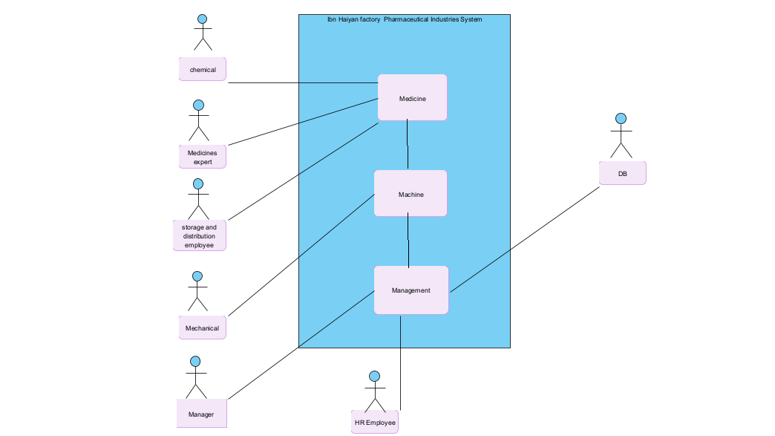
Figure 1 - System Environment

The laboratory system contains five bodies and one collaborating system .
All employees send daily reports to the manager ,where they communicate with him through a dispatch program .
The chemist assembles the drugs and after it is finished , he sends them to the drug expert who tests them according to health standers then the expert continues with storage and distribution staff to tell them that sample or medicine is ready storage or export .
Mechanical is responsible for repairing machines in the lab where it is sent to the broken machine.
The staff is logging and exit from the laboratory the thumb fingerprint sensor.

2.2 Functional Requirements Specification
This section outlines the use cases for each of the active employees separately. The mechanical , chemical , medicine expert , storage and distribution officer have only one use case apiece while the manager is main actor in this system.
2.2.1 chemical Use Case
Use case: Manufacture and installation of medicines.
Diagram: 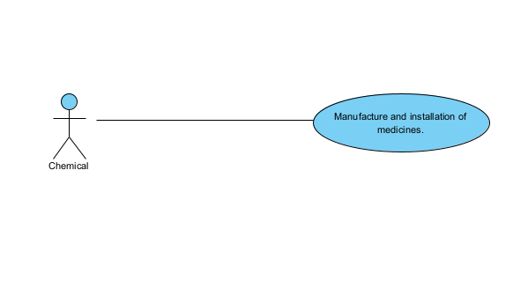
Brief Description
Chemical is manufacturing and installing drugs in private rooms within the laboratory through the installation of imported primary materials within certain conditions.
Initial Step-By-Step Description
- Chemical prepares himself and entry for cabins and wearing special clothes to install medicines from full and cavers and mask for face
- The chemical is preparing for the pharmaceutical process and its installing y preparing the necessary raw materials and tuning machines on appropriate conditions for manufacturing process.
- Installation of raw materials and manufacturing drug which was requested .
- After that sample is sent from the medicine for the drug expert.
- If the drug is in compliance with the standards, a report is sent to the director that the drug has met the conditions and approval is taken to start its manufacture.
- Finally, the medicine is wrapped and packed and sent to the storage and distribution department.

The diagram illustrates the pharmaceutical industry. The chemist performs the process of installing samples of the drug to be manufactured and then sends them to the drug expert, who in turn tests and tests them according to health standards. Either it is accepted as meeting the conditions or rejected, or the chemist is asked to make some adjustments based on the required health conditions. If accepted, the response is sent to the chemist with acceptance through the messaging program, and the chemist completes the drug manufacturing process and sends it to the storage and distribution department. The process of rejecting samples does not appear above.

2.2.2 Medicines expert Use Case

Use case: Test manufactured drug samples
Diagram:
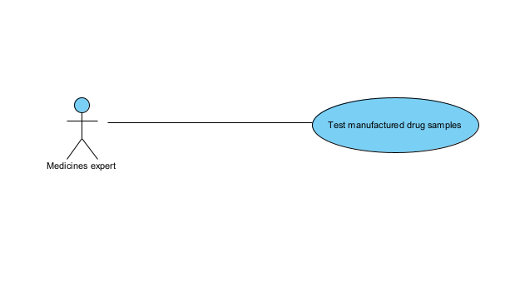
Brief Description
The drug expert tests the drug, and if it meets the required conditions, he sends the chemical response either by continuing or stopping the manufacturing process.

Initial Step-By-Step Description
- The expert receives the samples to be examined.
- The expert tests the required samples according to health standards.
- After the test, the expert sends a notice of acceptance of the continuation of the drug manufacturing process or rejection, or of modification of the raw materials used in manufacturing for the chemical.
- The expert sends a report to the manager about the results of the sampling evaluation.

2.2.3 Use case assign an employee
The manager uploads an advertisement for hiring employees
Diagram:

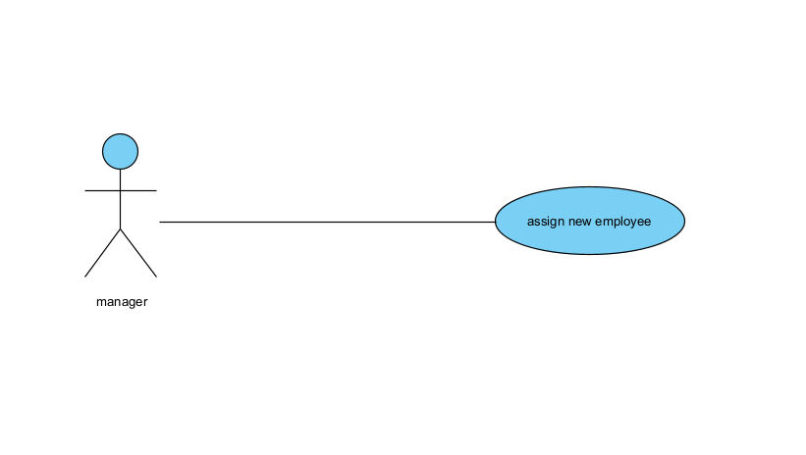

Brief Description
The manager appoints one or more employees in each department.
Initial Step-By-Step Description
- After the manager posts an advertisement, the applicants send the CV to the HR employee.
- The human resources employee selects the employees according to the criteria mentioned in the advertisement. If he meets the specifications, he submits it to the manager, other wise he will reject it.
- The manager reviews employment applications for an interview..
- After the interview, either the manager accepts or rejects, and in the event of acceptance, the applicant is added to the database.

2.2.4 Mechanical Use Case
In the case of multiple mechanics, this term denotes the principal mechanic, with whom all correspondence is to be made.
Use case: Machine repair
Diagram:
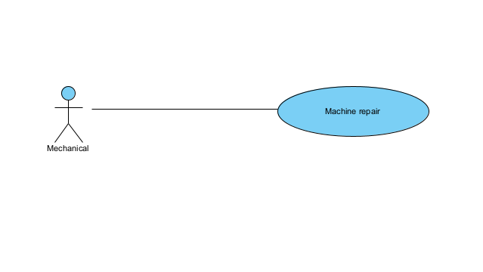
Brief Description
The mechanic either repairs a machine or routinely checks the machines.
Initial Step-By-Step Description
- A notification arrives to the mechanic via the messaging program with the number of the machine that has broken down.
- The mechanic checks the whole machine to find out where the malfunction is.
- The mechanic fixes the machine or sends a notice to the manager to order a new machine.
- 3. The mechanic will repair the machine if possible, or order a new machine, or replace damaged parts
- Finally, the mechanic sends a report to the manager with the instruction.

2.2.5 Manager Use Case

Use case:
Receive reports ,
The decisions are taken to accept or reject applicants.
Decisions for drugs,
Decisions for machines.
Diagram:
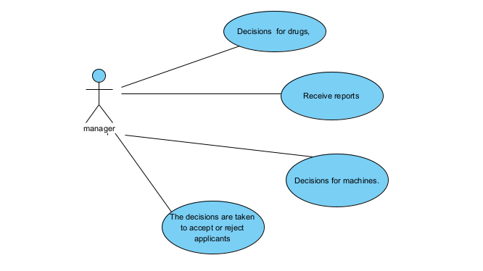
Figure 2 – Manager Use Cases

Brief Description
The manager is the person who holds the supreme power in elevating and getting reports from all lab employees.
Initial Step-By-Step Description
- A chemist submits a request to the director regarding the raw materials needed for the manufacturing process of a particular drug, so that the director makes the appropriate decision to accept or reject it. If the manufacturing process is approved and completed, the manager receives a comprehensive report of the manufacturing milestones through the messaging program.
- Upon the end of the drug sample testing phase, the director receives a comprehensive report of the test results from the drug expert.
- When a specific machine breaks down, a comprehensive report is sent to the manager by the mechanic with the number of the malfunctioning machine, the type of malfunction and how to fix it, either through repairing or replacing the broken parts or requesting the purchase of a new machine.
- In the event that a new drug is produced, the specialized workers fill it and send it to the storage and distribution department, and then send a report to the director containing a list of the drugs in the storage department and the quantity of each drug.
- After the director published the announcement of employment and its choice of applicants and interviewed with them sending their data to the human motor officer to add them to the database.

2.2.6 HR Employee
Use case: Adjustment on the database if a new employee is added.
Diagram:
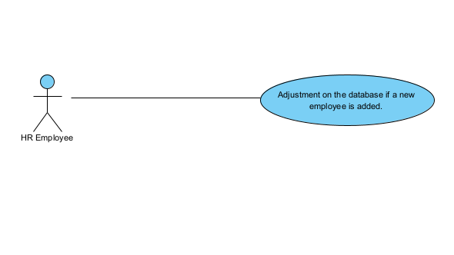
Brief Description
After the manager filed an advertisement for employment.
Initial Step-By-Step Description
- The human resources employee reviews the employment applications, selects the applications that meet the required conditions, and submits them to the manager.
- And when he receives the response from the manager to approve the requests that have been selected, he adds them to the database, otherwise he deletes them.

  - User Characteristics
It is expected that all employees (chemist - mechanical - pharmaceutical expert - warehousing and distribution officer - human resources employee) have sufficient knowledge to deal with the messaging program and the electronic system as a whole.
It is expected that the manager and the human resource officer are fully familiar with dealing with databases.
The detailed look of these pages is discussed in section 3.2 below.

  - Non-Functional Requirements
One of the requirements is that the security system in the laboratory is strong through the adoption of a high-quality encryption system for the system data, and the security of the system has been increased by adding a thumbprint sensor in addition to fire alarm devices.
And to be easy to use by containing a lot of interfaces and help messages
The system must be fast, with a response rate of at least 80%.
Regarding regulatory requirements, the devices in this system must contain the database software
As for the development requirements, this system requires a special program for its development process
As for external requirements, the privacy of employee data and accounts must be preserved (ethical requirements).

3.0. Requirements Specification
3.1 External Interface Requirements
The only link to an external system is to link to a factory database to verify employee membership. The manager believes that the community member is more likely to be an effective employee and has imposed the membership requirement on the employee. The HS database fields of interest
The laboratory system is the employee's name, identification number (ID), e-mail address, phone number, place of residence and certificates obtained (optional field for the Harmonized System database).
Case for using employee designation, the employee ID is sent to the Harmonized System database and a Boolean is returned to refer to Membership status.

3.2 Functional Requirements
The Logical Structure of the Data is contained in Section 3.3.1 .
3.2.1 Manufacture and installation of medicines.
Use Case Name | Manufacture and installation of medicines.
XRef | Section 2.2.1, Manufacture and installation of medicines.
Trigger | A chemist performs the process of making and synthesizing the drug.
Precondition | Availability of the raw materials required for the process of making and formulating the drug.
Basic Path | - Chemical prepares himself and entry for cabins and wearing special clothes to install medicines from full and cavers and mask for face  - The chemical is preparing for the pharmaceutical process and its installing y preparing the necessary raw materials and tuning machines on appropriate conditions for manufacturing process.  - Installation of raw materials and manufacturing drug which was requested .  - After that sample is sent from the medicine for the drug expert.  - If the drug is in compliance with the standards, a report is sent to the director that the drug has met the conditions and approval is taken to start its manufacture.  - Finally, the medicine is wrapped and packed and sent to the storage and distribution department.
Alternative paths | In step 3, the drug is manufactured and installed either on demand or according to the quantity available in stores.  The customer determines the amount of medication required.  The warehousing and distribution employee creates and submits a list of medications required by the customer and submits it to the manager.  In the event that the required drug is not available in the warehouse, the warehousing and distribution employee sends a report to the director to request the manager from the manufacturing department to start manufacturing it.
Postcondition | The drug is sent to the customer after the approval of the director.
Exception Paths | The customer may drop the order at any time.
Other | A list of drugs is created and submitted to the manager, regardless of the customer's request

3.2.2 Test manufactured drug samples
Use Case Name | Test manufactured drug samples.
XRef | Section 2.2.2, Test manufactured drug samples.
Trigger | The expert tests drug samples before manufacturing.
Precondition | Availability of samples resulting from manufacturing to be testd.
Basic Path | - The expert receives the samples to be examined.  - The expert tests the required samples according to health standards.  - After the test, the expert sends a notice of acceptance of the continuation of the drug manufacturing process or rejection, or of modification of the raw materials used in manufacturing for the chemical.  - The expert sends a report to the manager about the results of the sampling evaluation.
Alternative Paths | In the event that samples are present, they are tested, and the expert does not request a report from the chemist regarding the dates of manufacturing the drugs.
Postcondition | After testing the samples, they are approved to start manufacturing or rejected according to the result.
Exception Paths | The drug testing process may be abandoned in the absence of the necessary tools and equipment.  The drug testing process is also abandoned if samples are not properly manufactured and do not comply with health standards.
Other | Malfunction of machinery and tools necessary for the testing process.

3.2.3 assign an employee
Use Case Name | assign an employee.
XRef | Section 2.2.3, assign an employee.
Trigger | Add a new employee
Precondition | Personnel submitting employment requests in case there are vacancies in the lab departments.
Basic Path | - After the manager posts an advertisement, the applicants send the CV to the HR employee.  - The human resources employee selects the employees according to the criteria mentioned in the advertisement. If he meets the specifications, he submits it to the manager, other wise he will reject it.  - The manager reviews employment applications for an interview..  - After the interview, either the manager accepts or rejects, and in the event of acceptance, the applicant is added to the database.
Alternative Paths | If the vacancy applicant's specifications do not match the required criteria, the recruitment process will not take place.
Postcondition | At least one new employee is employed in each department in case there is a need for employees.
Exception Paths | The manager can abandon the hiring process at any time.
Other | Employment applications must contain previous experience, e-mail address, specialization and place of residence.

3.2.4 Machine repair
Use Case Name | Machine repair
XRef | Section 2.2.4 Machine repair
Trigger | Repair Machines in case of failure.
Precondition | The presence of disabled machines.
Basic Path | - A notification arrives to the mechanic via the messaging program with the number of the machine that has broken down.  - The mechanic checks the whole machine to find out where the malfunction is.  - The mechanic fixes the machine or sends a notice to the manager to order a new machine.  - 3. The mechanic will repair the machine if possible, or order a new machine, or replace damaged parts  - Finally, the mechanic sends a report to the manager with the instruction.
Alternative Paths | In the absence of disabled machines, machines are periodically inspected.
Postcondition | The machine is fixed.
Exception Paths | The mechanic may give up a machine repair at any time.  If the purchase or replacement is not possible.
Other | There is no.

3.2.5 Mangement of the laboratory

Use Case Name | Receive reports ,  The decisions are taken to accept or reject applicants.  Decisions for drugs,  Decisions for machines.
XRef | Section 2.2.5 , Receive reports ,  The decisions are taken to accept or reject applicants.  Decisions for drugs,  Decisions for machines.
Trigger | Management of drig laboratory and organization of work.
Precondition | Complaction of work and supervision by a high authority.
Basic Path | - A chemist submits a request to the director regarding the raw materials needed for the manufacturing process of a particular drug, so that the director makes the appropriate decision to accept or reject it. If the manufacturing process is approved and completed, the manager receives a comprehensive report of the manufacturing milestones through the messaging program.  - Upon the end of the drug sample testing phase, the director receives a comprehensive report of the test results from the drug expert.  - When a specific machine breaks down, a comprehensive report is sent to the manager by the mechanic with the number of the malfunctioning machine, the type of malfunction and how to fix it, either through repairing or replacing the broken parts or requesting the purchase of a new machine.  - In the event that a new drug is produced, the specialized workers fill it and send it to the storage and distribution department, and then send a report to the director containing a list of the drugs in the storage department and the quantity of each drug.  - After the director published the announcement of employment and its choice of applicants and interviewed with them sending their data to the human motor officer to add them to the database.
Alternative Paths | In the absence of the manager, there is someone who receives orders from it remotely to make decisions and complete the workflow.
Postcondition | Work on the fullest within the laboratory.
Exception Paths | The necessary reports of the manager do not complete the work.
Other | An unexpected failure in the laboratory (fire outbreak , correspondence crashes,……)

3.2.6 Adjustment on the database if a new employee is added .

Use Case Name | Adjustment on the database if a new employee is added .
XRef | Section 2.2.6 , Adjustment on the database if a new employee is added .
Trigger | Add new staff to the database.
Precondition | The presence of applicants were accepted by the manager.
Basic Path | - The human resources employee reviews the employment applications, selects the applications that meet the required conditions, and submits them to the manager.  - And when he receives the response from the manager to approve the requests that have been selected, he adds them to the database, otherwise he deletes them.
Alternative Paths | There are no new employees to enter them into the database.
Postcondition | Completion of an enterprise entry for the database.
Exception Paths | Give up the recruitment process at any time
Other | Unexpected disruption in the database, which prevents an HR employee from reaching database.

3.3 Detailed Non-Functional Requirements
3.3.1 Logical Structure of the Data
The logical structure of the data to be stored in the laboratory database.
database is given below.

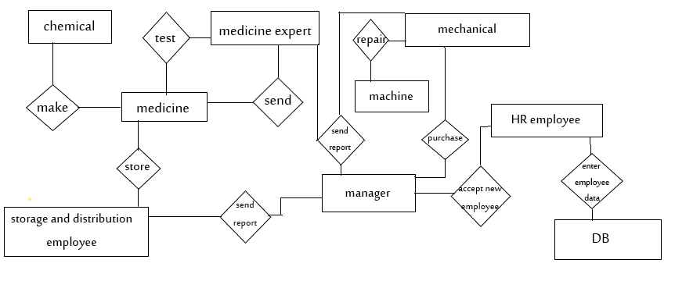

Figure 3 - Logical Structure of the laboratory Manager Data
The data descriptions of each of these data entities is as follows:
An employee data entity
Data Item | Type | Description | Comment
Name | Text | Employee Name
ID | Integer | Employee identification number | It is used as an employee's access key to the database.
Telephone number | Integer | Employee phone number | Composed of 10 numbers.
Specialty | Category | Area of expertise | May be several
The section that resides | Text | The department in which the employee works (chemist - pharmaceutical expert - mechanical - storage and distribution employee ...)

Drug data entity
Data Item | Type |  | Description | Comment
Name |  | Text | medicament name
The manufacturer of the medicine |  | pointe | Chemical entity | The name of the chemical that manufactured the drug.
Medicines expert |  | pointer | Expert entity | The person testing the drug samples
Contents |  | Text | The raw materials that we made is medicine | May be several
production date |  | Date | The date the medicine was made
Acceptable |  | Boolean | If he fulfills the health standards (manufacturing within a certain temperature _ fulfills all components in the required quantities _ hygiene ....) | May be several
Medical leaflet |  | Text | It contains (raw materials used in the manufacture of the medicine - indications - side effects - drug interactions - warnings - preservation method) | Can be dispensed with

Machine data entity
Data Item | Type |  | Description | Comment
Name |  | Text
ID |  | ID | Machine number | Machine number to be repaired
Type of malfunction |  | Text | Full or partial failure
Mechanic who fixes it |  | Text | The name of the mechanic who repairs the machine
Buy or replace |  | Text | Purchase or replace the machine | To purchase or replace the machine, the price of the machine must be present as a whole or the price of the parts affected by it

3.3.2 Security
The lab system will be equipped with a messaging program to facilitate work between employees and the manager, in addition to the presence of a fingerprint sensor that prevents any unauthorized entry, in addition to the presence of ease for employees to access the information they need to continue work.
The database that contains employee information will have a special security, and only those who have the authority (Director - Human Resources Officer) can access it.
Finally, the system includes a fire sensor to detect fires in the event they occur and trigger alarms.

