**User Manual**

**Of**



**INTEGRATED GROUP PROJECT**

**Members:**

**Imaad Solomon, Tara Snell, Kgotsofatso Bojatseha, Khanyiso Bikwana**

**Due Date: 11 November 2022**

**Lecturer: Mrs I Bawa and Mr W Shaw**

**User Master**

**Home Page**

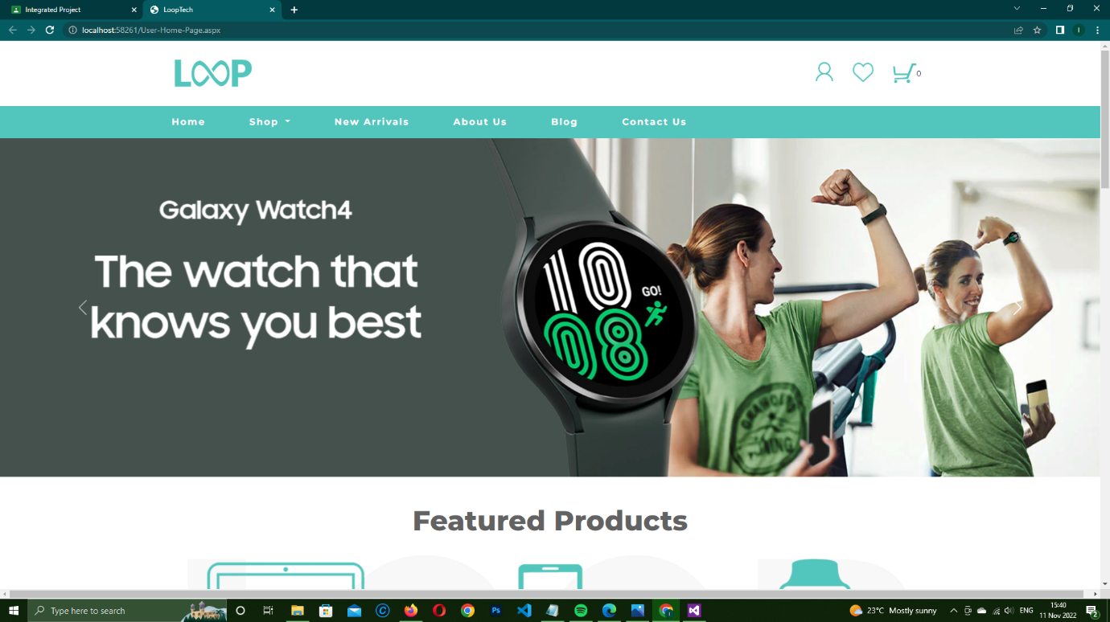

The home is the first page of the website and is linked to every other web form on the site.

1. A clickable logo that is a link back to the homepage.
2. Navigation
3. Menu Item
4. Drop down menu items

It contains links in the form of buttons or images and previews of the products and services LoopTECH has to offer

**About Us**



**Contact Us**

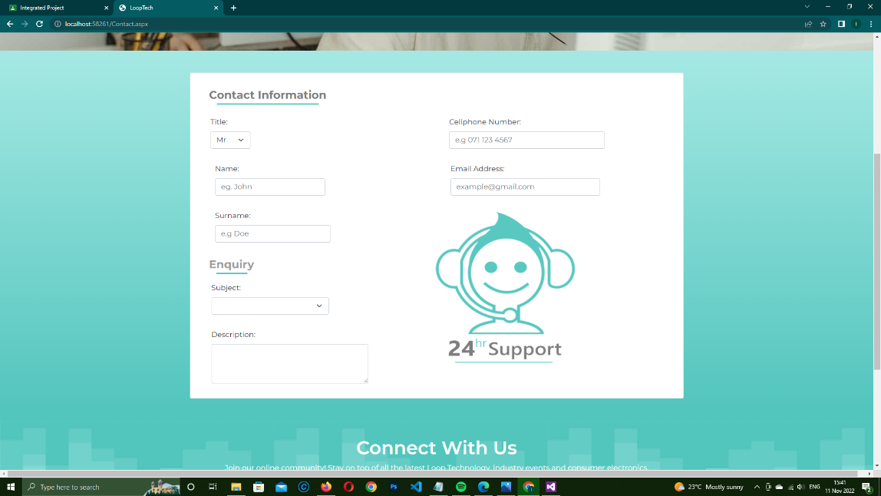

Allows User to Contact the company directly with any issues they are having with our products and services or enquiries.

**Search Pages**

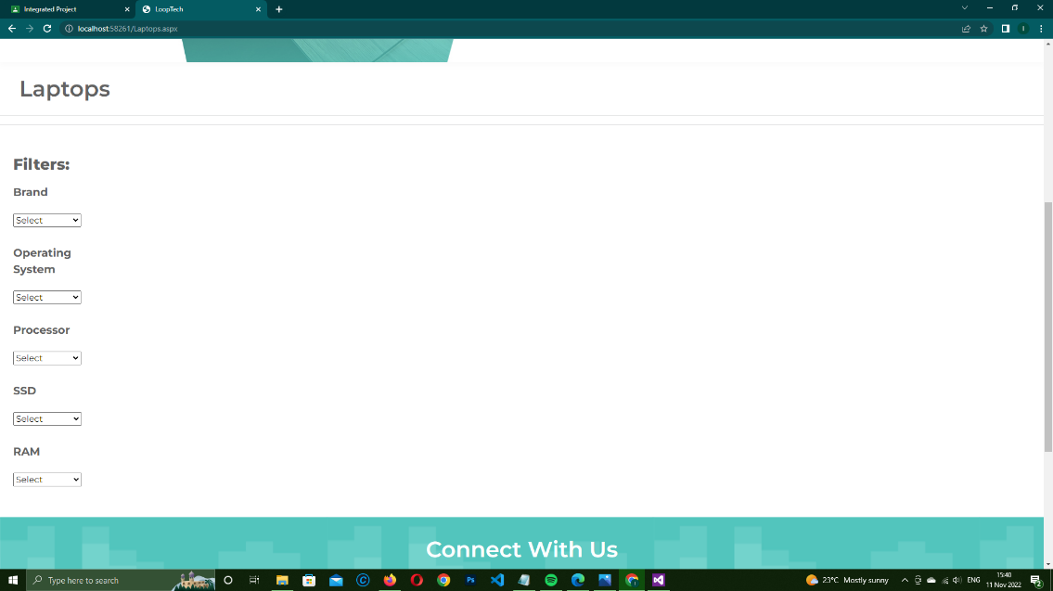

All Product search pages work exactly the same way. Use the drop-down list boxes to narrow search parameters to find the product you seek. You can use one OR more drop-downs to make your search more specific.

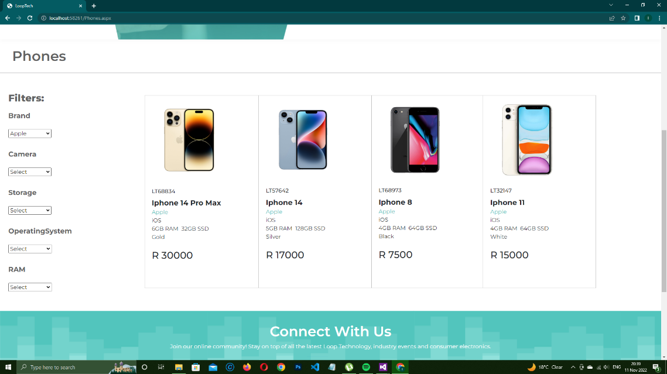

The search result will display and if you would like to know more about the product simply tap or select the image and it will run a product display session show you more perspectives of the product as well as in-depth details of the product in the form of accordions.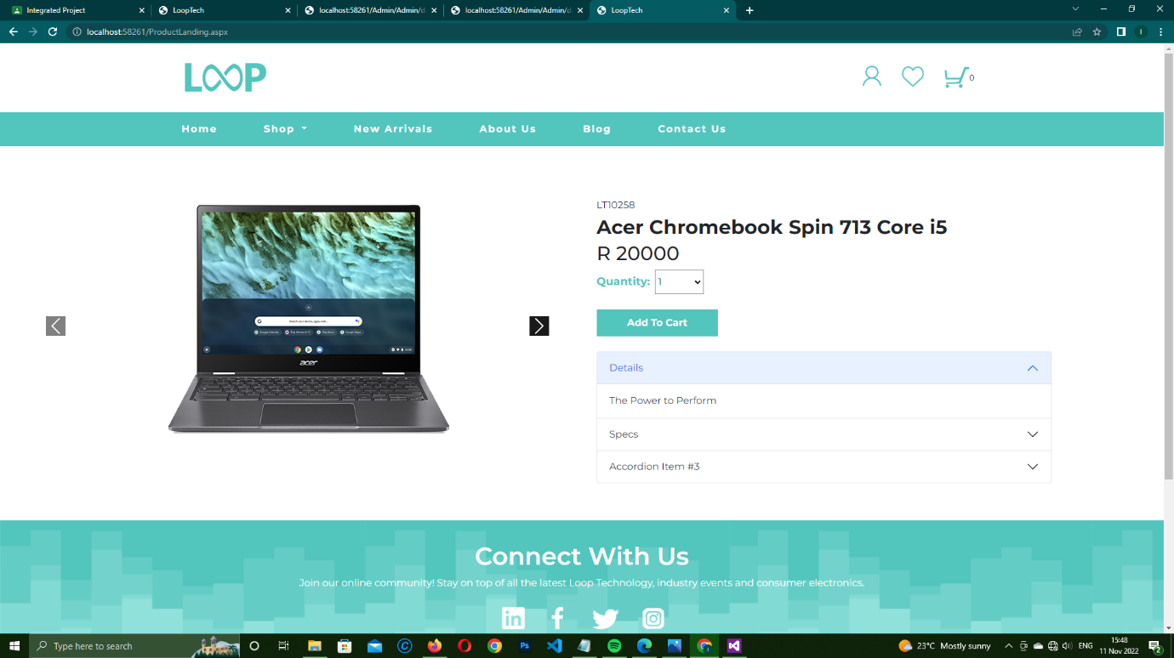

If it is the product they want they simply select the quantity (DEFAULT IS 1 ITEM) and click add to cart. You can continue shopping or click on the cart icon right on top of the page.

**Cart**

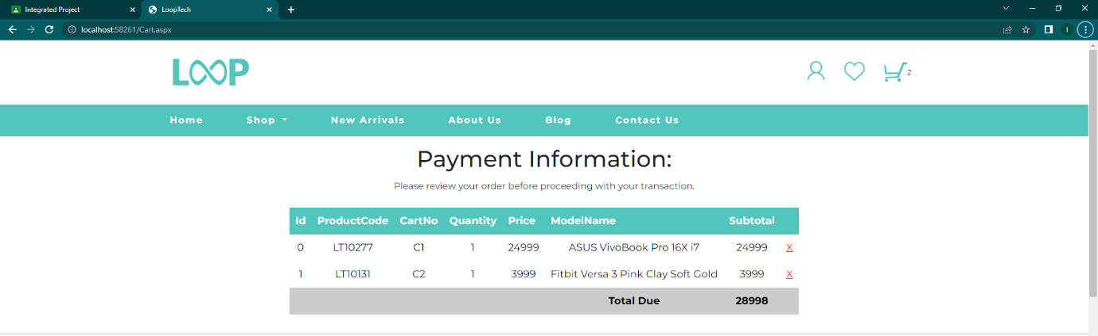

Straight forward transaction, you can remove items you do not want and if you happy with your order click on the buy button to enter billing information.

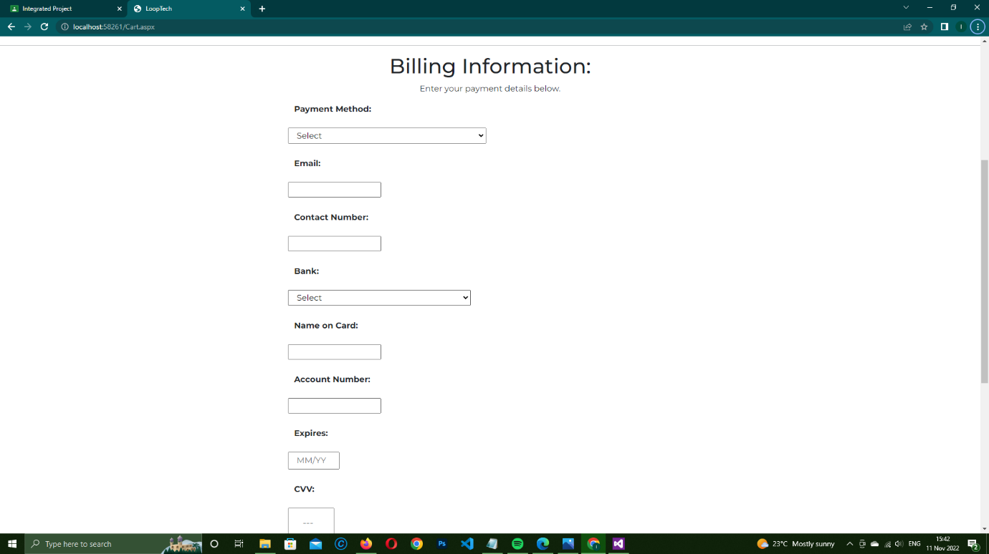

Once you entered your details click Confirm, if any of the controls are empty it will prompt a warning message stating the field requires a viable entry. If all are entered, click submit to complete the transaction, the window alert will indicate the success.

**Login**

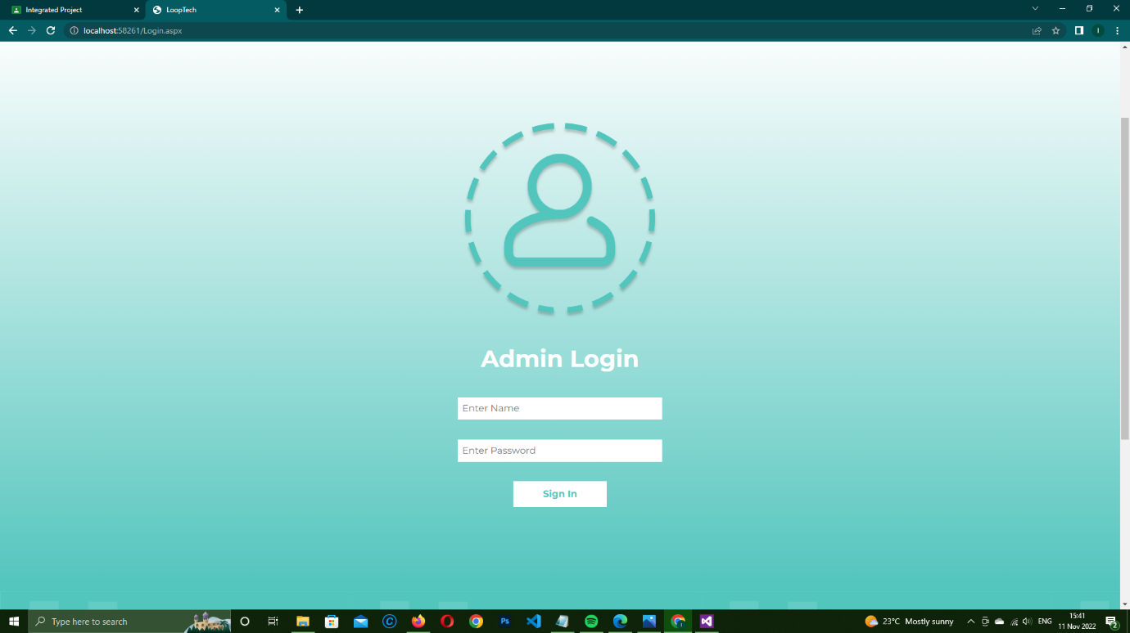

To gain more rights and access private information, an admin user has to login using a personal username and password given to them.

If the username and password that was inputed is false, nothing will occur. If its correct, the admin will be redirected to the admin home where he/she can access the Update,Insert and Delete pages.

**Delete Products**

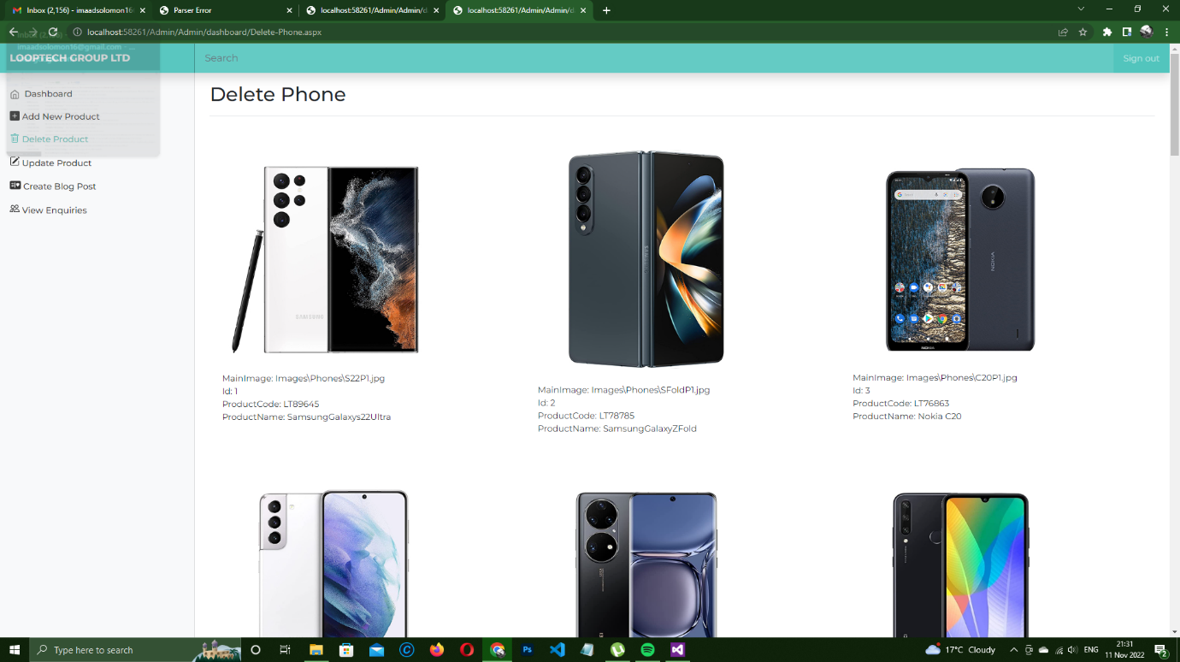

For All 3 Delete pages the process is simple:

1. Select an item
2. Then click on the ‘Delete’ button.
3. Select ‘Yes’ to confirm that you want to delete the record permanently from the database or ‘Cancel’ to re-enter
4. Message will display to indicate that flight record has been deleted.

**Update Products**

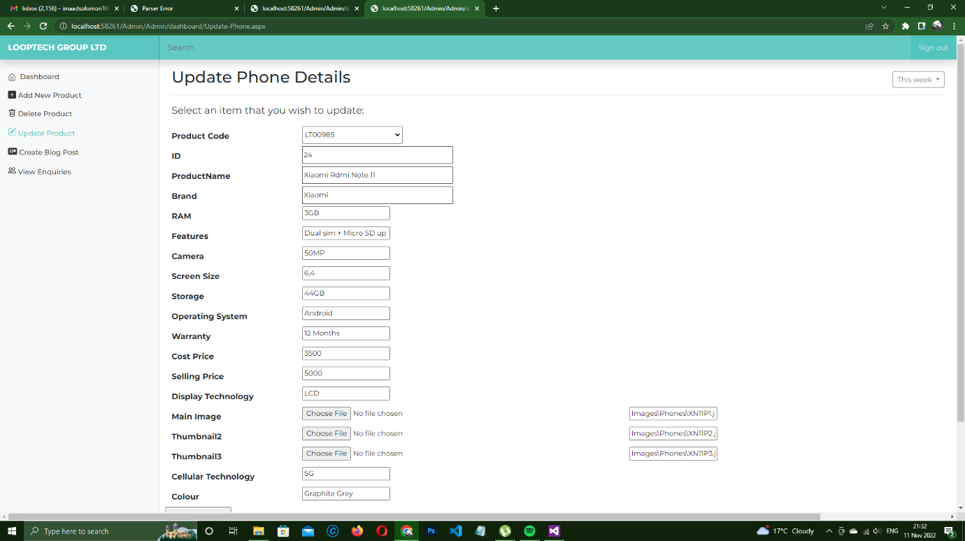

For All 3 Update pages the process is simple:

1. Select the product via its Product Code e.g. LT00282
2. Edit the details of the record via the textboxes
3. You MUST select image files before updating the database or an error will occur.
4. Click on the button to confirm update.

**Insert Products**

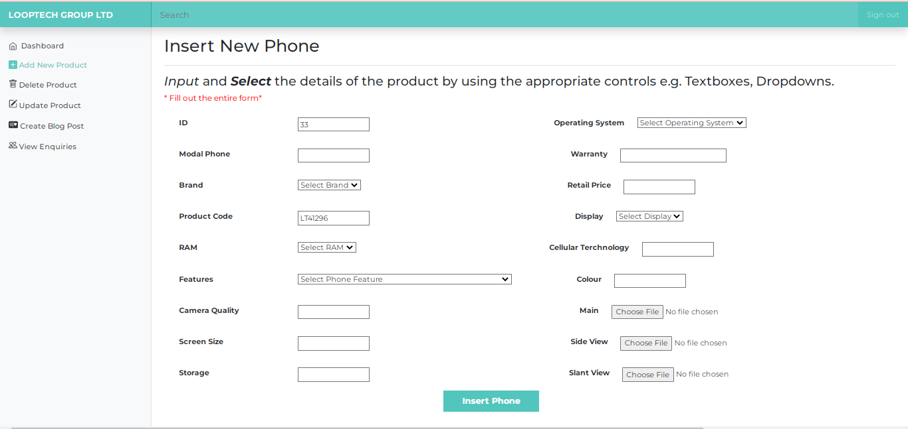

For All Insert pages the process is simple:

1. A auto generated id number e.g.32

including a auto generated Product Code

e.g. LT2182 which admin does not have to enter

1. Fill in the necessary Textboxes and Dropdown lists provided. **NB:** Fill out form first before selecting the images.
2. Click on the button to Insert a new product.