3soils_markdown

Kaizad Patel

This is the RMarkdown file for the 3Soils experiment. Tables and figures for molecular results. For formatted tables, see the Word document titled 000-3soils_markdown_YYYYMMDD.docx.

Run: 2019-10-29

# Soil characterization

## summary table

|  |  |  |  |
| --- | --- | --- | --- |
| variable | CPCRW | DWP | SR |
| TC_perc | 1.43 ± 0.21 b | 0.98 ± 0.1 b | 10.32 ± 0.45 a |
| TN_perc | 0.07 ± 0.01 b | 0.04 ± 0 b | 0.59 ± 0.01 a |
| TOC_perc | 1.43 ± 0.19 b | 0.88 ± 0.11 b | 9.94 ± 0.47 a |
| WSOC_mg_g | 1.04 ± 0.28 a | 1 ± 0.16 a | 0.67 ± 0.04 a |
| Ca_meq100g | 3.52 ± 0.41 b | 0.81 ± 0.11 c | 17.21 ± 0.75 a |
| Mg_meq100g | 1.08 ± 0.09 b | 0.26 ± 0.03 b | 7.56 ± 0.46 a |
| pH | 5.31 ± 0.17 b | 4.79 ± 0.11 c | 5.82 ± 0.05 a |
| EC_dS_m | 0.07 ± 0.01 a | 0.06 ± 0.01 a | NA |
| Sand_perc | 31.8 ± 7.47 b | 90.8 ± 1.74 a | 14 ± 2.12 b |
| Silt_perc | 53 ± 7.36 a | 3.8 ± 0.66 b | 58.5 ± 1.5 a |
| Clay_perc | 15.2 ± 0.37 b | 5.4 ± 1.29 c | 27.75 ± 1.65 a |

## pore distribution

## pore size distribution

## water retention curves

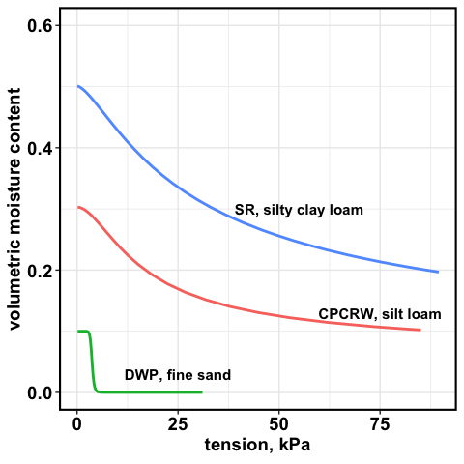

water retention curve

# WSOC tables

## soils

mg/g soil

|  |  |  |  |
| --- | --- | --- | --- |
| Treatment | CPCRW | DWP | SR |
| Drought | 0.85 ± 0.2 | 0.72 ± 0.37 | 0.6 ± 0.04 |
| Field Moist | 0.69 ± 0.07 | 0.35 ± 0.05 | 0.61 ± 0.05 |
| Saturated | 0.59 ± 0.05 | 0.39 ± 0.06 | 0.55 ± 0.06 |
| Time Zero | 0.78 ± 0.1 | 0.51 ± 0.08 | 0.43 ± 0.04 |

## pores

mg/g

|  |  |  |  |  |  |  |
| --- | --- | --- | --- | --- | --- | --- |
| Treatment | 1.5 kPa CPCRW | 1.5 kPa DWP | 1.5 kPa SR | 50 kPa CPCRW | 50 kPa DWP | 50 kPa SR |
| Drought | 25.81 ± 12.78 | NaN ± NA | 2.81 ± 0.55 | 3.45 ± 2.06 | NaN ± NA | 0.54 ± NA |
| Field Moist | 4.52 ± 1.73 | 4.02 ± NA | 4.03 ± 0.95 | 0.9 ± NA | 0.4 ± NA | 0.96 ± 0.27 |
| Saturated | 19.7 ± 6.62 | 5.94 ± 2.58 | 5.25 ± 0.84 | 1.05 ± 0.28 | 0.58 ± 0.26 | 1.4 ± NA |
| Time Zero | 5.1 ± 1.8 | 4.42 ± 1.98 | 1.46 ± NA | 1.05 ± 0.24 | 1.26 ± NA | NaN ± NA |

# FTICR Pores – figures

## native SOM

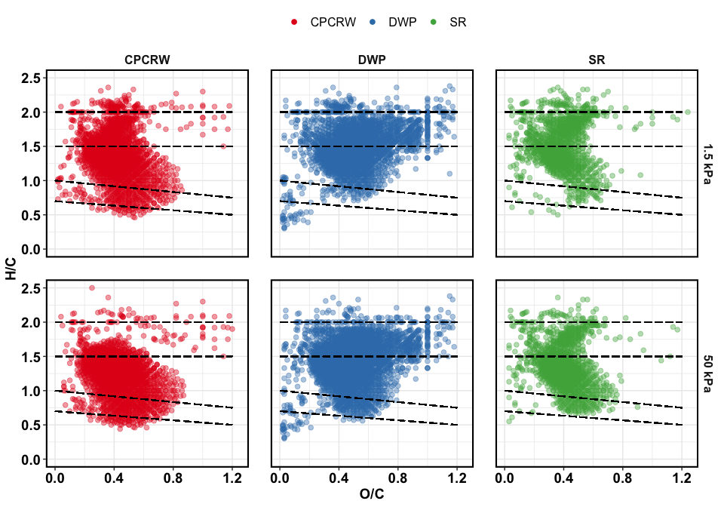

Van Krevelen plot for TZSat pores

## treatment effect – all peaks

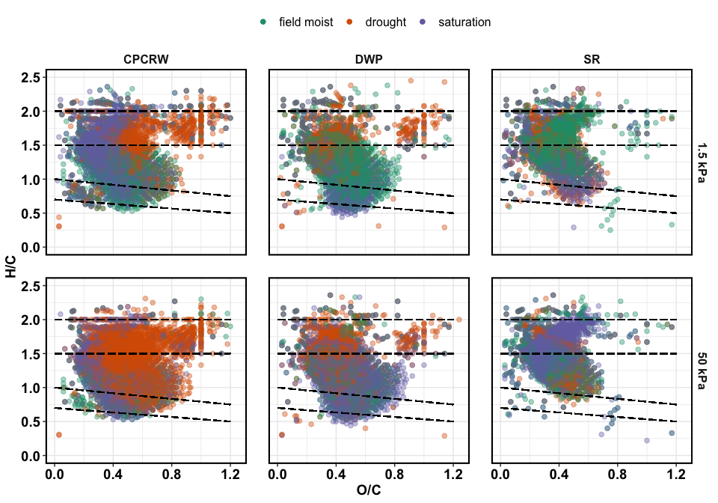

Van Krevelen plot for treatments

## treatment effect – unique peaks

unique in each treatment compared to all, including TZsaturation these are peaks that were uniquely **added** during a given treatment

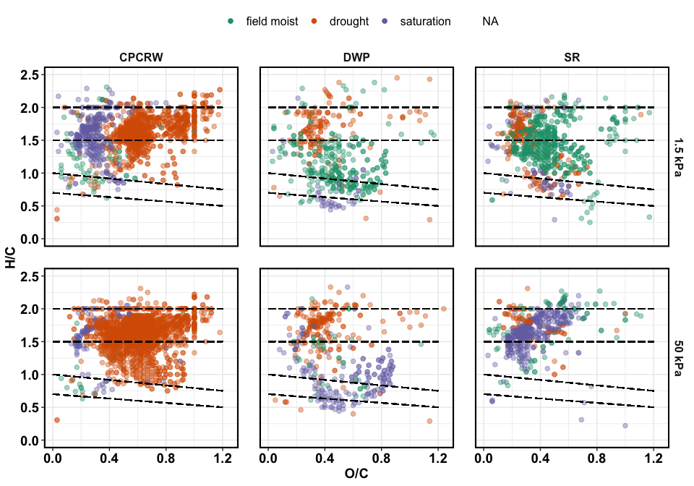

Van Krevelen plot for unique peaks

## treatment effect – relative abundance

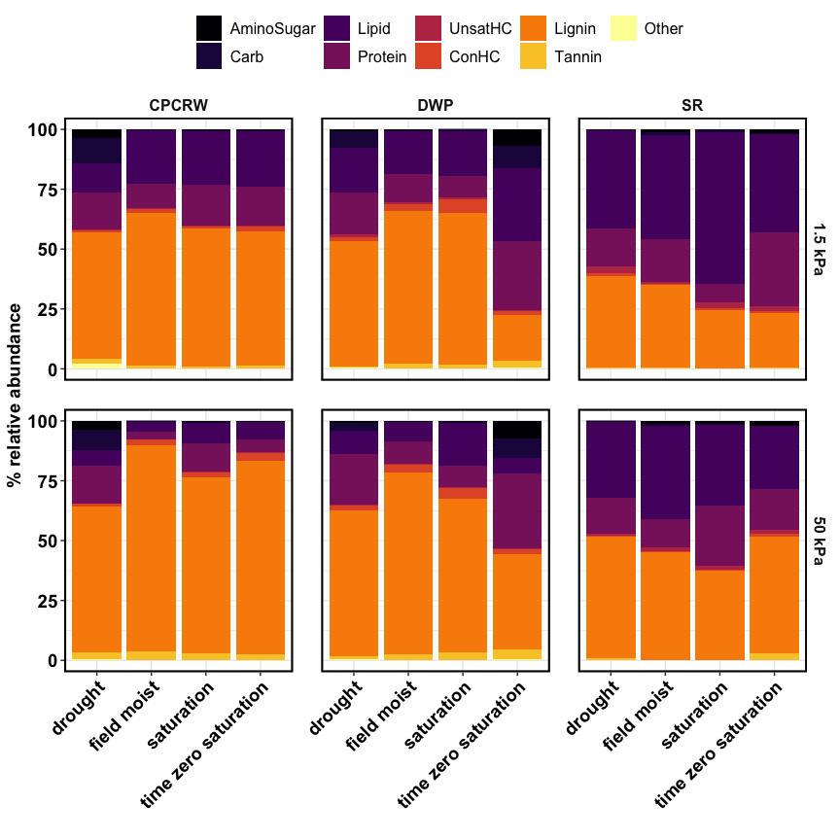

Relative abundance

## treatment effect – NOSC

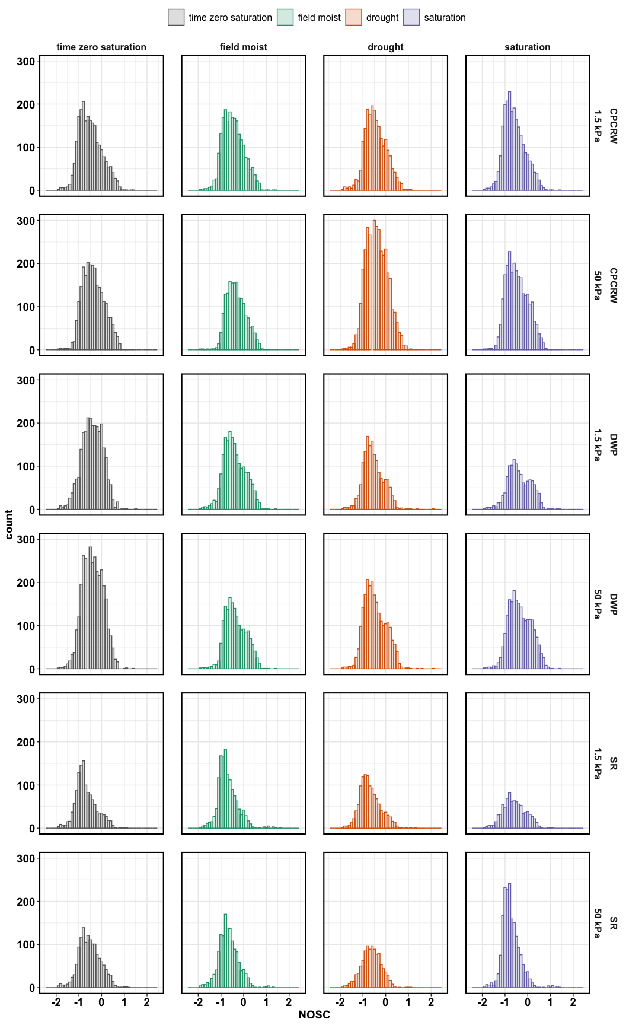

NOSC for CPCRW

## NOSC table

|  |  |  |  |  |  |
| --- | --- | --- | --- | --- | --- |
| tension | site | drought | field moist | saturation | time zero saturation |
| 1.5 kPa | CPCRW | -0.5000 | -0.5000 | -0.6429 | -0.5517 |
| 1.5 kPa | DWP | -0.6000 | -0.4615 | -0.4444 | -0.4000 |
| 1.5 kPa | SR | -0.7500 | -0.7742 | -0.6316 | -0.7710 |
| 50 kPa | CPCRW | -0.4286 | -0.3636 | -0.5185 | -0.4000 |
| 50 kPa | DWP | -0.5385 | -0.4189 | -0.4000 | -0.4167 |
| 50 kPa | SR | -0.6316 | -0.6957 | -0.8000 | -0.5600 |

## aromatic peaks

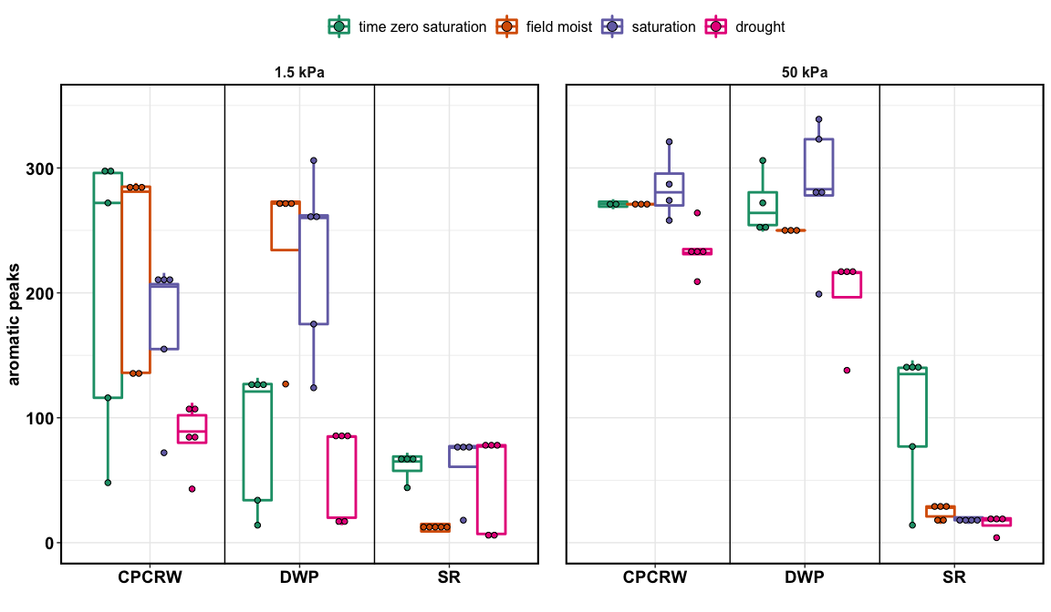

aromatic peaks

## shannon diversity index –

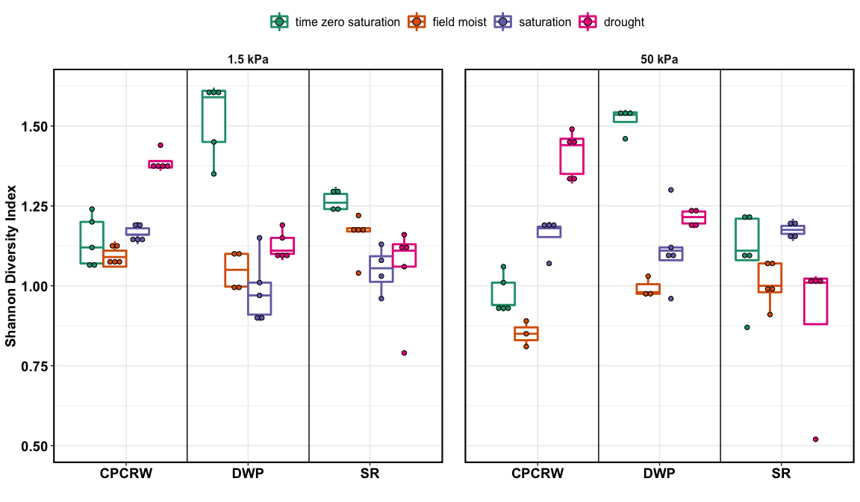

aromatic peaks

# FTICR Pores – tables

## peaks

## [1] "50 kPa"

|  |  |  |  |  |  |
| --- | --- | --- | --- | --- | --- |
| site | Class | drought | field moist | saturation | time zero saturation |
| CPCRW | AminoSugar | 381 | 13 | 38 | 28 |
| CPCRW | Carb | 434 | 14 | 84 | 30 |
| CPCRW | Lipid | 282 | 78 | 302 | 192 |
| CPCRW | Protein | 988 | 131 | 652 | 278 |
| CPCRW | UnsatHC | 4 | 9 | 3 | 11 |
| CPCRW | ConHC | 227 | 206 | 223 | 341 |
| CPCRW | Lignin | 2630 | 1950 | 2239 | 2296 |
| CPCRW | Tannin | 399 | 170 | 212 | 192 |
| CPCRW | Other | 21 | 10 | 2 | 12 |
| CPCRW | total | 5366 | 2581 | 3755 | 3380 |
| DWP | AminoSugar | 56 | 30 | 37 | 473 |
| DWP | Carb | 116 | 8 | 41 | 441 |
| DWP | Lipid | 246 | 112 | 196 | 268 |
| DWP | Protein | 777 | 332 | 431 | 1028 |
| DWP | UnsatHC | 6 | 3 | 10 | 20 |
| DWP | ConHC | 175 | 214 | 284 | 237 |
| DWP | Lignin | 2084 | 1969 | 2118 | 2443 |
| DWP | Tannin | 124 | 167 | 243 | 298 |
| DWP | Other | 13 | 2 | 3 | 35 |
| DWP | total | 3597 | 2837 | 3363 | 5243 |
| SR | AminoSugar | 8 | 48 | 88 | 72 |
| SR | Carb | 8 | 27 | 16 | 7 |
| SR | Lipid | 255 | 295 | 397 | 186 |
| SR | Protein | 466 | 425 | 862 | 572 |
| SR | UnsatHC | 5 | 20 | 18 | 21 |
| SR | ConHC | 13 | 15 | 17 | 123 |
| SR | Lignin | 1316 | 1521 | 1483 | 1790 |
| SR | Tannin | 28 | 11 | 12 | 201 |
| SR | Other | 2 | 5 | 4 | 3 |
| SR | total | 2101 | 2367 | 2897 | 2975 |

## [1] "1.5 kPa"

|  |  |  |  |  |  |
| --- | --- | --- | --- | --- | --- |
| site | Class | drought | field moist | saturation | time zero saturation |
| CPCRW | AminoSugar | 270 | 25 | 40 | 53 |
| CPCRW | Carb | 316 | 34 | 42 | 23 |
| CPCRW | Lipid | 184 | 207 | 377 | 249 |
| CPCRW | Protein | 755 | 478 | 771 | 779 |
| CPCRW | UnsatHC | 4 | 17 | 15 | 19 |
| CPCRW | ConHC | 92 | 207 | 146 | 243 |
| CPCRW | Lignin | 1882 | 1994 | 1985 | 1934 |
| CPCRW | Tannin | 193 | 145 | 95 | 144 |
| CPCRW | Other | 42 | 10 | 12 | 8 |
| CPCRW | total | 3738 | 3117 | 3483 | 3452 |
| DWP | AminoSugar | 40 | 31 | 6 | 434 |
| DWP | Carb | 120 | 11 | 18 | 477 |
| DWP | Lipid | 197 | 184 | 124 | 207 |
| DWP | Protein | 536 | 406 | 218 | 902 |
| DWP | UnsatHC | 5 | 10 | 8 | 19 |
| DWP | ConHC | 58 | 236 | 221 | 82 |
| DWP | Lignin | 1567 | 2023 | 1581 | 1827 |
| DWP | Tannin | 24 | 153 | 94 | 208 |
| DWP | Other | 17 | 7 | 3 | 41 |
| DWP | total | 2564 | 3061 | 2273 | 4197 |
| SR | AminoSugar | 27 | 79 | 25 | 65 |
| SR | Carb | 4 | 43 | 15 | 16 |
| SR | Lipid | 325 | 277 | 180 | 233 |
| SR | Protein | 494 | 770 | 208 | 683 |
| SR | UnsatHC | 15 | 14 | 25 | 22 |
| SR | ConHC | 46 | 15 | 52 | 57 |
| SR | Lignin | 1249 | 1433 | 1045 | 1090 |
| SR | Tannin | 15 | 39 | 11 | 15 |
| SR | Other | 3 | 6 | NA | 5 |
| SR | total | 2178 | 2676 | 1561 | 2186 |

## unique peaks

## [1] "50 kPa"

|  |  |  |  |  |
| --- | --- | --- | --- | --- |
| site | Class | drought | field moist | saturation |
| CPCRW | AminoSugar | 347 | NA | 3 |
| CPCRW | Carb | 347 | 1 | NA |
| CPCRW | Lipid | 40 | 1 | 49 |
| CPCRW | Protein | 373 | NA | 34 |
| CPCRW | UnsatHC | NA | 2 | NA |
| CPCRW | ConHC | 9 | 5 | 4 |
| CPCRW | Lignin | 380 | 10 | 33 |
| CPCRW | Tannin | 168 | NA | 7 |
| CPCRW | Other | 16 | NA | NA |
| DWP | AminoSugar | 9 | 2 | 3 |
| DWP | Carb | 9 | NA | NA |
| DWP | Lipid | 27 | 1 | 18 |
| DWP | Protein | 110 | 8 | 5 |
| DWP | UnsatHC | NA | NA | 2 |
| DWP | ConHC | 7 | 7 | 62 |
| DWP | Lignin | 36 | 20 | 45 |
| DWP | Tannin | 2 | 2 | 55 |
| DWP | Other | 5 | NA | NA |
| SR | AminoSugar | 2 | 16 | 24 |
| SR | Carb | 2 | 14 | 1 |
| SR | Lipid | 47 | 16 | 92 |
| SR | Protein | 26 | 24 | 153 |
| SR | UnsatHC | NA | 3 | 2 |
| SR | ConHC | NA | NA | 5 |
| SR | Lignin | 6 | 20 | 77 |
| SR | Tannin | NA | NA | 2 |
| SR | Other | NA | 2 | 2 |

## [1] "1.5 kPa"

|  |  |  |  |  |
| --- | --- | --- | --- | --- |
| site | Class | drought | field moist | saturation |
| CPCRW | AminoSugar | 236 | NA | 4 |
| CPCRW | Carb | 279 | 3 | 3 |
| CPCRW | Lipid | 10 | 7 | 129 |
| CPCRW | Protein | 156 | 6 | 76 |
| CPCRW | UnsatHC | NA | 7 | 3 |
| CPCRW | ConHC | 7 | 3 | 3 |
| CPCRW | Lignin | 195 | 45 | 109 |
| CPCRW | Tannin | 48 | NA | NA |
| CPCRW | Other | 30 | NA | NA |
| DWP | AminoSugar | 9 | 9 | NA |
| DWP | Carb | 6 | 3 | NA |
| DWP | Lipid | 31 | 17 | 4 |
| DWP | Protein | 56 | 12 | NA |
| DWP | UnsatHC | NA | 5 | 3 |
| DWP | ConHC | 4 | 45 | 28 |
| DWP | Lignin | 31 | 174 | 5 |
| DWP | Tannin | 1 | 38 | 1 |
| DWP | Other | 6 | 4 | NA |
| SR | AminoSugar | NA | 22 | 3 |
| SR | Carb | NA | 28 | 1 |
| SR | Lipid | 85 | 23 | 9 |
| SR | Protein | 24 | 128 | 10 |
| SR | UnsatHC | NA | NA | 6 |
| SR | ConHC | 13 | 11 | 16 |
| SR | Lignin | 76 | 249 | 23 |
| SR | Tannin | 5 | 25 | NA |
| SR | Other | 1 | 5 | NA |

## relative abundance

## [1] "50 kPa"

|  |  |  |  |  |  |
| --- | --- | --- | --- | --- | --- |
| site | Class | drought | field moist | saturation | time zero saturation |
| CPCRW | AminoSugar | 3.8 ± 0.77 * | 0.17 ± 0.01 | 0.36 ± 0.05 | 0.25 ± 0.02 |
| CPCRW | Carb | 8.51 ± 1.71 * | 0.17 ± 0.01 | 0.64 ± 0.2 | 0.24 ± 0.03 |
| CPCRW | Lipid | 6.59 ± 0.94 | 4.05 ± 1.43 | 8.44 ± 1.34 | 7.3 ± 1.6 |
| CPCRW | Protein | 15.69 ± 1.82 * | 3.26 ± 0.17 | 11.86 ± 0.86 * | 5.36 ± 0.61 |
| CPCRW | UnsatHC | 0.05 ± 0.02 | 0.18 ± 0.02 | 0.3 ± 0.22 | 0.36 ± 0.17 |
| CPCRW | ConHC | 1.26 ± 0.3 * | 2.21 ± 0.39 | 2.06 ± 0.35 | 3.34 ± 0.83 |
| CPCRW | Lignin | 60.67 ± 3.02 * | 86.41 ± 0.58 | 73.54 ± 1.48 | 80.73 ± 2.03 |
| CPCRW | Tannin | 3.02 ± 0.46 | 3.47 ± 1 | 2.78 ± 0.62 | 2.35 ± 0.35 |
| CPCRW | Other | 0.41 ± 0.1 | 0.09 ± 0.01 | 0.02 ± 0 | 0.08 ± 0.02 |
| DWP | AminoSugar | 1.03 ± 0.36 * | 0.47 ± 0.05 * | 0.35 ± 0.07 * | 7.45 ± 1.35 |
| DWP | Carb | 2.98 ± 0.83 * | 0.17 ± 0.01 * | 0.58 ± 0.11 * | 7.89 ± 1.05 |
| DWP | Lipid | 9.91 ± 0.98 | 8 ± 0.95 | 17.75 ± 10.67 | 6.64 ± 2.42 |
| DWP | Protein | 20.92 ± 2.06 * | 9.26 ± 1.81 * | 8.88 ± 1.35 * | 31.04 ± 3.95 |
| DWP | UnsatHC | 0.41 ± 0.18 | 0.44 ± 0.16 | 0.64 ± 0.3 | 0.7 ± 0.19 |
| DWP | ConHC | 1.97 ± 0.3 | 3.29 ± 0.79 | 4.12 ± 0.93 | 2.07 ± 0.23 |
| DWP | Lignin | 61.25 ± 2.21 | 75.83 ± 2.11 * | 64.4 ± 9.69 * | 39.58 ± 4.05 |
| DWP | Tannin | 1.2 ± 0.18 * | 2.48 ± 0.4 | 3.22 ± 0.8 | 4.19 ± 0.28 |
| DWP | Other | 0.34 ± 0.06 | 0.06 ± 0.01 | 0.06 ± 0.01 | 0.42 ± 0.05 |
| SR | AminoSugar | 0.17 ± 0.05 | 1.11 ± 0.24 | 1.19 ± 0.24 | 1.88 ± 1.14 |
| SR | Carb | 0.16 ± 0.03 | 0.83 ± 0.43 | 0.31 ± 0.04 | 0.12 ± 0.02 |
| SR | Lipid | 31.72 ± 6.96 | 39.07 ± 7.29 | 33.84 ± 6.11 | 26.53 ± 8.04 |
| SR | Protein | 14.94 ± 4.23 | 11.87 ± 1.93 | 25.29 ± 3.41 | 16.96 ± 6.27 |
| SR | UnsatHC | 0.95 ± 0.42 | 1.53 ± 0.24 | 1.33 ± 0.25 | 1.48 ± 0.51 |
| SR | ConHC | 0.44 ± 0.16 | 0.31 ± 0.09 * | 0.77 ± 0.27 | 1.38 ± 0.4 |
| SR | Lignin | 50.71 ± 8.36 | 45.05 ± 6.22 | 37.07 ± 3.27 | 48.73 ± 8.87 |
| SR | Tannin | 0.82 ± 0.64 | 0.15 ± 0.04 | 0.14 ± 0.03 | 2.81 ± 2.17 |
| SR | Other | 0.08 ± 0.03 | 0.08 ± 0.02 | 0.06 ± 0.02 | 0.11 ± 0.03 |

total = 100%

## [1] "1.5 kPa"

|  |  |  |  |  |  |
| --- | --- | --- | --- | --- | --- |
| site | Class | drought | field moist | saturation | time zero saturation |
| CPCRW | AminoSugar | 3.7 ± 0.53 * | 0.22 ± 0.04 | 0.35 ± 0.08 | 0.57 ± 0.09 |
| CPCRW | Carb | 10.63 ± 1.96 * | 0.29 ± 0.04 | 0.32 ± 0.04 | 0.26 ± 0.05 |
| CPCRW | Lipid | 11.96 ± 5.29 | 22.39 ± 8.25 | 22.31 ± 2.6 | 23.02 ± 4.21 |
| CPCRW | Protein | 15.66 ± 1.75 | 9.9 ± 1.12 | 17.09 ± 1.87 | 16.19 ± 2.42 |
| CPCRW | UnsatHC | 0.08 ± 0.02 * | 0.36 ± 0.05 | 0.37 ± 0.1 | 0.55 ± 0.13 |
| CPCRW | ConHC | 0.88 ± 0.2 | 1.79 ± 0.19 | 1.14 ± 0.33 | 2.02 ± 0.55 |
| CPCRW | Lignin | 52.93 ± 6.47 | 63.51 ± 9.14 | 57.52 ± 3.1 | 55.91 ± 5.53 |
| CPCRW | Tannin | 2.1 ± 0.58 | 1.49 ± 0.17 | 0.82 ± 0.18 | 1.45 ± 0.22 |
| CPCRW | Other | 2.06 ± 1.42 | 0.07 ± 0.02 | 0.07 ± 0.01 | 0.05 ± 0.01 |
| DWP | AminoSugar | 0.75 ± 0.13 * | 0.42 ± 0.08 * | 0.16 ± 0.05 * | 6.76 ± 2.17 |
| DWP | Carb | 6.74 ± 1.18 | 0.18 ± 0.02 * | 0.57 ± 0.2 * | 9.49 ± 2.97 |
| DWP | Lipid | 18.92 ± 2.29 | 18.1 ± 1.86 | 18.61 ± 5.48 | 30.52 ± 13.53 |
| DWP | Protein | 17.6 ± 1.8 * | 11.8 ± 1.51 * | 9.03 ± 1.94 * | 28.68 ± 3.3 |
| DWP | UnsatHC | 1.01 ± 0.75 | 0.84 ± 0.21 | 0.92 ± 0.17 | 0.65 ± 0.11 |
| DWP | ConHC | 1.56 ± 0.18 | 2.85 ± 0.79 | 5.65 ± 0.93 * | 1.23 ± 0.41 |
| DWP | Lignin | 52.45 ± 3.58 * | 63.65 ± 2.05 * | 63.14 ± 7.03 * | 19.43 ± 4.33 |
| DWP | Tannin | 0.3 ± 0.07 * | 2.06 ± 0.22 | 1.83 ± 0.71 | 2.67 ± 0.86 |
| DWP | Other | 0.67 ± 0.11 | 0.11 ± 0.02 | 0.09 ± 0.02 | 0.57 ± 0.18 |
| SR | AminoSugar | 0.5 ± 0.18 | 1.26 ± 0.38 | 0.55 ± 0.12 | 1.42 ± 0.22 |
| SR | Carb | 0.08 ± 0.01 | 1.29 ± 0.42 | 0.74 ± 0.27 | 0.49 ± 0.08 |
| SR | Lipid | 40.67 ± 2.64 | 43.33 ± 12.28 | 63.21 ± 4.55 | 41.29 ± 5.71 |
| SR | Protein | 15.92 ± 1.43 * | 17.72 ± 4.95 | 7.8 ± 1.08 * | 30.86 ± 5.27 |
| SR | UnsatHC | 2.99 ± 1.02 | 0.88 ± 0.15 | 2.43 ± 0.54 | 1.82 ± 0.56 |
| SR | ConHC | 1.09 ± 0.25 | 0.46 ± 0.21 | 0.65 ± 0.19 | 0.98 ± 0.19 |
| SR | Lignin | 38.42 ± 2.77 | 34.52 ± 11.07 | 24.5 ± 3.72 | 22.75 ± 0.89 |
| SR | Tannin | 0.21 ± 0.07 | 0.46 ± 0.17 | 0.12 ± 0.04 | 0.2 ± 0.05 |
| SR | Other | 0.15 ± 0.06 | 0.07 ± 0.01 | NA | 0.21 ± 0.08 |

total = 100%

# FTICR Soil – figures

## native SOM

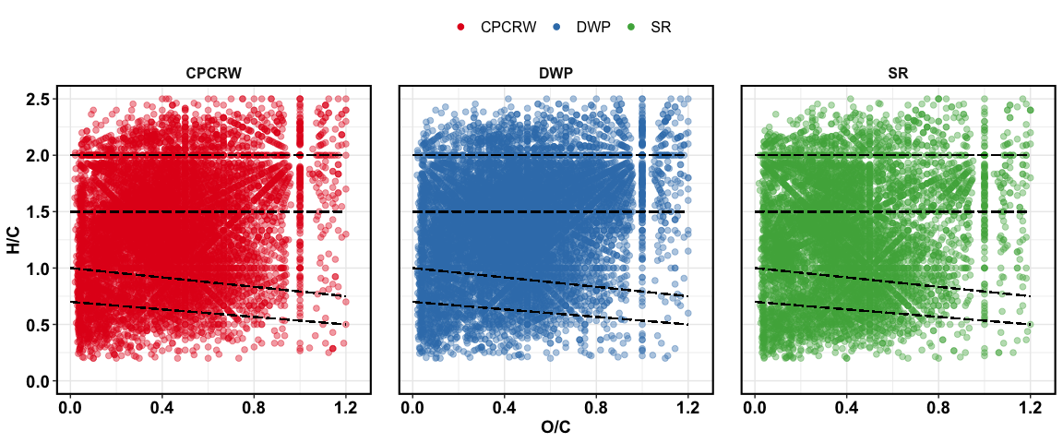

Van Krevelen plot for baseline soil

## treatment effect – all peaks

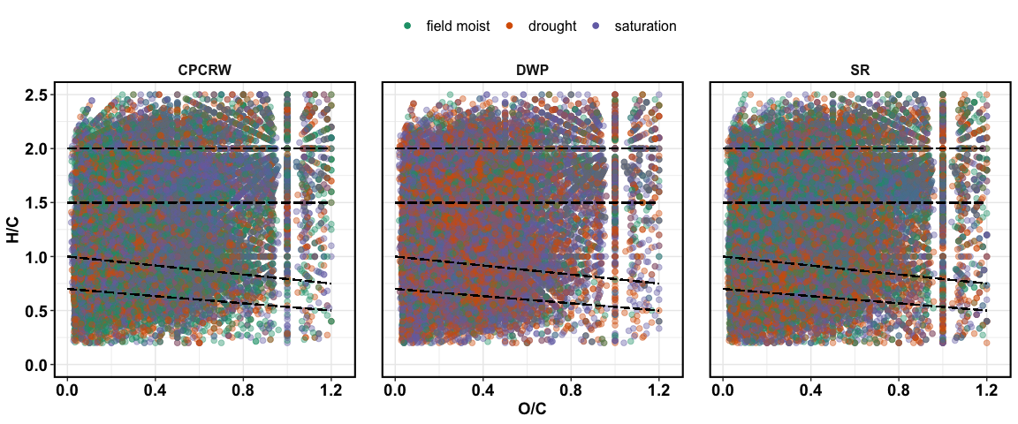

Van Krevelen plot for treatments

## treatment effect – unique peaks

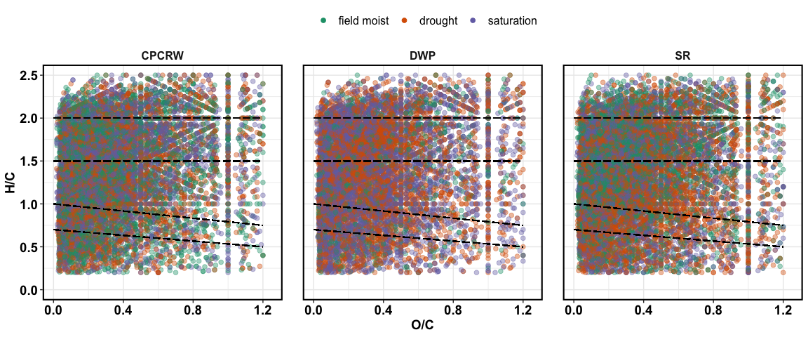

Van Krevelen plot for unique peaks

## treatment effect – relative abundance

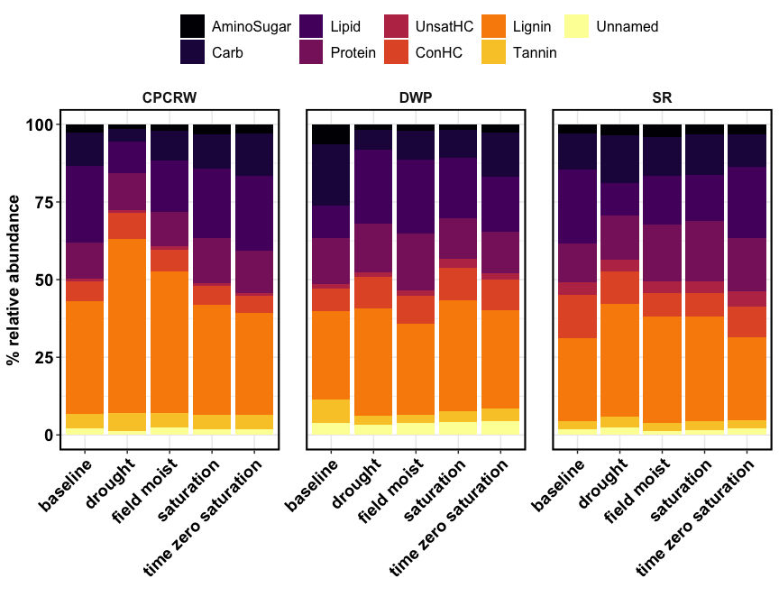

Relative abundance

## NOSC

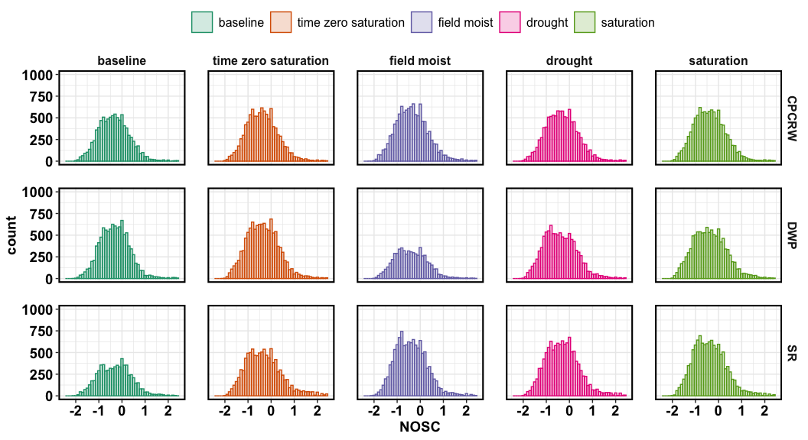

NOSC for CPCRW

## NOSC table

|  |  |  |  |  |  |
| --- | --- | --- | --- | --- | --- |
| site | baseline | drought | field moist | saturation | time zero saturation |
| CPCRW | -0.3636 | -0.3529 | -0.3846 | -0.4211 | -0.4000 |
| DWP | -0.3200 | -0.4545 | -0.4444 | -0.4211 | -0.3871 |
| SR | -0.2963 | -0.3333 | -0.4444 | -0.4286 | -0.3750 |

## aromatic peaks

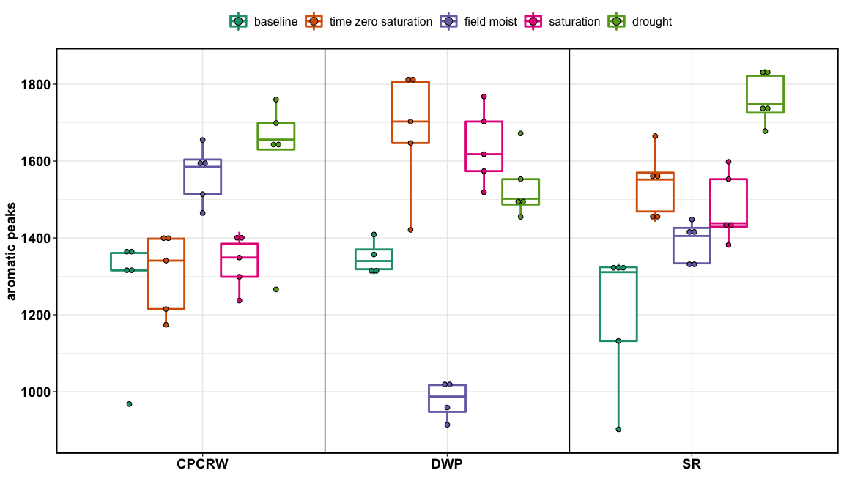

aromatic peaks

# FTICR Soil – tables

## relative abundance

|  |  |  |  |  |  |  |
| --- | --- | --- | --- | --- | --- | --- |
| site | Class | baseline | drought | field moist | saturation | time zero saturation |
| CPCRW | AminoSugar | 2.69 ± 0.32 | 1.48 ± 0.12 | 2.19 ± 0.48 | 3.37 ± 0.34 | 2.94 ± 0.35 |
| CPCRW | Carb | 10.82 ± 1.88 | 4.17 ± 0.92 * | 9.6 ± 2.33 | 10.78 ± 1.06 | 13.53 ± 1.87 |
| CPCRW | Lipid | 24.65 ± 3.11 | 10.11 ± 1.93 * | 16.35 ± 3.94 | 22.37 ± 0.85 | 24.32 ± 3.62 |
| CPCRW | Protein | 11.59 ± 1 | 11.91 ± 1.2 | 11.18 ± 0.5 | 14.69 ± 1.18 | 13.63 ± 1.63 |
| CPCRW | UnsatHC | 0.69 ± 0.07 | 0.84 ± 0.09 | 1 ± 0.12 | 0.93 ± 0.08 | 0.83 ± 0.06 |
| CPCRW | ConHC | 6.45 ± 0.92 | 8.29 ± 1.21 | 7.07 ± 0.6 | 6.01 ± 0.53 | 5.46 ± 0.63 |
| CPCRW | Lignin | 36.24 ± 0.71 | 56.17 ± 3.13 * | 45.5 ± 5.07 | 35.47 ± 1.45 | 32.94 ± 2.75 |
| CPCRW | Tannin | 4.79 ± 0.45 | 5.92 ± 0.29 | 4.61 ± 0.52 | 4.57 ± 0.25 | 4.44 ± 0.94 |
| CPCRW | Unnamed | 2.08 ± 0.34 | 1.12 ± 0.07 | 2.5 ± 0.42 | 1.8 ± 0.23 | 1.91 ± 0.18 |
| DWP | AminoSugar | 6.49 ± 0.45 | 1.82 ± 0.18 * | 2.05 ± 0.13 * | 1.74 ± 0.2 * | 2.75 ± 0.24 |
| DWP | Carb | 19.77 ± 0.65 | 6.38 ± 0.94 * | 9.32 ± 0.53 * | 9 ± 1.02 * | 14.22 ± 1.66 |
| DWP | Lipid | 10.43 ± 0.35 | 23.73 ± 2.62 * | 23.71 ± 2.24 * | 19.37 ± 2.09 | 17.52 ± 3.12 |
| DWP | Protein | 14.6 ± 1.09 | 15.61 ± 0.61 | 18.52 ± 1.89 | 13.29 ± 1.26 | 13.4 ± 0.76 |
| DWP | UnsatHC | 1.53 ± 0.29 | 1.54 ± 0.24 | 1.57 ± 0.16 | 2.74 ± 0.41 * | 2.05 ± 0.33 |
| DWP | ConHC | 7.27 ± 0.47 | 10.05 ± 0.47 | 9.14 ± 0.97 | 10.54 ± 1.27 * | 9.77 ± 0.37 |
| DWP | Lignin | 28.57 ± 1.26 | 34.54 ± 1.86 | 29.34 ± 2.83 | 35.62 ± 2.3 | 31.76 ± 4.2 |
| DWP | Tannin | 7.43 ± 0.33 | 3.11 ± 0.47 * | 2.58 ± 0.7 * | 3.52 ± 0.41 * | 4.06 ± 0.23 |
| DWP | Unnamed | 3.92 ± 0.08 | 3.21 ± 0.33 | 3.77 ± 0.18 | 4.18 ± 0.1 | 4.47 ± 0.5 |
| SR | AminoSugar | 2.82 ± 0.26 | 3.45 ± 0.32 | 4.16 ± 0.16 * | 3.37 ± 0.1 | 3.16 ± 0.27 |
| SR | Carb | 11.72 ± 1.38 | 15.55 ± 1.14 * | 12.38 ± 0.83 | 12.8 ± 0.78 | 10.39 ± 0.75 |
| SR | Lipid | 23.96 ± 3.3 | 10.45 ± 1.02 * | 15.64 ± 1.3 * | 15.05 ± 0.78 * | 23.02 ± 3.09 |
| SR | Protein | 12.49 ± 1.39 | 14.27 ± 1.97 | 18.22 ± 2.84 | 19.2 ± 1.84 | 17.12 ± 1.06 |
| SR | UnsatHC | 4 ± 0.29 | 3.61 ± 0.74 | 4 ± 0.33 | 4 ± 0.8 | 5 ± 0.73 |
| SR | ConHC | 13.77 ± 0.89 | 10.45 ± 0.75 | 7.44 ± 1.61 * | 7.59 ± 1.09 * | 9.72 ± 0.69 |
| SR | Lignin | 26.8 ± 2.15 | 36.4 ± 2.72 * | 34.19 ± 1.33 * | 33.55 ± 1.68 | 26.88 ± 1.05 |
| SR | Tannin | 2.74 ± 0.26 | 3.33 ± 0.46 | 2.64 ± 0.26 | 2.94 ± 0.22 | 2.68 ± 0.15 |
| SR | Unnamed | 1.72 ± 0.12 | 2.48 ± 0.14 * | 1.33 ± 0.13 | 1.49 ± 0.2 | 2.03 ± 0.2 |

## peaks

|  |  |  |  |  |  |  |
| --- | --- | --- | --- | --- | --- | --- |
| site | Class | baseline | drought | field moist | saturation | time zero saturation |
| CPCRW | AminoSugar | 495 | 431 | 523 | 587 | 540 |
| CPCRW | Carb | 554 | 472 | 603 | 675 | 655 |
| CPCRW | Lipid | 914 | 1056 | 1304 | 1353 | 1226 |
| CPCRW | Protein | 1313 | 1366 | 1528 | 1627 | 1527 |
| CPCRW | UnsatHC | 427 | 608 | 618 | 577 | 544 |
| CPCRW | ConHC | 1358 | 1684 | 1711 | 1379 | 1376 |
| CPCRW | Lignin | 3032 | 3414 | 3596 | 3237 | 3156 |
| CPCRW | Tannin | 587 | 603 | 598 | 585 | 563 |
| CPCRW | Unnamed | 385 | 428 | 463 | 436 | 391 |
| CPCRW | total | 9065 | 10062 | 10944 | 10456 | 9978 |
| DWP | AminoSugar | 742 | 435 | 291 | 448 | 615 |
| DWP | Carb | 994 | 476 | 369 | 589 | 774 |
| DWP | Lipid | 990 | 1462 | 841 | 1555 | 1447 |
| DWP | Protein | 1480 | 1653 | 982 | 1458 | 1615 |
| DWP | UnsatHC | 461 | 632 | 308 | 716 | 683 |
| DWP | ConHC | 1272 | 1649 | 923 | 1787 | 1839 |
| DWP | Lignin | 3215 | 3088 | 1868 | 3191 | 3551 |
| DWP | Tannin | 706 | 425 | 259 | 523 | 596 |
| DWP | Unnamed | 406 | 415 | 223 | 454 | 486 |
| DWP | total | 10266 | 10235 | 6064 | 10721 | 11606 |
| SR | AminoSugar | 247 | 552 | 625 | 607 | 427 |
| SR | Carb | 373 | 631 | 776 | 755 | 495 |
| SR | Lipid | 835 | 1220 | 1546 | 1505 | 1316 |
| SR | Protein | 836 | 1618 | 1725 | 1782 | 1406 |
| SR | UnsatHC | 410 | 651 | 767 | 770 | 687 |
| SR | ConHC | 1368 | 2000 | 1503 | 1621 | 1737 |
| SR | Lignin | 2111 | 3758 | 3702 | 3651 | 2951 |
| SR | Tannin | 362 | 607 | 536 | 547 | 510 |
| SR | Unnamed | 252 | 504 | 448 | 461 | 481 |
| SR | total | 6794 | 11541 | 11628 | 11699 | 10010 |

## unique peaks

|  |  |  |  |  |
| --- | --- | --- | --- | --- |
| site | Class | drought | field moist | saturation |
| CPCRW | AminoSugar | 153 | 161 | 166 |
| CPCRW | Carb | 150 | 190 | 209 |
| CPCRW | Lipid | 513 | 659 | 674 |
| CPCRW | Protein | 469 | 484 | 552 |
| CPCRW | UnsatHC | 289 | 284 | 298 |
| CPCRW | ConHC | 634 | 650 | 440 |
| CPCRW | Lignin | 965 | 1012 | 844 |
| CPCRW | Tannin | 157 | 147 | 149 |
| CPCRW | Unnamed | 202 | 221 | 210 |
| DWP | AminoSugar | 147 | 72 | 140 |
| DWP | Carb | 125 | 71 | 184 |
| DWP | Lipid | 734 | 271 | 832 |
| DWP | Protein | 627 | 194 | 515 |
| DWP | UnsatHC | 329 | 123 | 386 |
| DWP | ConHC | 620 | 236 | 735 |
| DWP | Lignin | 962 | 323 | 1043 |
| DWP | Tannin | 151 | 58 | 189 |
| DWP | Unnamed | 222 | 84 | 251 |
| SR | AminoSugar | 196 | 171 | 172 |
| SR | Carb | 211 | 184 | 168 |
| SR | Lipid | 541 | 690 | 647 |
| SR | Protein | 517 | 522 | 521 |
| SR | UnsatHC | 257 | 319 | 332 |
| SR | ConHC | 851 | 511 | 632 |
| SR | Lignin | 1110 | 966 | 964 |
| SR | Tannin | 246 | 147 | 175 |
| SR | Unnamed | 253 | 211 | 221 |