3soils_markdown

Kaizad Patel

10/10/2019

# Soil characterization

## summary table

|  |  |  |  |
| --- | --- | --- | --- |
|  | **CPCRW** | **DWP** | **SR** |
| TC_perc | 1.43 ± 0.21 b | 0.98 ± 0.1 b | 10.32 ± 0.45 a |
| TN_perc | 0.07 ± 0.01 b | 0.04 ± 0 b | 0.59 ± 0.01 a |
| TOC_perc | 1.43 ± 0.19 b | 0.88 ± 0.11 b | 9.94 ± 0.47 a |
| WSOC_mg_g | 1.04 ± 0.28 a | 1 ± 0.16 a | 0.67 ± 0.04 a |
|  |  |  |  |
| Ca_meq100g | 3.52 ± 0.41 b | 0.81 ± 0.11 c | 17.21 ± 0.75 a |
| Mg_meq100g | 1.08 ± 0.09 b | 0.26 ± 0.03 b | 7.56 ± 0.46 a |
| pH | 5.31 ± 0.17 b | 4.79 ± 0.11 c | 5.82 ± 0.05 a |
| EC_dS_m | 0.07 ± 0.01 a | 0.06 ± 0.01 a | - |
|  |  |  |  |
| Sand_perc | 31.8 ± 7.47 b | 90.8 ± 1.74 a | 14 ± 2.12 b |
| Silt_perc | 53 ± 7.36 a | 3.8 ± 0.66 b | 58.5 ± 1.5 a |
| Clay_perc | 15.2 ± 0.37 b | 5.4 ± 1.29 c | 27.75 ± 1.65 a |
| texture | Silt loam | Sand | Silty clay loam |

## pore distribution

## pore size distribution

## water retention curves

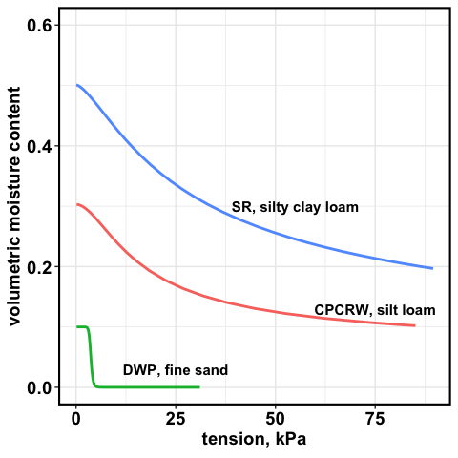

water retention curve

# WSOC tables

## soils

mg/g soil

|  |  |  |  |
| --- | --- | --- | --- |
|  | **CPCRW** | **DWP** | **SR** |
| Drought | 0.85 ± 0.2 a | 0.72 ± 0.37 a | 0.6 ± 0.04 a |
| Field Moist | 0.69 ± 0.07 a | 0.35 ± 0.05 a | 0.61 ± 0.05 a |
| Saturated | 0.59 ± 0.05 a | 0.39 ± 0.06 a | 0.55 ± 0.06 a |
| Time Zero | 0.78 ± 0.1 a | 0.51 ± 0.08 a | 0.43 ± 0.04 a |

## 

## pores

mg/L

|  |  |  |  |  |  |  |
| --- | --- | --- | --- | --- | --- | --- |
|  | **1.5 kPa** | | | **50 kPa** | | |
|  | **CPCRW** | **DWP** | **SR** | **CPCRW** | **DWP** | **SR** |
| Drought | 111.82 ± 41.45 a | 69.02 ± 13 a | 13.9 ± 2.43 ab | 186.86 ± 62.65 a | 69.97 ± 13.39 a | 19.3 ± 8.32 ab |
| Field Moist | 21.22 ± 3.73 b | 46.33 ± 11.94 a | 18.68 ± 2.36 a | 41.17 ± 12.67 ab | 52.43 ± 14.74 a | 19.82 ± 2.93 ab |
| Saturated | 52.82 ± 13.98 ab | 42.08 ± 7.34 a | 23.16 ± 3.29 a | 63.4 ± 20.84 ab | 82.7 ± 16.52 a | 24.07 ± 2.43 a |
| Time Zero | 26.3 ± 2.78 ab | 76.68 ± 21.76 a | 6.03 ± 0.57 b | 29.14 ± 4.41 b | 92.33 ± 22.22 a | 7.28 ± 0.34 b |

## 

## soils, pores combined

*need pore water volume collected*

# FTICR Pores – figures

## native SOM

## Van Krevelen plot for TZSat pores

## treatment effect – all peaks

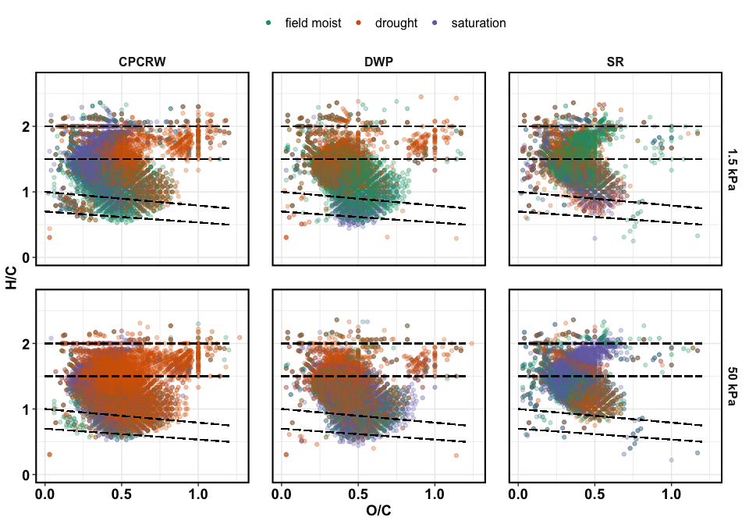

## treatment effect – unique peaks

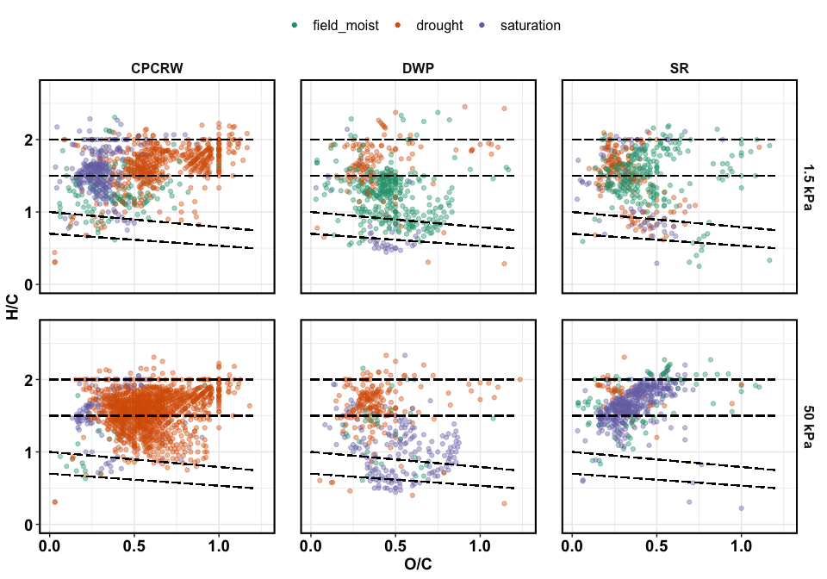

## treatment effect – relative abundance

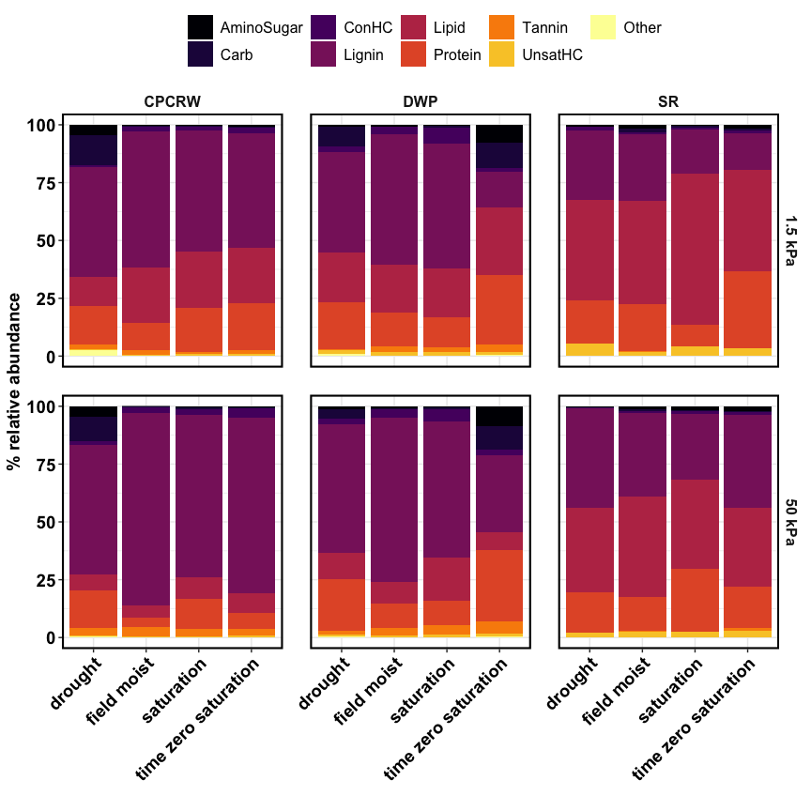

## treatment effect – NOSC

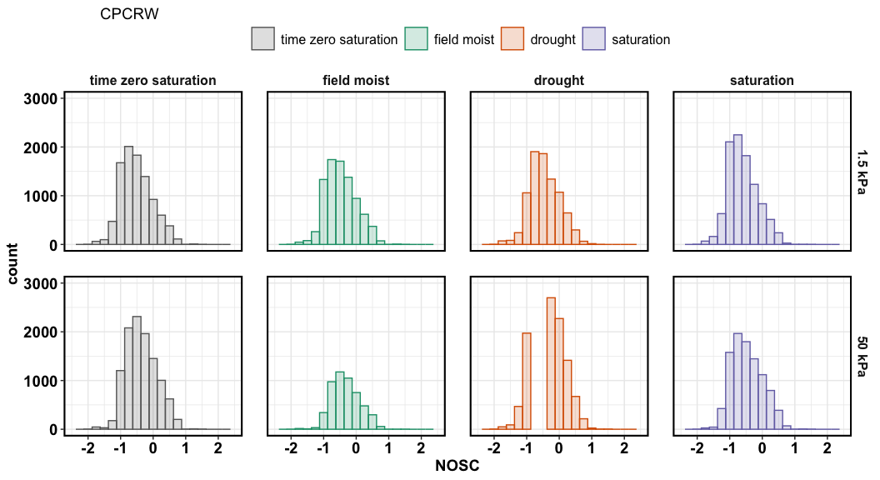

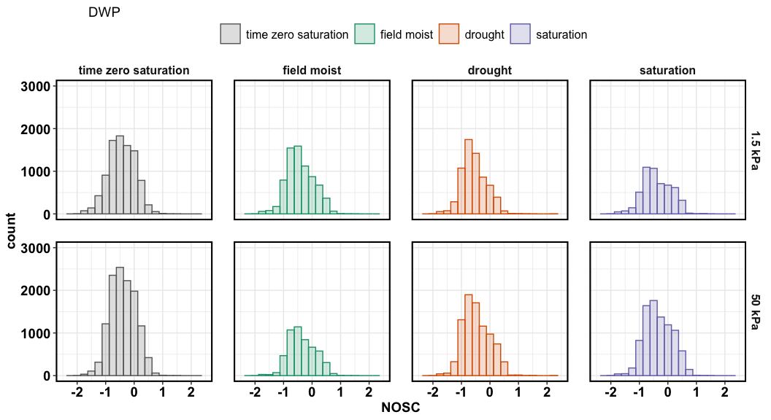

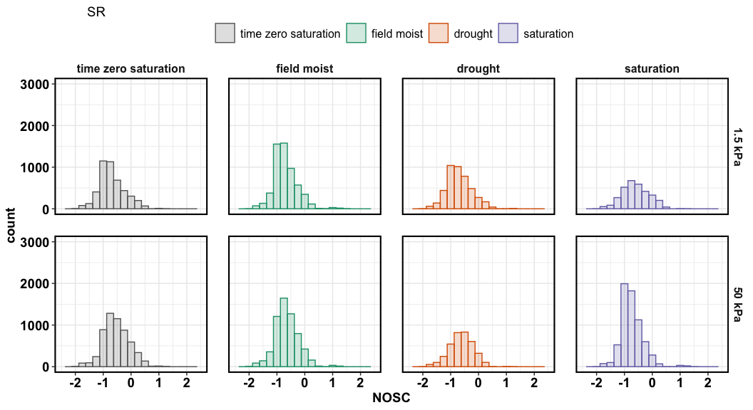

NOSC for SR

## aromatic peaks

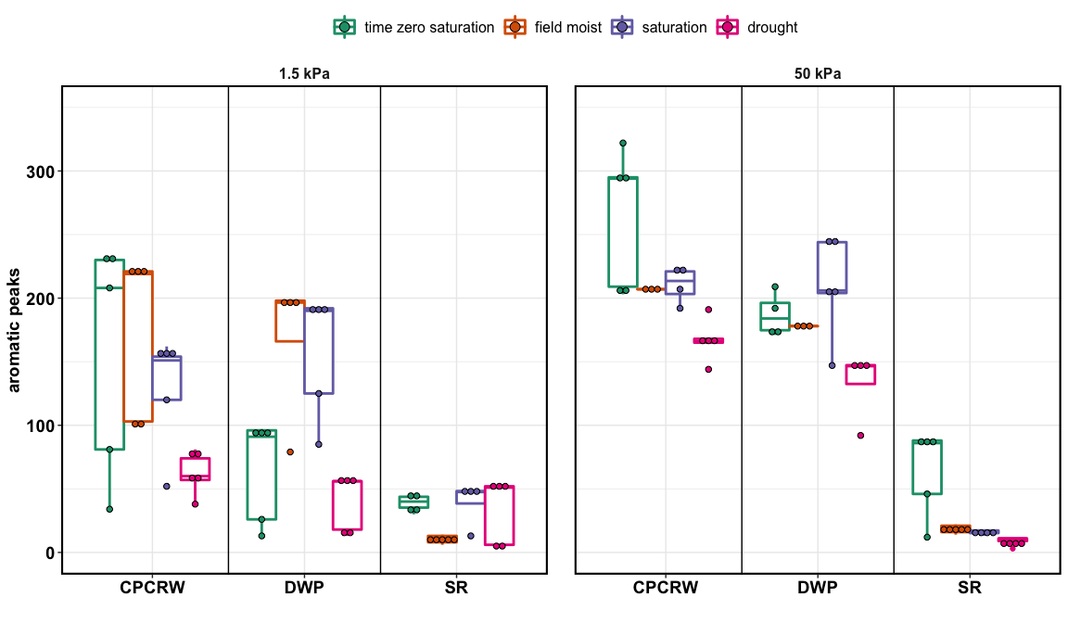

aromatic peaks

# FTICR Pores – tables

## Peaks: 50 kPa

|  |  |  |  |  |  |  |  |  |  |  |  |  |
| --- | --- | --- | --- | --- | --- | --- | --- | --- | --- | --- | --- | --- |
|  | **CPCRW** | | | | **DWP** | | | | **SR** | | | |
|  | **Drought** | **FM** | **Sat** | **TZSat** | **Drought** | **FM** | **Sat** | **TZSat** | **Drought** | **FM** | **Sat** | **TZSat** |
| AminoSugar | 912 | 27 | 101 | 95 | 156 | 78 | 118 | 1064 | 19 | 138 | 235 | 125 |
| Carb | 1220 | 39 | 186 | 92 | 305 | 24 | 120 | 1144 | 23 | 75 | 43 | 21 |
| ConHC | 582 | 408 | 558 | 967 | 372 | 396 | 815 | 529 | 11 | 55 | 59 | 210 |
| Lignin | 8749 | 3999 | 6125 | 7846 | 5015 | 3624 | 5602 | 5716 | 2268 | 3741 | 3071 | 3524 |
| Lipid | 813 | 132 | 713 | 574 | 586 | 195 | 447 | 606 | 471 | 891 | 999 | 520 |
| Other | 64 | 27 | 7 | 35 | 44 | 6 | 12 | 84 | 7 | 18 | 13 | 12 |
| Protein | 2831 | 255 | 1523 | 890 | 1796 | 606 | 1094 | 2474 | 814 | 1115 | 2143 | 1137 |
| Tannin | 993 | 285 | 452 | 577 | 289 | 318 | 619 | 751 | 13 | 40 | 33 | 110 |
| UnsatHC | 16 | 27 | 11 | 41 | 21 | 9 | 38 | 67 | 16 | 83 | 61 | 69 |
| **total** | **16180** | **5199** | **9676** | **11117** | **8584** | **5256** | **8865** | **12435** | **3642** | **6156** | **6657** | **5728** |

## Peaks: 1.5 kPa

|  |  |  |  |  |  |  |  |  |  |  |  |  |  |  |
| --- | --- | --- | --- | --- | --- | --- | --- | --- | --- | --- | --- | --- | --- | --- |
|  | **CPCRW** | | | | | **DWP** | | | | | **SR** | | | |
|  | **Drought** | **FM** | **Sat** | **TZSat** | **Drought** | | **FM** | **Sat** | **TZSat** | **Drought** | | **FM** | **Sat** | **TZSat** |
| AminoSugar | 508 | 72 | 122 | 162 | 117 | | 93 | 19 | 958 | 65 | | 205 | 57 | 172 |
| Carb | 792 | 89 | 123 | 74 | 380 | | 40 | 47 | 1219 | 14 | | 96 | 34 | 37 |
| ConHC | 195 | 556 | 353 | 565 | 125 | | 500 | 609 | 196 | 86 | | 49 | 82 | 113 |
| Lignin | 4393 | 5504 | 5737 | 5642 | 3827 | | 4852 | 3447 | 3414 | 2279 | | 2722 | 1982 | 1967 |
| Lipid | 472 | 588 | 1081 | 707 | 548 | | 465 | 358 | 555 | 845 | | 817 | 498 | 608 |
| Other | 110 | 28 | 40 | 23 | 58 | | 24 | 11 | 106 | 11 | | 17 | - | 18 |
| Protein | 1802 | 1308 | 2130 | 1957 | 1540 | | 979 | 605 | 2259 | 1081 | | 1802 | 433 | 1584 |
| Tannin | 385 | 372 | 256 | 389 | 61 | | 372 | 165 | 490 | 33 | | 35 | 31 | 39 |
| UnsatHC | 13 | 60 | 62 | 69 | 21 | | 33 | 33 | 60 | 55 | | 56 | 86 | 73 |
| **total** | **8670** | **8577** | **9904** | **9588** | **6677** | | **7358** | **5294** | **9257** | **4469** | | **5799** | **3203** | **4611** |

## unique peaks: 50 kPa

|  |  |  |  |  |  |  |  |  |  |
| --- | --- | --- | --- | --- | --- | --- | --- | --- | --- |
|  | **CPCRW** | | | **DWP** | | | **SR** | | |
|  | **Drought** | **FM** | **Sat** | **Drought** | **FM** | **Sat** | **Drought** | **FM** | **Sat** |
| AminoSugar | 217 | - | 2 | 5 | 2 | 3 | - | 11 | 23 |
| Carb | 240 | 1 | - | 8 | - | - | 2 | 10 | 1 |
| ConHC | 6 | 4 | 4 | 6 | 5 | 57 | - | - | 4 |
| Lignin | 328 | 12 | 38 | 45 | 14 | 67 | 2 | 26 | 91 |
| Lipid | 26 | 1 | 28 | 31 | - | 12 | 30 | 18 | 70 |
| Other | 10 | - | - | 5 | - | - | - | 2 | 2 |
| Protein | 282 | - | 24 | 93 | 7 | 6 | 11 | 17 | 175 |
| Tannin | 104 | - | 5 | 1 | 2 | 32 | - | - | 3 |
| UnsatHC | - | 2 | - | - | - | 2 | - | 3 | 2 |
| **total** | **1213** | **20** | **101** | **194** | **30** | **179** | **45** | **87** | **371** |

## 

## unique peaks: 1.5 kPa

|  |  |  |  |  |  |  |  |  |  |
| --- | --- | --- | --- | --- | --- | --- | --- | --- | --- |
|  | CPCRW | | | DWP | | | SR | | |
|  | Drought | FM | Sat | Drought | FM | Sat | Drought | FM | Sat |
| AminoSugar | 118 | - | 3 | 7 | 7 | - | - | 14 | 3 |
| Carb | 177 | 4 | 3 | 6 | 3 | - | - | 16 | 1 |
| ConHC | 6 | 3 | 3 | 4 | 29 | 27 | 8 | 10 | 8 |
| Lignin | 71 | 102 | 107 | 23 | 230 | 2 | 59 | 96 | 19 |
| Lipid | 8 | 5 | 88 | 25 | 16 | 4 | 63 | 22 | 9 |
| Other | 19 | - | - | 6 | 4 | - | 1 | 4 | - |
| Protein | 86 | 16 | 61 | 49 | 15 | - | 25 | 81 | 9 |
| Tannin | 15 | 6 | - | 1 | 34 | - | 4 | 5 | 1 |
| UnsatHC | - | 7 | 3 | - | 5 | 3 | - | - | 6 |
| **total** | **500** | **143** | **268** | **121** | **343** | **36** | **160** | **248** | **56** |

## relative abundance: 50 kPa

|  |  |  |  |  |
| --- | --- | --- | --- | --- |
| **group** | **drought** | **field moist** | **saturation** | **TZ saturation** |
| **CPCRW** |  |  |  |  |
| AminoSugar | 4.35 ± 0.66 a | 0.2 ± 0 b | 0.53 ± 0.06 b | 0.37 ± 0.02 b |
| Carb | 10.91 ± 2.17 a | 0.31 ± 0.01 b | 0.9 ± 0.25 b | 0.42 ± 0.05 b |
| ConHC | 1.37 ± 0.34 b | 2.58 ± 0.51 ab | 2.5 ± 0.45 ab | 4.14 ± 1.04 a |
| Lignin | 56.09 ± 2.88 c | 82.96 ± 1.55 a | 69.89 ± 1.46 b | 75.73 ± 2.43 ab |
| Lipid | 7.07 ± 1.09 a | 5.52 ± 2.18 a | 9.61 ± 1.49 a | 8.66 ± 1.76 a |
| Protein | 16.11 ± 1.74 a | 3.97 ± 0.08 b | 12.8 ± 0.71 a | 7 ± 0.8 b |
| Tannin | 3.37 ± 0.46 a | 3.93 ± 0.92 a | 3.14 ± 0.6 a | 2.88 ± 0.43 a |
| UnsatHC | 0.1 ± 0.03 a | 0.36 ± 0.04 a | 0.59 ± 0.44 a | 0.66 ± 0.32 a |
| Other | 0.63 ± 0.17 a | 0.16 ± 0.02 b | 0.04 ± 0 b | 0.13 ± 0.04 b |
| total | 100 | 100 | 100 | 100 |
| **DWP** |  |  |  |  |
| AminoSugar | 1.38 ± 0.38 b | 0.79 ± 0.07 b | 0.61 ± 0.12 b | 8.79 ± 1.49 a |
| Carb | 4.06 ± 1.1 b | 0.33 ± 0.01 b | 0.86 ± 0.15 b | 9.91 ± 1.31 a |
| ConHC | 2.35 ± 0.33 a | 3.66 ± 0.85 a | 4.96 ± 1.11 a | 2.47 ± 0.26 a |
| Lignin | 55.56 ± 2.55 ab | 71.02 ± 2.08 a | 58.9 ± 9.08 a | 33.19 ± 3.36 b |
| Lipid | 11.53 ± 1.44 a | 9.36 ± 1.09 a | 18.88 ± 10.45 a | 7.74 ± 2.81 a |
| Protein | 22.26 ± 2 a | 10.7 ± 1.54 b | 10.55 ± 1.35 b | 30.92 ± 3.15 a |
| Tannin | 1.52 ± 0.21 b | 3.16 ± 0.46 ab | 3.95 ± 0.93 ab | 5.18 ± 0.31 a |
| UnsatHC | 0.76 ± 0.32 a | 0.87 ± 0.32 a | 1.18 ± 0.53 a | 1.21 ± 0.33 a |
| Other | 0.58 ± 0.08 a | 0.11 ± 0.02 b | 0.11 ± 0.03 b | 0.59 ± 0.06 a |
| total | 100 | 100 | 100 | 100 |
| **SR** |  |  |  |  |
| AminoSugar | 0.31 ± 0.09 a | 1.24 ± 0.24 a | 1.66 ± 0.34 a | 2.18 ± 1.37 a |
| Carb | 0.3 ± 0.05 a | 1.03 ± 0.54 a | 0.38 ± 0.03 a | 0.17 ± 0.02 a |
| ConHC | 0.42 ± 0.19 a | 0.51 ± 0.15 a | 1.25 ± 0.52 a | 1.44 ± 0.32 a |
| Lignin | 42.7 ± 8.42 a | 36.06 ± 5.64 a | 28.39 ± 4.35 a | 40.32 ± 11.73 a |
| Lipid | 36.81 ± 7.51 a | 43.72 ± 6.42 a | 38.67 ± 7 a | 33.89 ± 9.83 a |
| Protein | 17.24 ± 4.14 a | 14.49 ± 2.04 a | 27 ± 3.64 a | 17.71 ± 5.26 a |
| Tannin | 0.25 ± 0.15 a | 0.26 ± 0.07 a | 0.22 ± 0.05 a | 1.54 ± 1.01 a |
| UnsatHC | 1.81 ± 0.79 a | 2.55 ± 0.35 a | 2.33 ± 0.46 a | 2.56 ± 0.89 a |
| Other | 0.16 ± 0.05 a | 0.13 ± 0.03 a | 0.11 ± 0.04 a | 0.2 ± 0.05 a |
| total | 100 | 100 | 100 | 100 |

## relative abundance: 1.5 kPa

|  |  |  |  |  |
| --- | --- | --- | --- | --- |
|  | **drought** | **field moist** | **saturation** | **TZ saturation** |
| **CPCRW** |  |  |  |  |
| AminoSugar | 4.3 ± 0.52 a | 0.33 ± 0.05 b | 0.54 ± 0.1 b | 0.82 ± 0.12 b |
| Carb | 13.15 ± 2.28 a | 0.4 ± 0.08 b | 0.46 ± 0.05 b | 0.36 ± 0.05 b |
| ConHC | 1.02 ± 0.23 a | 2.26 ± 0.21 a | 1.36 ± 0.42 a | 2.55 ± 0.68 a |
| Lignin | 47.39 ± 6.34 a | 58.67 ± 9.42 a | 52.55 ± 3.27 a | 49.34 ± 5.81 a |
| Lipid | 12.44 ± 5.18 a | 24.17 ± 8.26 a | 24.29 ± 2.66 a | 24.23 ± 4.1 a |
| Protein | 16.57 ± 1.96 a | 11.57 ± 1.44 a | 18.95 ± 2.03 a | 19.93 ± 2.86 a |
| Tannin | 2.28 ± 0.57 a | 1.85 ± 0.21 a | 1.04 ± 0.21 a | 1.75 ± 0.27 a |
| UnsatHC | 0.15 ± 0.05 b | 0.65 ± 0.09 ab | 0.68 ± 0.18 ab | 0.96 ± 0.21 a |
| Other | 2.71 ± 1.85 a | 0.1 ± 0.03 a | 0.13 ± 0.02 a | 0.07 ± 0.02 a |
| total | 100 | 100 | 100 | 100 |
| **DWP** |  |  |  |  |
| AminoSugar | 1.03 ± 0.16 b | 0.66 ± 0.11 b | 0.28 ± 0.1 b | 7.76 ± 2.46 a |
| Carb | 8.32 ± 1.22 ab | 0.32 ± 0.03 b | 0.8 ± 0.24 b | 10.99 ± 3.48 a |
| ConHC | 2.3 ± 0.29 b | 3.1 ± 0.91 b | 6.98 ± 1.16 a | 1.66 ± 0.54 b |
| Lignin | 43.38 ± 4.12 a | 56.46 ± 1.95 a | 54.11 ± 7.25 a | 15.26 ± 3.77 b |
| Lipid | 21.63 ± 3.13 a | 20.84 ± 1.54 a | 21.17 ± 5.37 a | 29.39 ± 12.34 a |
| Protein | 20.41 ± 2.14 b | 14.44 ± 1.13 b | 12.93 ± 2.3 b | 30.07 ± 2.2 a |
| Tannin | 0.44 ± 0.1 b | 2.46 ± 0.25 ab | 1.92 ± 0.51 ab | 3.15 ± 1.06 a |
| UnsatHC | 1.57 ± 1.11 a | 1.53 ± 0.36 a | 1.66 ± 0.26 a | 0.97 ± 0.15 a |
| Other | 0.9 ± 0.12 a | 0.19 ± 0.04 bc | 0.17 ± 0.03 c | 0.75 ± 0.24 ab |
| total | 100 | 100 | 100 | 100 |
| **SR** |  |  |  |  |
| AminoSugar | 0.66 ± 0.23 a | 1.63 ± 0.5 a | 0.59 ± 0.12 a | 1.84 ± 0.3 a |
| Carb | 0.13 ± 0.02 b | 1.61 ± 0.61 a | 0.79 ± 0.3 ab | 0.51 ± 0.08 ab |
| ConHC | 1.52 ± 0.45 a | 0.71 ± 0.34 a | 0.58 ± 0.12 a | 1.29 ± 0.31 a |
| Lignin | 30.2 ± 2.11 a | 28.94 ± 10.2 a | 19.26 ± 2.9 a | 15.94 ± 0.84 a |
| Lipid | 43.37 ± 1.9 a | 44.84 ± 11.52 a | 65.05 ± 3.58 a | 43.82 ± 6.28 a |
| Protein | 18.58 ± 1.49 ab | 20.2 ± 4.83 ab | 9.49 ± 0.92 b | 33.15 ± 5.46 a |
| Tannin | 0.22 ± 0.1 a | 0.42 ± 0.11 a | 0.18 ± 0.06 a | 0.21 ± 0.05 a |
| UnsatHC | 5.05 ± 1.66 a | 1.56 ± 0.21 a | 4.06 ± 0.85 a | 2.9 ± 0.81 a |
| Other | 0.26 ± 0.1 a | 0.11 ± 0.02 a | 0 ± 0 a | 0.35 ± 0.15 a |
| total | 100 | 100 | 100 | 100 |

# FTICR Soil – figures

## native SOM

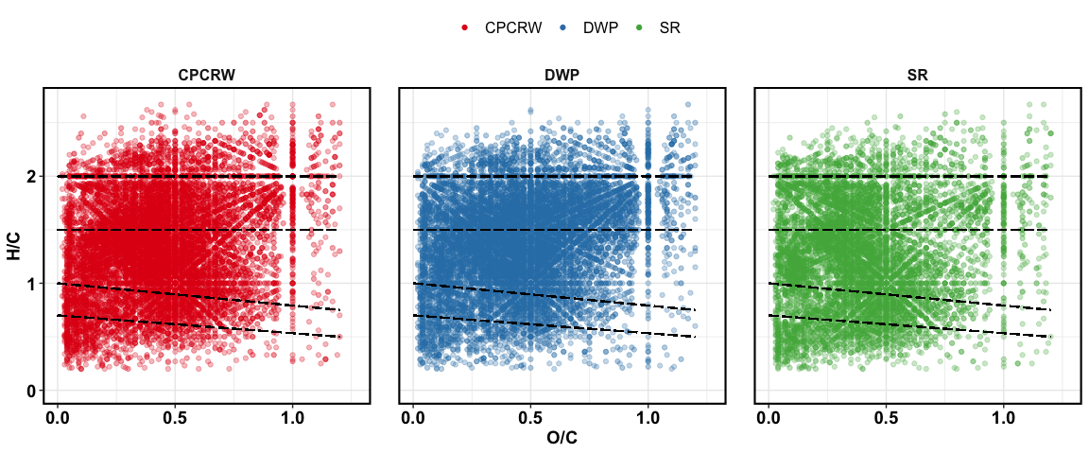

Van Krevelen plot for baseline soil

## treatment effect – all peaks

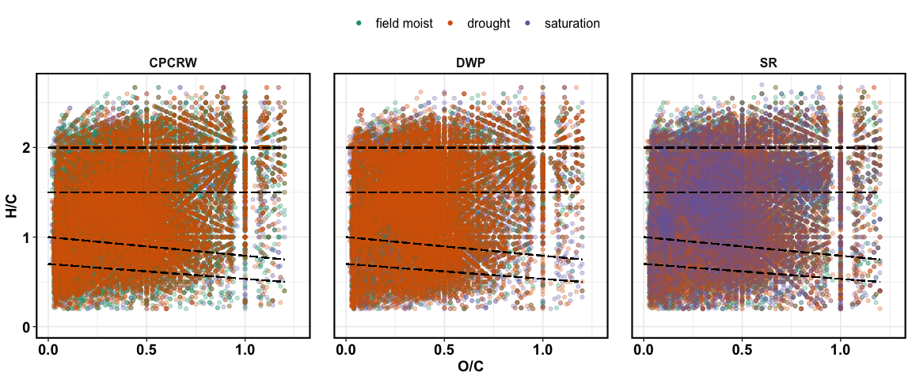

Van Krevelen plot for treatments

## treatment effect – unique peaks

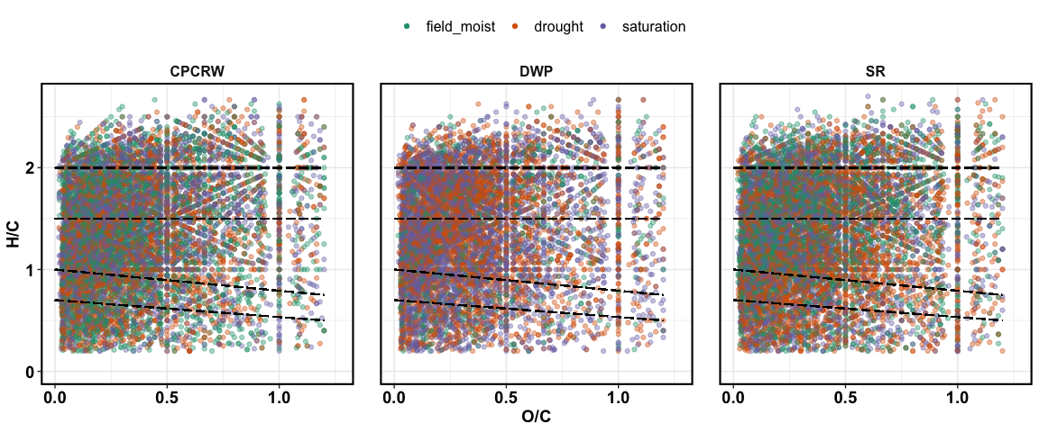

Van Krevelen plot for unique peaks

## treatment effect – relative abundance

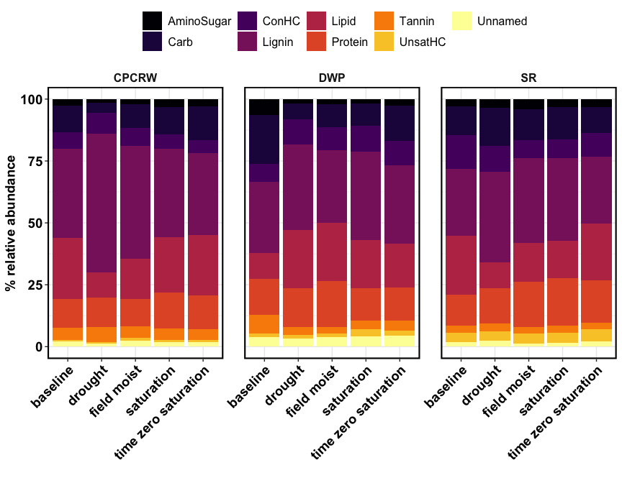

Relative abundance

## NOSC

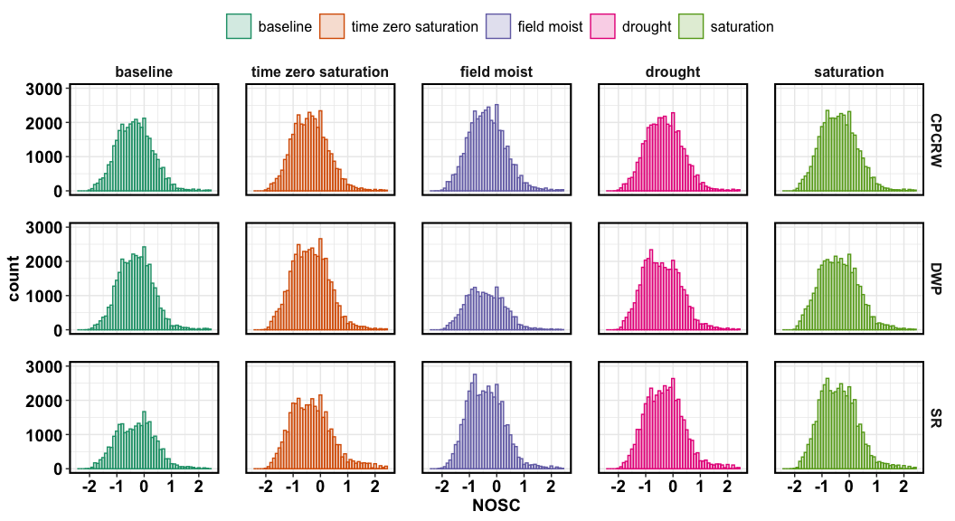

NOSC

## aromatic peaks

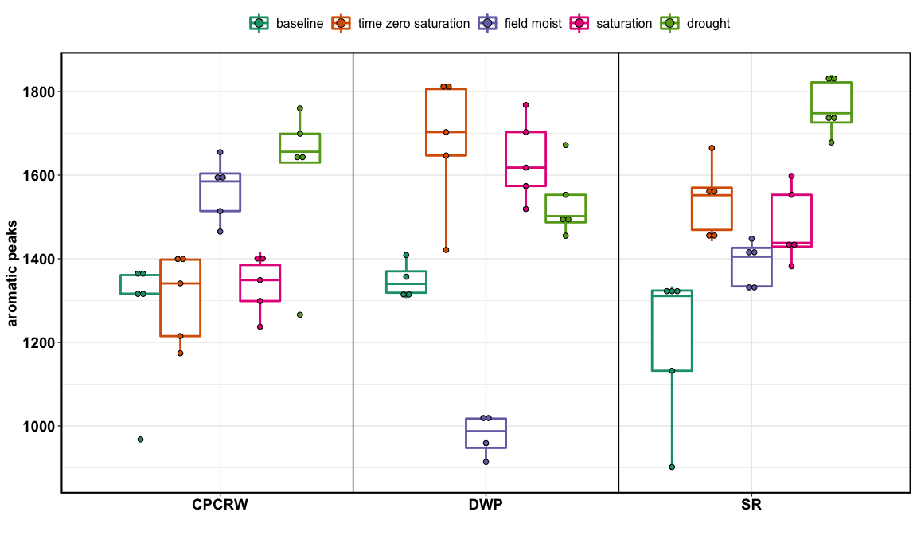

aromatic peaks

# FTICR Soil – relative abundance

|  |  |  |  |  |  |
| --- | --- | --- | --- | --- | --- |
| **group** | **baseline** | **drought** | **field moist** | **saturation** | **TZsaturation** |
| **CPCRW** |  |  |  |  |  |
| AminoSug | 2.69 ± 0.32 ab | 1.48 ± 0.12 b | 2.19 ± 0.48 ab | 3.37 ± 0.34 a | 2.94 ± 0.35 a |
| Carb | 10.82 ± 1.88 ab | 4.17 ± 0.92 b | 9.6 ± 2.33 ab | 10.78 ± 1.06 ab | 13.53 ± 1.87 a |
| ConHC | 6.45 ± 0.92 a | 8.29 ± 1.21 a | 7.07 ± 0.6 a | 6.01 ± 0.53 a | 5.46 ± 0.63 a |
| Lignin | 36.24 ± 0.71 b | 56.17 ± 3.13 a | 45.5 ± 5.07 ab | 35.47 ± 1.45 b | 32.94 ± 2.75 b |
| Lipid | 24.65 ± 3.11 a | 10.11 ± 1.93 b | 16.35 ± 3.94 ab | 22.37 ± 0.85 ab | 24.32 ± 3.62 a |
| Protein | 11.59 ± 1 a | 11.91 ± 1.2 a | 11.18 ± 0.5 a | 14.69 ± 1.18 a | 13.63 ± 1.63 a |
| Tannin | 4.79 ± 0.45 a | 5.92 ± 0.29 a | 4.61 ± 0.52 a | 4.57 ± 0.25 a | 4.44 ± 0.94 a |
| UnsatHC | 0.69 ± 0.07 a | 0.84 ± 0.09 a | 1 ± 0.12 a | 0.93 ± 0.08 a | 0.83 ± 0.06 a |
| Unnamed | 2.08 ± 0.34 ab | 1.12 ± 0.07 b | 2.5 ± 0.42 a | 1.8 ± 0.23 ab | 1.91 ± 0.18 ab |
| total | 100 | 100 | 100 | 100 | 100 |
| **DWP** |  |  |  |  |  |
| AminoSug | 6.49 ± 0.45 a | 1.82 ± 0.18 b | 2.05 ± 0.13 b | 1.74 ± 0.2 b | 2.75 ± 0.24 b |
| Carb | 19.77 ± 0.65 a | 6.38 ± 0.94 c | 9.32 ± 0.53 c | 9 ± 1.02 c | 14.22 ± 1.66 b |
| ConHC | 7.27 ± 0.47 a | 10.05 ± 0.47 a | 9.14 ± 0.97 a | 10.54 ± 1.27 a | 9.77 ± 0.37 a |
| Lignin | 28.57 ± 1.26 a | 34.54 ± 1.86 a | 29.34 ± 2.83 a | 35.62 ± 2.3 a | 31.76 ± 4.2 a |
| Lipid | 10.43 ± 0.35 b | 23.73 ± 2.62 a | 23.71 ± 2.24 a | 19.37 ± 2.09 ab | 17.52 ± 3.12 ab |
| Protein | 14.6 ± 1.09 ab | 15.61 ± 0.61 ab | 18.52 ± 1.89 a | 13.29 ± 1.26 b | 13.4 ± 0.76 b |
| Tannin | 7.43 ± 0.33 a | 3.11 ± 0.47 b | 2.58 ± 0.7 b | 3.52 ± 0.41 b | 4.06 ± 0.23 b |
| UnsatHC | 1.53 ± 0.29 a | 1.54 ± 0.24 a | 1.57 ± 0.16 a | 2.74 ± 0.41 a | 2.05 ± 0.33 a |
| Unnamed | 3.92 ± 0.08 a | 3.21 ± 0.33 a | 3.77 ± 0.18 a | 4.18 ± 0.1 a | 4.47 ± 0.5 a |
| total | 100 | 100 | 100 | 100 | 100 |
| **SR** |  |  |  |  |  |
| AminoSug | 2.82 ± 0.26 b | 3.45 ± 0.32 ab | 4.16 ± 0.16 a | 3.37 ± 0.1 ab | 3.16 ± 0.27 b |
| Carb | 11.72 ± 1.38 ab | 15.55 ± 1.14 a | 12.38 ± 0.83 ab | 12.8 ± 0.78 ab | 10.39 ± 0.75 b |
| ConHC | 13.77 ± 0.89 a | 10.45 ± 0.75 ab | 7.44 ± 1.61 b | 7.59 ± 1.09 b | 9.72 ± 0.69 ab |
| Lignin | 26.8 ± 2.15 b | 36.4 ± 2.72 a | 34.19 ± 1.33 ab | 33.55 ± 1.68 ab | 26.88 ± 1.05 b |
| Lipid | 23.96 ± 3.3 a | 10.45 ± 1.02 b | 15.64 ± 1.3 ab | 15.05 ± 0.78 ab | 23.02 ± 3.09 a |
| Protein | 12.49 ± 1.39 a | 14.27 ± 1.97 a | 18.22 ± 2.84 a | 19.2 ± 1.84 a | 17.12 ± 1.06 a |
| Tannin | 2.74 ± 0.26 a | 3.33 ± 0.46 a | 2.64 ± 0.26 a | 2.94 ± 0.22 a | 2.68 ± 0.15 a |
| UnsatHC | 4 ± 0.29 a | 3.61 ± 0.74 a | 4 ± 0.33 a | 4 ± 0.8 a | 5 ± 0.73 a |
| Unnamed | 1.72 ± 0.12 bc | 2.48 ± 0.14 a | 1.33 ± 0.13 c | 1.49 ± 0.2 bc | 2.03 ± 0.2 ab |
| total | 100 | 100 | 100 | 100 | 100 |

## Peaks

|  |  |  |  |  |  |
| --- | --- | --- | --- | --- | --- |
| **Class** | **baseline** | **drought** | **field moist** | **saturation** | **TZsaturation** |
| **CPCRW** |  |  |  |  |  |
| AminoSugar | 1894 | 1513 | 1884 | 2236 | 2057 |
| Carb | 2138 | 1704 | 2249 | 2624 | 2499 |
| ConHC | 5087 | 6271 | 6303 | 5136 | 5145 |
| Lignin | 12092 | 13273 | 13956 | 12754 | 12219 |
| Lipid | 3244 | 3647 | 4531 | 4826 | 4248 |
| Protein | 5093 | 5028 | 5689 | 6193 | 5747 |
| Tannin | 2386 | 2325 | 2313 | 2317 | 2180 |
| Unnamed | 1340 | 1458 | 1609 | 1508 | 1362 |
| UnsatHC | 1438 | 2024 | 2113 | 1932 | 1795 |
| total | 34712 | 37243 | 40647 | 39526 | 37252 |
| **DWP** |  |  |  |  |  |
| AminoSugar | 2661 | 1579 | 983 | 1621 | 2277 |
| Carb | 3609 | 1784 | 1271 | 2198 | 3018 |
| ConHC | 4429 | 6301 | 3182 | 6658 | 6885 |
| Lignin | 11551 | 12105 | 6612 | 12358 | 13708 |
| Lipid | 3387 | 5272 | 2858 | 5515 | 5210 |
| Protein | 5274 | 6270 | 3450 | 5483 | 6107 |
| Tannin | 2560 | 1564 | 870 | 1955 | 2232 |
| Unnamed | 1396 | 1438 | 720 | 1558 | 1692 |
| UnsatHC | 1526 | 2146 | 994 | 2480 | 2370 |
| total | 36393 | 38459 | 20940 | 39826 | 43499 |
| **SR** |  |  |  |  |  |
| AminoSugar | 873 | 2016 | 2290 | 2278 | 1588 |
| Carb | 1348 | 2382 | 2871 | 2949 | 1874 |
| ConHC | 5186 | 7470 | 5489 | 5899 | 6485 |
| Lignin | 8067 | 14737 | 14305 | 14504 | 11664 |
| Lipid | 3042 | 4370 | 5540 | 5525 | 4852 |
| Protein | 3097 | 6081 | 6493 | 6813 | 5373 |
| Tannin | 1334 | 2297 | 2031 | 2104 | 1934 |
| Unnamed | 840 | 1777 | 1521 | 1580 | 1665 |
| UnsatHC | 1465 | 2333 | 2725 | 2736 | 2512 |
| total | 25252 | 43463 | 43265 | 44388 | 37947 |

## unique peaks

|  |  |  |  |  |
| --- | --- | --- | --- | --- |
| **Class** | **drought** | **field_moist** | **saturation** | **time_zero_sat** |
| **CPCRW** |  |  |  |  |
| AminoSugar | 128 | 132 | 135 | 107 |
| Carb | 127 | 162 | 171 | 149 |
| ConHC | 581 | 592 | 397 | 399 |
| Lignin | 856 | 875 | 733 | 655 |
| Lipid | 459 | 580 | 598 | 520 |
| Protein | 417 | 415 | 466 | 388 |
| Tannin | 150 | 130 | 133 | 124 |
| Unnamed | 181 | 202 | 190 | 175 |
| UnsatHC | 252 | 246 | 255 | 228 |
| total | 3151 | 3334 | 3078 | 2745 |
| **DWP** |  |  |  |  |
| AminoSugar | 125 | 61 | 112 | 137 |
| Carb | 107 | 62 | 148 | 157 |
| ConHC | 500 | 208 | 619 | 579 |
| Lignin | 819 | 279 | 872 | 901 |
| Lipid | 642 | 241 | 711 | 577 |
| Protein | 537 | 170 | 439 | 421 |
| Tannin | 128 | 53 | 162 | 142 |
| Unnamed | 194 | 73 | 215 | 212 |
| UnsatHC | 275 | 110 | 315 | 280 |
| total | 3327 | 1257 | 3593 | 3406 |
| **SR** |  |  |  |  |
| AminoSugar | 175 | 157 | 150 | 110 |
| Carb | 185 | 167 | 150 | 105 |
| ConHC | 747 | 460 | 530 | 590 |
| Lignin | 965 | 846 | 860 | 617 |
| Lipid | 481 | 634 | 556 | 452 |
| Protein | 452 | 465 | 446 | 312 |
| Tannin | 216 | 130 | 146 | 149 |
| Unnamed | 222 | 182 | 178 | 212 |
| UnsatHC | 209 | 288 | 281 | 220 |
| total | 3652 | 3329 | 3297 | 2767 |