6-fticr_pores_output

Kaizad Patel

10/10/2019

# Pores

## aromatic peaks

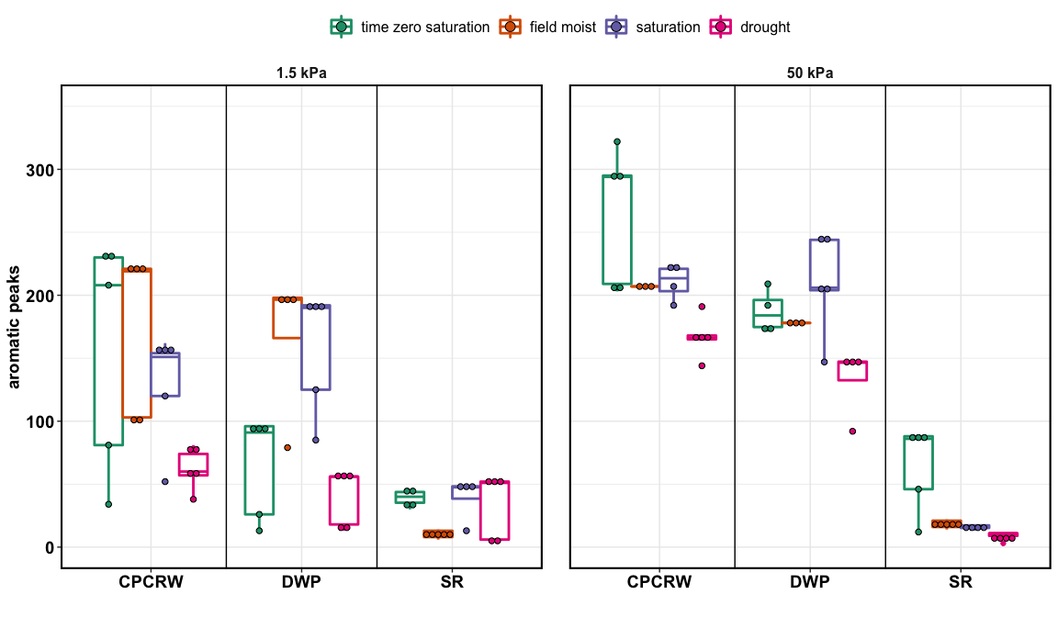

aromatic peaks

## native SOM

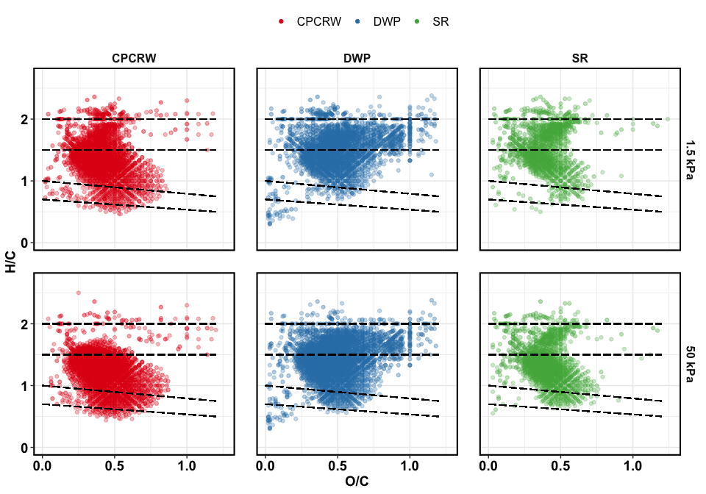

Van Krevelen plot for TZSat pores

## treatment effect

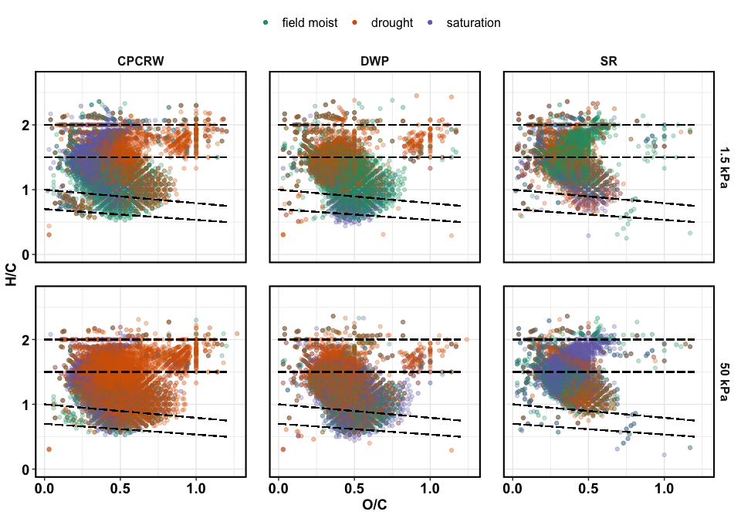

Van Krevelen plot for treatments

## treatment effect – unique molecules

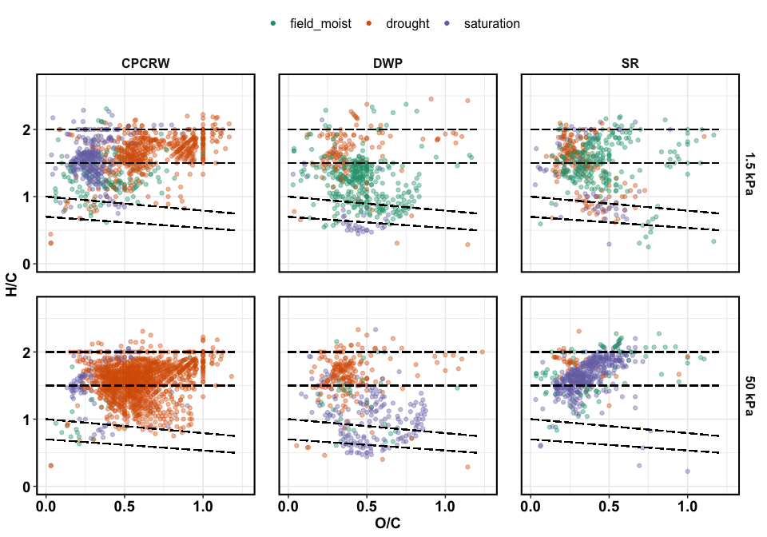

Van Krevelen plot for uniqiue peaks

## treatment effect – relative abundance

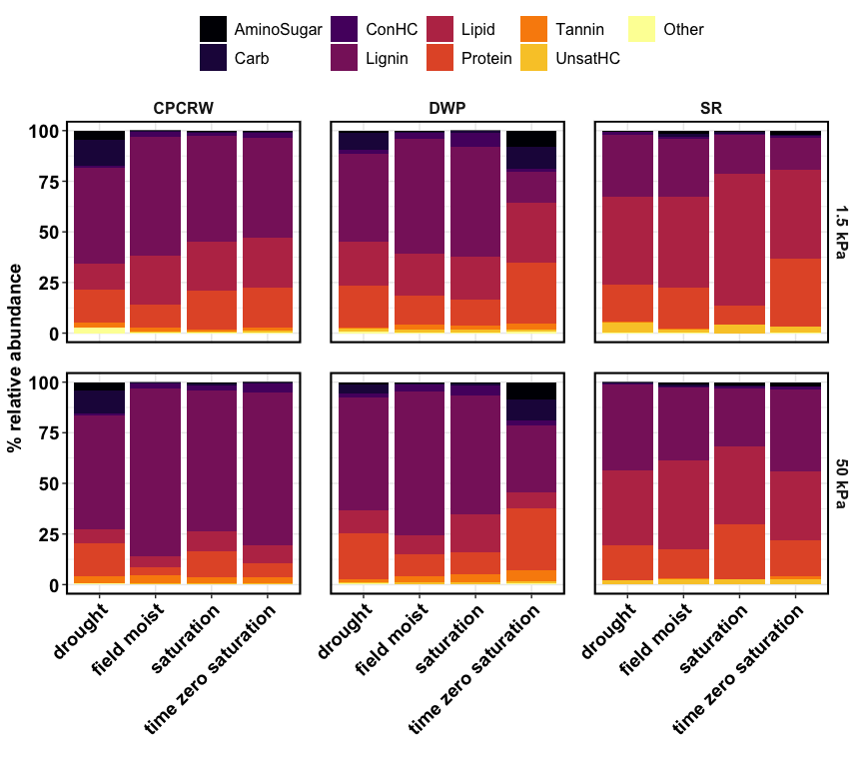

Relative abundance

## treatment effect – NOSC

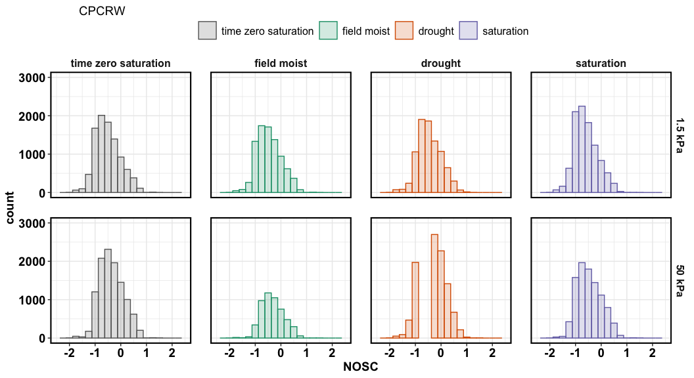

Relative abundance

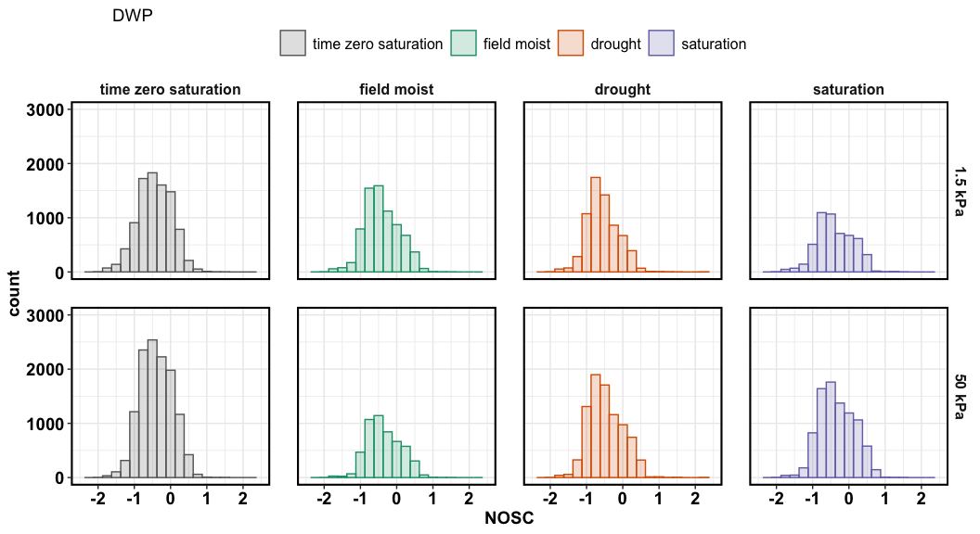

Relative abundance

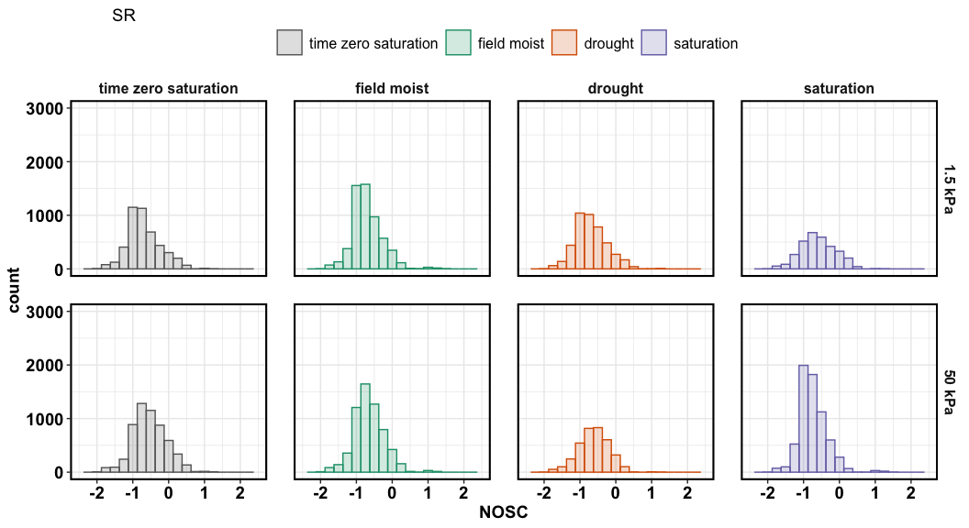

Relative abundance