3soils_markdown

Kaizad Patel

This is the RMarkdown file for the 3Soils experiment. Tables and figures for molecular results. For formatted tables, see the Word document titled 000-3soils_markdown_YYYYMMDD.docx.

Run: 2019-10-30

# Soil characterization

## summary table

|  |  |  |  |
| --- | --- | --- | --- |
| variable | CPCRW | DWP | SR |
| TC_perc | 1.43 ± 0.21 b | 0.98 ± 0.1 b | 10.32 ± 0.45 a |
| TN_perc | 0.07 ± 0.01 b | 0.04 ± 0 b | 0.59 ± 0.01 a |
| TOC_perc | 1.43 ± 0.19 b | 0.88 ± 0.11 b | 9.94 ± 0.47 a |
| WSOC_mg_g | 1.04 ± 0.28 a | 1 ± 0.16 a | 0.67 ± 0.04 a |
| Ca_meq100g | 3.52 ± 0.41 b | 0.81 ± 0.11 c | 17.21 ± 0.75 a |
| Mg_meq100g | 1.08 ± 0.09 b | 0.26 ± 0.03 b | 7.56 ± 0.46 a |
| pH | 5.31 ± 0.17 b | 4.79 ± 0.11 c | 5.82 ± 0.05 a |
| EC_dS_m | 0.07 ± 0.01 a | 0.06 ± 0.01 a | NA |
| Sand_perc | 31.8 ± 7.47 b | 90.8 ± 1.74 a | 14 ± 2.12 b |
| Silt_perc | 53 ± 7.36 a | 3.8 ± 0.66 b | 58.5 ± 1.5 a |
| Clay_perc | 15.2 ± 0.37 b | 5.4 ± 1.29 c | 27.75 ± 1.65 a |

## pore distribution

## pore size distribution

## water retention curves

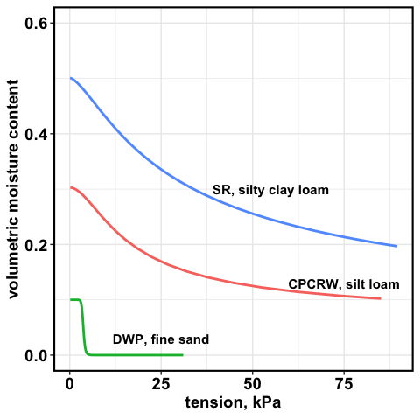

water retention curve

# WSOC tables

## soils

mg/g soil

|  |  |  |  |
| --- | --- | --- | --- |
| Treatment | CPCRW | DWP | SR |
| Drought | 0.85 ± 0.2 | 0.72 ± 0.37 | 0.6 ± 0.04 |
| Field Moist | 0.69 ± 0.07 | 0.35 ± 0.05 | 0.61 ± 0.05 |
| Saturated | 0.59 ± 0.05 | 0.39 ± 0.06 | 0.55 ± 0.06 |
| Time Zero | 0.78 ± 0.1 | 0.51 ± 0.08 | 0.43 ± 0.04 |

## pores

mg/L

|  |  |  |  |  |  |  |
| --- | --- | --- | --- | --- | --- | --- |
| Treatment | 1.5 kPa CPCRW | 1.5 kPa DWP | 1.5 kPa SR | 50 kPa CPCRW | 50 kPa DWP | 50 kPa SR |
| Drought | 111.82 ± 41.45 * | 69.02 ± 13 | 13.9 ± 2.43 | 186.86 ± 62.65 * | 69.97 ± 13.39 | 19.3 ± 8.32 |
| Field Moist | 21.22 ± 3.73 | 46.33 ± 11.94 | 18.68 ± 2.36 * | 41.17 ± 12.67 | 52.43 ± 14.74 | 19.82 ± 2.93 |
| Saturated | 52.82 ± 13.98 | 42.08 ± 7.34 | 23.16 ± 3.29 * | 63.4 ± 20.84 | 82.7 ± 16.52 | 24.07 ± 2.43 * |
| Time Zero | 26.3 ± 2.78 | 76.68 ± 21.76 | 6.03 ± 0.57 | 29.14 ± 4.41 | 92.33 ± 22.22 | 7.28 ± 0.34 |

## pores

mg/g

|  |  |  |  |  |  |  |
| --- | --- | --- | --- | --- | --- | --- |
| Treatment | 1.5 kPa CPCRW | 1.5 kPa DWP | 1.5 kPa SR | 50 kPa CPCRW | 50 kPa DWP | 50 kPa SR |
| Drought | 25.81 ± 12.78 | NaN ± NA | 2.81 ± 0.55 | 3.45 ± 2.06 | NaN ± NA | 0.54 ± 0.05 |
| Field Moist | 4.52 ± 1.73 | 4.02 ± 1.45 | 4.03 ± 0.95 | 0.9 ± 0.32 | 0.4 ± 0.08 | 0.96 ± 0.27 |
| Saturated | 19.7 ± 6.62 | 5.94 ± 2.58 | 5.25 ± 0.84 | 1.05 ± 0.28 | 0.58 ± 0.26 | 1.4 ± 0.36 |
| Time Zero | 5.1 ± 1.8 | 4.42 ± 1.98 | 1.46 ± NA | 1.05 ± 0.24 | 1.26 ± 0.77 | NaN ± NA |

# FTICR Pores – figures

## native SOM

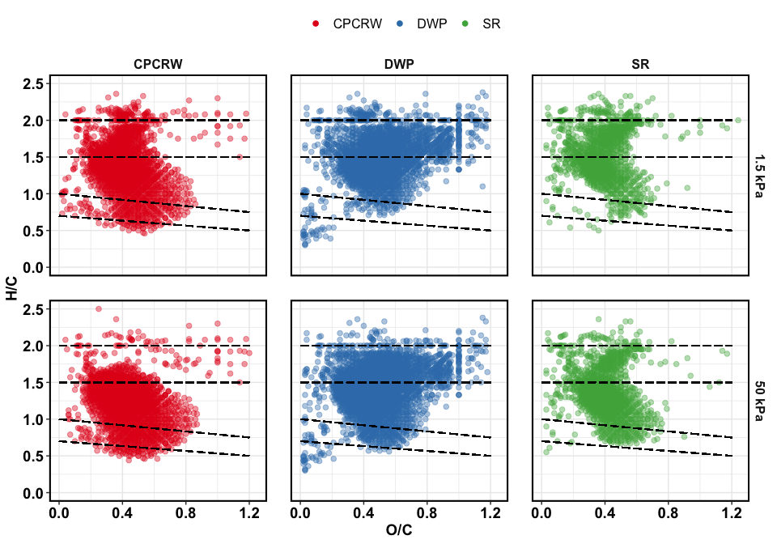

Van Krevelen plot for TZSat pores

## treatment effect – all peaks

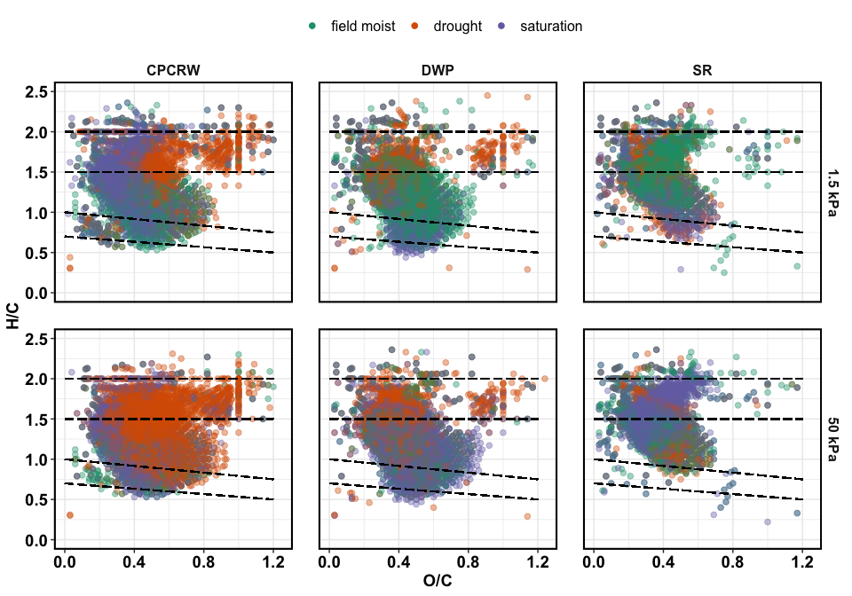

Van Krevelen plot for treatments

## treatment effect – unique peaks

unique in each treatment compared to all, including TZsaturation these are peaks that were uniquely **added** during a given treatment

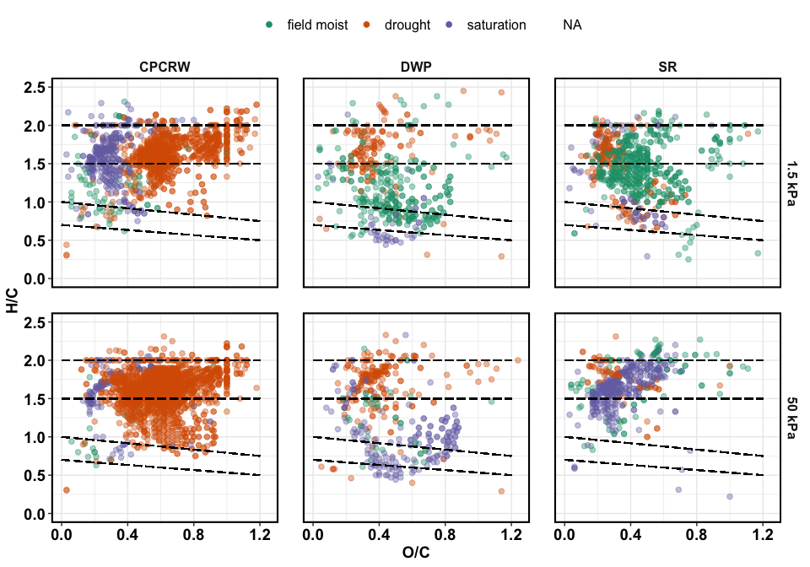

Van Krevelen plot for unique peaks

## treatment effect – relative abundance

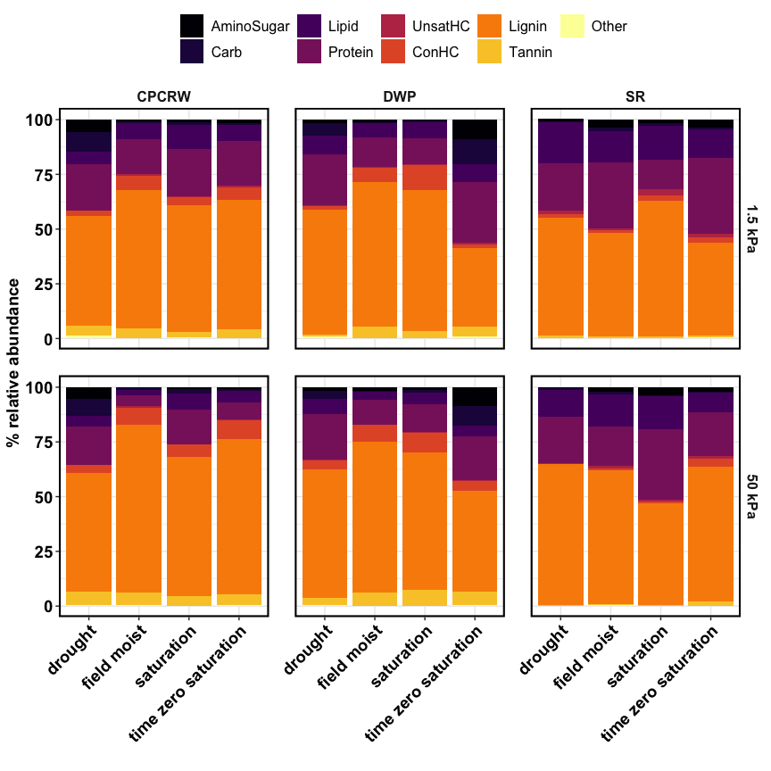

Relative abundance

## treatment effect – NOSC

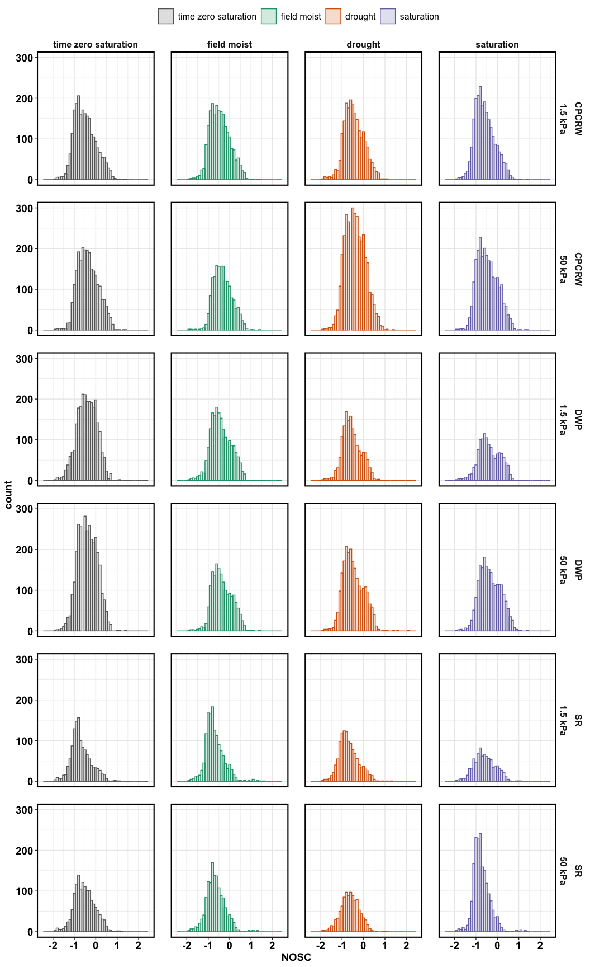

NOSC for CPCRW

## NOSC table

|  |  |  |  |  |  |
| --- | --- | --- | --- | --- | --- |
| tension | site | drought | field moist | saturation | time zero saturation |
| 1.5 kPa | CPCRW | -0.5000 | -0.5000 | -0.6429 | -0.5517 |
| 1.5 kPa | DWP | -0.6000 | -0.4615 | -0.4444 | -0.4000 |
| 1.5 kPa | SR | -0.7500 | -0.7742 | -0.6316 | -0.7710 |
| 50 kPa | CPCRW | -0.4286 | -0.3636 | -0.5185 | -0.4000 |
| 50 kPa | DWP | -0.5385 | -0.4189 | -0.4000 | -0.4167 |
| 50 kPa | SR | -0.6316 | -0.6957 | -0.8000 | -0.5600 |

## aromatic peaks

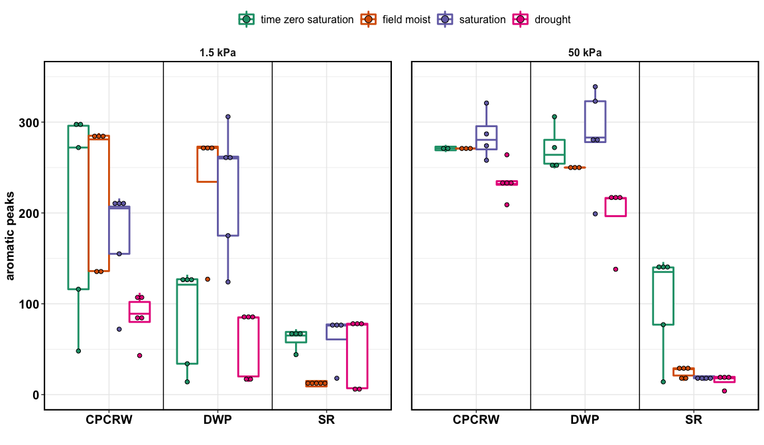

aromatic peaks

## shannon diversity index –

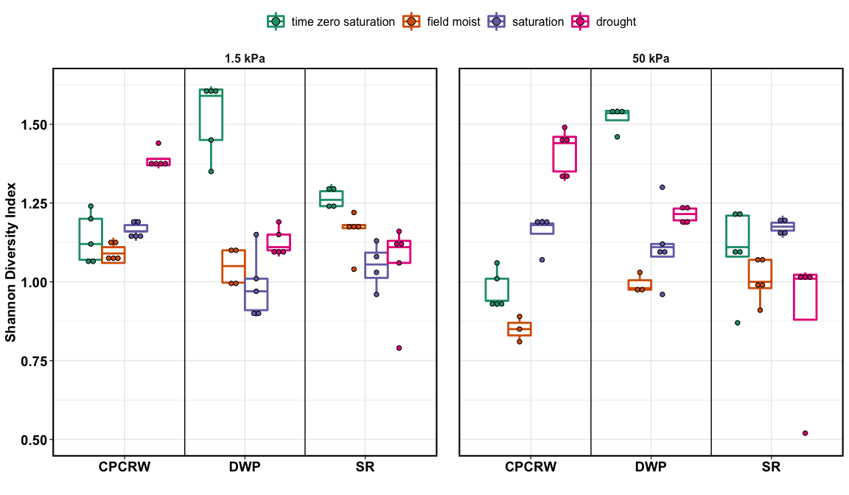

aromatic peaks

# FTICR Pores – tables

## peaks

## [1] "50 kPa"

|  |  |  |  |  |  |
| --- | --- | --- | --- | --- | --- |
| site | Class | drought | field moist | saturation | time zero saturation |
| CPCRW | AminoSugar | 243 | 9 | 28 | 23 |
| CPCRW | Carb | 301 | 13 | 60 | 26 |
| CPCRW | Lipid | 184 | 44 | 193 | 142 |
| CPCRW | Protein | 661 | 85 | 404 | 210 |
| CPCRW | UnsatHC | 4 | 9 | 3 | 11 |
| CPCRW | ConHC | 139 | 136 | 151 | 248 |
| CPCRW | Lignin | 1948 | 1333 | 1583 | 1686 |
| CPCRW | Tannin | 236 | 95 | 119 | 121 |
| CPCRW | Other | 15 | 9 | 2 | 11 |
| CPCRW | total | 3731 | 1733 | 2543 | 2478 |
| DWP | AminoSugar | 45 | 26 | 33 | 305 |
| DWP | Carb | 85 | 8 | 30 | 319 |
| DWP | Lipid | 161 | 65 | 118 | 172 |
| DWP | Protein | 481 | 202 | 271 | 687 |
| DWP | UnsatHC | 6 | 3 | 10 | 19 |
| DWP | ConHC | 106 | 132 | 195 | 151 |
| DWP | Lignin | 1297 | 1208 | 1321 | 1529 |
| DWP | Tannin | 79 | 106 | 151 | 206 |
| DWP | Other | 12 | 2 | 3 | 22 |
| DWP | total | 2272 | 1752 | 2132 | 3410 |
| SR | AminoSugar | 6 | 31 | 67 | 37 |
| SR | Carb | 7 | 21 | 13 | 6 |
| SR | Lipid | 145 | 214 | 272 | 129 |
| SR | Protein | 253 | 270 | 570 | 294 |
| SR | UnsatHC | 5 | 19 | 17 | 19 |
| SR | ConHC | 3 | 14 | 16 | 63 |
| SR | Lignin | 606 | 826 | 834 | 849 |
| SR | Tannin | 4 | 11 | 10 | 31 |
| SR | Other | 2 | 5 | 4 | 3 |
| SR | total | 1031 | 1411 | 1803 | 1431 |

## [1] "1.5 kPa"

|  |  |  |  |  |  |
| --- | --- | --- | --- | --- | --- |
| site | Class | drought | field moist | saturation | time zero saturation |
| CPCRW | AminoSugar | 142 | 21 | 31 | 42 |
| CPCRW | Carb | 201 | 28 | 32 | 19 |
| CPCRW | Lipid | 114 | 143 | 253 | 167 |
| CPCRW | Protein | 429 | 313 | 489 | 494 |
| CPCRW | UnsatHC | 4 | 17 | 15 | 18 |
| CPCRW | ConHC | 54 | 143 | 95 | 172 |
| CPCRW | Lignin | 1055 | 1409 | 1323 | 1277 |
| CPCRW | Tannin | 98 | 94 | 63 | 93 |
| CPCRW | Other | 30 | 9 | 11 | 7 |
| CPCRW | total | 2127 | 2177 | 2312 | 2289 |
| DWP | AminoSugar | 32 | 27 | 5 | 300 |
| DWP | Carb | 88 | 11 | 14 | 363 |
| DWP | Lipid | 132 | 128 | 83 | 145 |
| DWP | Protein | 355 | 272 | 149 | 600 |
| DWP | UnsatHC | 5 | 10 | 8 | 16 |
| DWP | ConHC | 36 | 152 | 152 | 60 |
| DWP | Lignin | 895 | 1265 | 819 | 946 |
| DWP | Tannin | 18 | 98 | 42 | 152 |
| DWP | Other | 14 | 7 | 3 | 32 |
| DWP | total | 1575 | 1970 | 1275 | 2614 |
| SR | AminoSugar | 20 | 56 | 16 | 49 |
| SR | Carb | 4 | 26 | 10 | 11 |
| SR | Lipid | 222 | 203 | 135 | 167 |
| SR | Protein | 316 | 458 | 122 | 424 |
| SR | UnsatHC | 15 | 13 | 25 | 20 |
| SR | ConHC | 27 | 13 | 26 | 34 |
| SR | Lignin | 597 | 635 | 521 | 543 |
| SR | Tannin | 11 | 10 | 10 | 11 |
| SR | Other | 3 | 5 | NA | 5 |
| SR | total | 1215 | 1419 | 865 | 1264 |

## unique peaks

## [1] "50 kPa"

|  |  |  |  |  |
| --- | --- | --- | --- | --- |
| site | Class | drought | field moist | saturation |
| CPCRW | AminoSugar | 347 | NA | 3 |
| CPCRW | Carb | 347 | 1 | NA |
| CPCRW | Lipid | 40 | 1 | 49 |
| CPCRW | Protein | 373 | NA | 34 |
| CPCRW | UnsatHC | NA | 2 | NA |
| CPCRW | ConHC | 9 | 5 | 4 |
| CPCRW | Lignin | 380 | 10 | 33 |
| CPCRW | Tannin | 168 | NA | 7 |
| CPCRW | Other | 16 | NA | NA |
| DWP | AminoSugar | 9 | 2 | 3 |
| DWP | Carb | 9 | NA | NA |
| DWP | Lipid | 27 | 1 | 18 |
| DWP | Protein | 110 | 8 | 5 |
| DWP | UnsatHC | NA | NA | 2 |
| DWP | ConHC | 7 | 7 | 62 |
| DWP | Lignin | 36 | 20 | 45 |
| DWP | Tannin | 2 | 2 | 55 |
| DWP | Other | 5 | NA | NA |
| SR | AminoSugar | 2 | 16 | 24 |
| SR | Carb | 2 | 14 | 1 |
| SR | Lipid | 47 | 16 | 92 |
| SR | Protein | 26 | 24 | 153 |
| SR | UnsatHC | NA | 3 | 2 |
| SR | ConHC | NA | NA | 5 |
| SR | Lignin | 6 | 20 | 77 |
| SR | Tannin | NA | NA | 2 |
| SR | Other | NA | 2 | 2 |

## [1] "1.5 kPa"

|  |  |  |  |  |
| --- | --- | --- | --- | --- |
| site | Class | drought | field moist | saturation |
| CPCRW | AminoSugar | 236 | NA | 4 |
| CPCRW | Carb | 279 | 3 | 3 |
| CPCRW | Lipid | 10 | 7 | 129 |
| CPCRW | Protein | 156 | 6 | 76 |
| CPCRW | UnsatHC | NA | 7 | 3 |
| CPCRW | ConHC | 7 | 3 | 3 |
| CPCRW | Lignin | 195 | 45 | 109 |
| CPCRW | Tannin | 48 | NA | NA |
| CPCRW | Other | 30 | NA | NA |
| DWP | AminoSugar | 9 | 9 | NA |
| DWP | Carb | 6 | 3 | NA |
| DWP | Lipid | 31 | 17 | 4 |
| DWP | Protein | 56 | 12 | NA |
| DWP | UnsatHC | NA | 5 | 3 |
| DWP | ConHC | 4 | 45 | 28 |
| DWP | Lignin | 31 | 174 | 5 |
| DWP | Tannin | 1 | 38 | 1 |
| DWP | Other | 6 | 4 | NA |
| SR | AminoSugar | NA | 22 | 3 |
| SR | Carb | NA | 28 | 1 |
| SR | Lipid | 85 | 23 | 9 |
| SR | Protein | 24 | 128 | 10 |
| SR | UnsatHC | NA | NA | 6 |
| SR | ConHC | 13 | 11 | 16 |
| SR | Lignin | 76 | 249 | 23 |
| SR | Tannin | 5 | 25 | NA |
| SR | Other | 1 | 5 | NA |

## relative abundance

## [1] "50 kPa"

|  |  |  |  |  |  |
| --- | --- | --- | --- | --- | --- |
| site | Class | drought | field moist | saturation | time zero saturation |
| CPCRW | AminoSugar | 5.45 ± 0.65 * | 0.52 ± 0 | 1.04 ± 0.06 | 0.85 ± 0.07 |
| CPCRW | Carb | 7.44 ± 0.42 * | 0.75 ± 0 | 1.91 ± 0.52 | 0.81 ± 0.15 |
| CPCRW | Lipid | 5.09 ± 0.31 | 2.54 ± 0 * | 7.36 ± 0.28 * | 5.11 ± 0.47 |
| CPCRW | Protein | 17.45 ± 0.6 * | 4.9 ± 0 * | 15.73 ± 0.23 * | 7.93 ± 0.62 |
| CPCRW | UnsatHC | 0.1 ± 0.01 * | 0.52 ± 0 * | 0.11 ± 0.01 * | 0.37 ± 0.05 |
| CPCRW | ConHC | 3.69 ± 0.35 * | 7.85 ± 0 | 5.78 ± 0.38 | 8.81 ± 1.3 |
| CPCRW | Lignin | 54.3 ± 0.76 * | 76.92 ± 0 * | 63.32 ± 0.71 * | 70.58 ± 1.01 |
| CPCRW | Tannin | 6.09 ± 0.44 | 5.48 ± 0 | 4.67 ± 0.02 | 5.23 ± 0.26 |
| CPCRW | Other | 0.4 ± 0.03 | 0.52 ± 0 | 0.07 ± 0.01 | 0.31 ± 0.1 |
| DWP | AminoSugar | 1.82 ± 0.12 * | 1.48 ± 0 * | 1.32 ± 0.12 * | 8.47 ± 0.8 |
| DWP | Carb | 3.56 ± 0.26 * | 0.46 ± 0 * | 1.37 ± 0.16 * | 9.14 ± 0.69 |
| DWP | Lipid | 6.83 ± 0.16 | 3.71 ± 0 | 5.09 ± 0.68 | 4.9 ± 0.56 |
| DWP | Protein | 20.93 ± 0.5 | 11.53 ± 0 * | 12.51 ± 1.43 * | 19.83 ± 0.61 |
| DWP | UnsatHC | 0.25 ± 0.02 * | 0.17 ± 0 * | 0.42 ± 0.07 | 0.54 ± 0.03 |
| DWP | ConHC | 4.32 ± 0.48 | 7.53 ± 0 * | 9.25 ± 0.62 * | 4.27 ± 0.27 |
| DWP | Lignin | 58.42 ± 0.35 * | 68.95 ± 0 * | 62.75 ± 2.12 * | 46.13 ± 1.34 |
| DWP | Tannin | 3.37 ± 0.12 | 6.05 ± 0 | 7.15 ± 1.15 | 6.04 ± 0.04 |
| DWP | Other | 0.51 ± 0.02 | 0.11 ± 0 | 0.14 ± 0.02 | 0.68 ± 0.04 |
| SR | AminoSugar | 0.49 ± 0.11 * | 2.26 ± 0.12 | 3.52 ± 0.15 * | 2.12 ± 0.58 |
| SR | Carb | 0.6 ± 0.09 | 1.2 ± 0.11 * | 0.65 ± 0.02 | 0.36 ± 0.03 |
| SR | Lipid | 12.31 ± 1.84 | 14.49 ± 0.68 * | 15.03 ± 0.63 * | 9.16 ± 1.21 |
| SR | Protein | 21.1 ± 3.72 | 17.89 ± 1.46 | 32.23 ± 0.38 * | 19.81 ± 2.67 |
| SR | UnsatHC | 0.43 ± 0.04 * | 1.36 ± 0.1 | 0.92 ± 0.08 | 1.22 ± 0.25 |
| SR | ConHC | 0.31 ± 0.01 * | 0.9 ± 0.08 * | 0.89 ± 0.03 * | 3.78 ± 1 |
| SR | Lignin | 64.21 ± 5.74 | 60.94 ± 1.49 | 46.08 ± 0.74 * | 61.42 ± 3.66 |
| SR | Tannin | 0.35 ± 0.03 * | 0.66 ± 0.13 * | 0.5 ± 0.09 * | 1.9 ± 0.36 |
| SR | Other | 0.21 ± 0.05 | 0.3 ± 0.04 | 0.19 ± 0.04 | 0.21 ± 0.03 |

total = 100%

## [1] "1.5 kPa"

|  |  |  |  |  |  |
| --- | --- | --- | --- | --- | --- |
| site | Class | drought | field moist | saturation | time zero saturation |
| CPCRW | AminoSugar | 5.76 ± 0.49 * | 0.77 ± 0.12 | 1.17 ± 0.15 | 1.66 ± 0.14 |
| CPCRW | Carb | 8.96 ± 0.56 * | 0.9 ± 0.23 | 1.19 ± 0.14 | 0.76 ± 0.08 |
| CPCRW | Lipid | 5.55 ± 0.33 | 7.25 ± 0.66 | 11.02 ± 0.54 * | 7.57 ± 0.65 |
| CPCRW | Protein | 21.23 ± 1.25 | 16.14 ± 1.54 | 21.61 ± 0.74 | 20.27 ± 2.15 |
| CPCRW | UnsatHC | 0.15 ± 0.02 * | 0.67 ± 0.06 | 0.63 ± 0.02 | 0.71 ± 0.07 |
| CPCRW | ConHC | 2.34 ± 0.4 | 6.43 ± 0.37 | 3.67 ± 0.77 | 5.59 ± 1.55 |
| CPCRW | Lignin | 50.28 ± 1.12 * | 63.27 ± 1.69 | 57.69 ± 0.63 | 59.21 ± 1.86 |
| CPCRW | Tannin | 4.47 ± 0.47 | 4.31 ± 0.08 | 2.63 ± 0.32 * | 4.01 ± 0.24 |
| CPCRW | Other | 1.26 ± 0.07 | 0.34 ± 0.08 | 0.38 ± 0.07 | 0.27 ± 0.05 |
| DWP | AminoSugar | 1.76 ± 0.13 * | 1.26 ± 0.15 * | 0.35 ± 0.07 * | 9.02 ± 1.64 |
| DWP | Carb | 5.74 ± 0.48 * | 0.54 ± 0.03 * | 0.96 ± 0.27 * | 11.37 ± 2.31 |
| DWP | Lipid | 8.36 ± 0.76 | 6.31 ± 0.21 | 7.08 ± 1.03 | 8.14 ± 2.72 |
| DWP | Protein | 23.29 ± 1.08 | 13.29 ± 1.12 * | 11.78 ± 1.37 * | 27.63 ± 4.29 |
| DWP | UnsatHC | 0.32 ± 0.04 * | 0.45 ± 0.09 | 0.66 ± 0.11 | 0.76 ± 0.15 |
| DWP | ConHC | 1.81 ± 0.31 | 6.74 ± 1.32 * | 11.39 ± 1.3 * | 1.86 ± 0.32 |
| DWP | Lignin | 56.96 ± 1.73 * | 66.02 ± 0.98 * | 64.51 ± 2.1 * | 35.88 ± 2.09 |
| DWP | Tannin | 0.89 ± 0.14 * | 5.07 ± 0.14 | 3.07 ± 0.25 | 4.36 ± 1.16 |
| DWP | Other | 0.87 ± 0.02 | 0.33 ± 0.03 | 0.21 ± 0.02 | 0.98 ± 0.21 |
| SR | AminoSugar | 1.24 ± 0.34 * | 3.64 ± 0.4 | 1.77 ± 0.16 * | 3.7 ± 0.18 |
| SR | Carb | 0.3 ± 0.04 | 1.8 ± 0.45 * | 1.06 ± 0.1 | 0.79 ± 0.06 |
| SR | Lipid | 18.82 ± 0.53 * | 14.2 ± 0.4 | 15.55 ± 0.32 * | 13.22 ± 0.19 |
| SR | Protein | 21.83 ± 3.64 * | 30.04 ± 3.08 | 13.52 ± 0.6 * | 34.5 ± 0.87 |
| SR | UnsatHC | 1.41 ± 0.27 | 1.03 ± 0.17 | 2.68 ± 0.11 * | 1.59 ± 0.04 |
| SR | ConHC | 1.85 ± 0.53 | 0.86 ± 0.12 * | 2.54 ± 0.63 | 2.5 ± 0.35 |
| SR | Lignin | 53.56 ± 3.95 * | 47.47 ± 2.03 | 61.91 ± 0.79 * | 42.44 ± 1.33 |
| SR | Tannin | 1.12 ± 0.2 | 0.65 ± 0.16 | 0.96 ± 0.13 | 0.86 ± 0.12 |
| SR | Other | 0.32 ± 0.13 | 0.32 ± 0.07 | NA | 0.4 ± 0.05 |

total = 100%

# FTICR Soil – figures

## native SOM

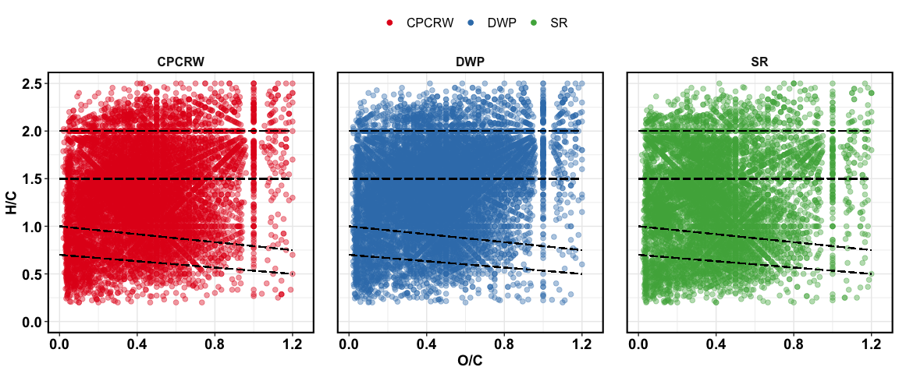

Van Krevelen plot for baseline soil

## treatment effect – all peaks

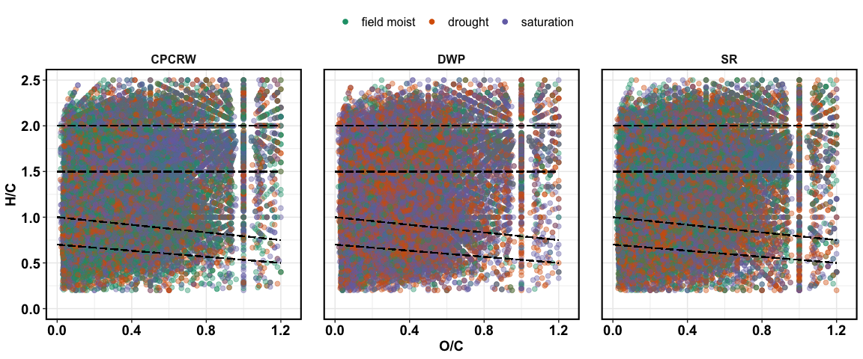

Van Krevelen plot for treatments

## treatment effect – unique peaks

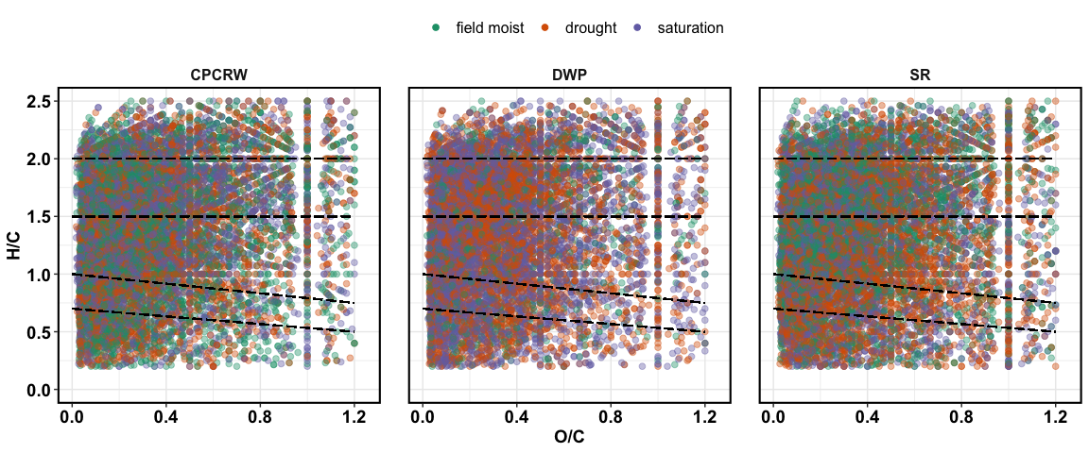

Van Krevelen plot for unique peaks

## treatment effect – relative abundance

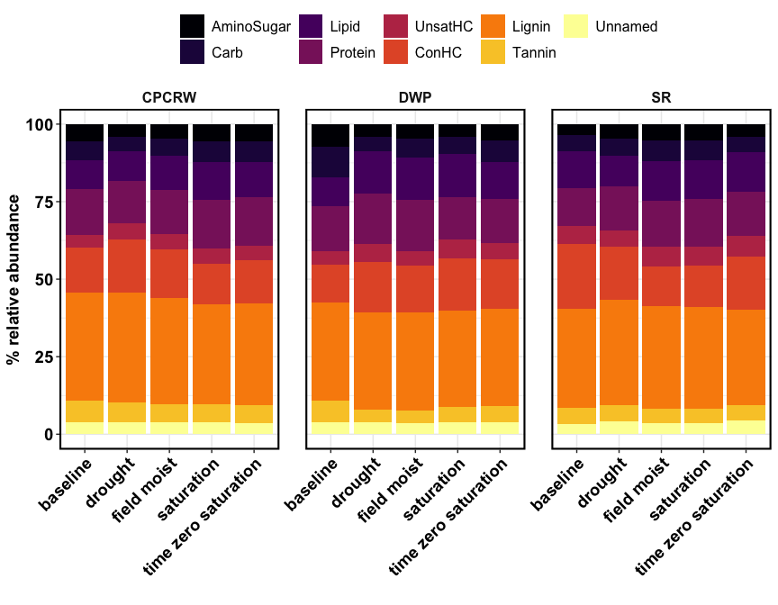

Relative abundance

## NOSC

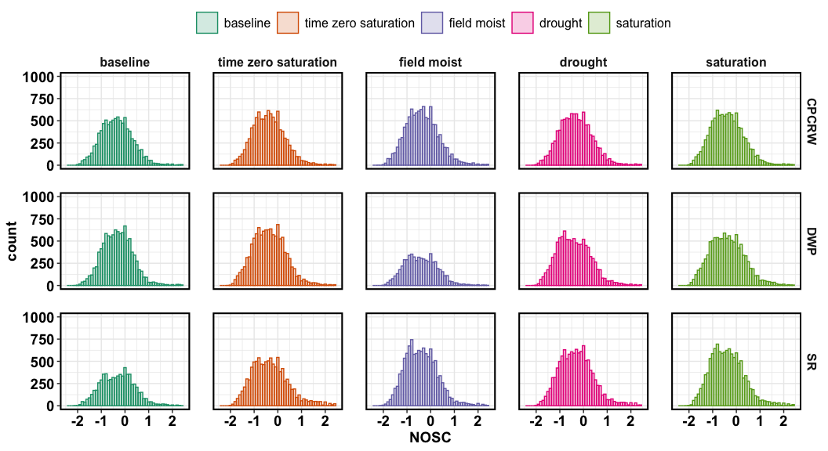

NOSC for CPCRW

## NOSC table

|  |  |  |  |  |  |
| --- | --- | --- | --- | --- | --- |
| site | baseline | drought | field moist | saturation | time zero saturation |
| CPCRW | -0.3636 | -0.3529 | -0.3846 | -0.4211 | -0.4000 |
| DWP | -0.3200 | -0.4545 | -0.4444 | -0.4211 | -0.3871 |
| SR | -0.2963 | -0.3333 | -0.4444 | -0.4286 | -0.3750 |

## aromatic peaks

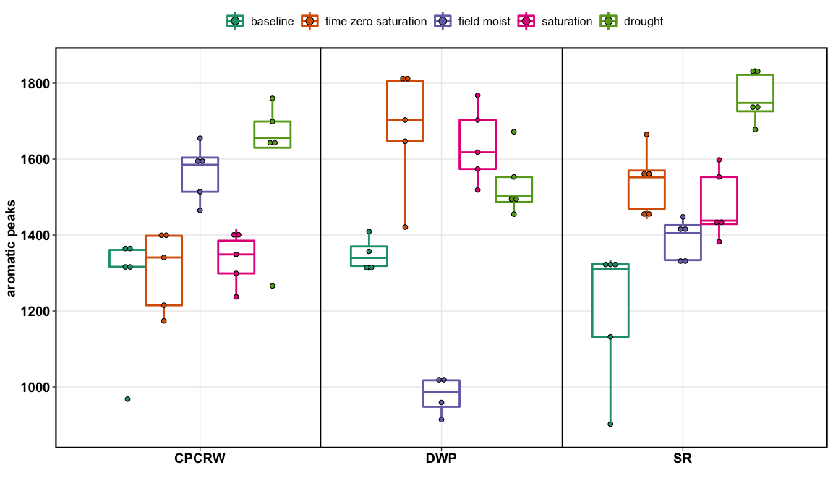

aromatic peaks

# FTICR Soil – tables

## relative abundance

|  |  |  |  |  |  |  |
| --- | --- | --- | --- | --- | --- | --- |
| site | Class | baseline | drought | field moist | saturation | time zero saturation |
| CPCRW | AminoSugar | 5.46 ± 0.16 | 4.06 ± 0.11 * | 4.63 ± 0.1 * | 5.66 ± 0.11 | 5.53 ± 0.15 |
| CPCRW | Carb | 6.16 ± 0.16 | 4.57 ± 0.06 * | 5.53 ± 0.1 * | 6.64 ± 0.12 * | 6.72 ± 0.12 |
| CPCRW | Lipid | 9.3 ± 0.34 | 9.8 ± 0.17 | 11.16 ± 0.23 * | 12.22 ± 0.2 * | 11.43 ± 0.28 |
| CPCRW | Protein | 14.68 ± 0.24 | 13.48 ± 0.19 * | 14 ± 0.13 | 15.67 ± 0.17 * | 15.44 ± 0.3 |
| CPCRW | UnsatHC | 4.1 ± 0.27 | 5.4 ± 0.17 * | 5.2 ± 0.08 * | 4.89 ± 0.07 * | 4.82 ± 0.04 |
| CPCRW | ConHC | 14.62 ± 0.43 | 16.89 ± 0.38 * | 15.51 ± 0.1 | 12.99 ± 0.23 * | 13.8 ± 0.26 |
| CPCRW | Lignin | 34.91 ± 0.48 | 35.65 ± 0.18 | 34.32 ± 0.32 | 32.26 ± 0.23 * | 32.77 ± 0.32 |
| CPCRW | Tannin | 6.91 ± 0.29 | 6.24 ± 0.08 * | 5.69 ± 0.08 * | 5.86 ± 0.12 * | 5.84 ± 0.1 |
| CPCRW | Unnamed | 3.84 ± 0.11 | 3.91 ± 0.05 | 3.96 ± 0.02 | 3.81 ± 0.07 | 3.65 ± 0.1 |
| DWP | AminoSugar | 7.31 ± 0.12 | 4.1 ± 0.07 * | 4.7 ± 0.05 * | 4.08 ± 0.09 * | 5.21 ± 0.15 |
| DWP | Carb | 9.92 ± 0.05 | 4.64 ± 0.07 * | 6.07 ± 0.08 * | 5.51 ± 0.12 * | 6.92 ± 0.12 |
| DWP | Lipid | 9.31 ± 0.08 | 13.72 ± 0.22 * | 13.65 ± 0.09 * | 13.85 ± 0.3 * | 12.05 ± 0.47 |
| DWP | Protein | 14.49 ± 0.11 | 16.29 ± 0.19 * | 16.48 ± 0.14 * | 13.77 ± 0.16 * | 14.04 ± 0.06 |
| DWP | UnsatHC | 4.19 ± 0.03 | 5.58 ± 0.05 * | 4.75 ± 0.05 * | 6.23 ± 0.07 * | 5.47 ± 0.16 |
| DWP | ConHC | 12.17 ± 0.22 | 16.38 ± 0.09 * | 15.19 ± 0.23 * | 16.71 ± 0.3 * | 15.82 ± 0.12 |
| DWP | Lignin | 31.74 ± 0.17 | 31.48 ± 0.19 | 31.57 ± 0.19 | 31.03 ± 0.25 | 31.49 ± 0.32 |
| DWP | Tannin | 7.03 ± 0.05 | 4.07 ± 0.09 * | 4.15 ± 0.11 * | 4.91 ± 0.1 * | 5.11 ± 0.15 |
| DWP | Unnamed | 3.84 ± 0.04 | 3.74 ± 0.07 | 3.44 ± 0.1 * | 3.91 ± 0.07 | 3.89 ± 0.04 |
| SR | AminoSugar | 3.41 ± 0.13 | 4.64 ± 0.08 * | 5.26 ± 0.22 * | 5.13 ± 0.11 * | 4.18 ± 0.06 |
| SR | Carb | 5.33 ± 0.03 | 5.48 ± 0.11 | 6.56 ± 0.45 * | 6.63 ± 0.38 * | 4.94 ± 0.19 |
| SR | Lipid | 12.02 ± 0.23 | 10.06 ± 0.26 * | 12.78 ± 0.21 | 12.45 ± 0.15 | 12.79 ± 0.17 |
| SR | Protein | 12.17 ± 0.47 | 14 ± 0.39 * | 14.93 ± 0.48 * | 15.35 ± 0.19 * | 14.15 ± 0.2 |
| SR | UnsatHC | 5.76 ± 0.13 | 5.37 ± 0.13 | 6.32 ± 0.13 * | 6.16 ± 0.1 | 6.61 ± 0.11 |
| SR | ConHC | 20.77 ± 0.76 | 17.19 ± 0.19 * | 12.84 ± 0.89 * | 13.3 ± 0.48 * | 17.08 ± 0.3 |
| SR | Lignin | 31.98 ± 0.26 | 33.9 ± 0.42 * | 33.08 ± 0.16 * | 32.68 ± 0.22 | 30.76 ± 0.31 |
| SR | Tannin | 5.24 ± 0.13 | 5.28 ± 0.12 | 4.7 ± 0.06 * | 4.74 ± 0.08 * | 5.1 ± 0.04 |
| SR | Unnamed | 3.32 ± 0.06 | 4.09 ± 0.05 * | 3.53 ± 0.08 | 3.56 ± 0.16 | 4.38 ± 0.15 |

## peaks

|  |  |  |  |  |  |  |
| --- | --- | --- | --- | --- | --- | --- |
| site | Class | baseline | drought | field moist | saturation | time zero saturation |
| CPCRW | AminoSugar | 495 | 431 | 523 | 587 | 540 |
| CPCRW | Carb | 554 | 472 | 603 | 675 | 655 |
| CPCRW | Lipid | 914 | 1056 | 1304 | 1353 | 1226 |
| CPCRW | Protein | 1313 | 1366 | 1528 | 1627 | 1527 |
| CPCRW | UnsatHC | 427 | 608 | 618 | 577 | 544 |
| CPCRW | ConHC | 1358 | 1684 | 1711 | 1379 | 1376 |
| CPCRW | Lignin | 3032 | 3414 | 3596 | 3237 | 3156 |
| CPCRW | Tannin | 587 | 603 | 598 | 585 | 563 |
| CPCRW | Unnamed | 385 | 428 | 463 | 436 | 391 |
| CPCRW | total | 9065 | 10062 | 10944 | 10456 | 9978 |
| DWP | AminoSugar | 742 | 435 | 291 | 448 | 615 |
| DWP | Carb | 994 | 476 | 369 | 589 | 774 |
| DWP | Lipid | 990 | 1462 | 841 | 1555 | 1447 |
| DWP | Protein | 1480 | 1653 | 982 | 1458 | 1615 |
| DWP | UnsatHC | 461 | 632 | 308 | 716 | 683 |
| DWP | ConHC | 1272 | 1649 | 923 | 1787 | 1839 |
| DWP | Lignin | 3215 | 3088 | 1868 | 3191 | 3551 |
| DWP | Tannin | 706 | 425 | 259 | 523 | 596 |
| DWP | Unnamed | 406 | 415 | 223 | 454 | 486 |
| DWP | total | 10266 | 10235 | 6064 | 10721 | 11606 |
| SR | AminoSugar | 247 | 552 | 625 | 607 | 427 |
| SR | Carb | 373 | 631 | 776 | 755 | 495 |
| SR | Lipid | 835 | 1220 | 1546 | 1505 | 1316 |
| SR | Protein | 836 | 1618 | 1725 | 1782 | 1406 |
| SR | UnsatHC | 410 | 651 | 767 | 770 | 687 |
| SR | ConHC | 1368 | 2000 | 1503 | 1621 | 1737 |
| SR | Lignin | 2111 | 3758 | 3702 | 3651 | 2951 |
| SR | Tannin | 362 | 607 | 536 | 547 | 510 |
| SR | Unnamed | 252 | 504 | 448 | 461 | 481 |
| SR | total | 6794 | 11541 | 11628 | 11699 | 10010 |
| ## uniqu | e peaks |  |  |  |  |  |
| site | Class | drought | field moist | saturation |
| CPCRW | AminoSugar | 153 | 161 | 166 |
| CPCRW | Carb | 150 | 190 | 209 |
| CPCRW | Lipid | 513 | 659 | 674 |
| CPCRW | Protein | 469 | 484 | 552 |
| CPCRW | UnsatHC | 289 | 284 | 298 |
| CPCRW | ConHC | 634 | 650 | 440 |
| CPCRW | Lignin | 965 | 1012 | 844 |
| CPCRW | Tannin | 157 | 147 | 149 |
| CPCRW | Unnamed | 202 | 221 | 210 |
| DWP | AminoSugar | 147 | 72 | 140 |
| DWP | Carb | 125 | 71 | 184 |
| DWP | Lipid | 734 | 271 | 832 |
| DWP | Protein | 627 | 194 | 515 |
| DWP | UnsatHC | 329 | 123 | 386 |
| DWP | ConHC | 620 | 236 | 735 |
| DWP | Lignin | 962 | 323 | 1043 |
| DWP | Tannin | 151 | 58 | 189 |
| DWP | Unnamed | 222 | 84 | 251 |
| SR | AminoSugar | 196 | 171 | 172 |
| SR | Carb | 211 | 184 | 168 |
| SR | Lipid | 541 | 690 | 647 |
| SR | Protein | 517 | 522 | 521 |
| SR | UnsatHC | 257 | 319 | 332 |
| SR | ConHC | 851 | 511 | 632 |
| SR | Lignin | 1110 | 966 | 964 |
| SR | Tannin | 246 | 147 | 175 |
| SR | Unnamed | 253 | 211 | 221 |