3soils_markdown

Kaizad Patel

This is the RMarkdown file for the 3Soils experiment. Tables and figures for molecular results. For formatted tables, see the Word document titled 000-3soils_markdown_YYYYMMDD.docx.

Run: 2019-11-07

# Soil characterization

## summary table

|  |  |  |  |
| --- | --- | --- | --- |
| variable | CPCRW | DWP | SR |
| TC_perc | 1.43 ± 0.21 b | 0.98 ± 0.1 b | 10.32 ± 0.45 a |
| TN_perc | 0.07 ± 0.01 b | 0.04 ± 0 b | 0.59 ± 0.01 a |
| TOC_perc | 1.43 ± 0.19 b | 0.88 ± 0.11 b | 9.94 ± 0.47 a |
| WSOC_mg_g | 1.04 ± 0.28 a | 1 ± 0.16 a | 0.67 ± 0.04 a |
| Ca_meq100g | 3.52 ± 0.41 b | 0.81 ± 0.11 c | 17.21 ± 0.75 a |
| Mg_meq100g | 1.08 ± 0.09 b | 0.26 ± 0.03 b | 7.56 ± 0.46 a |
| pH | 5.31 ± 0.17 b | 4.79 ± 0.11 c | 5.82 ± 0.05 a |
| EC_dS_m | 0.07 ± 0.01 a | 0.06 ± 0.01 a | NA |
| Sand_perc | 31.8 ± 7.47 b | 90.8 ± 1.74 a | 14 ± 2.12 b |
| Silt_perc | 53 ± 7.36 a | 3.8 ± 0.66 b | 58.5 ± 1.5 a |
| Clay_perc | 15.2 ± 0.37 b | 5.4 ± 1.29 c | 27.75 ± 1.65 a |

## pore distribution

## pore size distribution

## water retention curves

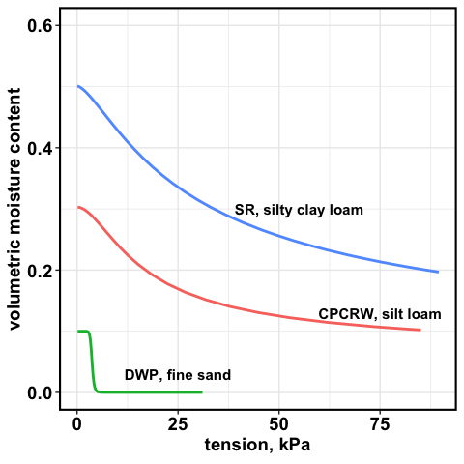

water retention curve

# WSOC tables

## soils

mg/g soil

|  |  |  |  |
| --- | --- | --- | --- |
| Treatment | CPCRW | DWP | SR |
| Drought | 0.85 ± 0.2 | 0.72 ± 0.37 | 0.6 ± 0.04 |
| Field Moist | 0.69 ± 0.07 | 0.35 ± 0.05 | 0.61 ± 0.05 |
| Saturated | 0.59 ± 0.05 | 0.39 ± 0.06 | 0.55 ± 0.06 |
| Time Zero | 0.78 ± 0.1 | 0.51 ± 0.08 | 0.43 ± 0.04 |

## pores

mg/L

|  |  |  |  |  |  |  |
| --- | --- | --- | --- | --- | --- | --- |
| Treatment | 1.5 kPa CPCRW | 1.5 kPa DWP | 1.5 kPa SR | 50 kPa CPCRW | 50 kPa DWP | 50 kPa SR |
| Drought | 111.82 ± 41.45 * | 69.02 ± 13 | 13.9 ± 2.43 | 186.86 ± 62.65 * | 69.97 ± 13.39 | 19.3 ± 8.32 |
| Field Moist | 21.22 ± 3.73 | 46.33 ± 11.94 | 18.68 ± 2.36 * | 41.17 ± 12.67 | 52.43 ± 14.74 | 19.82 ± 2.93 |
| Saturated | 52.82 ± 13.98 | 42.08 ± 7.34 | 23.16 ± 3.29 * | 63.4 ± 20.84 | 82.7 ± 16.52 | 24.07 ± 2.43 * |
| Time Zero | 26.3 ± 2.78 | 76.68 ± 21.76 | 6.03 ± 0.57 | 29.14 ± 4.41 | 92.33 ± 22.22 | 7.28 ± 0.34 |

## pores

mg/g

|  |  |  |  |  |  |  |
| --- | --- | --- | --- | --- | --- | --- |
| Treatment | 1.5 kPa CPCRW | 1.5 kPa DWP | 1.5 kPa SR | 50 kPa CPCRW | 50 kPa DWP | 50 kPa SR |
| Drought | 25.81 ± 12.78 | NaN ± NA | 2.81 ± 0.55 | 3.45 ± 2.06 | NaN ± NA | 0.54 ± 0.05 |
| Field Moist | 4.52 ± 1.73 | 4.02 ± 1.45 | 4.03 ± 0.95 | 0.9 ± 0.32 | 0.4 ± 0.08 | 0.96 ± 0.27 |
| Saturated | 19.7 ± 6.62 | 5.94 ± 2.58 | 5.25 ± 0.84 | 1.05 ± 0.28 | 0.58 ± 0.26 | 1.4 ± 0.36 |
| Time Zero | 5.1 ± 1.8 | 4.42 ± 1.98 | 1.46 ± NA | 1.05 ± 0.24 | 1.26 ± 0.77 | NaN ± NA |

# FTICR Soil – figures

## native SOM

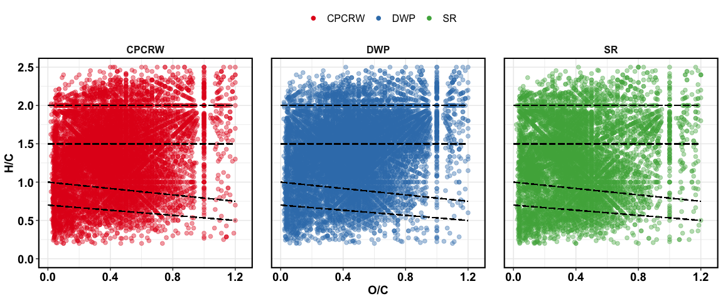

Van Krevelen plot for baseline soil

## treatment effect – all peaks

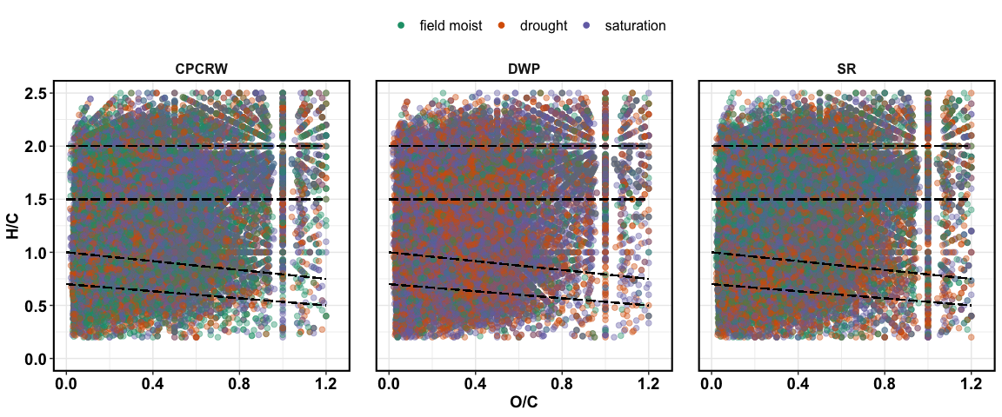

Van Krevelen plot for treatments

## treatment effect – unique peaks

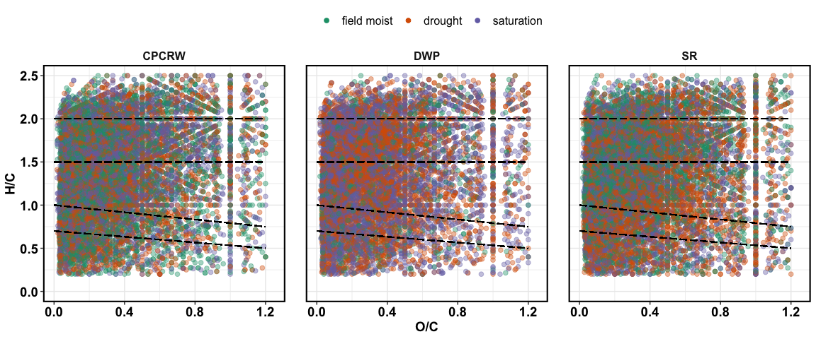

Van Krevelen plot for unique peaks

## treatment effect – relative abundance

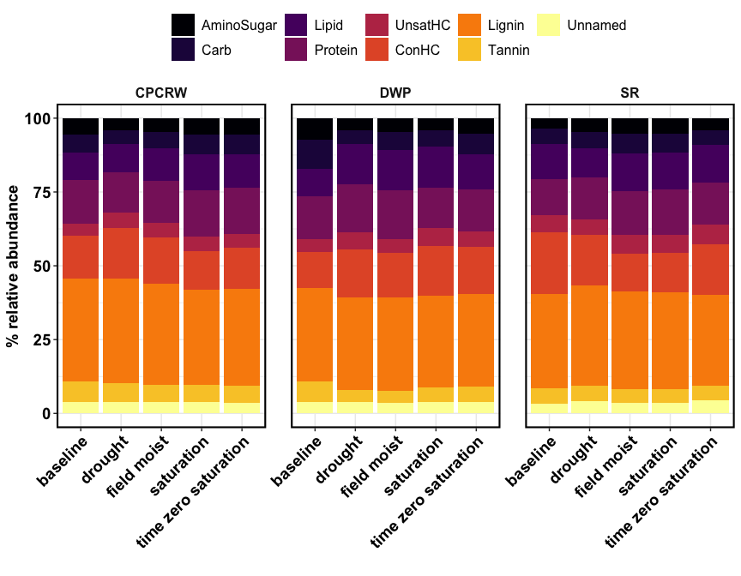

Relative abundance

## NOSC

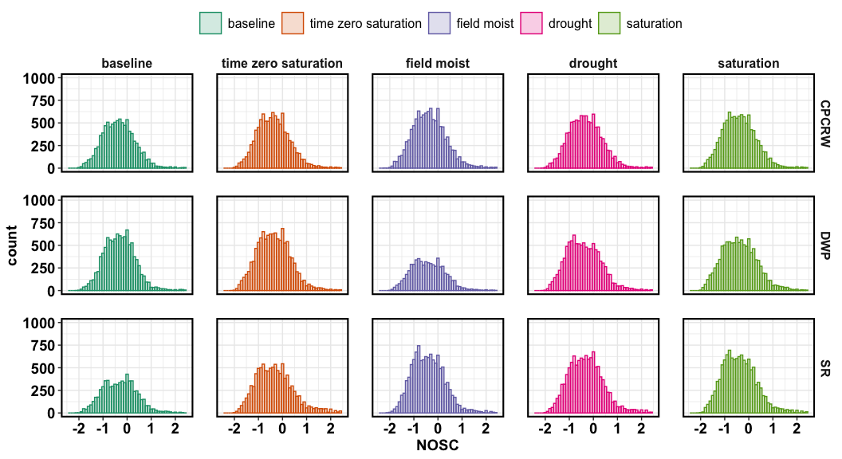

NOSC for CPCRW

## NOSC table

|  |  |  |  |  |  |
| --- | --- | --- | --- | --- | --- |
| site | baseline | drought | field moist | saturation | time zero saturation |
| CPCRW | -0.3636 | -0.3529 | -0.3846 | -0.4211 | -0.4000 |
| DWP | -0.3200 | -0.4545 | -0.4444 | -0.4211 | -0.3871 |
| SR | -0.2963 | -0.3333 | -0.4444 | -0.4286 | -0.3750 |

## aromatic peaks

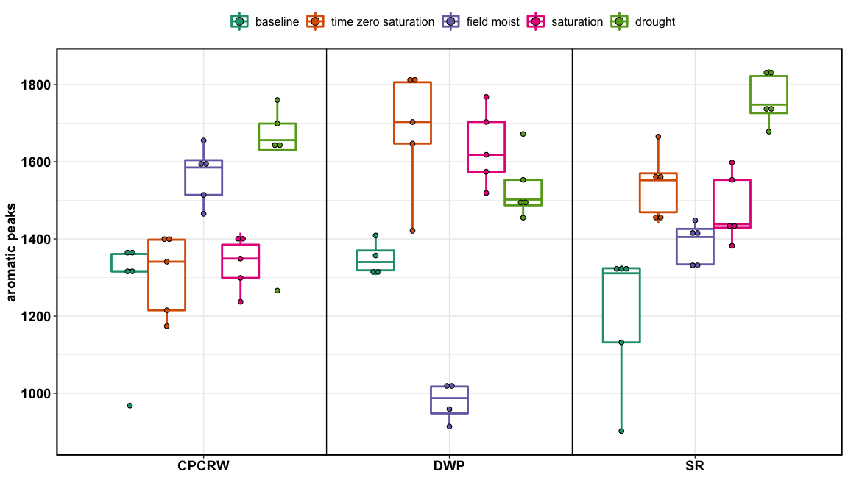

aromatic peaks

# FTICR Soil – tables

## relative abundance

|  |  |  |  |  |  |  |
| --- | --- | --- | --- | --- | --- | --- |
| site | Class | baseline | drought | field moist | saturation | time zero saturation |
| CPCRW | AminoSugar | 5.46 ± 0.16 | 4.06 ± 0.11 * | 4.63 ± 0.1 * | 5.66 ± 0.11 | 5.53 ± 0.15 |
| CPCRW | Carb | 6.16 ± 0.16 | 4.57 ± 0.06 * | 5.53 ± 0.1 * | 6.64 ± 0.12 * | 6.72 ± 0.12 |
| CPCRW | Lipid | 9.3 ± 0.34 | 9.8 ± 0.17 | 11.16 ± 0.23 * | 12.22 ± 0.2 * | 11.43 ± 0.28 |
| CPCRW | Protein | 14.68 ± 0.24 | 13.48 ± 0.19 * | 14 ± 0.13 | 15.67 ± 0.17 * | 15.44 ± 0.3 |
| CPCRW | UnsatHC | 4.1 ± 0.27 | 5.4 ± 0.17 * | 5.2 ± 0.08 * | 4.89 ± 0.07 * | 4.82 ± 0.04 |
| CPCRW | ConHC | 14.62 ± 0.43 | 16.89 ± 0.38 * | 15.51 ± 0.1 | 12.99 ± 0.23 * | 13.8 ± 0.26 |
| CPCRW | Lignin | 34.91 ± 0.48 | 35.65 ± 0.18 | 34.32 ± 0.32 | 32.26 ± 0.23 * | 32.77 ± 0.32 |
| CPCRW | Tannin | 6.91 ± 0.29 | 6.24 ± 0.08 * | 5.69 ± 0.08 * | 5.86 ± 0.12 * | 5.84 ± 0.1 |
| CPCRW | Unnamed | 3.84 ± 0.11 | 3.91 ± 0.05 | 3.96 ± 0.02 | 3.81 ± 0.07 | 3.65 ± 0.1 |
| DWP | AminoSugar | 7.31 ± 0.12 | 4.1 ± 0.07 * | 4.7 ± 0.05 * | 4.08 ± 0.09 * | 5.21 ± 0.15 |
| DWP | Carb | 9.92 ± 0.05 | 4.64 ± 0.07 * | 6.07 ± 0.08 * | 5.51 ± 0.12 * | 6.92 ± 0.12 |
| DWP | Lipid | 9.31 ± 0.08 | 13.72 ± 0.22 * | 13.65 ± 0.09 * | 13.85 ± 0.3 * | 12.05 ± 0.47 |
| DWP | Protein | 14.49 ± 0.11 | 16.29 ± 0.19 * | 16.48 ± 0.14 * | 13.77 ± 0.16 * | 14.04 ± 0.06 |
| DWP | UnsatHC | 4.19 ± 0.03 | 5.58 ± 0.05 * | 4.75 ± 0.05 * | 6.23 ± 0.07 * | 5.47 ± 0.16 |
| DWP | ConHC | 12.17 ± 0.22 | 16.38 ± 0.09 * | 15.19 ± 0.23 * | 16.71 ± 0.3 * | 15.82 ± 0.12 |
| DWP | Lignin | 31.74 ± 0.17 | 31.48 ± 0.19 | 31.57 ± 0.19 | 31.03 ± 0.25 | 31.49 ± 0.32 |
| DWP | Tannin | 7.03 ± 0.05 | 4.07 ± 0.09 * | 4.15 ± 0.11 * | 4.91 ± 0.1 * | 5.11 ± 0.15 |
| DWP | Unnamed | 3.84 ± 0.04 | 3.74 ± 0.07 | 3.44 ± 0.1 * | 3.91 ± 0.07 | 3.89 ± 0.04 |
| SR | AminoSugar | 3.41 ± 0.13 | 4.64 ± 0.08 * | 5.26 ± 0.22 * | 5.13 ± 0.11 * | 4.18 ± 0.06 |
| SR | Carb | 5.33 ± 0.03 | 5.48 ± 0.11 | 6.56 ± 0.45 * | 6.63 ± 0.38 * | 4.94 ± 0.19 |
| SR | Lipid | 12.02 ± 0.23 | 10.06 ± 0.26 * | 12.78 ± 0.21 | 12.45 ± 0.15 | 12.79 ± 0.17 |
| SR | Protein | 12.17 ± 0.47 | 14 ± 0.39 * | 14.93 ± 0.48 * | 15.35 ± 0.19 * | 14.15 ± 0.2 |
| SR | UnsatHC | 5.76 ± 0.13 | 5.37 ± 0.13 | 6.32 ± 0.13 * | 6.16 ± 0.1 | 6.61 ± 0.11 |
| SR | ConHC | 20.77 ± 0.76 | 17.19 ± 0.19 * | 12.84 ± 0.89 * | 13.3 ± 0.48 * | 17.08 ± 0.3 |
| SR | Lignin | 31.98 ± 0.26 | 33.9 ± 0.42 * | 33.08 ± 0.16 * | 32.68 ± 0.22 | 30.76 ± 0.31 |
| SR | Tannin | 5.24 ± 0.13 | 5.28 ± 0.12 | 4.7 ± 0.06 * | 4.74 ± 0.08 * | 5.1 ± 0.04 |
| SR | Unnamed | 3.32 ± 0.06 | 4.09 ± 0.05 * | 3.53 ± 0.08 | 3.56 ± 0.16 | 4.38 ± 0.15 |

## peaks

|  |  |  |  |  |  |  |
| --- | --- | --- | --- | --- | --- | --- |
| site | Class | baseline | drought | field moist | saturation | time zero saturation |
| CPCRW | AminoSugar | 495 | 431 | 523 | 587 | 540 |
| CPCRW | Carb | 554 | 472 | 603 | 675 | 655 |
| CPCRW | Lipid | 914 | 1056 | 1304 | 1353 | 1226 |
| CPCRW | Protein | 1313 | 1366 | 1528 | 1627 | 1527 |
| CPCRW | UnsatHC | 427 | 608 | 618 | 577 | 544 |
| CPCRW | ConHC | 1358 | 1684 | 1711 | 1379 | 1376 |
| CPCRW | Lignin | 3032 | 3414 | 3596 | 3237 | 3156 |
| CPCRW | Tannin | 587 | 603 | 598 | 585 | 563 |
| CPCRW | Unnamed | 385 | 428 | 463 | 436 | 391 |
| CPCRW | total | 9065 | 10062 | 10944 | 10456 | 9978 |
| DWP | AminoSugar | 742 | 435 | 291 | 448 | 615 |
| DWP | Carb | 994 | 476 | 369 | 589 | 774 |
| DWP | Lipid | 990 | 1462 | 841 | 1555 | 1447 |
| DWP | Protein | 1480 | 1653 | 982 | 1458 | 1615 |
| DWP | UnsatHC | 461 | 632 | 308 | 716 | 683 |
| DWP | ConHC | 1272 | 1649 | 923 | 1787 | 1839 |
| DWP | Lignin | 3215 | 3088 | 1868 | 3191 | 3551 |
| DWP | Tannin | 706 | 425 | 259 | 523 | 596 |
| DWP | Unnamed | 406 | 415 | 223 | 454 | 486 |
| DWP | total | 10266 | 10235 | 6064 | 10721 | 11606 |
| SR | AminoSugar | 247 | 552 | 625 | 607 | 427 |
| SR | Carb | 373 | 631 | 776 | 755 | 495 |
| SR | Lipid | 835 | 1220 | 1546 | 1505 | 1316 |
| SR | Protein | 836 | 1618 | 1725 | 1782 | 1406 |
| SR | UnsatHC | 410 | 651 | 767 | 770 | 687 |
| SR | ConHC | 1368 | 2000 | 1503 | 1621 | 1737 |
| SR | Lignin | 2111 | 3758 | 3702 | 3651 | 2951 |
| SR | Tannin | 362 | 607 | 536 | 547 | 510 |
| SR | Unnamed | 252 | 504 | 448 | 461 | 481 |
| SR | total | 6794 | 11541 | 11628 | 11699 | 10010 |
| ## uniqu | e peaks |  |  |  |  |  |

|  |  |  |  |  |
| --- | --- | --- | --- | --- |
| site | Class | drought | field moist | saturation |
| CPCRW | AminoSugar | 153 | 161 | 166 |
| CPCRW | Carb | 150 | 190 | 209 |
| CPCRW | Lipid | 513 | 659 | 674 |
| CPCRW | Protein | 469 | 484 | 552 |
| CPCRW | UnsatHC | 289 | 284 | 298 |
| CPCRW | ConHC | 634 | 650 | 440 |
| CPCRW | Lignin | 965 | 1012 | 844 |
| CPCRW | Tannin | 157 | 147 | 149 |
| CPCRW | Unnamed | 202 | 221 | 210 |
| DWP | AminoSugar | 147 | 72 | 140 |
| DWP | Carb | 125 | 71 | 184 |
| DWP | Lipid | 734 | 271 | 832 |
| DWP | Protein | 627 | 194 | 515 |
| DWP | UnsatHC | 329 | 123 | 386 |
| DWP | ConHC | 620 | 236 | 735 |
| DWP | Lignin | 962 | 323 | 1043 |
| DWP | Tannin | 151 | 58 | 189 |
| DWP | Unnamed | 222 | 84 | 251 |
| SR | AminoSugar | 196 | 171 | 172 |
| SR | Carb | 211 | 184 | 168 |
| SR | Lipid | 541 | 690 | 647 |
| SR | Protein | 517 | 522 | 521 |
| SR | UnsatHC | 257 | 319 | 332 |
| SR | ConHC | 851 | 511 | 632 |
| SR | Lignin | 1110 | 966 | 964 |
| SR | Tannin | 246 | 147 | 175 |
| SR | Unnamed | 253 | 211 | 221 |