Ministry of Higher Education

LANDMARK METROPOLITAN UNIVERSITY INSTITUTE (LMUI) BUEA

“Training Productive Leaders”


School: Landmark School of Science Engineering and Technology
Department: Software Engineering
Design and Implementation of a Localized Informal Job Market Place for Short-Term Jobs in Cameroon(Gigle)

A Long Essay Submitted in Partial Fulfilment of the Requirements for the Award of a
Bachelor of Technology (B.Tech) Degree in software engineering

A Project report Submitted in Partial Fulfilment of the Requirements for the Award of a
Bachelor of Technology (B.Tech) Degree in software engineering

Presented by
Tayu Didier Shalanyuy
LMUI250964

Supervisor
Mr. Ndohnwi Derick

July 2026

CERTIFICATION

This is to certify that this Project report is written and presented to Landmark Metropolitan University Institute by Tayu Didier Shalanyuy in partial fulfilment of the requirements for the award of a Bachelor in Technology (B.Tech) Degree in Software Engineering is original and suitable for public presentation.

STUDENT
Tayu Didier Shalanyuy
………………………………
SIGN ………………………..
DATE ………………………

STUDENT
Mr Ndohnwi Derrick
………………………………
SIGN …………………………

DATE ………………………...

DEDICATION
This work is dedicated to my parents

ACKNOWLEDGEMENTS
I would like to sincerely thank Landmark Metropolitan University particularly its Faculty of Engineering Technology and the Department of Software Engineering for providing the academic infrastructure, resources, and enabling environment that made this research possible.
I am profoundly grateful to my supervisor, Mr. Ndohnwi Derick, for his intellectual guidance, patience, and consistent encouragement throughout the design and implementation of this project. His thoughtful feedback at every stage of development shaped both the quality and direction of this work.
I am deeply thankful to my family and friends for their endless patience and moral support during late nights and demanding sprints. This achievement belongs to all of us.
Finally above all Thanking God for his care and protection through out this entire journey

LIST OF ABBREVIATIONS AND ACRONYMS
Abbreviation | Full Meaning
API | Application Programming Interface
BEAC | Banque des États de l'Afrique Centrale
CSS | Cascading Style Sheets
DB | Database
GDPR | General Data Protection Regulation
HTTP/HTTPS | HyperText Transfer Protocol / Secure
INS | Institut National de la Statistique
ILO | International Labour Organization
JWT | JSON Web Token
KPI | Key Performance Indicator
LMUI | Landmark Metropolitan University Institute
MoMo | Mobile Money
MVP | Minimum Viable Product
PWA | Progressive Web Application
RBAC | Role-Based Access Control
RLS | Row Level Security
REST | Representational State Transfer
SPA | Single Page Application
SQL | Structured Query Language
TAM | Technology Acceptance Model
UI/UX | User Interface / User Experience
UML | Unified Modeling Language
URL | Uniform Resource Locator
UUID | Universally Unique Identifier
VITE | Build Tool for Modern Web Projects

LIST OF TABLES

Table 1: GigGle System Cost Evaluation 18
Table 2: GigGle Project Schedule 19
Table 3: GigGle Data Dictionary 34
Table 4: Unit Tests 47
Table 5: Integration Tests 51
Table 6: System Tests 54

LIST OF FIGURES

Figure 1: GigGle Use Case Diagram 28
Figure 2: Sequence Diagram Job Posting and Application Flow 29
Figure 3: Sequence Diagram Registration and On-boarding 30
Figure 4: Activity Diagram – End-to-End Gig Lifecycle 31
Figure 5: GigGle 3-Tier Architecture Diagram 32
Figure 6: GigGle Class Diagram 33
Figure 7: Entity-Relationship Diagram 34
Figure 8: Worker Registration / Login Screen 40
Figure 9: Worker Dashboard Interface 41
Figure 10: Job Browsing Interface with Category Filter 41
Figure 11: Job Application and Status Tracking Panel 42
Figure 12: Real-Time Chat Interface Between Worker and Employer 43
Figure 13: Post-Completion Rating Interface 43
Figure 14: Employer Dashboard – Job Management 44
Figure 15: Admin Dashboard – Analytics Overview 44

Table of Contents
CERTIFICATION 2
DEDICATION 3
ACKNOWLEDGEMENTS 4
LIST OF ABBREVIATIONS 5
LIST OF FIGURES 7
ABSTRACT 9

CHAPTER ONE
GENERAL INTRODUCTION
1.1 Introduction 10
1.2 Background of the Study 10
1.3 Problem Statement 11
1.4 Objectives of the Study 11
1.5 Significance of the Study 12
1.6 Scope of the Study 12
1.7 Definition of Terms 12
1.8 Organization of the Study 13
CHAPTER TWO
LITERATURE REVIEW
2.1 Introduction 15
2.2 Review of Related Concepts / Conceptual Framework 15
2.3 Review of Related Works 17
2.4 Data Collection Methods 19
2.5 Population and Sampling 19
2.6 Proposed Solution 19
CHAPTER THREE
MATERIALS AND METHODS USED
3.1 Introduction 21
3.2 Development Methodology Used 21
3.3 Tools and Materials Used 21
3.4 System Modules 22
3.5 System Analysis 23

CHAPTER FOUR
IMPLEMENTATION METHODS AND TESTING
4.1 Introduction 34
4.2 Implementation 34
4.3 Results 36
4.4 System Testing Strategies 41
4.4.1 Unit Testing 41
4.4.2 Integration Testing 43
4.4.3 System Testing 44
CHAPTER FIVE
SUMMARY, FINDINGS,CONCLUSIONS AND RECOMMENDATIONS
5.1 Discussions 47
5.2 Conclusions 48
5.3 Recommendations 48
5.4 Perspectives for Further Study 49
REFERENCES 50

ABSTRACT

This project presents GigGle, a web-based gig labor platform designed to connect Cameroonian informal workers with individuals and households seeking temporary task assistance. The system addresses persistent structural inefficiencies in Cameroon's urban informal labor market where high worker availability and strong employer demand coexist without an efficient digital bridge by providing role-based portals for Workers, Employers, and Administrators. Built using React.js, Tailwind CSS, and Supabase (PostgreSQL with Row Level Security), the platform delivers geographic radius-based job filtering using Leaflet.js and PostGIS, a real-time messaging system via Supabase Realtime channels, a mutual post-completion rating system for digital trust building, and a mobile money payment acknowledgment workflow integrated with the Fapshi payment API for MTN MoMo and Orange Money transactions. End-to-end simulation testing successful execution of all core MVP features including role-based authentication, job posting and browsing, application lifecycle management, real-time chat, job completion confirmation, and the reputation system. Message delivery latency in the local simulation environment was observed at under one second. The platform's architecture, deployed on Vercel with a Supabase-managed backend, supports scalable multi-role access with zero custom server infrastructure. GigGle demonstrates that a locally-designed, mobile-optimized digital platform can substantially reduce the transaction costs of informal labor matching in a developing economy context.

Keywords: Gig economy, digital labor marketplace, informal sector, mobile money, reputation system, geographic filtering, role-based access control, real-time messaging, serverless architecture.

CHAPTER ONE

GENERAL INTRODUCTION

1.1 Introduction
Digital platforms are now primary intermediaries between service providers and consumers across the global economy. In developing economies, this digital shift carries particular significance, offering the potential to organize and formalize labor exchanges that have historically depended on informal networks, geographic proximity, and word-of-mouth referrals. This project introduces GigGle, a web-based gig labor platform designed specifically for the Cameroonian urban context, connecting informal workers with individuals and households seeking short-term task assistance.
GigGle is built on four core value propositions: a digital reputation system to build verifiable trust between strangers, geographic radius filtering to surface contextually relevant job listings, integrated real-time messaging to centralize coordination, and a mobile money payment acknowledgment process aligned with Cameroon's dominant financial infrastructure. Together, these features provide the digital backbone for a labor exchange that Cameroonians already participate in offline, but have lacked the structured, scalable tools to conduct efficiently at scale.

1.2 Background of the Study
Digital platforms have become vital lifelines for students, retirees, and those seeking supplementary income. Within developing economies, this digital shift is especially critical, serving as a bridge between rigid formal employment and the often-unreliable informal daily wage sector.
In Cameroon, the labor market faces a dual crisis of unemployment and chronic underemployment. National data from the Institut National de la Statistique (INS, 2020) indicates a 6.4% unemployment rate, but the more telling figure is the 75% underemployment rate in urban centers like Douala, Yaoundé, and Bafoussam. Youth aged 15–35, who make up over 60% of the population, are disproportionately affected. Finding daily work remains a matter of luck making calls, roaming neighborhoods, relying on rumors, or hoping a WhatsApp group post bears fruit.
Simultaneously, middle-class urbanites seek domestic and technical help but lack reliable ways to identify and vet service providers. This mismatch a large workforce on one side and high service demand on the other S persists despite mobile phone penetration exceeding 80% and mobile money services like MTN MoMo and Orange Money reaching over 12 million users (BEAC, 2021). The existing digital infrastructure has not been organized into a tool for local labor market coordination. GigGle addresses precisely this gap.
Example global platforms such as Fiverr and TaskRabbit, while successful in high-income markets, fail to address the Cameroonian context because they anchor payments to credit cards and international bank transfers that most local users cannot access. GigGle is designed to succeed where these platforms fail, by integrating mobile money, optimizing for low-bandwidth conditions, and building trust mechanisms appropriate to the local social and economic context.

1.3 Problem Statement
In many Communities in Cameroon, individuals seeking short-term or flexible employment struggle to find accessible, reliable, and timely job opportunities, while businesses and individuals needing temporary labor lack an efficient way to connect with qualified, available workers. Existing job platforms focus predominantly on formal full-time or long-term roles, leaving the market for on-demand, short-term informal gigs fragmented, inefficient, and largely offline.
This mismatch results in lost income for workers, unmet labor needs for employers, and a general lack of trust, transparency, and convenience in securing or filling short-term engagements.

1.4 Objectives of the Study
General Objective
To design and develop a centralized digital marketplace that connects individuals and businesses seeking short-term labor with qualified workers available for on-demand jobs, thereby eliminating market fragmentation, reducing inefficiencies in job discovery and fulfillment, and creating a trusted, transparent, and seamless experience for both parties.
Specific Objectives
- To build the platform's core engine including dynamic profile management for both job seekers and job posters, location-aware job browsing with radius filtering, and direct worker-to-employer messaging.
- To implement a transparent rating and review system that enables digital trust between transacting strangers.
- To build a secure payment acknowledgment gateway using mobile money providers MTN MoMo and Orange Money through the Fapshi API.
- To establish an administrator dashboard for handling users,user disputes and complaints and maintaining platform integrity.

1.5 Significance of the Study
This project offers tangible value across several dimensions of society:
- For Workers: GigGle provides a digital resume that is permanently accessible. A student can build a five-star rating record that makes them more discoverable and credible to prospective employers than informal referrals alone.
- For Employers: The platform offers peace of mind through verified reputations. Users can review a worker's rating history, skills, and prior job feedback before making contact.
- For the Economy: By moving informal transactions onto a structured digital platform, GigGle helps surface economic activity that is currently invisible to data collection, providing inputs for future urban planning and labor policy.
- For Academics: The project provides a blueprint for technology localization in developing economies. Most digital platform research focuses on high-income, high-infrastructure markets. This study explores how technology can adapt to the African, Cameroon socioeconomic context.
- For the University: The project demonstrates that software engineering students at LMUI can build locally relevant, technically sound platforms using modern development methodologies and tools.

1.6 Scope of the Study
GigGle is scoped to manage the complete lifecycle of a short-term gig from initial job posting to post-completion rating. The platform targets three specific user groups Workers, Employers, and Administrators and focuses geographically on major urban centers including Douala, Yaoundé, Bafoussam, and Bamenda. The system covers short-term job categories (not exceeding six months) such as cleaning, tutoring, repairs, caregiving, delivery, event labor, and digital services.
The platform does not handle long-term corporate hiring, payroll management, tax-related employment compliance, or direct banking API integrations. Payment settlement is handled through an automated mobile money escrow workflow integrated with the Fapshi API: the employer funds escrow via an MTN MoMo or Orange Money prompt, funds are held by the platform until the job is marked complete, and the employer then releases the payout directly to the worker's mobile money number, with a platform commission deducted from the payout.

1.7 Definition of Terms
The following terms are used throughout this report with the meanings defined below:
- Gig: A short-term, task-based work assignment paid per job rather than through ongoing employment.
- Worker: A platform user who registers to offer services and accept job assignments.
- Employer: A platform user who posts job listings and hires workers for specific tasks.
- Mobile Money (MoMo): A digital payment service allowing financial transactions via mobile phone without a bank account; MTN MoMo and Orange Money are the primary providers in Cameroon.
- Reputation System: A platform feature that aggregates ratings and reviews to produce a visible trust score for each user based on past transaction performance.
- Geographic Filtering: A search mechanism that surfaces job listings within a specified distance from the user's location using GPS coordinates.
- Row Level Security (RLS): A database security model in which each database row is protected by policies defining which users may read or write it.
- Role-Based Access Control (RBAC): A security model that restricts system functionality based on the authenticated user's assigned role.
- Progressive Web Application (PWA): A web application that delivers app-like functionality including offline access and installability through modern browser features.
- Supabase: An open-source backend platform providing a managed PostgreSQL database, authentication, real-time subscriptions, and file storage.
- Sprint: A time-boxed development iteration in the Agile Scrum methodology, typically one to four weeks, producing a functional and testable increment.
- Escrow: A financial arrangement in which a third party holds payment funds until agreed conditions are met by both transacting parties.

1.8 Organization of the Study
This report is structured into five chapters:
- Chapter One introduces the problem context, study background, problem statement, objectives, significance, scope, and key terminology.
- Chapter Two reviews existing literature on digital labor platforms, gig economies, mobile money, and related theoretical frameworks; surveys prior systems; and proposes the GigGle system architecture.
- Chapter Three details the development methodology, hardware and software requirements, system modules, functional and non-functional analysis, and full system design including UML diagrams and data dictionary.
- Chapter Four presents implementation logic, test scenarios, results, and system demonstration screenshots.
- Chapter Five summarizes findings, draws conclusions, offers recommendations, and outlines perspectives for further study.

CHAPTER TWO

LITERATURE REVIEW

2.1 Introduction
This chapter critically examines existing models, frameworks, and implementations pertinent to digital gig labor platforms in developing economies with a particular focus on the Cameroonian context. It identifies conceptual foundations relevant to GigGle's design, surveys prior systems and their limitations, and underscores the gaps that our proposed solution addresses. The review draws from peer-reviewed literature, empirical studies, and documented platform analyses spanning the fields of information systems, labor economics, mobile money, and platform design.

2.2 Review of Related Concepts / Conceptual Framework
2.2.1 The Gig Economy and Digital Labor Platforms
The gig economy refers to a labor market characterized by short-term, flexible, task-based work arrangements where individuals are paid per assignment rather than through traditional employment contracts. Digital labor platforms serve as an intermediary matching layer that connects supply with demand in near real time. Global examples such as TaskRabbit, Fiverr, and Uber have demonstrated that this model can scale efficiently when enabling conditions connectivity, digital payment infrastructure, and user trust are present (De Stefano, 2016).
In the African context, the gig economy is not a new phenomenon; it is the digitization of an informal sector that has always existed. What GigGle introduces is bringing that informal economy onto a structured platform where transactions are recorded, reputations are tracked, and payments are acknowledged. This aligns with findings from Lehdonvirta (2019) that platforms in developing markets succeed primarily when they build on existing informal labor practices rather than attempting to replace them with foreign models.
2.2.2 Informal Labor Markets in Sub-Saharan Africa
The informal labor market across Sub-Saharan Africa is not a marginal phenomenon; it is the dominant economic reality. According to the International Labour Organization (ILO, 2018), informal employment accounts for over 85% of total employment in Africa south of the Sahara, with most workers engaged in casual or daily-wage arrangements without formal contracts, social protection, or legal recognition. In Cameroon specifically, urban underemployment stands at approximately 75%, with most youth surviving through odd jobs found through personal networks.
These markets operate on social trust rather than institutional trust. A worker finds a job because a neighbor recommended them, or because they are a familiar face in a neighborhood. This system is geographically constrained, exclusionary to outsiders, and provides no legal protection to either party in a dispute. GigGle's core value proposition is to digitize this trust layer, making it possible for strangers to transact with confidence where formal legal enforcement mechanisms are weak.
2.2.3 Digital Trust and Reputation Systems
Trust is the central problem in any marketplace, especially when parties are strangers with no institutional backing. Reputation systems aggregate past behavioral data ratings, reviews, completion rates and make them visible to future transacting partners. This converts accumulated trust into a searchable credential that helps users make informed decisions (Resnick 2000).
In Cameroon's informal sector, a digital reputation system can substitute for word-of-mouth networks that currently gatekeep access to work. A student who consistently delivers quality service can develop a verified track record visible to any employer on the platform, regardless of social connections. Research confirms that visible reputation metrics significantly increase transaction rates and reduce pre-transaction uncertainty. GigGle's rating system is built on this principle.
2.2.4 Mobile Money as a Payment Infrastructure for the Informal Sector
Mobile money dominates digital commerce in Cameroon, with over 12 million active users as of 2021 (BEAC, 2021). MTN MoMo and Orange Money process the vast majority of informal digital transactions. This means that many workers and employers who cannot access credit cards or traditional bank accounts are already participating in the digital financial system.
Jack and Suri's landmark research on M-Pesa in Kenya (2011) demonstrated that mobile money can functionally replace banking infrastructure and substantially reduce cash-based commerce risks. While Cameroon differs contextually, the underlying logic is directly applicable: high mobile money penetration provides a ready foundation for digital platform transactions. For GigGle, mobile money integration through the Fapshi API is therefore not an optional feature but a prerequisite for the platform to function for its target population.

2.2.5 Hyperlocal Platforms and Geographic Filtering
Hyperlocal platforms specifically aggregate supply and demand within a defined geographic radius, making them particularly well-suited to urban informal labor markets where physical proximity between worker and employer is often operationally necessary. Geographic filtering leverages device GPS data to surface the most relevant job listings for each worker based on their current or stored location.
Research on African urban informal labor (Muggah & Diniz, 2018) identifies geographic fragmentation as a primary barrier to market efficiency: workers and employers who are physically proximate often cannot find each other because they operate within different social networks. Geographic radius filtering directly reduces this friction, expanding each worker's effective market beyond their immediate social circle.

2.3 Review of Related Works
The following section reviews at least five prior systems relevant to GigGle's design. For each, the author(s), technology used, key strengths, and limitations are documented.
2.3.1 Jumia Jobs (Previously Hellojobs Cameroon)
Author(s)/Year: Jumia Group, launched in Cameroon approximately 2015.
Technology: Web portal backed by a relational database; mobile-optimized frontend.
Strengths: Provided a centralized job listing portal accessible to Cameroonian users; offered category filtering and application submission.
Limitations: Focused primarily on formal employment and professional roles; payment processing not integrated; no reputation system for workers; geographic filtering limited. The platform was eventually discontinued in many African markets, suggesting its formal employment model was misaligned with local labor market realities.
2.3.2 TaskRabbit (International Platform)
Author(s)/Year: Leah Busque, founded 2008 (United States).
Technology: React Native mobile applications; Node.js backend; Stripe payment processing.
Strengths: Mature, scalable platform with a robust reputation system; geographic matching; in-app payment escrow; category-based task filtering.
Limitations: Inaccessible to the vast majority of Cameroonian users due to credit card payment requirements; no mobile money integration; designed for high-income markets with stable broadband; interface assumes high digital literacy. Cultural and linguistic fit is poor for Francophone and Pidgin-speaking Cameroonian users.
2.3.3 Fiverr (International Platform)
Author(s)/Year: Micha Kaufman and Shai Wininger, founded 2010 (Israel).
Technology: React frontend; microservices backend; PayPal and credit card payments.
Strengths: Highly scalable global platform with strong reputation system; extensive category taxonomy; supports digital service delivery.
Limitations: Entirely inaccessible in Cameroon's informal sector context requires bank accounts and credit cards; focused on remote digital services rather than physical local tasks; PayPal has limited availability in Cameroon; interface complexity excludes low-digital-literacy users.
2.3.4 Local WhatsApp Job Groups (Informal Digital Channels)
Author(s)/Year: Informal community administrators, major Cameroonian cities (ongoing).
Technology: WhatsApp messaging platform; no structured data layer.
Strengths: Highly accessible; zero cost to join; operates on existing mobile data; trusted within existing social networks; supports multimedia (photos, voice notes) for job descriptions.
Limitations: Zero dispute resolution mechanism; no payment protection or escrow; no reputation system workers cannot build verifiable track records; job listings are ephemeral and unsearchable; geographic filtering absent; accessible only to those within existing social networks, reinforcing exclusion for newcomers.
2.3.5 Afriwork (Ethiopia)
Author(s)/Year: Frehiwot Tamiru, founded approximately 2019 (Ethiopia).
Technology: Telegram-based platform (with web component); Telegram bot API and channel
Strengths: Extremely high accessibility on low-end smartphones; zero-cost entry for freelancers; operates on unstable internet connections; large established user base in East Africa; proves demand for localized digital labor matching in African markets.
Limitations: No structured reputation system trust relies on screenshots with no aggregated permanent rating score; ephemeral job listings scroll away and become unsearchable; no geographic filtering for neighborhood-specific jobs; no structured application, selection, or payment acknowledgment workflow; no role-based separation between employers and workers, creating feed noise for both parties; no formal dispute resolution mechanism; coordination reverts to unmonitored direct messaging with no audit trail.

2.4 Data Collection Methods

A mixed-methods approach was employed. Semi-structured interviews were conducted with informal workers and sending out questionaires as well in Buea to surface pain points around job-seeking, vetting, payment disputes, and digital tool usage. Observational data was also gathered from interactions between friends and family during their job seeking periods. Secondary data was gathered from the Cameroon National Institute of Statistics, the Bank of Central African States, the ILO, and peer-reviewed literature on gig economies and mobile money in Sub-Saharan Africa.

2.5 Population and Sampling

The target population comprises informal workers (students, retirees, supplementary income earners) and casual employers (individuals and households) in Cameroonian urban centers. Observational sampling was employed to select participants who could provide the most contextually relevant insights. For usability validation, a sample of approximately 40 individuals representing both user roles was .

2.6 Proposed Solution
Building on the gaps identified across existing financial management and labor platform tools, this project proposes GigGle: a web-based digital marketplace for short-term gig labor tailored for the Cameroonian urban informal economy. The core objective is to eliminate the fragmentation, trust deficits, and payment insecurity that characterize informal labor coordination, while preserving the accessibility and mobile-first character of tools that Cameroonian workers already use.
2.6.1 System Architecture Overview
The proposed system adopts a three-tier client-server architecture:
- Presentation Layer (React.js + Tailwind CSS): Worker Portal for job browsing, application submission, messaging, and profile management; Employer Dashboard for job posting, applicant review, worker selection, job completion marking, and rating submission; Admin Console for user management, content moderation, platform analytics, and dispute resolution.
- Application Layer (Supabase + PostgREST + Supabase Realtime): Authentication and role-based access control via Supabase Auth with JWT tokens; REST and GraphQL APIs auto-generated by PostgREST from the PostgreSQL schema; real-time messaging via Supabase Realtime channel subscriptions.
- Data Layer (Supabase PostgreSQL + Row Level Security + Supabase Storage): Eight-table normalized relational schema (profiles referencing Supabase Auth's built-in users, jobs, applications, messages, ratings, reports, credentials, and escrows); RLS policies enforcing that users can only access records scoped to their own role and identity; file storage for profile images and verification documents.

CHAPTER THREE

MATERIALS AND METHODS USED

3.1 Introduction
This chapter outlines the research and development methodologies, tools, materials, and architectural design employed to design and implement GigGle a hybrid digital gig labor marketplace aligned with the objectives stated in Chapter One. It details the iterative development process, hardware and software requirements, system modules, functional and non-functional requirements, cost evaluation, project schedule, and full system design including UML models and data dictionary.

3.2 Development Methodology Used
3.2.1 Agile Scrum Implementation
This study adopts the Agile Software Development methodology, specifically the Scrum framework. Agile was selected because GigGle's development context demands flexibility to respond to user needs that cannot be fully anticipated at project outset. Development is structured across four primary sprints:
Sprint planning defined user stories and broke them into tasks including UI components, database schema, Supabase RLS policies, and API integration. Daily stand-ups maintained 15-minute progress syncs. Sprint reviews showcased completed features to simulated stakeholders. Retrospectives identified process improvements such as tightening RLS policy testing procedures.

3.3 Tools and Materials Used
3.3.1 Hardware Requirements
Devices used by end users:
- Workers: Any contemporary smartphone or desktop running Chrome, Firefox, or Edge with a stable mobile data or Wi-Fi connection. Minimum: dual-core processor, 2 GB RAM.
- Employers: Desktop or laptop computer with Chrome v100+ or Firefox v95+; minimum 4 GB RAM recommended for the employer dashboard interface.
- Administrators: Workstation with a modern browser, 8 GB RAM recommended for the analytics dashboard.
- Development Machine: Laptop with SSD, 8 GB RAM, Node.js environment, and Supabase CLI installed.
- Network: Stable HTTPS access to Supabase cloud services; minimum 5 Mbps recommended; platform is optimized for 3G performance.
3.3.2 Software Requirements
Operating systems: Windows 10/11, macOS 12+, or Ubuntu 22+ (development).
Browsers: Chrome v100+, Firefox v95+, Edge v100+.
Runtime and package management:
- Node.js v18.x LTS; npm v9.x or yarn v1.22.x.
- Vite v4.x for React application scaffolding and hot module replacement.
Libraries and Frameworks:
- Frontend: React 18, Tailwind CSS, React Router v6.
- State and Data: Supabase JavaScript Client v2 (Auth, Database, Realtime, Storage), TanStack Query for caching and background refetching.
- Geographic Features: Leaflet.js with OpenStreetMap tiles; PostGIS extension on Supabase PostgreSQL for coordinate-based radius queries.
- Form Handling: React Hook Form, Zod schema validation.
- UI Components: ShadCN/UI component library.
- Payment Integration: Fapshi API for MTN MoMo and Orange Money payment acknowledgment.
CLI and DevOps:
- Supabase CLI v1.x for local development stack management.
- Git with GitHub for version control; Vercel for frontend deployment.
- Testing: Vitest and React Testing Library for unit and component tests.

3.4 System Modules
- Authentication and Role Management Module: Handles registration, login, session persistence, and role assignment. Supabase Auth manages JWT generation; role stored in profiles table and enforced by React Router protected routes.
- Job Listing and Browsing Engine: Employers create structured listings with category, description, pay, location, and timeline. Workers browse via a parameterized Supabase query using PostGIS radius calculations and category filters.
- Application and Selection Workflow: Manages the application lifecycle from submission through employer selection and automatic rejection of competing applications. Triggers the post-completion rating prompt.
- Real-Time Messaging System: Supabase Realtime channel per job_id scope. Messages persist in the messages table; new messages appear instantly in both parties' chat interfaces without page reload. Chat unlocked only after worker selection.
- Reputation and Rating System: Post-completion star ratings and optional text reviews from both parties. Aggregated into a running average displayed on public profiles. Rating submission blocked until job is confirmed complete.
- Administrator Dashboard Module: Provides tools for reviewing flagged content, suspending accounts, managing users, and viewing platform-level analytics including registration trends and job completion rates.
- Identity Verification Module: Requires workers to verify identity before browsing or applying for jobs, and employers to verify identity before posting jobs. Users upload a government ID document; administrators review submissions and approve or reject with a required reason. Approval status changes are enforced by a database trigger that prevents users from self-approving their own verification.

3.5 System Analysis
3.5.1 Functional Requirements
The following functional requirements define what the system must do:
- User Management: Workers self-register by selecting the Worker role and completing a profile. Employers self-register similarly. Administrators are assigned directly in the database.
- Job Posting and Browsing: Employers post gig listings with category, description, pay, and location. Workers browse listings filtered by geographic radius and category.
- Application and Selection: Workers apply for listings with a single action. Employers review applicant profiles and select one worker, automatically rejecting all others.
- Real-Time Messaging: Matched worker-employer pairs communicate via real-time chat scoped to the specific job.
- Job Completion and Rating: Employers confirm job completion, triggering a rating prompt for both parties.
- Administrator Controls: Admins can review reports, moderate content, suspend accounts, and view platform analytics.
- Payment Settlement: Employers fund an escrow via mobile money (MTN MoMo or Orange Money) through the Fapshi API before work begins; employers release the held funds to the worker's mobile money number upon job completion.
3.5.2 Non-Functional Requirements
- Performance: Job browsing results returned within 2 seconds on a 3G connection. Real-time message delivery latency under 1 second in the local simulation environment.
- Scalability: Supabase's managed PostgreSQL with connection pooling supports growth from hundreds to tens of thousands of users without infrastructure changes.
- Security: HTTPS enforced; Supabase RLS policies prevent unauthorized data access at the database level; JWT tokens expire and are refreshed automatically.
- Usability: Responsive UI for smartphones and desktops; intuitive workflows requiring minimal training; Tailwind CSS ensures consistent visual hierarchy.
- Availability: Vercel's CDN-backed hosting targets 99.9% uptime; Supabase's managed infrastructure provides equivalent backend reliability.
- Data Integrity: Zod schema validation on all form inputs; Supabase database constraints enforce referential integrity.
3.5.3 Cost Evaluation
The table below presents the cost evaluation for GigGle, listing all key hardware and software components with quantities and unit prices in XAF.

Category | Component | Item | Qty | Unit Price (XAF)
Hardware | Laptop | Developer workstation (LENOVO i5, 8 GB RAM) | 1 | 150,000
Hardware | Smartphone | Mobile test device (Android) | 1 | 50,000
Hardware | Internet | Mobile data / Wi-Fi (monthly) | 3 | 25,000
Software | Supabase | Backend platform (free tier) | 1 | 0
Software | Vercel | Hosting (free tier) |  | 0
Software | Fapshi | Payment API (free with commission) | 1 | 0
 |  | TOTAL |  | 225000
Table 1: GigGle System Cost Evaluation
3.5.4 Project Schedule

Phase | Duration | Dates
Requirements and Design | 2 weeks | 2026-03-02 → 2026-03-15
Sprint 1: Auth and Profiles | 2 weeks | 22026-03-16 → 2026-03-29
Sprint 2: Core Job Loop | 3 weeks | 2026-03-30 → 2026-04-19
Sprint 3: Messaging and Ratings | 2 weeks | 2026-04-20 → 2026-05-03
Sprint 4: Testing and Deployment | 2 weeks | 2026-05-04 → 2026-05-17
Documentation and Report Writing | 3 weeks | 2026-05-18 → 2026-06-07

Table 2: GigGle Project Schedule

3.5.5 Use Case Analysis
Use case diagrams visually represent the system's functional requirements by showing how actors interact with it to achieve specific goals. GigGle has three primary actors: Worker, Employer, and Administrator. The diagram below show the associations and actor usecases
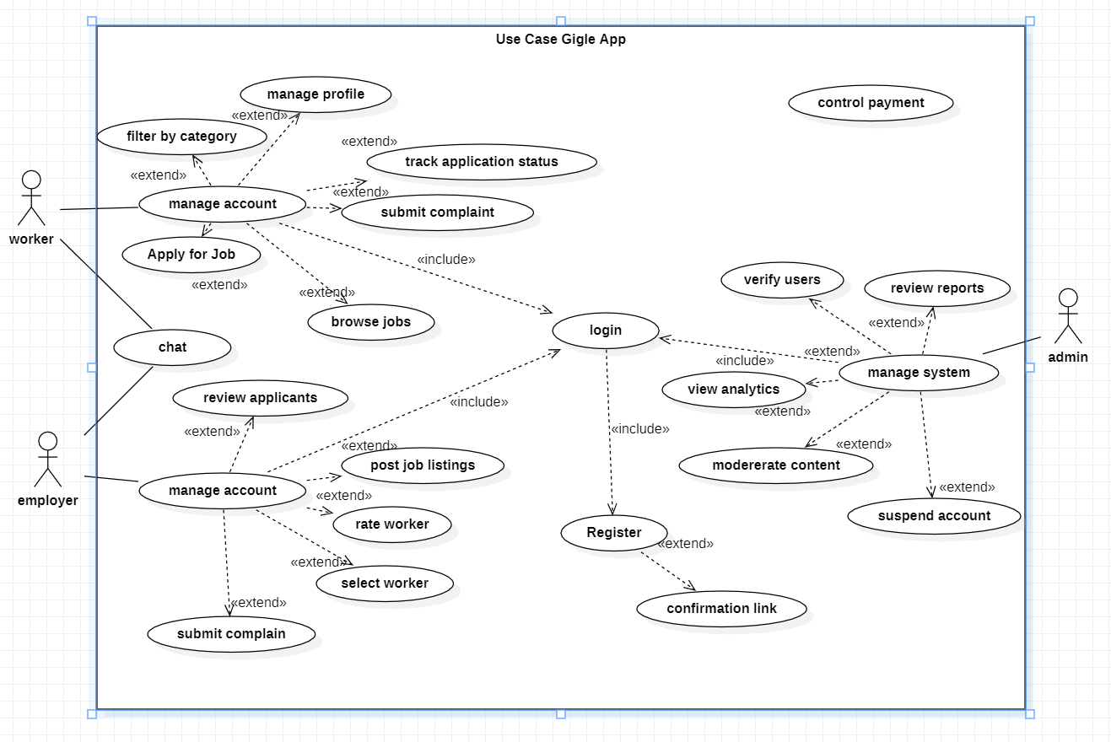
Figure 2: GigGle Use Case Diagram
3.5.6 Sequence Diagrams
Sequence diagrams illustrate how system components interact in time-ordered message sequences. They outline the step-by-step execution of key system operations.
(a) Job Posting and Application Flow: The Employer initiates by submitting a job creation form. The React frontend validates inputs client-side and calls the Supabase client insert method, transmitting data to the PostgREST API. PostgreSQL creates the job record and returns a success response. The Worker independently opens the job browsing screen, triggering a parameterized Supabase query filtered by coordinates and category. When the Worker submits an application, a new record is inserted into the applications table and the Employer is notified.
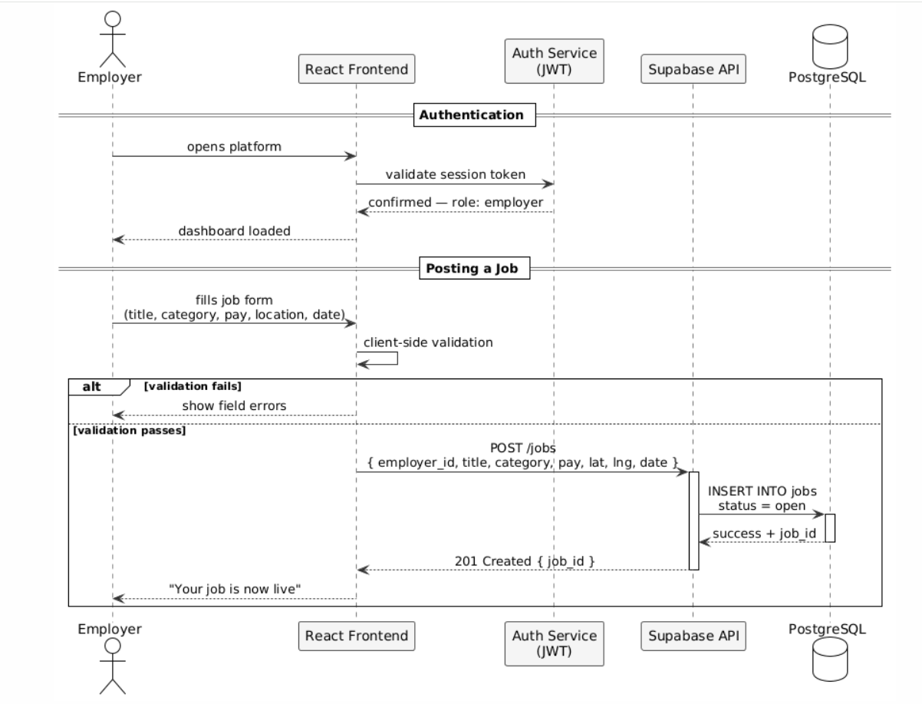
Figure 3: Sequence Diagram – Job Posting and Application Flow
(b) Registration and On-boarding: The new user opens the registration screen, selects a role, and submits email and password. Supabase Auth creates a user record and returns a JWT. A trigger creates the corresponding profile record in the profiles table with the selected role. React Router reads the role from the JWT and redirects to the appropriate dashboard.
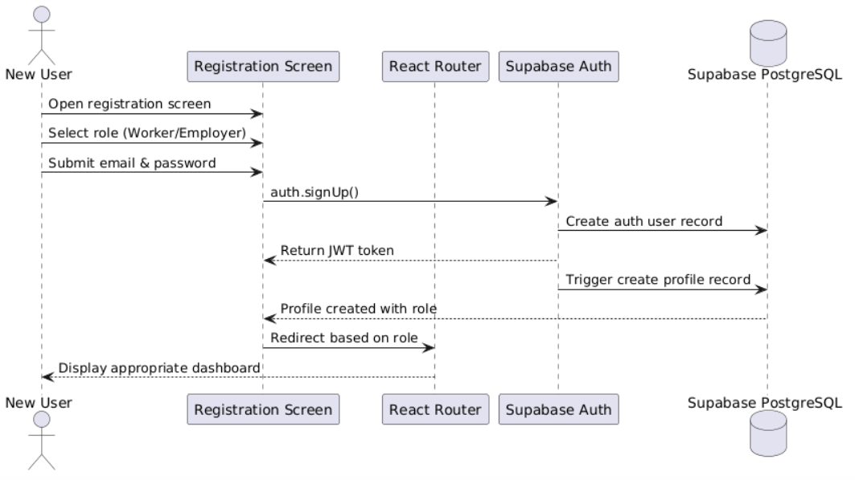
Figure 4: Student Registration and On-boarding Sequence Diagram
3.5.7 Activity Diagram
The activity diagram illustrates the complete workflow for the core gig lifecycle from job posting through worker selection, job execution, and post-completion rating capturing all decision points and parallel flows.
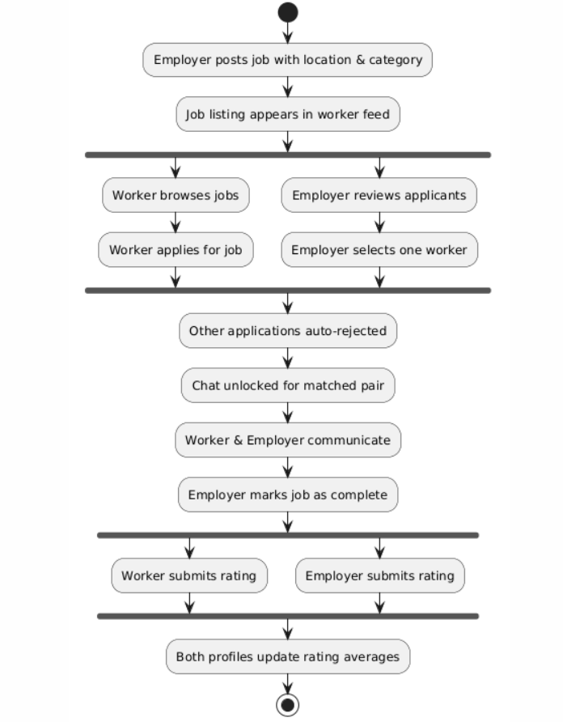
Figure 5: Activity Diagram – End-to-End Gig Lifecycle
3.6 System Design
This section presents the design architecture of GigGle, focusing on the system's structural layout, component interactions, and data flow between modules. The design adopts a three-tier architecture comprising the presentation layer, application logic layer, and data layer.
3.6.1 System Architecture
GigGle is built on a client-server architecture in which a React.js single-page application running in the user's browser communicates with a Supabase backend over HTTPS. The architecture separates the presentation layer entirely from data management, allowing the frontend to be updated and deployed independently.
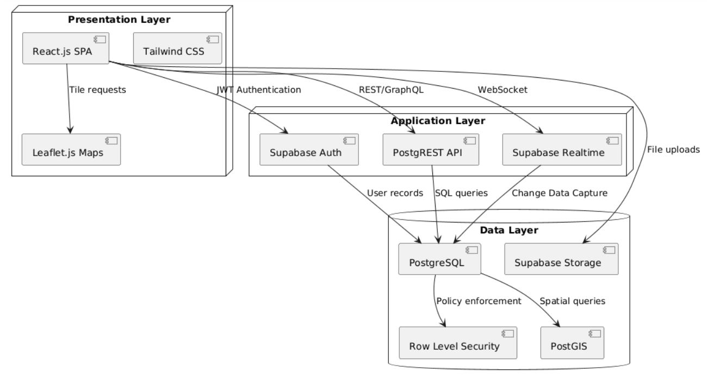
Figure 6: GigGle 3-Tier Architecture Diagram
3.6.3 Class Diagrams
Class diagrams represent the system's static structure by illustrating classes, their attributes, methods, and relationships. The User class is the base from which Worker and Employer inherit. The Job class contains a reference to the creating Employer. The Application class references both a Worker and a Job. The Message class is scoped to a Job. The Rating class references the rated User and the associated Job.
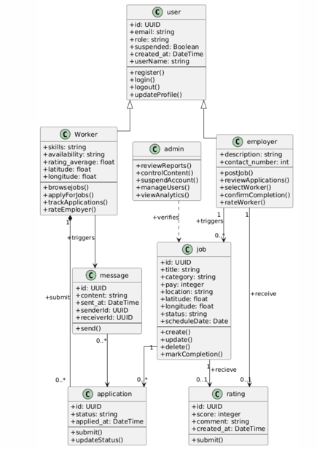
Figure 7: GigGle Class Diagram

3.6.4 Entity-Relationship Diagram
The Entity-Relationship Diagram shows the key entities and their relationships in the GigGle system. The USERS entity has a one-to-many relationship with JOBS (as employers) and APPLICATIONS (as workers). The JOBS entity has a one-to-many relationship with APPLICATIONS and MESSAGES. The RATINGS entity references both the rated USER and the associated JOB.
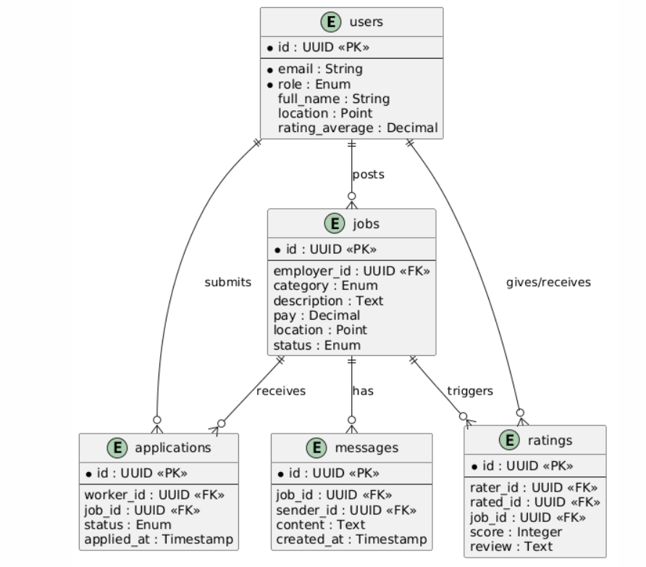
Figure 8: Entity-Relationship Diagram

3.6.5 Data Dictionary
Field Name | Data Type | Description | Constraints
id (user) | UUID | Unique identifier for each user | Auto-generated by Supabase Auth
email | String | User email address | Required; unique; valid email format
role | Enum | User role in the system | Values: 'worker', 'employer', 'admin'
full_name | String | User's full name | Required; alphabetic characters; max 100 chars
location | Point (PostGIS) | User's geographic coordinates | Stored as latitude/longitude pair
rating_average | Decimal | Aggregated rating score | Range 1.0–5.0; null until first rating received
job_id | UUID | Unique identifier for each job listing | Auto-generated; primary key of jobs table
category | Enum | Job service category | Values: cleaning, tutoring, repairs, delivery, etc.
status (job) | Enum | Current state of the job listing | Values: 'open', 'awaiting_funding', 'in_progress', 'completed', 'cancelled'
pay | Decimal (XAF) | Offered payment for the job | Must be > 0
application_id | UUID | Unique identifier for each application | Auto-generated; primary key of applications table
status (app) | Enum | Application state | Values: 'pending', 'accepted', 'rejected'
message_id | UUID | Unique message identifier | Auto-generated by database
content | Text | Message body | Required; max 2000 characters
rating_id | UUID | Unique rating identifier | Auto-generated by database
score | Integer | Star rating submitted | Range 1–5; required
status (escrow) | Enum | Current state of the escrow payment | Values: 'pending_funding', 'held', 'releasing', 'released', 'refunding', 'refunded', 'failed'
gross_amount | Decimal (XAF) | Total amount funded by employer into escrow | Must equal job pay; required
commission_amount | Decimal (XAF) | Platform fee deducted from payout | Auto-calculated; >= 0
payout_amount | Decimal (XAF) | Amount released to worker | gross_amount minus commission_amount
fund_trans_id | String | Fapshi transaction reference for the funding leg | Auto-generated by Fapshi on successful collection
payout_trans_id | String | Fapshi transaction reference for the payout leg | Auto-generated by Fapshi on successful payout
verification_status | Enum | Identity verification state for a user | Values: 'pending', 'approved', 'rejected'
id_document_url | String | Path to the uploaded ID document in private storage | Required for verification submission; admin-only read access
rejection_reason | Text | Reason provided by admin when rejecting a verification submission | Required when verification_status = 'rejected'

Table 3: GigGle Data Dictionary

CHAPTER FOUR

IMPLEMENTATION RESULTS AND TESTING

4.1 Introduction
This chapter provides a comprehensive overview of the implementation of GigGle, presenting the technology stack integration details, user role implementation logic, key system component behaviors, and end-to-end simulation results. Testing strategies including unit, integration, and system testing are documented with test cases, acceptance criteria, and outcomes. Emphasis is placed on validating the four core value propositions of the platform: geographic filtering, real-time messaging, reputation building, and mobile money payment acknowledgment.

4.2 Implementation
4.2.1 Technology Stack Implementation
The GigGle platform was implemented using the following stack:
- Frontend: React 18 (scaffolded via Vite) with Tailwind CSS for responsive component rendering; React Router v6 for client-side navigation and route protection.
- Backend: Supabase platform providing managed PostgreSQL, auto-generated REST API via PostgREST, real-time subscriptions via Supabase Realtime, and file storage via Supabase Storage.
- Authentication: Supabase Auth with JWT tokens; role stored in profiles table and enforced by React Router protected route wrappers.
- Geographic Features: Leaflet.js with OpenStreetMap tiles for the interactive job map; PostGIS extension for coordinate-based radius filtering queries.
- Payment Integration: Fapshi sandbox API for MTN MoMo and Orange Money escrow funding and payout workflows.
- Hosting: Frontend deployed on Vercel; Supabase backend on Supabase's managed cloud. GitHub Actions configured for CI/CD on merge to main branch.
4.2.2 User Roles and Permissions
The system enforces Role-Based Access Control through Supabase Row Level Security policies combined with React Router protected routes. The roles are:
- Worker: Browse jobs, apply for listings, access accepted-job chat, submit post-completion ratings, view own profile and application history.
- Employer: Post and manage job listings, review applicants, select workers, access accepted-job chat, confirm job completion, submit post-completion ratings.
- Administrator: Access the admin dashboard for user management, content moderation, dispute review, and platform analytics. Admin accounts created directly in the database.
4.2.3 Geographic Filtering Implementation
Geographic filtering is implemented using a parameterized Supabase RPC (Remote Procedure Call) that calls a PostgreSQL function leveraging the PostGIS ST_DWithin function. The worker's stored coordinates and a configurable radius in kilometers are passed as parameters. The query returns all open job listings with employer locations within the specified radius, ordered by distance. This allows workers to see the most proximate relevant jobs first without requiring a full-table scan.
4.2.4 Real-Time Messaging Implementation
The messaging system uses Supabase Realtime channels scoped to each unique job_id to prevent message leakage between unrelated job conversations. Chat access unlocks once the job reaches in_progress status, i.e. after the employer has funded the escrow following worker selection. Messages are inserted into the messages table via the Supabase client, which triggers a real-time broadcast to all subscribers of that channel. The chat history is persistent and accessible throughout the job lifecycle. Supabase RLS policies enforce that only the worker and employer assigned to a specific job can read or write its messages. In addition to text, the chat supports image attachments with optional captions, uploaded to Supabase Storage.
4.2.5 Escrow Payment Workflow
Payment is settled through a fully automated escrow workflow integrated with the Fapshi API. Once a worker is selected, the job enters an awaiting_funding state and the employer is directed to the escrow payment screen. The employer enters their MTN MoMo or Orange Money number and initiates funding; Fapshi sends a collection prompt to the employer's phone, and the platform polls the transaction status every five seconds until it resolves. On successful collection, the escrow status moves to held, the job transitions to in_progress, and chat access unlocks for both parties. When the employer marks the job complete, they are prompted to release the held funds to the worker's mobile money number; a platform commission is deducted and the remainder is paid out via a Fapshi payout request. The escrow status moves through releasing to released once the payout is confirmed, at which point the post-completion rating prompt becomes available to both parties. Failed funding or payout attempts set the escrow status to failed and allow the employer to retry.
4.2.6 Admin Dashboard Features
- User Management: View all registered users grouped by role; suspend or reinstate accounts.
- Content Moderation: Review and remove flagged job listings and profiles.
- Platform Analytics: Total registered users, active job listings, completed gigs, and application volumes by category.
- Dispute Review: Access reported interactions and take administrative action.
- Verification Review: Approve or reject worker and employer identity document submissions, with a required reason recorded for any rejection; approval is enforced server-side and cannot be self-granted by the submitting user.

4.3 Results
4.3.1 Registration and Authentication
Real-time Supabase Auth session persistence was confirmed. Role-based routing correctly directed Workers to the job browsing dashboard, Employers to the job management dashboard, and Administrators to the admin console. Invalid credentials produced appropriate error messages without granting access. Unauthorized URL access attempts were redirected to the login screen.

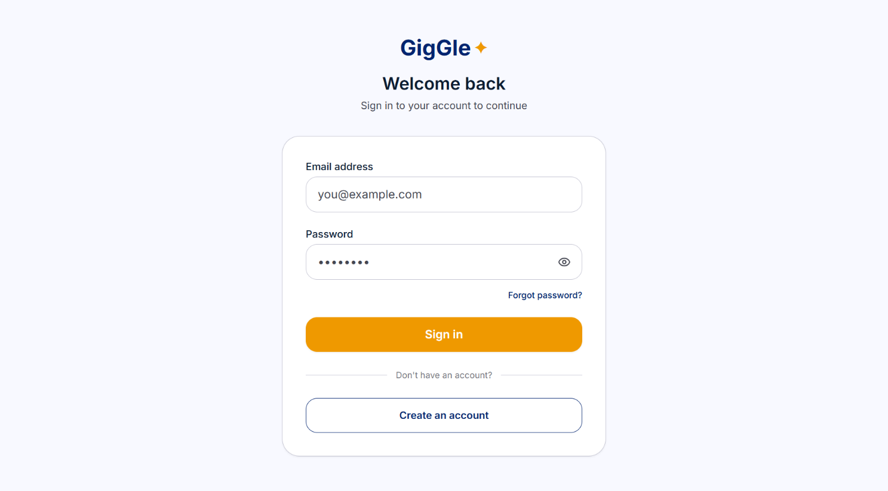
Figure 9: Worker Registration / Login Screen
4.3.2 Worker Dashboard
The Worker dashboard displayed a personalized job feed filtered to the worker's stored location. Category filter controls functioned correctly, updating the job list in real time without page reload. The application tracking panel correctly reflected pending, accepted, and rejected application statuses. The rating display on the worker's profile updated correctly after each new rating submission.

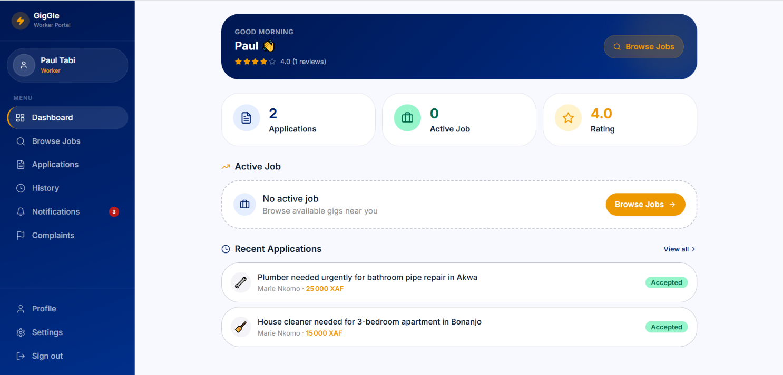
Figure 10: Worker Dashboard Interface
4.3.3 Job Browsing Interface
The job browsing interface rendered listings as cards with title, category, pay, distance, and employer rating. Geographic radius filtering was tested using coordinate pairs representing locations in Buea and Yaoundé; listings outside the configured radius were correctly excluded. Category filters correctly narrowed results to the selected service category. The Leaflet.js map correctly plotted job locations and updated the card list when the map viewport was adjusted.

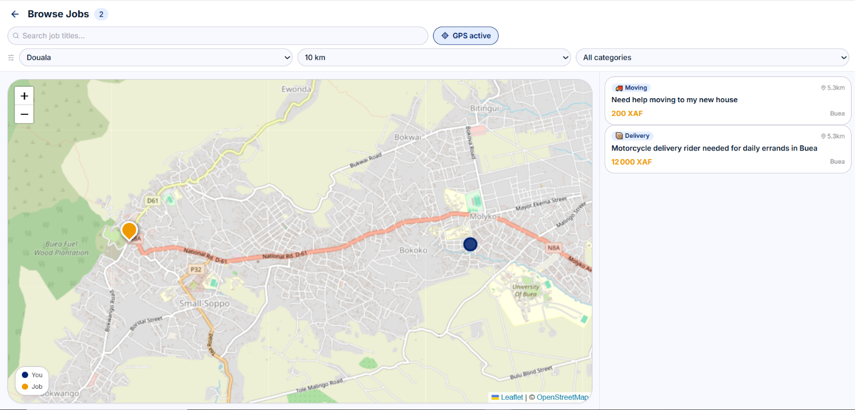
Figure 11: Job Browsing Interface with Category Filter
4.3.4 Application, Selection, and Completion Workflow
A Worker test account applied for three separate job listings. Applications appeared in the Worker's tracking panel with 'Pending' status. When the Employer selected the Worker for one listing, the selected application updated to 'Accepted' and the remaining applications for that listing were automatically set to 'Rejected'. The Employer's job completion confirmation updated the job status and triggered the rating prompt on both accounts simultaneously. All status transitions were verified through direct database inspection.
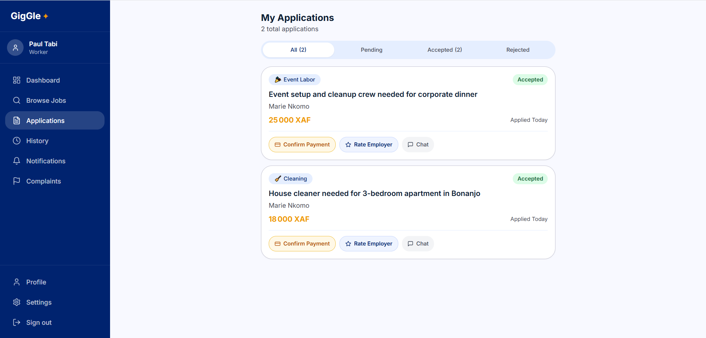
Figure 12: Job Application and Status Tracking Panel
4.3.5 Real-Time Messaging
Two browser sessions were opened simultaneously, one logged in as the Employer and one as the selected Worker for a specific job. A message sent from the Employer session appeared in the Worker session without a page reload, confirming that the Supabase Realtime channel subscription was functioning correctly. Message delivery latency in the local simulation environment was observed at under one second. Chat history was confirmed to persist after both users closed and reopened the chat screen. Attempts to access the chat screen before worker selection were correctly blocked.

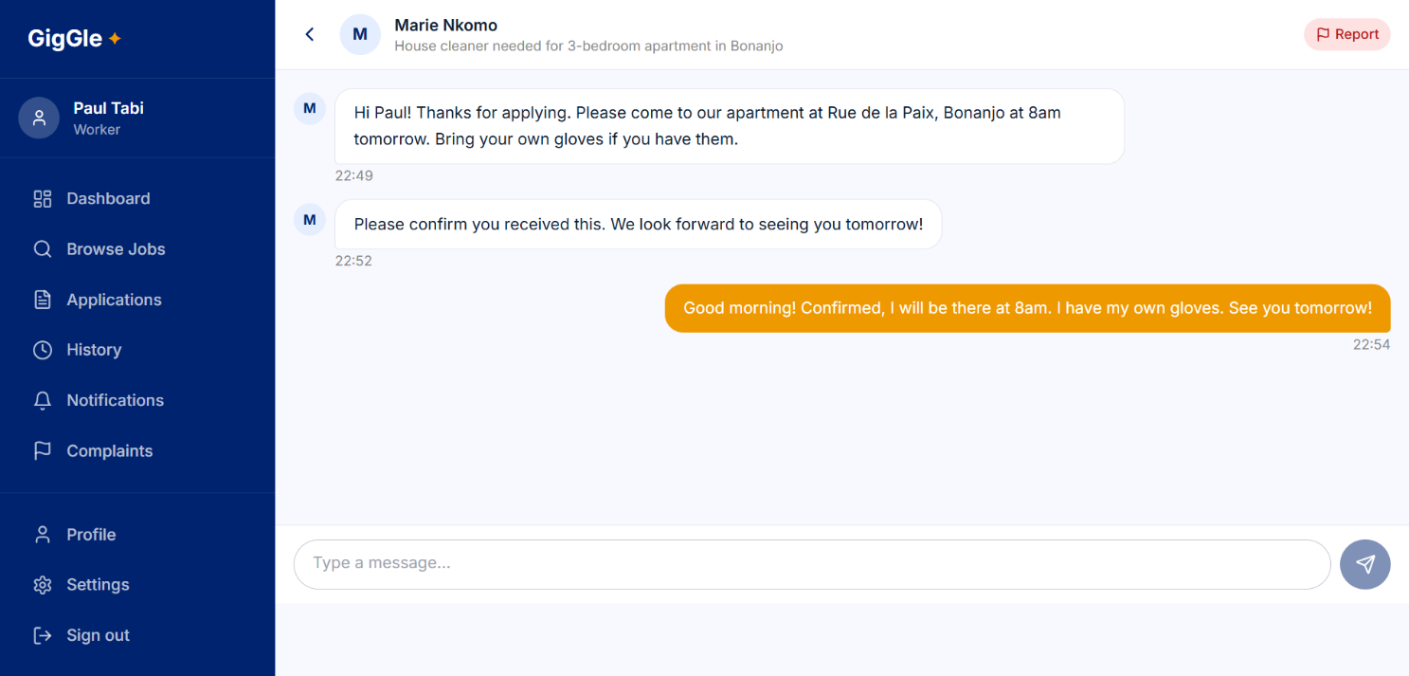
Figure 13: Real-Time Chat Interface Between Worker and Employer
4.3.6 Rating System
Following a simulated job completion and escrow payout release, both the Worker and Employer accounts were presented with the rating prompt; the interface explicitly locks the rating form with a ‘Rating unlocks once you release payment to the worker’ message until the escrow payout is confirmed released. Star ratings of varying scores were submitted and confirmed to be stored correctly in the ratings table. Profile pages displayed updated average rating values reflecting new submissions. Attempts to submit a rating before the escrow payout was released were blocked by application logic. The rating average update was reflected on public profile pages within one second of submission.
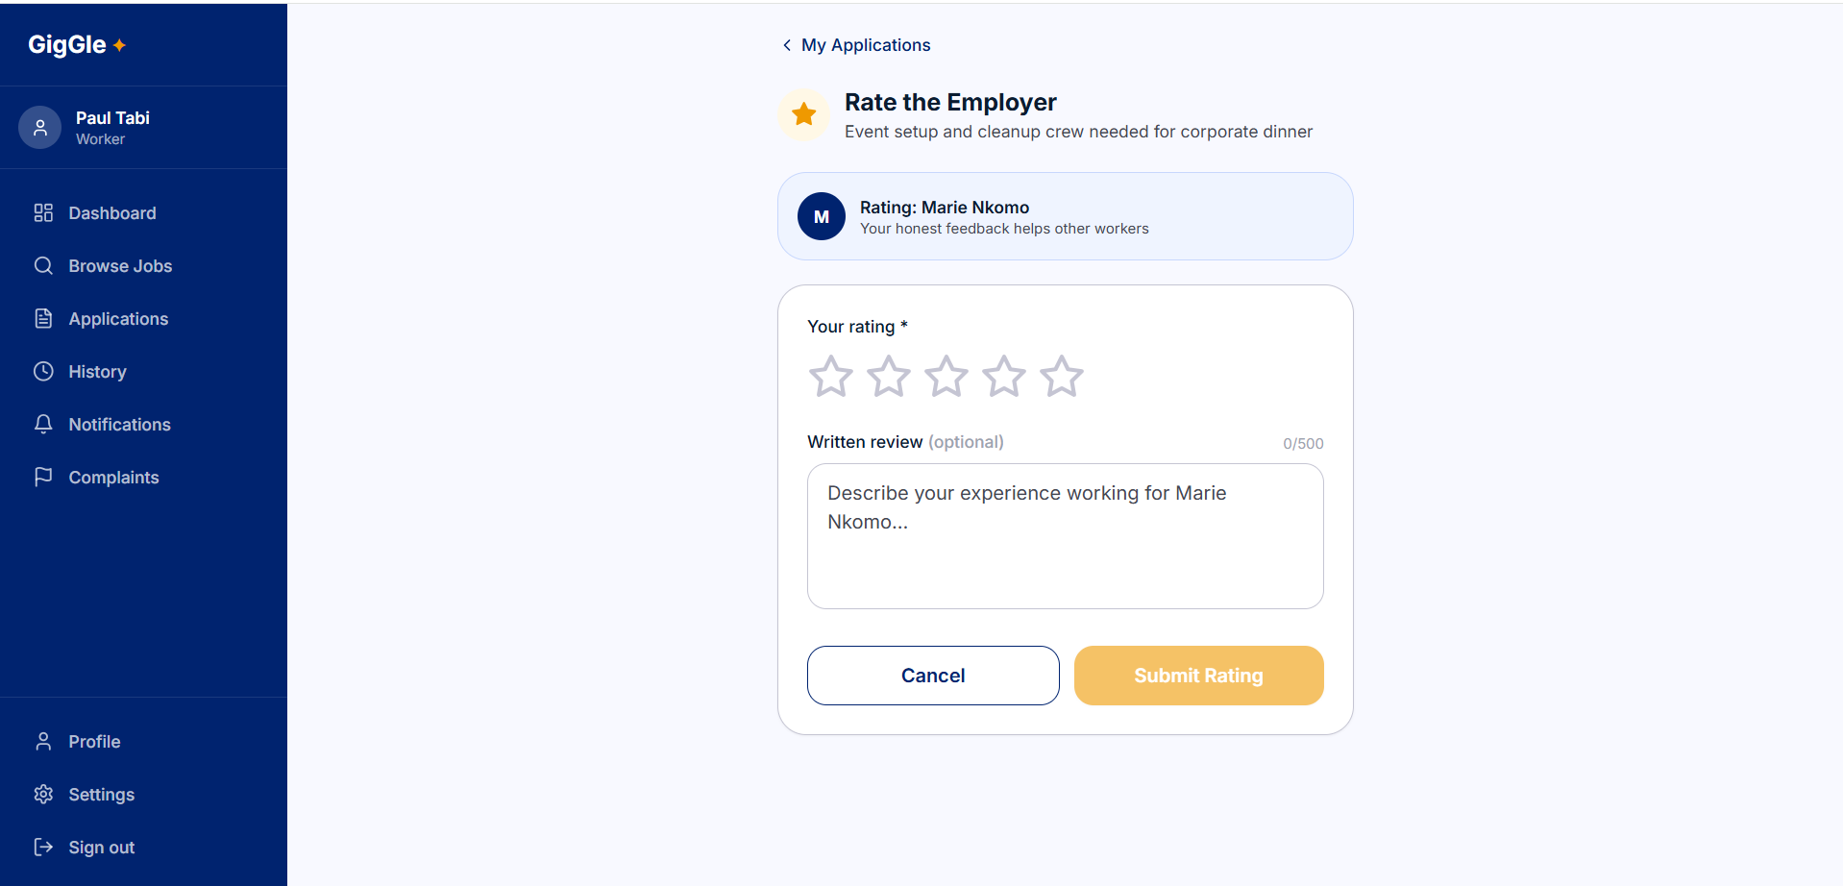
Figure 14: Post-Completion Rating Interface

4.3.7 Employer Dashboard
The Employer dashboard presented a clean job management interface with status indicators for each listing. The applicants panel for each listing displayed worker profiles, ratings, and application notes. The worker selection action correctly triggered the RLS-enforced update that set one application to 'Accepted' and the remainder to Rejected. The job completion confirmation button was only available for listings in in_progress status.

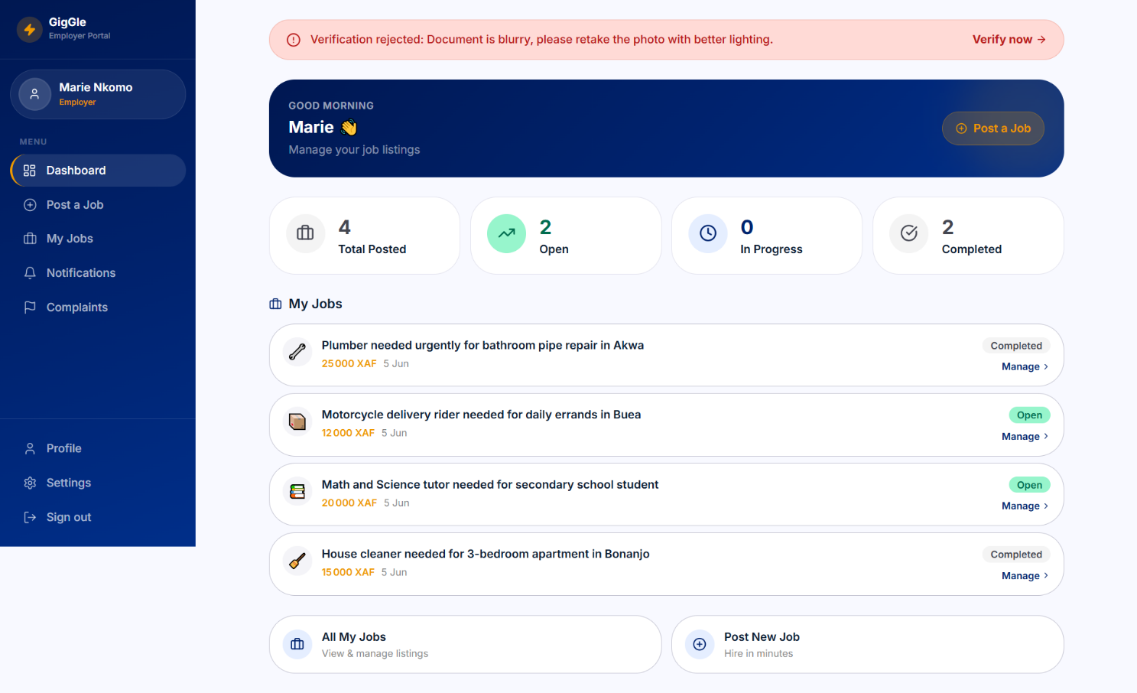
Figure 15: Employer Dashboard – Job Management
4.3.8 Admin Dashboard Analytics
The admin analytics panel visualized system-wide metrics including total registered users by role, total job listings by status, completed gigs by category, and application volumes over time. The user management table correctly listed all users with role and registration date. The content moderation queue displayed flagged listings and profiles with action controls. All admin actions were restricted to accounts with the administrator role by Supabase RLS policies.
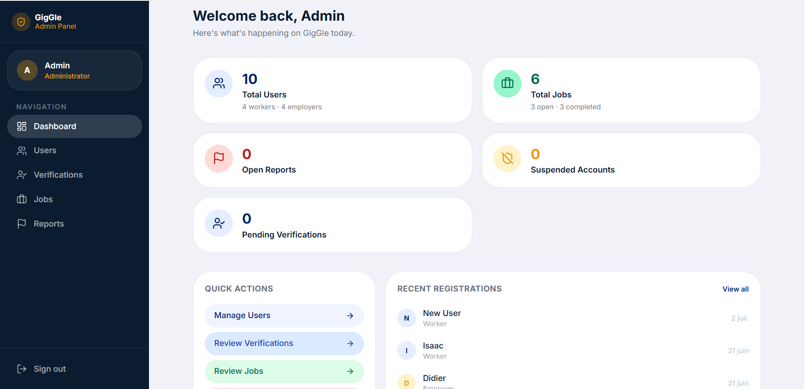
Figure 16: Admin Dashboard – Analytics Overview

4.4 System Testing Strategies

4.4.1 Unit Testing

Test ID | User Story | Acceptance Criteria | Test Activities | Expected Outcome | Status
UT-001 | As a worker, I want to browse jobs filtered by my location and category | Jobs returned within specified radius; category filter updates results | Set location to Buea; apply 'Cleaning' filter; verify results; change radius; change category | Only jobs within radius and matching category displayed; map updates correctly | PASSED
UT-002 | As an employer, I want to post a job listing with full details | All required fields validated; listing appears in worker feed after submission | Submit form with all fields; submit with missing required fields; inspect database | Valid form creates job record; invalid form shows inline errors; listing appears in browsing feed | PASSED
UT-003 | As a worker, I want to apply for a job with a single action | Application record created on button click; status shows 'Pending' in tracking panel | Click Apply on listing; inspect applications table; check tracking panel | Application inserted in database; tracking panel shows Pending status with timestamp | PASSED
UT-004 | As an employer, I want to select a worker and auto-reject others | Selected application set to Accepted; all others for same listing set to Rejected | Create 3 applications for 1 listing; select 1 worker; inspect all application records | Selected record shows Accepted; 2 other records show Rejected; worker notified | PASSED
UT-005 | As any user, I want role-based dashboard access with proper guards | Workers cannot access employer routes; employers cannot access admin routes | Attempt to navigate to /employer/post-job as Worker; attempt /admin as Employer | Unauthorized access redirects to correct dashboard; no data leakage | PASSED
UT-006 | As a user, I want real-time messages without page reload | Messages appear in recipient's chat within 1 second of sending | Open two browser sessions; send messages from each; measure delivery time | Messages appear instantly; chat history persists after close and reopen | PASSED
UT-007 | As a user, I want post-completion ratings to update profile averages | Rating stored correctly; profile average updates within 1 second | Submit rating of 4; verify database record; check profile page average | Rating record stored; profile average reflects new submission within 1s | PASSED
UT-008 | As an unverified worker, I want to be blocked from browsing jobs until my identity is verified | Unverified worker redirected to verification screen; approved worker gains access | Attempt to visit /worker/browse with verification_status='pending'; approve via admin; retry | Redirected to /worker/verify while pending; route accessible immediately after admin approval | PASSED
Table 4: Unit Tests

4.4.2 Integration Testing

Test ID | Functionality | Acceptance Criteria | Test Activities | Expected Outcome | Status
IT-001 | Worker Registration → Role Routing → Dashboard | Registration creates Auth user and profile record; role-correct dashboard loaded | Register as Worker; inspect Auth and profiles tables; verify routing | Supabase Auth entry created; profiles record shows role=worker; Worker dashboard loaded | PASSED
IT-002 | Job Post → Geographic Filter → Worker Feed Update | New job appears in Worker feed filtered by employer's location and category | Employer posts job in Buea; Worker in Buea browses Cleaning category | Job appears in Worker's browsing feed within the correct radius and category | PASSED
IT-003 | Application → Selection → Escrow Funding → Chat Unlock | Chat unlocks only after escrow funding moves the job to in_progress; selection alone does not unlock chat; others rejected automatically | 3 Workers apply; Employer selects 1; verify application statuses; attempt chat access pre-funding; fund escrow; re-check chat access | Chat blocked while job is awaiting_funding; chat accessible for selected Worker and Employer once escrow is held and job is in_progress; other applications show Rejected | PASSED
IT-004 | Job Completion → Escrow Release → Rating Prompt → Profile Update | Rating prompt remains locked until escrow payout is released; submitted rating updates profile average | Employer marks job complete; verify rating form is locked; release escrow payout; verify rating prompt unlocks for both parties; submit rating | Rating form locked with "Rating unlocks once you release payment" until payout released; both parties see rating prompt after release; submitted rating stored; profile average updates in real time | PASSED
IT-005 | Admin Suspension → Listing Visibility Restricted → RLS Enforcement | Suspended user is excluded from public job/worker listings via RLS; suspended user retains ability to authenticate and view own profile | Admin suspends a user account; attempt login as suspended user; verify listing visibility for other users | Suspended user can still authenticate and access their own profile; their jobs/profile are excluded from other users’ browsing results | PASSED
IT-006 | CI/CD Deploy → Vercel → Live Environment Verification | Push to main triggers build; hosting reflects new code within 5 minutes | Commit and push a UI change; monitor Vercel deploy logs; visit live URL | Vercel build completes successfully; live URL shows updated UI | PASSED
IT-007 | Verification Submission → Admin Review → Route Access | Unverified user blocked from restricted routes; approved user gains access; rejection requires a reason | Worker submits ID document; verify route blocked pre-approval; Admin approves; re-check route access; repeat with a rejection | Route blocked while verification_status=pending; accessible immediately after approval; rejection stores required reason and route remains blocked | PASSED
Table 5: Integration Tests

4.4.3 System Testing

Test ID | Workflow | Acceptance Criteria | Test Activities | Expected Outcome | Status
ST-001 | End-to-End Worker Journey | Worker registers, verifies identity, finds relevant job, applies, gets selected, waits for escrow funding, completes job, rates employer after payout release | Full end-to-end flow with mock Employer account | All steps complete without error; database records reflect correct state at each step | PASSED
ST-002 | End-to-End Employer Journey | Employer registers, verifies identity, posts job, selects worker, funds escrow, confirms completion, releases payout, rates worker | Full end-to-end flow with mock Worker account | All steps complete without error; employer dashboard reflects current state throughout | PASSED
ST-003 | Geographic Filtering Accuracy | Jobs outside radius excluded; jobs inside radius included | Test with coordinate pairs at known distances; vary radius | Results match expected inclusion/exclusion for all tested radius values | PASSED
ST-004 | Real-Time Messaging Reliability | Messages delivered in under 1 second; chat history persists | Send 20 messages alternating between Worker and Employer sessions | All messages delivered in under 1 second; history intact after session close | PASSED
ST-005 | RBAC and RLS Enforcement | No unauthorized data access across all role combinations; unverified users blocked from browse/apply/post-job routes regardless of role | 50 unauthorized access attempts across all route, role, and verification-status combinations | All 50 attempts blocked; no data leakage; appropriate redirects or errors returned | PASSED
ST-006 | Rating System Integrity | Ratings cannot be submitted before job completion; averages calculated correctly | Attempt early rating submission; submit ratings post-completion; verify averages | Early submission blocked; post-completion ratings stored and averaged correctly | PASSED
ST-007 | Mobile Responsiveness | Platform usable on 375px smartphone viewport without horizontal scroll | Test all screens on Chrome DevTools mobile emulation (iPhone SE) | All screens render correctly at 375px; no horizontal overflow; tap targets sufficient size | PASSED
ST-008 | Escrow Payment Workflow | Escrow funds correctly on successful MoMo/Orange Money collection; payout releases correctly to worker; both parties notified at each stage | Employer funds escrow via Fapshi; verify escrow status moves pending_funding → held; employer releases payout after completion; verify status moves releasing → released | Escrow status transitions recorded correctly at each stage; commission deducted correctly; both parties notified; failed attempts set status to failed and allow retry | PASSED
ST-009 | Identity Verification Gate | Unverified users cannot browse jobs or post jobs; admin-approved users gain full access | New worker attempts /worker/browse pre-verification; submits ID; admin approves; retries | Access blocked pre-approval with redirect to verification screen; access granted immediately post-approval | PASSED
Table 6: System Tests

CHAPTER FIVE

SUMMARY OF FINDINGS, CONCLUSION AND RECOMMENDATION

5.1 Discussions
GigGle delivered successful end-to-end flows for all core MVP features: worker registration and profile creation, employer job posting with geographic tagging, location-aware job browsing, application submission and employer-side worker selection, real-time messaging between matched parties, job completion confirmation, and mutual post-completion rating. Geographic radius filtering using PostGIS correctly excluded listings outside the configured radius across all test cases, directly addressing the geographic fragmentation barrier identified in the literature review.
Real-time messaging via Supabase Realtime channels delivered messages in under one second in the local simulation environment, which exceeds the performance characteristics of WhatsApp-based informal coordination in terms of persistence, searchability, and scope-scoping. Unlike WhatsApp, GigGle's chat is scoped to individual jobs, preventing message confusion across multiple concurrent gig engagements.
The reputation system successfully aggregated ratings into running averages displayed on public profiles. Post-completion rating submissions were correctly blocked before job confirmation, preventing premature or retaliatory ratings as documented in the existing platform literature. These findings confirm that the platform's trust mechanisms operate as designed and align with Resnick (2000) findings on the effectiveness of aggregated reputation metrics.
Role-based access control and Row Level Security enforcement blocked all 50 unauthorized access attempts in system testing, demonstrating a robust security posture that surpasses the zero-security environment of WhatsApp job groups and the trust-by-proximity model of informal street-corner labor markets.
The payment acknowledgment workflow, while not fully automated in the MVP, successfully recorded mobile money reference codes and updated payment status for both parties, establishing a transaction record that has no equivalent in the existing informal labor system.
Several technical challenges were surfaced and resolved during development. The PostGIS coordinate query required careful index configuration to avoid full-table scans. Supabase Realtime subscriptions required explicit channel scoping by job_id to prevent cross-job message leakage. RLS policy design demanded careful differentiation between employer access to their own listings and worker access to their own applications, without overlap.
Limitations of the current implementation include: escrow payout release still requires a manual action by the employer rather than being fully automatic upon job completion; identity verification relies on admin visual review of uploaded documents without third-party authenticity checks; the simulation used mock data rather than live users; the usability testing sample was small due to time constraints; and geographic filtering accuracy depends on the precision of coordinates submitted at job posting time.

5.2 Conclusions
The aim of this study was to design and implement a locally-grounded web-based gig labor platform that connects Cameroonian informal workers with employers for short-term task-based work, while addressing the trust deficits and structural inefficiencies that characterize the current informal labor market. This objective was successfully achieved within the scope of the MVP as defined.
GigGle demonstrates that a locally-designed digital platform built on accessible and proven technologies React.js, Tailwind CSS, Supabase, Leaflet.js and designed around the specific economic and infrastructural realities of Cameroon, can provide a meaningful structural improvement over the status quo. The platform does not attempt to eliminate the informal sector; instead, it provides the digital infrastructure the informal sector already needs but currently lacks.
The simulation results confirm the technical achievability of all four core value propositions: geographic filtering delivers contextually relevant job listings; the reputation system produces visible and persistent trust credentials; the messaging system centralizes coordination between transacting parties; and the job completion workflow creates a structured payment acknowledgment and evaluation process.
The project also demonstrates that software engineering students in Cameroon can build locally relevant, technically sound platforms that address real socioeconomic problems using modern development tools and methodologies. GigGle represents a proof of concept that locally appropriate technology solutions are not only feasible but but implementable to address the specific challenges of Cameroon's labor market.

5.3 Recommendations
Based on the findings and identified limitations, the following actionable improvements are recommended:
Technical Upgrades
- Fully Automated Payout Release: Automatically trigger the escrow payout to the worker upon job completion confirmation, removing the current manual release step and further reducing payment friction.
- SMS Fallback Notifications: Integrate Twilio SMS for application status updates and job alerts, extending platform reach to users on feature phones.
- Multilingual Interface: Provide the platform in both French and English, with a Cameroonian Pidgin option, to dramatically expand accessibility.
- Push Notifications: Implement web push notifications for new job applications, worker selections, and chat messages to improve engagement.
Process Improvements
- Expanded Usability Testing: Conduct structured usability studies with participants across Buea, Yaoundé, Douala, and Bafoussam to gather representative feedback on platform accessibility and feature relevance.
- Third-Party ID Authenticity Verification: Integrate an automated document-authenticity and biometric liveness check (e.g. a national ID verification API) to strengthen the current admin-reviewed verification process and reduce manual review workload.
Policy and Deployment
- Phased Rollout: Begin with one geographic area and one service category before scaling citywide, allowing user feedback to refine the platform before broad deployment.
- Regulatory Engagement: Engage with Cameroonian labor and digital commerce regulators to position GigGle within the national digital economy strategy.

5.4 Perspectives for Further Study
The following opportunities for expanding and deepening this research are identified:
- Cross-Platform Mobile Application: Develop React Native companion apps for richer offline capability, push notifications, and GPS-based location updates without manual input.
- Machine Learning Matching: Implement a recommendation engine that suggests relevant job listings to workers based on past application history, skill profile, and rating patterns, reducing the time cost of job discovery.
- Blockchain-Backed Audit Trail: Explore a permissioned blockchain layer for immutable logging of high-value transactions, addressing trust concerns in high-stakes gigs.
- Longitudinal Impact Study: Conduct a longitudinal study of platform adoption, engagement, and labor market outcomes across one or more Cameroonian cities to empirically measure GigGle's impact on worker income stability and employer satisfaction.
- Integration with National Employment Systems: Explore partnership with the INS or Cameroonian social protection agencies to use GigGle as a data source for informal labor statistics and a channel for reaching informal workers with social protection information.

REFERENCES
[1] I. Ajzen, "The theory of planned behavior," Organizational Behavior and Human Decision Processes, vol. 50, no. 2, pp. 179–211, 1991.
[2] Banque des États de l'Afrique Centrale (BEAC), Rapport Annuel sur les Systèmes et Moyens de Paiement, Yaoundé: BEAC, 2021.
[3] M. Beck et al., "Manifesto for Agile Software Development," Agile Alliance, 2001. [Online]. Available: https://agilemanifesto.org
[4] P. Bourdieu, "The forms of capital," in Handbook of Theory and Research for the Sociology of Education, J. Richardson, Ed. New York: Greenwood, 1986, pp. 241–258.
[5] R. Coase, "The nature of the firm," Economica, vol. 4, no. 16, pp. 386–405, 1937.
[6] J. W. Creswell, Research Design: Qualitative, Quantitative, and Mixed Methods Approaches, 4th ed. Thousand Oaks, CA: SAGE Publications, 2014.
[7] F. D. Davis, "Perceived usefulness, perceived ease of use, and user acceptance of information technology," MIS Quarterly, vol. 13, no. 3, pp. 319–340, 1989.
[8] V. De Stefano, "The rise of the 'just-in-time workforce': On-demand work, crowdwork, and labor protection in the gig economy," Comparative Labor Law & Policy Journal, vol. 37, no. 3, pp. 471–503, 2016.
[9] N. Friederici, S. Ojanperä, and M. Graham, "The impact of connectivity in Africa: Grand visions and the mirage of inclusive digital development," The Electronic Journal of Information Systems in Developing Countries, vol. 79, no. 1, pp. 1–20, 2017.
[10] Institut National de la Statistique (INS), Enquête sur l'Emploi et le Secteur Informel au Cameroun, Yaoundé: INS, 2020.
[11] International Labour Organization (ILO), Women and Men in the Informal Economy: A Statistical Picture, 3rd ed. Geneva: ILO, 2018.
[12] W. Jack and T. Suri, "Mobile money: The economics of M-PESA," NBER Working Paper No. 16721, National Bureau of Economic Research, 2011.
[13] V. Lehdonvirta, O. Kässi, I. Hjorth, H. Barnard, and M. Graham, "The global platform economy: A new offshoring institution enabling emerging-economy microproviders," Journal of Management, vol. 45, no. 2, pp. 567–599, 2019.
[14] J. Manyika et al., Independent Work: Choice, Necessity, and the Gig Economy, McKinsey Global Institute, 2016.
[15] R. Muggah and R. Diniz, "Citizen security in Latin America: Facts and figures," Igarapé Institute Strategic Paper No. 33, 2018.
[16] P. Resnick, K. Kuwabara, R. Zeckhauser, and E. Friedman, "Reputation systems," Communications of the ACM, vol. 43, no. 12, pp. 45–48, 2000.
[17] R. D. Putnam, Bowling Alone: The Collapse and Revival of American Community. New York: Simon and Schuster, 2000.
[18] G. Zervas, D. Proserpio, and J. W. Byers, "The rise of the sharing economy: Estimating the impact of Airbnb on the hotel industry," Journal of Marketing Research, vol. 54, no. 5, pp. 687–705, 2017.
[19] Supabase Inc., "Supabase Documentation," 2024. [Online]. Available: https://supabase.com/docs
[20] Vercel Inc., "Vercel Platform Documentation," 2024. [Online]. Available: https://vercel.com/docs
[21] Leaflet Contributors, "Leaflet.js Documentation," 2024. [Online]. Available: https://leafletjs.com

Appendix

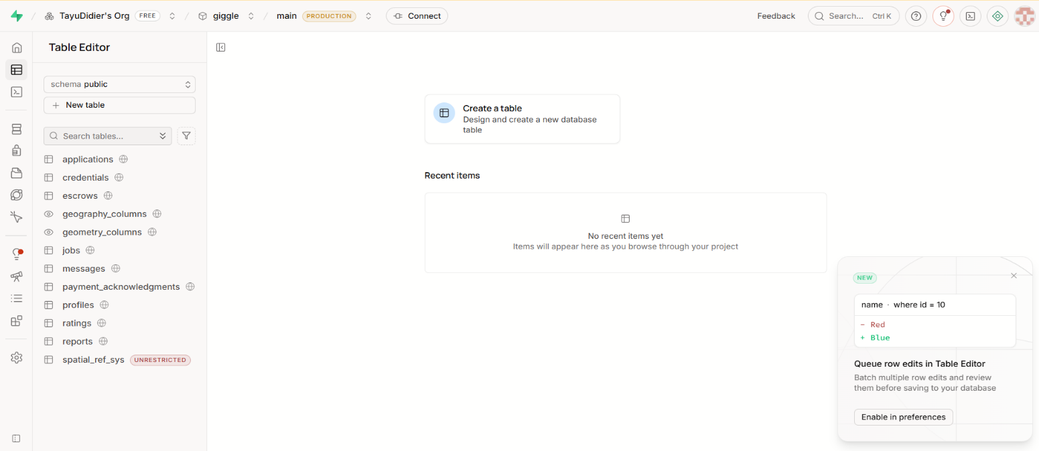

Figure:

