HCI LAB 7:
Name: Muhammad Tayyab
Sap: 67606

Activity 1:

Heuristic Evaluation Report
Website Chosen: Yale School of Art (art.yale.edu) Evaluator: Muhammad Date: March 2026
Nielsen’s Ten Usability Heuristics Applied
- Visibility of system status
- Match between system and the real world
- User control and freedom
- Consistency and standards
- Error prevention
- Recognition rather than recall
- Flexibility and efficiency of use
- Aesthetic and minimalist design
- Help users recognize, diagnose, and recover from errors
- Help and documentation
Identified Usability Issues
1. Cluttered Layout (Aesthetic & Minimalist Design)
- Issue: The homepage is overloaded with text blocks, images, and links in different fonts and colors. There’s no clear hierarchy.
- Impact: Visitors struggle to identify important information like admissions or program details.
- Suggested Improvement: Redesign the homepage with a cleaner layout. Use consistent typography, whitespace, and clear sections for navigation.
2. Unclear Navigation (Consistency & Standards)
- Issue: The navigation menu is inconsistent. Some links are embedded in text paragraphs rather than in a structured menu.
- Impact: Users must scroll and scan extensively to find basic information (e.g., faculty, courses, exhibitions).
- Suggested Improvement: Introduce a standard navigation bar with clear categories (Admissions, Programs, Faculty, News, Contact).
3. Poor Visibility of System Status (Visibility of System Status)
- Issue: When clicking links, pages load slowly without feedback. Users don’t know if the site is responding.
- Impact: This creates frustration and uncertainty, especially for first-time visitors.
- Suggested Improvement: Add loading indicators or progress feedback when navigating between pages.
Conclusion
The Yale School of Art website deliberately breaks conventional design rules, but from a usability perspective it violates several of Nielsen’s heuristics. The main issues are cluttered layout, inconsistent navigation, and poor visibility of system status. Addressing these would make the site more accessible and user-friendly, especially for prospective students seeking essential information.

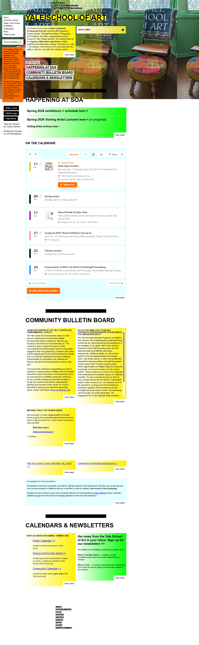
Activity 2:

UI Component Redesign Report
Component Selected: Navigation Menu of Yale School of Art website Evaluator: Muhammad Date: March 2026

Analysis Using Nielsen’s Heuristics

Current Issues
- Consistency & Standards
  - Links are scattered inside text blocks instead of a structured menu.
  - Terminology is inconsistent (e.g., “Courses” vs. “Programs”).
- Recognition Rather Than Recall
  - Users must remember where links are hidden in paragraphs.
  - No visible navigation bar to guide them.
- Aesthetic & Minimalist Design
  - Overloaded homepage forces users to scroll extensively.
  - Important links (Admissions, Faculty, Exhibitions) are buried.

Redesigned Component (Navigation Menu)

Wireframe Sketch (conceptual description)
Imagine a horizontal navigation bar at the top of the page with clear categories:
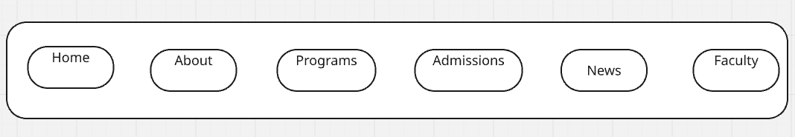
Justification of Redesign Choices
- Consistency & Standards: A fixed navigation bar ensures users always know where to find information. Terminology is standardized.
- Recognition Rather Than Recall: Users don’t need to remember hidden links; everything is visible and accessible.
- Aesthetic & Minimalist Design: Clean layout reduces clutter. Only essential categories are shown, secondary info moved to dropdowns.
- Flexibility & Efficiency of Use: Search bar allows advanced users to quickly locate content.
Activity 3:

Group Discussion Summary – Nielsen’s Heuristics

Question 1: Which of Nielsen’s heuristics is the most important? Why?
- Consensus: Visibility of System Status was considered the most critical.
- Reasoning: Users need constant feedback to know what the system is doing. Without it, they feel lost or frustrated. For example, progress bars during file uploads reassure users that the system is working.
- Key Point: Clear feedback builds trust and reduces uncertainty.

Question 2: Real-world example of heuristic violation
- Example: The Yale School of Art website violates several heuristics:
  - Aesthetic & Minimalist Design: Homepage clutter makes it hard to find admissions info.
  - Consistency & Standards: Navigation links are hidden inside text blocks.
- Impact: Visitors waste time searching, feel confused, and may leave the site without finding what they need.
- Other Example: ATM machines that don’t clearly show transaction progress (e.g., “Processing…”). Users may think the machine is stuck and cancel prematurely.

Question 3: Applying heuristics to emerging technologies (Voice Assistants, AR/VR)
- Voice Assistants:
  - Visibility of System Status: Must confirm when listening or processing (e.g., Alexa’s light ring).
  - Error Prevention: Should clarify ambiguous commands (“Did you mean play music or set an alarm?”).
- AR/VR Interfaces:
  - Consistency & Standards: Controls should mimic real-world interactions (e.g., grabbing objects with hand gestures).
  - Aesthetic & Minimalist Design: Avoid overwhelming users with too many floating menus or icons.
- Key Point: Nielsen’s heuristics remain relevant but must adapt to multimodal feedback (visual, auditory, haptic).

Conclusion
The group agreed that Visibility of System Status is foundational across all platforms. Real-world violations (like cluttered websites or unclear ATMs) highlight how poor usability frustrates users. Applying Nielsen’s heuristics to voice assistants and AR/VR ensures these emerging technologies remain intuitive, trustworthy, and user-friendly.

