Subject: Software Requirement Engineering (Lab)

Class: BSSE4-1 Lab Instructor: Muhammad Islam
Semester: Spring 2025

Lab#03:
Topic: Student will be provided the case study and they will perform the problem analysis on that case study.

Objective:
In this lab, you will be provided with a case study that involves a real-world problem. Your task is to perform a problem analysis to identify the key issues, gather relevant data, decompose the problem, and document your findings. This process will help you understand how to define and analyze problems to set the foundation for deriving requirements in a real-world scenario.

Prerequisites:
- Basic understanding of Requirement Engineering concepts.
- Familiarity with problem-solving techniques (e.g., root cause analysis, stakeholder analysis).
- Ability to document findings clearly and logically.

Lab Procedure:

Step 1: Read and Understand the Case Study
- Carefully read the provided case study. Ensure you understand the problem context, the key stakeholders involved, and any relevant background information.
- Identify the core problem that the case study addresses. This is the central issue the system or solution is supposed to solve.
Key Questions to Consider:
- What is the problem or challenge the organization is facing?
- Who are the main stakeholders (users, clients, customers, etc.)?
- What is the expected outcome or goal of the solution?

Step 2: Identify and Analyze Stakeholders
- List the Stakeholders: Who is affected by the problem or will benefit from the solution? This can include internal and external stakeholders (e.g., customers, business managers, IT team, end-users).
- Understand Stakeholder Needs: For each stakeholder, understand what their needs or expectations are regarding the system or solution. This helps in framing the problem from multiple perspectives.

Step 3: Define the Problem Clearly
- Problem Definition: Create a concise and clear statement of the problem. Include:
  - What is the main issue?
  - What are the key symptoms or manifestations of the problem (e.g., slow website, poor customer experience)?
  - What is the impact of the problem (financial, operational, reputational)?
- Scope of the Problem: Determine the boundaries of the problem. What is in-scope (to be solved) and what is out-of-scope?

Step 4: Decompose the Problem
- Break Down the Problem: Split the problem into smaller, more manageable components. This can involve:
  - Identifying functional and non-functional issues.
  - Analyzing related subproblems, such as performance, usability, or security.
- Identify Constraints: What limitations (e.g., time, budget, technology) exist that will influence the solution? Consider external constraints like regulations, market conditions, and organizational policies.

Step 5: Root Cause Analysis
- Identify Root Causes: Dig deeper to find the underlying causes of the problem. Is the issue a result of poor process design, lack of resources, ineffective policies, or technical failure?
- Use Techniques:
  - 5 Whys: Ask "Why?" five times to drill down to the root cause.
  - Fishbone (Ishikawa) Diagram: Use this diagram to categorize potential causes under headings such as People, Process, Technology, etc.
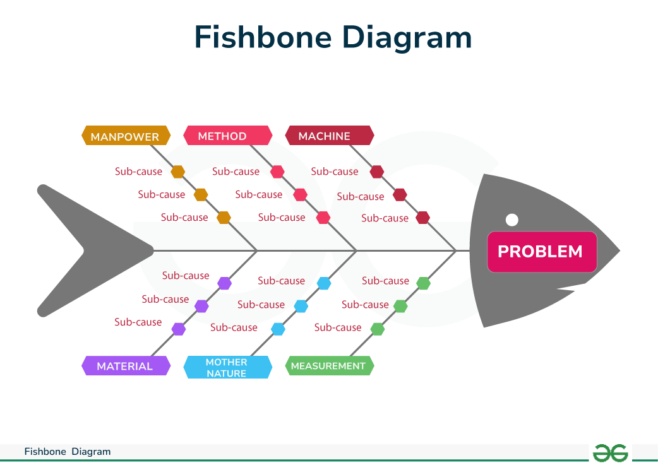

Step 6: Analyze Requirements
- Functional Requirements: Based on the problem analysis, what must the system do to solve the problem? Functional requirements specify what actions or features are needed (e.g., a new user authentication system, a faster database query).
- Non-Functional Requirements: What performance, security, usability, or reliability standards must the solution meet?

Step 7: Document Findings
- Create a Problem Analysis Report: Document the following:
  - Problem definition.
  - Stakeholder analysis and needs.
  - Decomposition of the problem into subcomponents.
  - Root cause analysis results.
  - Identified constraints.
  - Functional and non-functional requirements.

Example:

Case Study: TeleConnect Telecom - Declining Customer Satisfaction and Retention
Background: TeleConnect Telecom, a leading telecommunications provider in a major region, offers internet, mobile, and landline services. Over the past two years, they have seen a steady decline in customer satisfaction and retention. Customers are complaining about poor service quality, high prices, and unresponsive customer support. This decline has led to a loss in subscribers and a decrease in overall revenue.

Step 1: Read and Understand the Case Study
Problem Context: TeleConnect Telecom is facing a decline in customer satisfaction, retention, and overall market share due to poor service quality, high pricing, and subpar customer support. These issues have caused existing customers to churn, while potential customers are turning to competitors with better service offers.

Step 2: Identify and Analyze Stakeholders
- List of Stakeholders:
  - Customers: Who are the ones experiencing the poor service.
  - Customer Support Team: Responsible for resolving customer complaints.
  - Sales & Marketing Team: Dependent on customer satisfaction to generate new leads.
  - Management/Executives: Responsible for the overall health of the business and profits.
  - Technical/Operations Team: Ensures network quality, service delivery, and maintenance.
  - Competitors: Companies offering better pricing and customer service.
- Understand Stakeholder Needs:
  - Customers: Need reliable, affordable services and quick, effective support.
  - Customer Support Team: Needs better training and tools to manage the growing number of complaints.
  - Sales & Marketing Team: Need positive customer feedback to create effective campaigns and attract new customers.
  - Management: Needs better retention rates and financial growth.
  - Technical/Operations Team: Needs clear guidelines on service quality expectations.
  - Competitors: Look for opportunities to capture market share from dissatisfied customers.

Step 3: Define the Problem Clearly
- Problem Definition: TeleConnect Telecom is experiencing a significant decline in customer satisfaction and retention due to poor service quality, high prices, and ineffective customer support.

- Scope of the Problem:
  - In-scope: Addressing the service quality issues, customer support inefficiencies, and pricing strategies.
  - Out-of-scope: The problem doesn't include external economic factors, such as market-wide price increases or unrelated competitors' strategies.

Step 4: Decompose the Problem
- Break Down the Problem:
  - Service Quality Issues:
    - Network infrastructure is outdated, causing connectivity problems.
    - High latency and poor coverage in certain regions.
  - Customer Support Issues:
    - Long call wait times and unresolved complaints.
    - Lack of sufficient training for support agents.
  - Pricing Issues:
    - TeleConnect’s pricing is higher than its competitors.
    - Lack of promotional offers or loyalty programs for existing customers.
- Identify Constraints:
  - Budget Constraints: Limited funds for immediate network upgrades or hiring additional support agents.
  - Time Constraints: The need for quick fixes to prevent further customer churn.
  - Technological Constraints: Outdated network infrastructure that requires significant investment for improvement.

Step 5: Root Cause Analysis
- Identify Root Causes: The root causes of the problem can be traced back to:
  - Poor Network Infrastructure: The network is not capable of supporting the growing demand for higher-speed internet and seamless service.
  - Inefficient Customer Support Systems: Long call wait times are caused by outdated CRM systems and insufficiently trained customer service representatives.
  - High Pricing: Competitors are offering more competitive pricing with better service bundles.
- Use of Techniques:
  - 5 Whys Analysis:
    - Why are customers unhappy? → Because service quality is poor.
    - Why is service quality poor? → Due to outdated network infrastructure.
    - Why is the network outdated? → The company has not invested sufficiently in network upgrades.
    - Why hasn’t the company invested in upgrades? → Due to budget constraints and a focus on other areas.
    - Why are budget constraints in place? → Management has not prioritized long-term infrastructure over short-term profits.
  - Fishbone Diagram (Ishikawa):
    - People: Lack of training for customer service representatives.
    - Process: Slow issue resolution due to ineffective CRM systems.
    - Technology: Outdated network infrastructure, leading to poor service quality.
    - Environment: External competitors offering better pricing and value.

Step 6: Analyze Requirements
- Functional Requirements:
  - Network Upgrades: The company needs to upgrade its infrastructure to improve service quality (higher speeds, better coverage).
  - Customer Support Enhancement: Implement a new CRM system, offer better training to support agents, and reduce call wait times.
  - Pricing Strategy: Review and adjust pricing to offer more competitive plans, including bundle offers and loyalty rewards for existing customers.
- Non-Functional Requirements:
  - Performance: Network upgrades should result in a minimum 25% improvement in connection speed and coverage.
  - Security: Ensure that customer data is secure during any CRM system transitions.
  - Reliability: Ensure that the upgraded network and customer support systems are stable and reliable with minimal downtime.
  - Usability: Customer support agents must have easy-to-use interfaces for quicker resolutions.

Step 7: Document Findings
Problem Analysis Report:
- Problem Definition: TeleConnect Telecom is facing a significant decline in customer satisfaction and retention due to poor service quality, high pricing, and ineffective customer support.
- Stakeholder Analysis: Customers, support agents, management, and competitors are affected by the situation. Each has different needs such as better service, more efficient support, and improved business performance.
- Decomposition of Problem: The main issues are poor service quality (due to outdated infrastructure), slow customer support (due to old CRM systems), and high pricing compared to competitors.
- Root Cause Analysis: The company’s inability to invest in infrastructure upgrades and the lack of sufficient support for customer-facing teams have led to dissatisfaction.
- Identified Constraints: Budget and time constraints limit the company’s ability to implement immediate fixes to network issues and customer support.
- Functional Requirements: Network upgrades, CRM system improvements, pricing adjustments.
- Non-Functional Requirements: Performance improvement, security, reliability, and usability considerations.
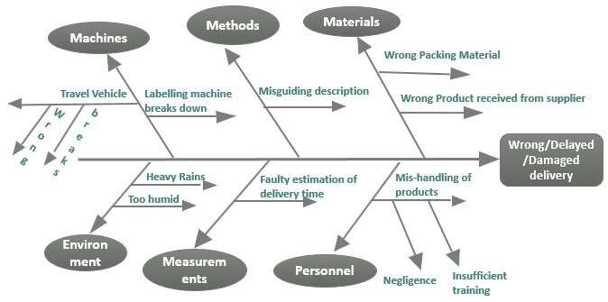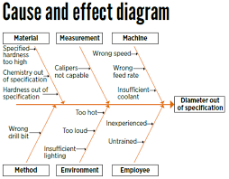
Lab Activity/To Do:
A private university has been facing operational inefficiencies due to outdated manual systems and lack of integration among various departments. These issues impact student registrations, faculty schedules, financial management, and the overall administrative workload. The university decides to implement a comprehensive University Management System (UMS) to streamline operations, reduce redundancy, and improve user experience for both students and staff.

