Correlation
- Define correlation coefficient between two variables X and Y and give its meaning.
Ans: Correlation: If the change in one variable affects a change in the other variable, then the variables are said to be correlated. The correlation is of three types. They are a) positive correlation
b) negative correlation
c) linear correlation
- positive correlation: If the increase (decrease) in one variable results in a corresponding increase (decrease) in the other variable i.e if the two variables are deviated in the same direction then the correlation is said to be direct or positive correlation
Eg: The heights and weights of a group of persons are positively correlated.
- negative correlation: If the increase (decrease) in one variable results in a corresponding decrease (increase) in the other variable i.e if the two variables are deviated in the opposite direction then the correlation is said to be inverse or negative correlation
Eg: The volume and pressure of a perfect gas are negatively correlated
- linear correlation: The correlation is said to be linear if corresponding to unit change in one variable , there is a constant change in the other variable over the entire range of values.

Karl Pearson’s correlation coefficient:
For the measure of intensity or degree of linear relationship between two variables, this formula is developed. Correlation coefficient is defined as the ratio of the covariance between x and y to the product of standard deviations of x and y.
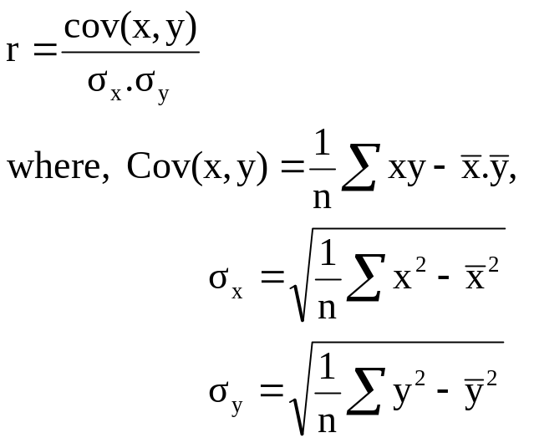
Note 1: The sign of correlation coefficient will depend upon the sign of covariance.
Note 2: The limits of correlation coefficient are –1 and +1.
Problems on Correlation coefficient:
- Find the Karl Pearson’s correlation coefficient to the given data:
X | 16 | 21 | 26 | 23 | 28 | 24 | 17 | 22 | 21
Y | 33 | 38 | 50 | 39 | 52 | 47 | 35 | 43 | 41
Sol:-

x | y | xy | x² | y²
16 | 33 | 528 | 256 | 1089
21 | 38 | 798 | 441 | 1444
26 | 50 | 1300 | 676 | 2500
23 | 39 | 897 | 529 | 1521
28 | 52 | 1456 | 784 | 2704
24 | 47 | 1128 | 576 | 2209
17 | 35 | 595 | 289 | 1225
22 | 43 | 946 | 484 | 1849
21 | 41 | 861 | 441 | 1681
198 | 378 | 8509 | 4476 | 16222

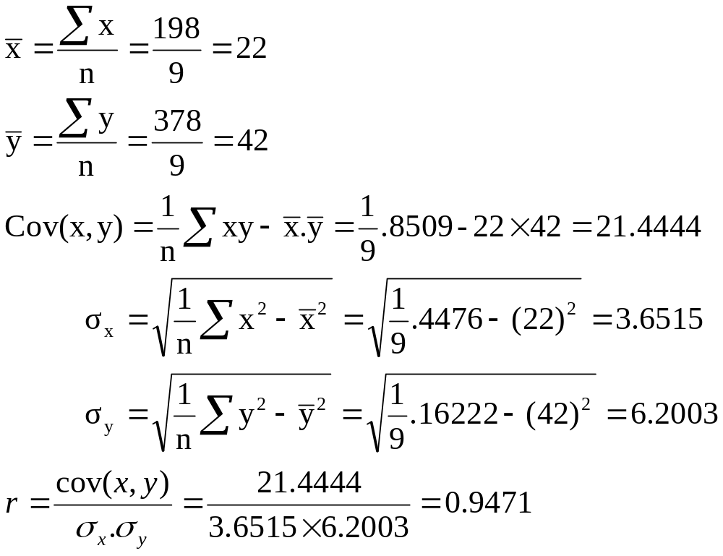

- Find the correlation coefficient between the sales and expenses (in Rs.’000) of the following 10 firms.

Firm | 1 | 2 | 3 | 4 | 5 | 6 | 7 | 8 | 9 | 10
Sales | 50 | 50 | 55 | 60 | 65 | 65 | 65 | 60 | 60 | 60
Expenses | 11 | 13 | 14 | 16 | 16 | 16 | 15 | 14 | 13 | 13
Sol:-

x | y | xy | x² | y²
50 | 11 | 550 | 2500 | 121
50 | 13 | 650 | 2500 | 169
55 | 14 | 770 | 3025 | 196
60 | 16 | 960 | 3600 | 256
65 | 16 | 1040 | 4225 | 256
65 | 16 | 1040 | 4225 | 256
65 | 15 | 975 | 4225 | 225
60 | 14 | 840 | 3600 | 196
60 | 13 | 780 | 3600 | 169
60 | 13 | 780 | 3600 | 169
590 | 141 | 8385 | 35100 | 2013

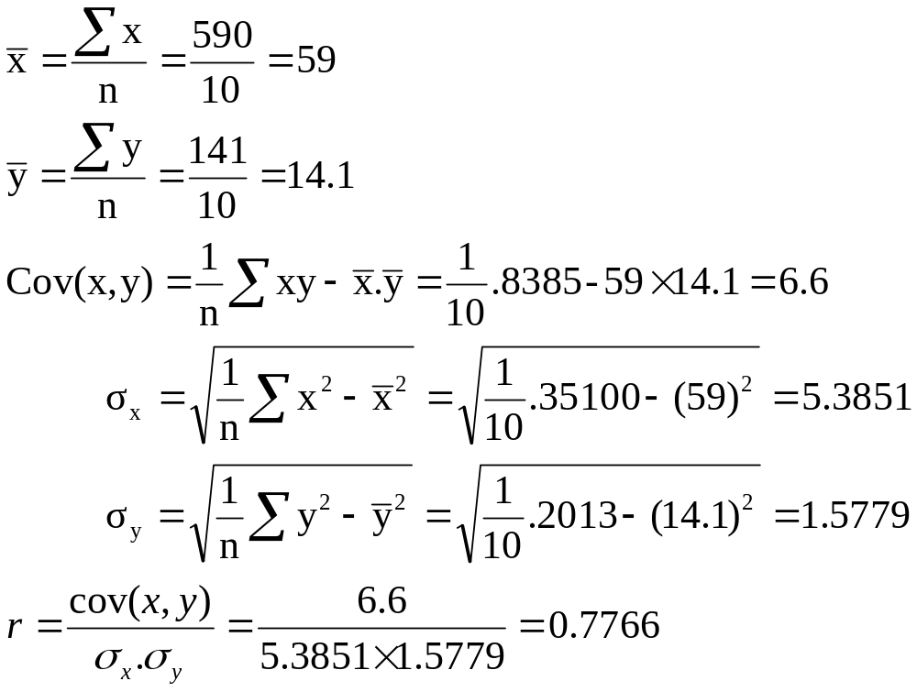

  - The following data pertains to length of service (in years) X and annual income (in thousand rupees) Y for a sample for ten employees of an industry.
X | 6 | 8 | 9 | 10 | 11 | 12 | 14 | 16
Y | 14 | 17 | 15 | 18 | 16 | 22 | 25 | 26
Sol:-

x | y | xy | x² | y²
6 | 14 | 84 | 36 | 196
8 | 17 | 136 | 64 | 289
9 | 15 | 135 | 81 | 225
10 | 18 | 180 | 100 | 324
11 | 16 | 176 | 121 | 256
12 | 22 | 264 | 144 | 484
14 | 25 | 350 | 196 | 625
16 | 26 | 416 | 256 | 676
86 | 153 | 1741 | 998 | 3075

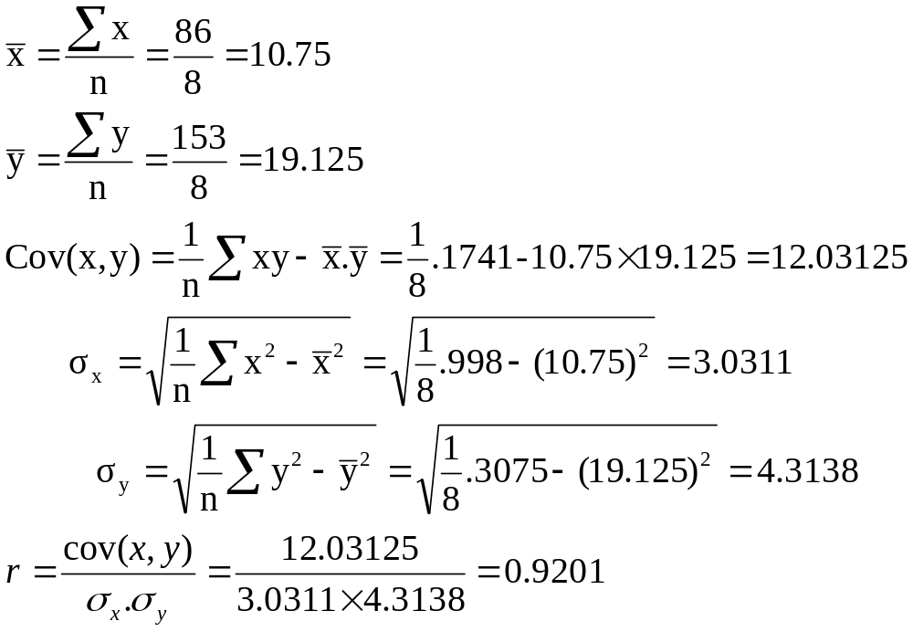

Regression
Regression is the average relationship between two or more variables. There are two lines of Regression, they are
1) Regression line x on y
- Regression line y on x
- Regression line x on y:
Regression line x on y is given by
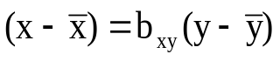
where b_{xy} is the regression coefficient x on y and is given by 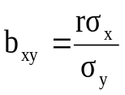
Therefore, regression line x on y is given by
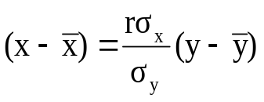
- Regression line y on x:
Regression line y on x is given by
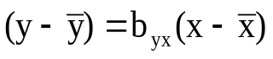
where b_{yx} is the regression coefficient y on x and is given by 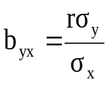
Therefore, regression line y on x is given by

Note1: Regression lines always pass through the point (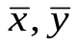).
Note2: Correlation coefficient is the geometric mean of regression
coefficients.i.e 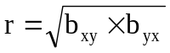

2) What are the uses of Regression analysis? (or) What is Regression and
how is regression analysis useful in forecasting?
1) In many situations the dependent variable Y is such that it cannot be measured directly. But with the help of some concomitant or auxiliary variables as independent variables in regression equation, Y can be estimated
Eg:- Height of a person at a given age can be estimated by finding the
regression of height (Y) on age (X).
2) The affect of certain treatments can better be adjudged by estimating the
effect of concomitant variables
Eg:-The yield of a crop can be predicted for different doses of a fertilizer.
3) Regression equation is often used as prediction equation .
Eg:-Future demand of food may be predicted with the help of regression
models.
4) The length of a confidence interval of population mean can be reduced by considering the effect of dummy variables.
Eg:-A scientist may be able to estimate the brain size on the basis of certain related external body measurements.
5) To measure the influence of independent variables on the dependent variable which may be having a casual relationship, regression may be used.
Eg:- certain crops can be compared accurately by eliminating the effect of certain variables like number of weeds per unit area etc.

Problems on Regression Lines:
- Find the regression lines to the given data:
X | 16 | 21 | 26 | 23 | 28 | 24 | 17 | 22 | 21
Y | 33 | 38 | 50 | 39 | 52 | 47 | 35 | 43 | 41
Sol:-
X | y | xy | x² | y²
16 | 33 | 528 | 256 | 1089
21 | 38 | 798 | 441 | 1444
26 | 50 | 1300 | 676 | 2500
23 | 39 | 897 | 529 | 1521
28 | 52 | 1456 | 784 | 2704
24 | 47 | 1128 | 576 | 2209
17 | 35 | 595 | 289 | 1225
22 | 43 | 946 | 484 | 1849
21 | 41 | 861 | 441 | 1681
198 | 378 | 8509 | 4476 | 16222

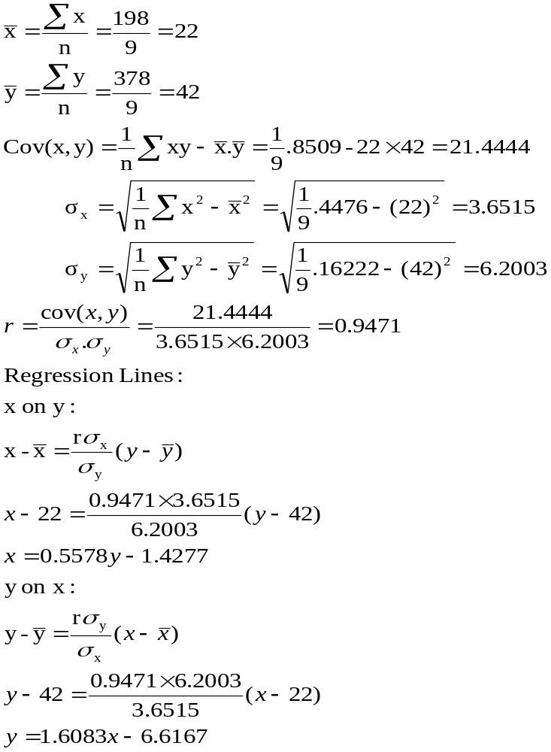
- Find the regression lines to the given data:
X | 2 | 5 | 3 | 4 | 9 | 12
Y | 12 | 8 | 6 | 8 | 4 | 5
Sol:-
X | y | xy | x² | y²
2 | 12 | 24 | 4 | 144
5 | 8 | 40 | 25 | 64
3 | 6 | 18 | 9 | 36
4 | 8 | 32 | 16 | 64
9 | 4 | 36 | 81 | 16
12 | 5 | 60 | 144 | 25
35 | 43 | 210 | 279 | 349

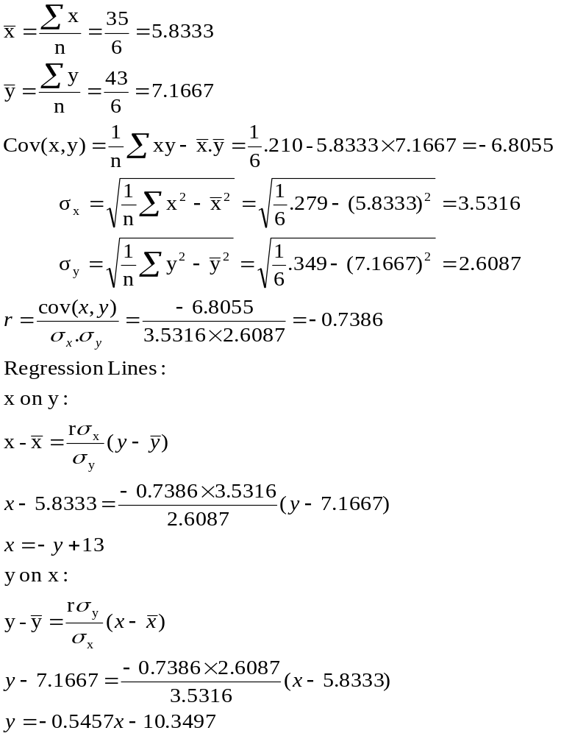

- The R & D expenditure (x) and annual profits(y) of a company are given for the last 8 years. Find the regression lines and estimate y if x=6.
Year | 1994 | 1995 | 1996 | 1997 | 1998 | 1999 | 2000 | 2001
X | 9 | 7 | 5 | 10 | 4 | 5 | 3 | 2
Y | 45 | 42 | 41 | 60 | 30 | 34 | 25 | 20
Sol:-
X | y | xy | x² | y²
9 | 45 | 405 | 81 | 2025
7 | 42 | 294 | 49 | 1764
5 | 41 | 205 | 25 | 1681
10 | 60 | 600 | 100 | 3600
4 | 30 | 120 | 16 | 900
5 | 34 | 170 | 25 | 1156
3 | 25 | 75 | 9 | 625
2 | 20 | 40 | 4 | 400
45 | 297 | 1909 | 309 | 12151
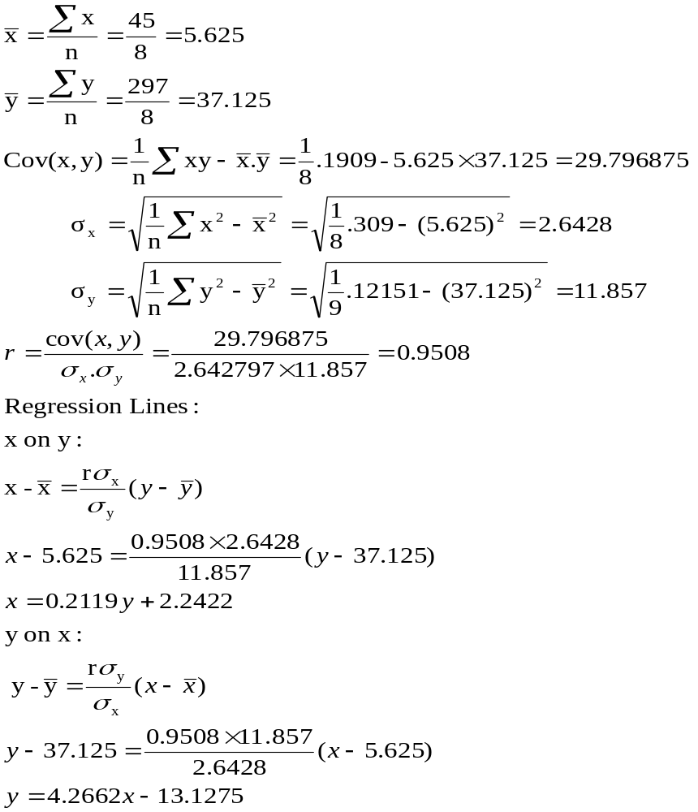

If x=6, y=38.7246 (using regression line y on x)
Rank correlation Coefficient
- Define rank correlation coefficient.
Ans: Some times we come across statistical series in which the variables under consideration are not capable of quantitative measurement. But can be arranged in a serial order. This happens when we are dealing with qualitative characteristics such as honesty, beauty, morality etc… which cannot be measured quantitatively but can be arranged serially. In such situations Edward Spearman developed a formula which consists of obtaining the correlation between the ranks
ρ= 1- 6.Σd²/n(n²-1)

2) What are the uses of Spearman’s Rank correlation coefficient?
- In comparison with Karl Pearson’s method, this method is much easy to understand and simple to calculate.
- This method can be applied to the phenomena of qualitative nature viz. honesty, beauty, efficiency etc which can be ranked in some order.
- This method is not effected by the extreme values.
- This method is considered indispensable when the data are given in the form of ranks rather than their real values.
- This method does not need the assumption that the population from which the samples are taken should be parametric or normally distributed.

Problem1:- The I.Q’s of a group of 6 persons are measured and they then sat for a certain examination. Then I.Q’s and examination marks are as follows:
Find the rank correlation coefficient.
person | I.Q | Exam  marks | X_{i} | Y_{i} | d_{i}=x_{i}-y_{i} | d_{i}²
A | 110 | 70 | 3 | 3 | 0 | 0
B | 100 | 60 | 4 | 4 | 0 | 0
C | 140 | 80 | 1 | 2 | -1 | 1
D | 120 | 90 | 2 | 1 | 1 | 1
E | 80 | 10 | 6 | 6 | 0 | 0
F | 90 | 20 | 5 | 5 | 0 | 0
 |  |  |  |  |  | Σd²=2

ρ= 1- 6.Σd²/n(n²-1)=1-0.0572 = 0.9428

Problem2:-Obtain the rank correlation coefficient to the given data.
X | Y | x_{i} | y_{i} | d_{i}=x_{i}-y_{i} | d_{i}²
68 | 62 | 4 | 5 | -1 | 1
64 | 58 | 6 | 7 | -1 | 1
75 | 68 | 2.5 | 3.5 | -1 | 1
50 | 45 | 9 | 10 | -1 | 1
64 | 81 | 6 | 1 | 5 | 25
80 | 60 | 1 | 6 | -5 | 25
75 | 68 | 2.5 | 3.5 | -1 | 1
40 | 48 | 10 | 9 | 1 | 1
55 | 50 | 8 | 8 | 0 | 0
64 | 70 | 6 | 2 | 4 | 16
 |  |  |  |  | Σd²=72

In x-series 75 has occurred twice ,so c.f =m(m²-1)/12=0.5
In x-series 64 has occurred thrice ,so c.f =m(m²-1)/12=2
In y-series 68 has occurred twice ,so c.f =m(m²-1)/12=0.5

Now corrected Σd²=72+0.5+2+0.5=75

ρ= 1- 6.Σd²/n(n²-1)=1-0.0572 = 0.5454

Problem3:-Obtain the rank correlation coefficient to the given data.
A | B | x_{i} | y_{i} | d_{i}=x_{i}-y_{i} | d_{i}²
115 | 75 | 3 | 5 | -2 | 4
109 | 73 | 5 | 6.5 | -1.5 | 2.25
112 | 85 | 4 | 1 | 3 | 9
87 | 70 | 10 | 8 | 2 | 4
98 | 76 | 8 | 4 | 4 | 16
120 | 82 | 1 | 2 | -1 | 1
98 | 65 | 8 | 10 | -2 | 4
100 | 73 | 6 | 6.5 | -0.5 | 0.25
98 | 68 | 8 | 9 | -1 | 1
118 | 80 | 2 | 3 | -1 | 1
 |  |  |  |  | Σd²=42.50

In A-series 98 has occurred thrice ,so c.f =m(m²-1)/12=2
In B-series 73 has occurred twice ,so c.f =m(m²-1)/12=0.5

Now corrected Σd²=42.5+2+0.5=45

ρ= 1- 6.Σd²/n(n²-1)=1-0.27 = 0.7272
Problem4:-Obtain the rank correlation coefficient to the given data.
X | Y | x_{i} | y_{i} | d_{i}=x_{i}-y_{i} | d_{i}²
81 | 10 | 1 | 8 | -7 | 49
78 | 12 | 2 | 7 | -5 | 25
73 | 18 | 6.5 | 5 | -1.5 | 2.25
73 | 18 | 3.5 | 5 | -1.5 | 2.25
69 | 18 | 5 | 5 | 0 | 0
68 | 22 | 6 | 2 | 4 | 16
62 | 20 | 7 | 3 | 4 | 16
58 | 24 | 8 | 1 | 7 | 49
 |  |  |  |  | Σd²=159.50

In x-series 73 has occurred twice ,so c.f =m(m²-1)/12=0.5
In y-series 18 has occurred thrice ,so c.f =m(m²-1)/12=2

Now corrected Σd²=159.5+0.5+2=162

ρ= 1- 6.Σd²/n(n²-1)=1-1.93 = -0.9285

