# chmod Command:

chmod is used to change the permissions of the user, group and owner.

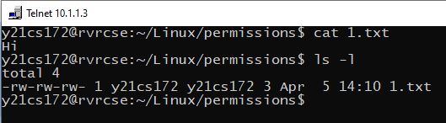

**Syntax:** chmod [user]-[mode] [filename]

## Changing permissions of user:

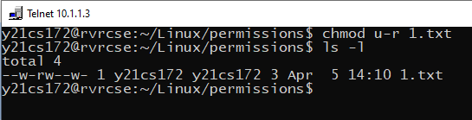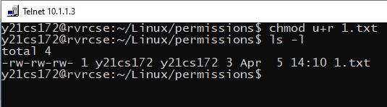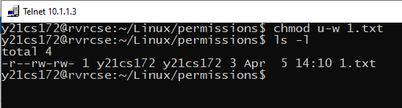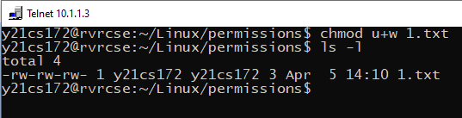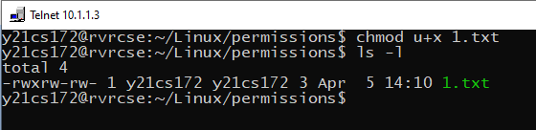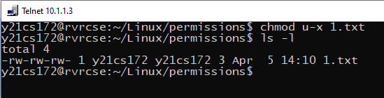

## Changing the permissions of group:

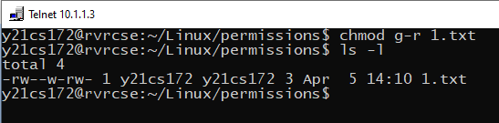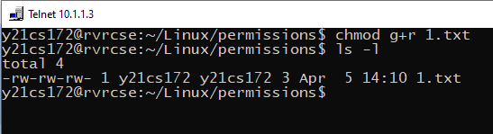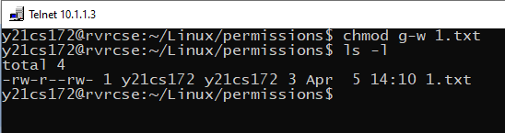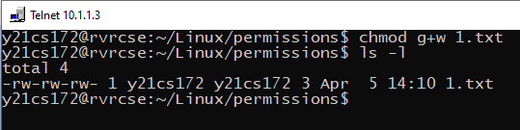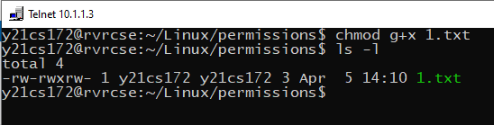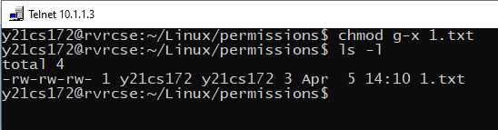

1. Changing the permissions of owner: