Name: Tayyab Abdullah
Reg No.: SP23-BCS-121
Course: PDC
Exam: Lab Exam
Date: 18 December, 2025

Performance Comparison:
Concurrent Load Test Results
Generated: 2025-12-18 13:32:34.006767
Total Requests: 100

gRPC Average: 2351.84 ms
REST Average: 2343.69 ms
After running a test script of 20 concurrent users, these are the results.

In our case REST runs faster because it is on localhost and has the translation logic within memory, while gRPC has to call over network for its processing. Despite the network overhead, gRPC is more advantageous as it is much more scalable, has better concurrency resolution, and better resource utilization. If all this processing is done on REST server , it would put unnecessary load on the server which would affect the other endpoints and services in it.
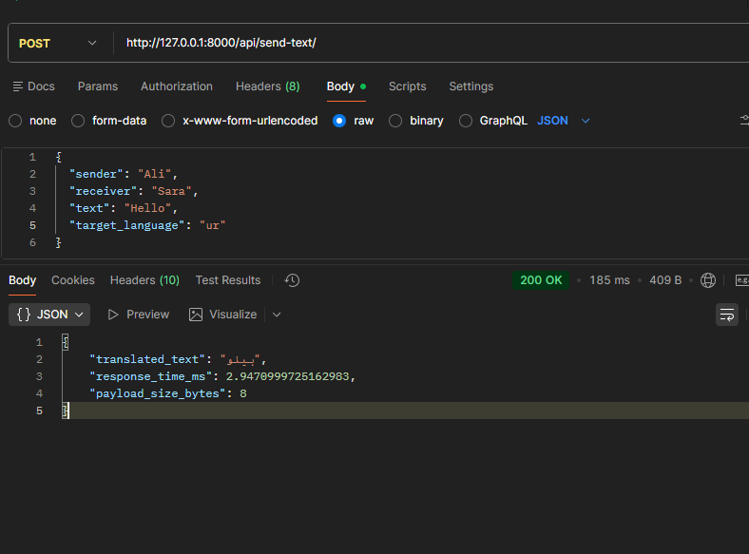
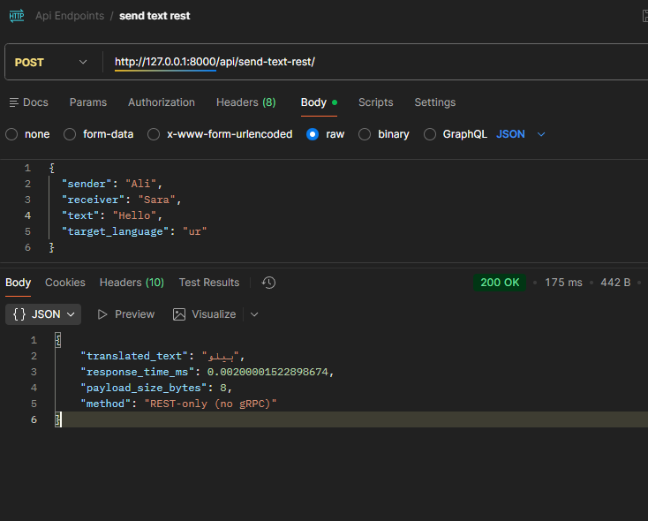
Why is audio over REST slower?
Audio over REST is significantly slower because REST/JSON cannot handle raw binary data directly, requiring base64 encoding which increases the payload size by approximately 33% and adds CPU-intensive encoding/decoding overhead at both client and server. This means a 1MB audio file becomes 1.33MB when base64-encoded, requiring more network bandwidth and processing time. Additionally, the JSON parsing process is text-based and less efficient than binary protocols, and REST typically uses HTTP/1.1 which lacks the multiplexing capabilities of HTTP/2. In contrast, gRPC with Protocol Buffers handles binary data natively without conversion overhead, resulting in smaller payloads, faster transmission, and reduced CPU usage, making it 3-4x faster for large binary audio data.
Why is gRPC preferred for service-to-service communication?
gRPC is preferred for service-to-service communication because it provides superior performance, scalability, and reliability for microservices architectures through its binary Protocol Buffers format (40-60% smaller payloads than JSON), HTTP/2 multiplexing (enabling multiple concurrent requests over a single connection), and strongly-typed contracts that prevent runtime errors through compile-time validation. Unlike REST which requires manual serialization and lacks formal contracts, gRPC auto-generates client/server code from .proto files, ensuring type safety and reducing integration bugs. Additionally, gRPC offers built-in features essential for distributed systems including bi-directional streaming, client-side load balancing, automatic retries, deadline propagation, and language-agnostic support, making it ideal for polyglot microservices where different services may be written in different programming languages while maintaining consistent, efficient, and reliable communication across the entire system.

Step 6:
- REST is suitable for client communication because it uses human-readable JSON, works natively in web browsers, requires no special tooling or code generation, and is widely understood by developers, making it ideal for public APIs and browser-based applications. However, REST is not ideal for microservices because JSON parsing is slower and less efficient than binary protocols, HTTP/1.1 lacks multiplexing leading to connection overhead, there are no formal contracts causing potential version mismatches between services, and the text-based format creates larger payloads consuming more bandwidth. For high-frequency service-to-service communication in microservices, the overhead of JSON serialization, lack of type safety, and HTTP/1.1 limitations make REST

- gRPC performs better for binary data because it uses Protocol Buffers which handle binary data natively without any conversion, whereas REST/JSON requires base64 encoding that increases payload size by 33% and adds CPU-intensive encoding/decoding overhead. With gRPC, audio bytes are transmitted directly as binary data over HTTP/2, eliminating the serialization penalty and reducing both network transfer time and processing overhead. For example, a 1MB audio file remains 1MB in gRPC but becomes 1.33MB when base64-encoded for REST, and the additional encoding/decoding operations can add 50-100ms of latency, making gRPC 3-4x faster for large binary payloads like audio, video, or images.

- Protocol Buffers reduce payload size by using a compact binary format instead of text-based JSON, employing variable-length encoding for integers (small numbers use fewer bytes), eliminating field names from the transmitted data (using numeric field IDs instead), and automatically omitting default values and optional fields that aren't set. For example, JSON {"text": "Hello", "language": "ur"} (37 bytes) becomes a Protocol Buffer binary representation of approximately 15 bytes, achieving 40-60% size reduction. This binary encoding is more efficient because it stores data types directly without string delimiters, quotes, or whitespace, and uses optimized encoding schemes like varint for integers and length-prefixing for strings, resulting in minimal overhead and maximum compression.

- This system scales horizontally by deploying multiple instances of each microservice (translation and audio services) behind load balancers, with the REST API gateway distributing requests across these instances using round-robin or least-connections algorithms. Since the gRPC services are stateless and process-independent, you can add more translation service instances on different servers/containers to handle increased translation load, and similarly scale audio service instances independently based on audio processing demand. The architecture supports horizontal scaling because each service can scale independently (translation may need 10 instances while audio needs 5), gRPC's HTTP/2 connection pooling efficiently manages connections to multiple service instances, database operations are centralized in the API gateway avoiding distributed transaction complexity, and container orchestration platforms like Kubernetes can automatically scale services based on CPU/memory usage or request queue depth, enabling the system to handle millions of concurrent users by simply adding more service instances.

