International Islamic University Islamabad
Department of Computer Science

PROJECT REPORT

Simulating a Dictionary Attack on a Protected ZIP File

Course: Information Security
Submitted To: Dr.Zahid Mehmood

Submitted By:
Tayyab Akhtar

Platform: Ubuntu
Date: 12-May-2026

Table of Contents
Abstract 3
1. Introduction 4
1.1 Background 4
1.2 Problem Statement 4
1.3 Objectives 4
1.4 Scope and Limitations 4
2. Tools and Technologies Used 5
3. Implementation 5
Step 1: Create a Secret Text File 5
Step 2: Create Weak ZIP File 5
Step 3: Create Strong ZIP File 5
Step 4: Attack weak.zip Using fcrackzip 5
Step 5: Attack strong.zip Using fcrackzip 5
Step 6: Attack Using John the Ripper 6
Step 7: Run ZipReaper Custom Tool 6
4. Results and Analysis 6
5. Defense Mechanisms 7
6. Ethical and Legal Considerations 7
7. Conclusion 7
8. References 8
9. Appendix 9
Appendix A: Screenshot Evidence 9
Appendix B: Command Reference 9

Abstract
This project demonstrates a simulated dictionary attack on password-protected ZIP files within a controlled, ethical, and educational lab environment. The experiment was conducted on Ubuntu using fcrackzip, John the Ripper, and ZipReaper — a custom Python-based tool developed by Tayyab Akhtar. Two ZIP files were tested: weak.zip, protected with the common password password123, and strong.zip, protected with the complex password Xy7#mK9$pL2!. The rockyou.txt wordlist, containing 14.3 million real leaked passwords, served as the attack dictionary. Results confirmed that the weak password was cracked within seconds, while the strong password successfully resisted the full attack. This project educates students on practical attack methods, real-world implications of poor password hygiene, and effective defense strategies aligned with NIST guidelines.

1. Introduction

1.1 Background
ZIP file password protection is widely used to secure sensitive documents, archives, and confidential data shared across digital platforms. While encryption provides a layer of security, its effectiveness depends entirely on the strength of the password chosen. ZIP file encryption has historically used ZipCrypto, a relatively weak proprietary cipher. Modern tools support AES-256 encryption for ZIP files, which provides substantially stronger protection. NIST Special Publication 800-63B (2024) recommends passwords of at least 15 characters. Users commonly select simple, memorable passwords that are highly vulnerable to automated attacks. Weak passwords represent one of the most significant and avoidable security risks in modern information systems.

1.2 Problem Statement
Weak ZIP file passwords can be systematically cracked using dictionary attacks that test thousands of commonly used passwords per second. Wordlists such as rockyou.txt, derived from real data breaches, make these attacks highly effective against predictable passwords. This poses a serious threat to the confidentiality of password-protected files.

1.3 Objectives
- To simulate a dictionary attack on a weak password-protected ZIP file.
- To compare weak and strong password resistance against dictionary attacks.
- To use tools such as fcrackzip, John the Ripper, and ZipReaper.
- To recommend effective password security best practices.

1.4 Scope and Limitations
This project was conducted exclusively on ZIP files created by the project team for experimental purposes. Only the dictionary attack method was applied; brute-force and rainbow table attacks were not tested. The project is strictly for educational purposes and was performed in an isolated, controlled environment. No unauthorized systems, accounts, or files were accessed or targeted at any stage.

2. Tools and Technologies Used
All tools were configured and executed on Ubuntu Linux. The following table summarizes the tools used:

Tool | Description
Ubuntu Linux | Operating system used as the lab environment for all testing activities.
fcrackzip | Command-line tool for cracking ZIP passwords using wordlists or brute-force methods.
John the Ripper | Advanced open-source password cracking tool used for hash-based comparison attacks.
rockyou.txt | Wordlist of 14.3 million real leaked passwords from the 2009 RockYou data breach.
ZipReaper | Custom Python educational tool by Tayyab Akhtar: colored terminal output, ASCII logo, and real-time progress tracking.
zip / unzip | Standard Linux utilities used to create and manage password-protected ZIP archives.

3. Implementation
The project was implemented step by step on Ubuntu Linux. No unauthorized files or systems were involved at any stage.

Step 1: Create a Secret Text File
echo "This is a secret document" > secret.txt
A plain text file was created to serve as the content to be archived and encrypted inside ZIP files.

Step 2: Create Weak ZIP File
zip -P password123 weak.zip secret.txt
The file was archived with a simple, commonly used password to simulate poor password hygiene.

Step 3: Create Strong ZIP File
zip -P 'Xy7#
mK9$pL2!' strong.zip secret.txt
A second archive was created using a complex, randomly generated password to test resistance to dictionary attacks.

Step 4: Attack weak.zip Using fcrackzip
fcrackzip -u -D -p rockyou.txt weak.zip
fcrackzip loaded the rockyou.txt wordlist and tested each entry against weak.zip. The password password123 was discovered within seconds.

Step 5: Attack strong.zip Using fcrackzip
fcrackzip -u -D -p rockyou.txt strong.zip
The same attack was run against strong.zip. The tool exhausted the entire wordlist without finding a match, confirming the strong password's resistance.

Step 6: Attack Using John the Ripper
zip2john weak.zip > weak.hash
john --wordlist=rockyou.txt weak.hash
john --show weak.hash
The zip2john utility extracted the password hash from weak.zip. John the Ripper cracked it using rockyou.txt, confirming the fcrackzip result.

Step 7: Run ZipReaper Custom Tool
python3 zip_reaper.py
ZipReaper, developed by Tayyab Akhtar, was executed with a professional terminal interface. It displayed a custom ASCII logo, real-time attack progress, and a final security lesson upon completion.

4. Results and Analysis
The experiment produced clear and conclusive results. The weak.zip file was cracked by all three tools within seconds. The strong.zip file was not cracked by any tool, confirming its full resistance to the dictionary attack.

ZIP File | Password | Type | Tool Used | Result
weak.zip | password123 | Weak | fcrackzip / John / ZipReaper | Cracked
strong.zip | Xy7#mK9$pL2! | Strong | fcrackzip / ZipReaper | Not Cracked

Figure 1: Dictionary Attack Flow Diagram
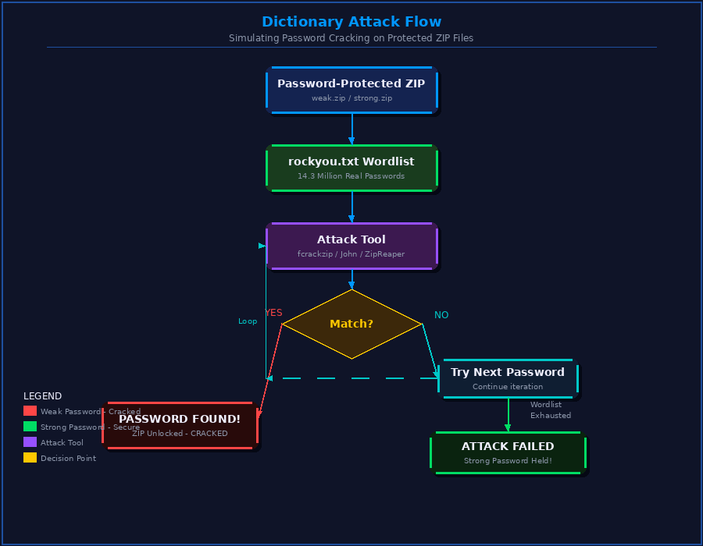

The weak password was cracked because it appears in the rockyou.txt wordlist, a compilation of real user passwords exposed in historical breaches. Dictionary attacks are extremely efficient against such predictable credentials. The strong password Xy7#mK9$pL2! was absent from the wordlist and contains uppercase, lowercase, numbers, and special characters — making it computationally infeasible to guess through dictionary methods alone.

5. Defense Mechanisms
Based on the results of this experiment, the following defense mechanisms are strongly recommended:
- Use strong passwords of at least 12 characters, combining uppercase, lowercase, numbers, and special symbols. Avoid common words, names, or keyboard patterns.
- Use a reputable password manager such as Bitwarden or LastPass to generate and securely store complex passwords without the need to memorize them.
- Enable Two-Factor Authentication (2FA) wherever possible to add a secondary layer of security beyond the password alone.
- Use AES-256 encryption instead of the outdated ZipCrypto when creating ZIP archives, providing substantially stronger protection against both dictionary and brute-force attacks.
- Implement account lockout policies after a defined number of failed login attempts to limit automated attack attempts on authentication-protected systems.

6. Ethical and Legal Considerations
This project was conducted strictly within ethical and legal boundaries. All ZIP files tested were created by ourself specifically for this educational experiment. No unauthorized files, systems, accounts, or networks were accessed or targeted at any stage. Dictionary attacks are powerful methods that must only be performed with explicit written permission from the file or system owner.
Unauthorized access to any computer system or file is a criminal offense. In Pakistan, the Prevention of Electronic Crimes Act (PECA) 2016 prohibits unauthorized access, data interference, and cyber intrusions.
In the United States, the Computer Fraud and Abuse Act (CFAA) imposes severe penalties for unauthorized computer access. All security testing activities must be conducted legally and ethically.

7. Conclusion
This project successfully demonstrated the effectiveness of dictionary attacks against weak password-protected ZIP files and the resilience of strong passwords under identical attack conditions. Using fcrackzip, John the Ripper, and the custom ZipReaper tool, the weak password password123 was cracked within seconds, while the strong password Xy7#mK9$pL2! remained uncracked. The results conclusively prove that password strength is the most critical factor in protecting encrypted files. In future, a hacker could explore GPU-accelerated password cracking or AI-based password prediction models to assess threats against even stronger credentials.

8. References
Knopper, M. (n.d.). fcrackzip – A free fast ZIP password cracker. Retrieved from http://oldhome.schmorp.de/marc/fcrackzip.html

Openwall. (2023). John the Ripper password cracker – Official documentation. Retrieved from https://www.openwall.com/john/doc/

Python Software Foundation. (2024). zipfile – Work with ZIP archives. Python 3 Documentation. Retrieved from https://docs.python.org/3/library/zipfile.html

Grassi, P. A., Garcia, M. E., & Fenton, J. L. (2024). NIST Special Publication 800-63B: Digital Identity Guidelines – Authentication and Lifecycle Management. National Institute of Standards and Technology. https://doi.org/10.6028/NIST.SP.800-63b

Wikipedia. (2023). RockYou. Retrieved from https://en.wikipedia.org/wiki/RockYou

OWASP Foundation. (2023). Authentication Cheat Sheet – Password Security Guidance. Retrieved from https://cheatsheetseries.owasp.org/cheatsheets/Authentication_Cheat_Sheet.html

Canonical Ltd. (2024). Ubuntu Linux official documentation. Retrieved from https://ubuntu.com/tutorials

Stallings, W. (2022). Cryptography and Network Security: Principles and Practice (8th ed.). Pearson Education. ISBN: 978-0135764213

9. Appendix

Appendix A: Screenshot Evidence

Screenshot 1
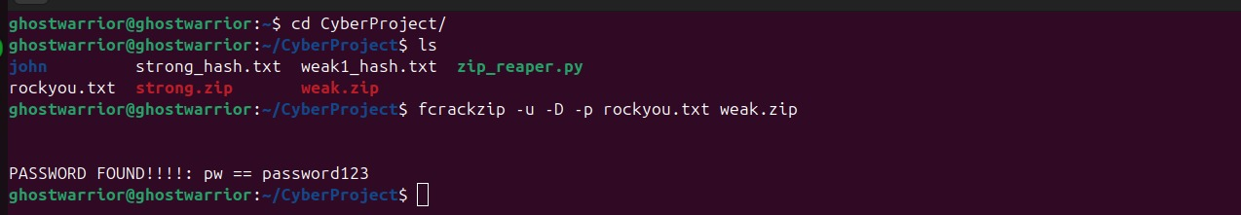

Figure A1: fcrackzip successfully cracking weak.zip and revealing password: password123

Screenshot 2
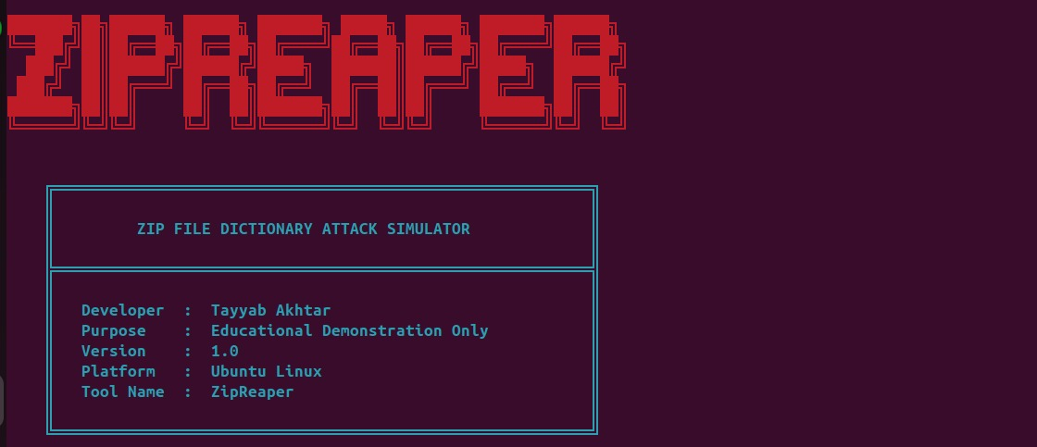
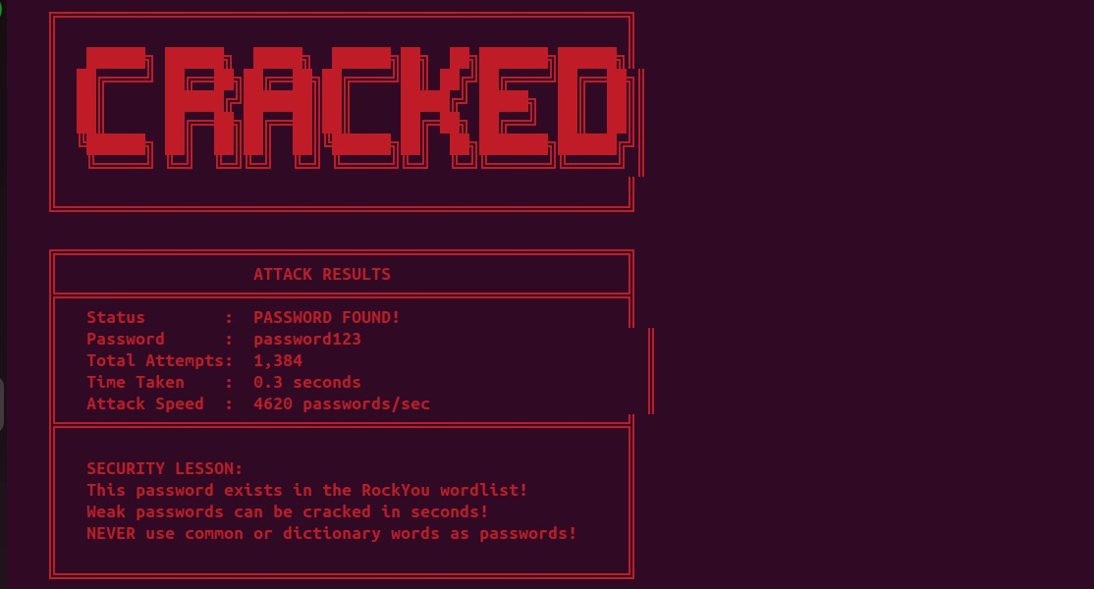

Figure A2: ZipReaper custom tool output showing professional logo, attack result, and security lesson

Appendix B: Command Reference

Command | Purpose
zip -P password123 weak.zip secret.txt | Create weak ZIP file
zip -P 'Xy7#mK9$pL2!' strong.zip secret.txt | Create strong ZIP file
fcrackzip -u -D -p rockyou.txt weak.zip | Attack weak ZIP with fcrackzip
zip2john weak.zip > weak.hash | Convert ZIP hash for John the Ripper
john --wordlist=rockyou.txt weak.hash | Run John the Ripper dictionary attack
python3 zip_reaper.py | Run ZipReaper custom tool

