

THE UNIVERSITY OF AZAD JAMMU & KASHMIR,
MUZAFFARABAD

COURSE TITLE | COMPUTER NETWORKS
COURSE CODE | CS-2203
LAB | 01
NAME | Tayyab Hanif
ROLL NUMBER | 2024-SE-11
INSTRUCTOR’s NAME | ENGR. ASMA JAVED
SUBMISSION DATE | 2nd March, 2026

1. Objective
Objective of this lab is to install Cisco Packet Tracer 9.0.0 (64-bit) on a Windows operating system and verify its operational status by launching the application interface.

2. Prerequisites
- Operating System: Windows (64-bit architecture)
- Software Executable: Cisco Packet Tracer 9.0.0 Setup Wizard
- Storage Requirement: Minimum of 715.0 MB of free disk space

3. Introduction
Cisco Packet Tracer is a comprehensive network simulation tool that allows users to create network topologies and imitate modern computer networks. The software is utilized for practicing network configuration, troubleshooting, and understanding complex networking concepts in a virtual environment.

4. Step-by-Step Installation Procedure

1. License Agreement
Run the setup executable to initialize the setup wizard. The installation begins with the End User License Agreement (EULA). Read the terms, select the radio button corresponding to "I accept the agreement", and click Next to proceed.

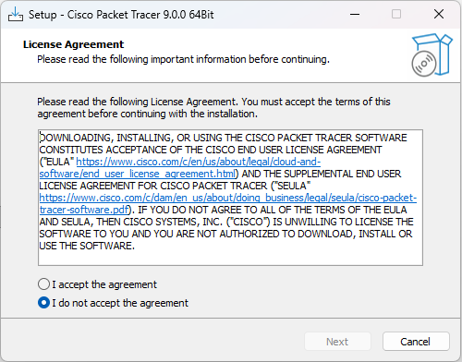

2. Destination Location
Leave it as default or click Browse to choose a different location, then click Next.
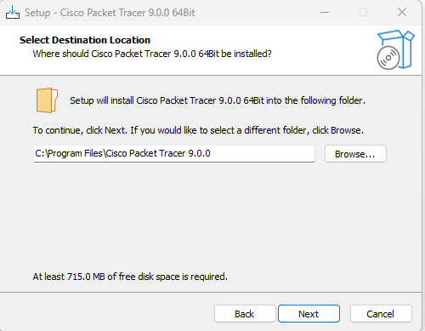

Keep moving next, leaving the options as default (not important).

4. Installation
Review these details to ensure accuracy, and click Install to begin the writing process.
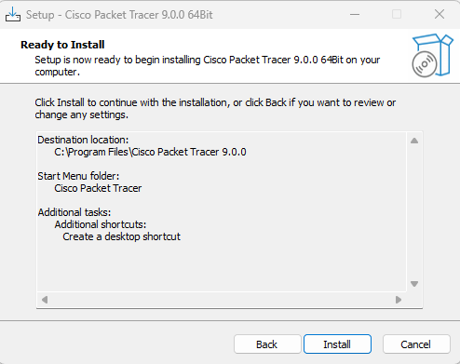

Installation in Progress
Wait for this process to complete…

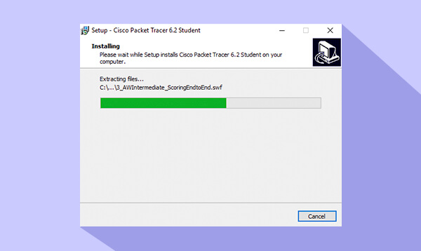

5. Completing the Setup Wizard
To immediately verify the installation, ensure the "Launch Cisco Packet Tracer" checkbox is selected, and click Finish.
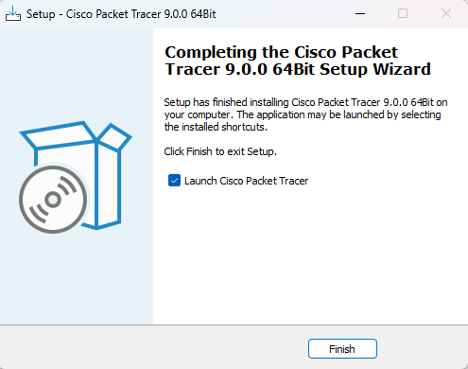

6. Verification and Launch The Cisco Packet Tracer application will execute and open to its default workspace. The presence of the logical/physical workspace tabs and the network component library at the bottom confirms that the software has been installed successfully and is ready for use.

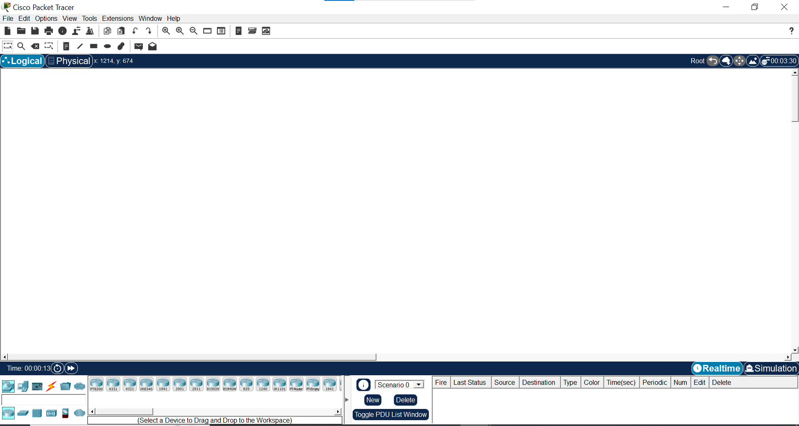

5. Conclusion
The installation of Cisco Packet Tracer 9.0.0 64-bit completed successfully with no errors encountered. The application launched correctly, demonstrating that the environment is fully prepared for subsequent network simulation tasks.

------------------------------------------------

