

THE UNIVERSITY OF AZAD JAMMU & KASHMIR, MUZAFFARABAD
Name | Tayyab Hanif
COURSE TILE | Computer Networks
Lab # | 03
ROLL NUMBER | 2024-SE-11
INSTRUCTOR NAME | ENGR. DR. ASMA JAVED
SUBMISSION DATE | 28th March, 2026

Physical Layer of the OSI Model

Introduction
The primary objective of this laboratory session was to gain a practical understanding of the Physical Layer within the OSI model. This was achieved through the manual termination of an Ethernet cable using RJ45 connectors and the subsequent verification of its physical connectivity. This exercise emphasizes the critical role that proper cabling and termination play in ensuring reliable data transmission across a network.

Equipment and Materials
The following tools and materials were utilized during the experimental procedure:
- Unshielded Twisted Pair (UTP) Cable (Category 5/6)
- RJ45 Connectors
- Professional Cable Crimping Tool
- Network Cable Tester
- Digital Camera for result documentation

Methodology
The cable termination followed the standard T568B wiring protocol. The systematic procedure is outlined below:
- Preparation: The UTP cable was measured and cut to the desired length.
- Stripping: The external insulation was carefully removed to expose the internal twisted pairs.
- Alignment: The internal wires were untwisted and arranged according to the T568B color-coding standard.
- Termination: The aligned wires were inserted into the RJ45 connector, ensuring they reached the end of the tracks, and secured using the crimping tool.
- Replication: The same process was applied to the opposite end of the cable to create a straight-through connection.
- Verification: The completed cable was connected to a network tester to evaluate the integrity of the physical connection.
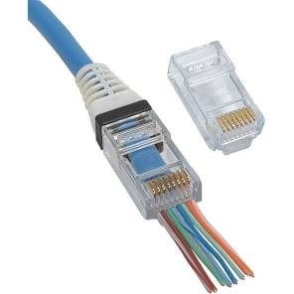
RJ45 Connector Terminated Cable

Observations and Results
Upon testing, the LED indicators on the cable tester provided a visual representation of the connection status. While most pairs showed successful continuity, a specific fault was identified in the final sequence.
Wire Pair / Pin | Tester LED Status | Remarks
1–2 | ON | Functioning Correctly
3–6 | ON | Functioning Correctly
4–5 | ON | Functioning Correctly
6th Wire / Remaining | OFF | Connectivity Failure (Not Connected)

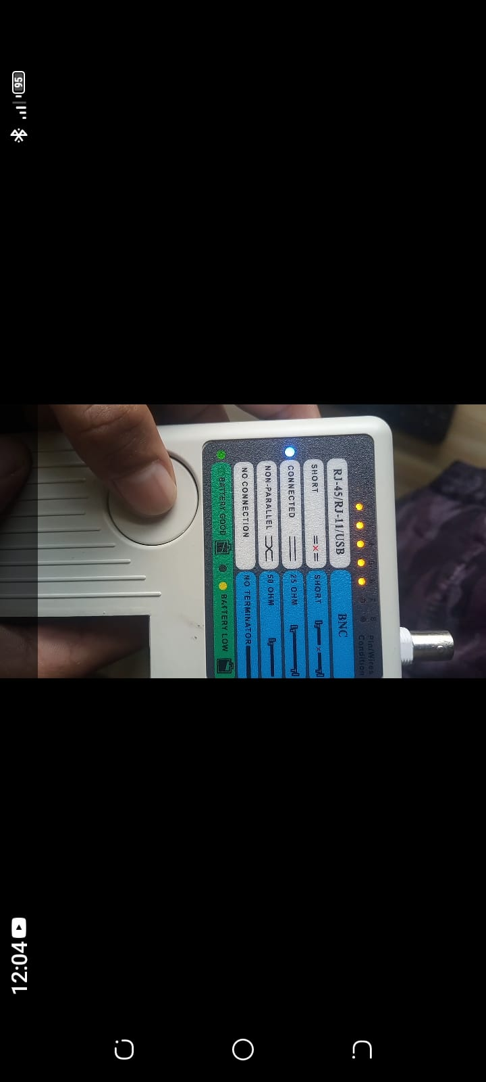
Cable Tester Verification

Result Summary
The terminated cable is considered partially functional due to a mis-wiring or lack of contact on the 6th wire.

Conclusion
Although the cable was only partially functional due to a termination error on one wire, the exercise provided valuable hands-on experience in network installation. It highlighted the precision required for proper cable termination and the necessity of using testing tools for troubleshooting real-world network infrastructure. Successful demonstration!

-----------------------------------

