Healthcare Facilities
List of healthcare facilities page has two modules. 1) To add facilities 2) to display the facilities added.
Every Facility consist of 10 fields which were mentioned in requirement file.
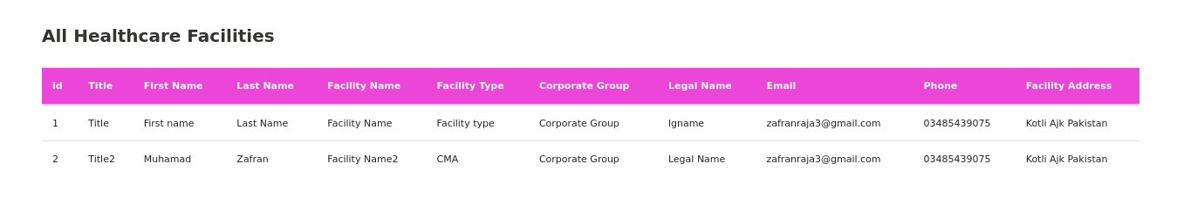
Helatcare facility form to add health care facility
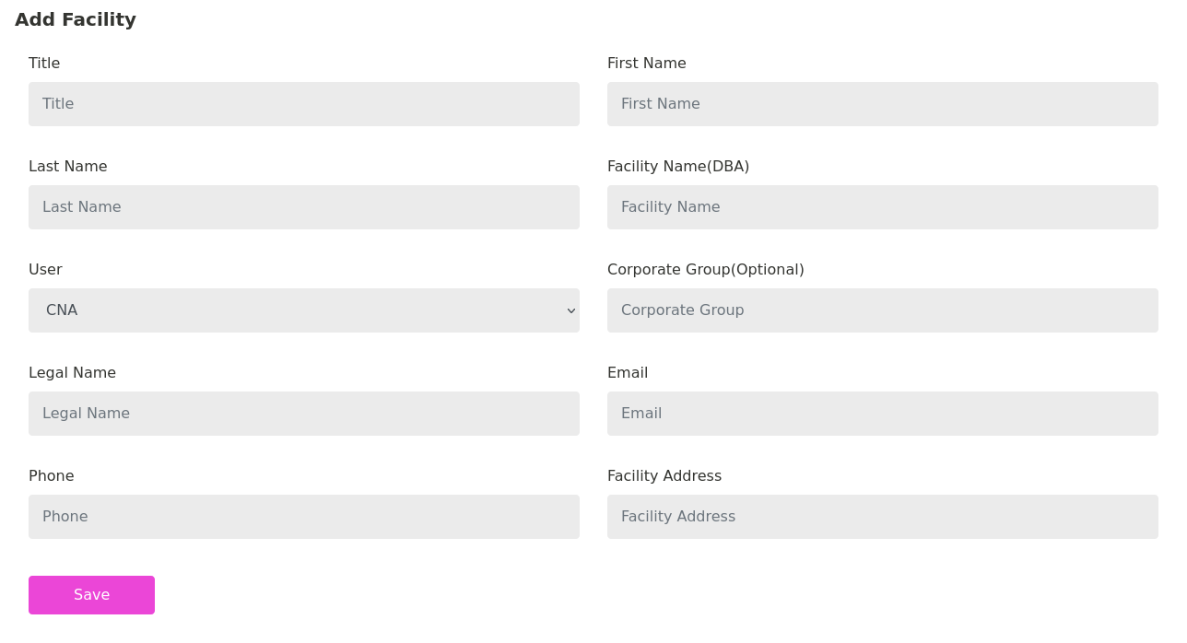

Healthcare Professionals
Healthcare Professionals are those who have their login access to dashbaord after signup.

What Professionals can do?
-Professionals can view the Facilities.
-Can Add shift
-Select the suitable facility from the list of facilities that are added. That shift would be displayed in schedule page for each individual.

-They can add earnings
-view total earnings (if required in future)
-filter earnings for months( if required in future)

-add credentials
-Professionals can add credentials and download view their credentials.

What admin can do?

Admin can view, edit, delete any facility, Professional account, shift, credentials , earnings and everything. By adding /admin with website url he would have access to backend dashbaord.
On frontend dashboard, admins can view credentials, shifts, facilities and earnings of all the professionals.

There are so many possible functionalities that can be added in future.

