Project Documentation & Pipeline Walkthrough
- Repository: https://github.com/TayyabKhalid25/ETL_MLOps_Task_3
- Task: MLOps Task 3 Building Airflow ETL Pipeline
- Orchestration: Astronomer (Astro) CLI with Apache Airflow
- Database: MongoDB with Mongo Express Administration UI
- Data Source: Frankfurter API v2

Architecture & Data Flow
The pipeline executes sequentially in three stages:
- Extraction: Airflow issues an HTTP GET request to the Frankfurter API endpoint and pushes the raw payload to Airflow's metadata database under the explicit XCom key raw_exchange_data.
- Transformation: The transformation task retrieves raw_exchange_data from XCom, extracts each quote, casts numeric rates to float values, appends extraction timestamps in UTC ISO-8601 format, and pushes the standardized list to XCom key transformed_exchange_data.
- Loading: The database task pulls transformed_exchange_data, connects to the containerized MongoDB service via Docker networking, creates a compound unique index on (base_currency, target_currency, rate_date), and upserts each record into currency_db.exchange_rates to ensure idempotency.

Step-by-Step Implementation and Screenshots

Step 1: Environment Setup & Project Initialization
The project workspace was scaffolded using the Astronomer CLI (astro dev init). This generated the standard directory layout for Airflow configurations, DAGs, runtime dependencies, and container definitions.
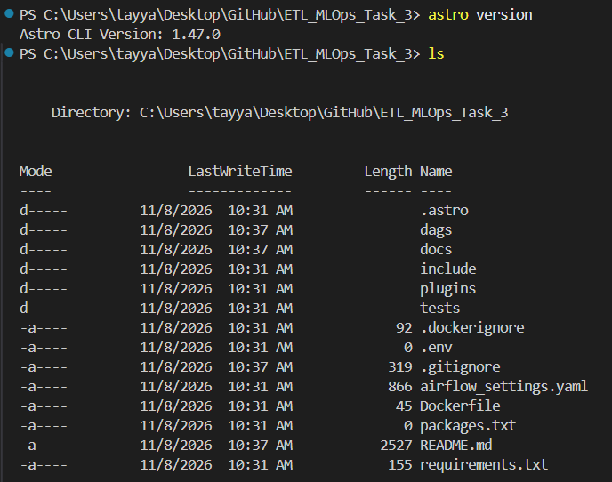

Step 2: Docker Infrastructure Configuration
MongoDB and Mongo Express were integrated into the Astro CLI stack using docker-compose.override.yml.
- Custom Networking: Both services join Astro's default airflow bridge network. This enables Airflow worker tasks to communicate with MongoDB directly by its service hostname (mongodb:27017) instead of host-level port binding.
- Persistent Storage: A named volume (mongodb_data) is mounted to /data/db within the MongoDB container, ensuring database records survive container restarts and rebuilds.
- Dependency Management: requirements.txt was configured with requests for API ingestion and pymongo for database interaction.
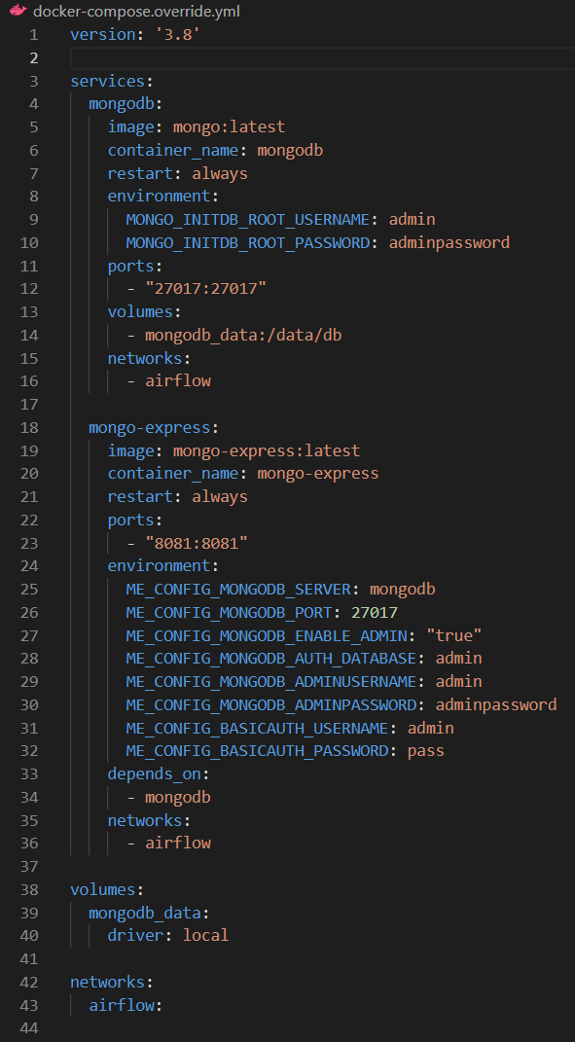

Step 3: DAG Implementation & Named XCom Design
The pipeline logic was authored in dags/currency_exchange_etl.py using three PythonOperator tasks:
- extract_currency_rates: Queries https://api.frankfurter.dev/v2/rates?base=EUR&quotes=USD,GBP,JPY, validates the HTTP response, and writes the raw list to XCom key raw_exchange_data.
- transform_exchange_rates: Reads from raw_exchange_data, maps fields to the required target schema, attaches an ISO-8601 UTC timestamp, and writes the structured records to XCom key transformed_exchange_data.
- load_to_mongodb: Reads from transformed_exchange_data, connects to currency_db, ensures an index over the unique business keys, and upserts the documents.
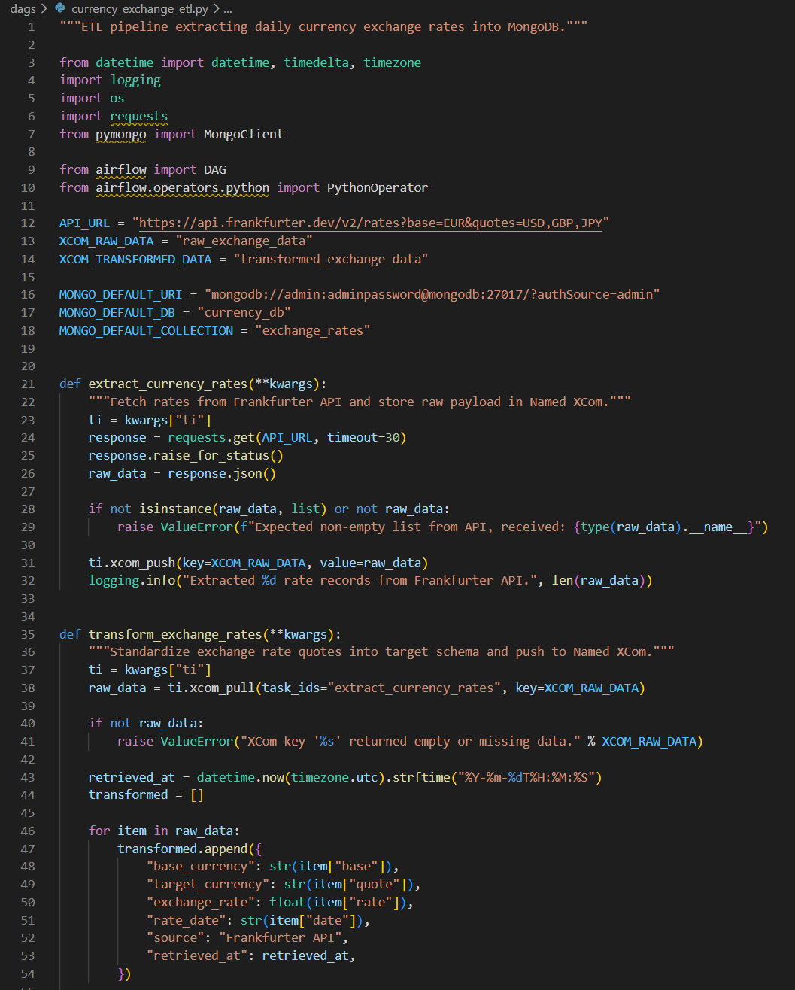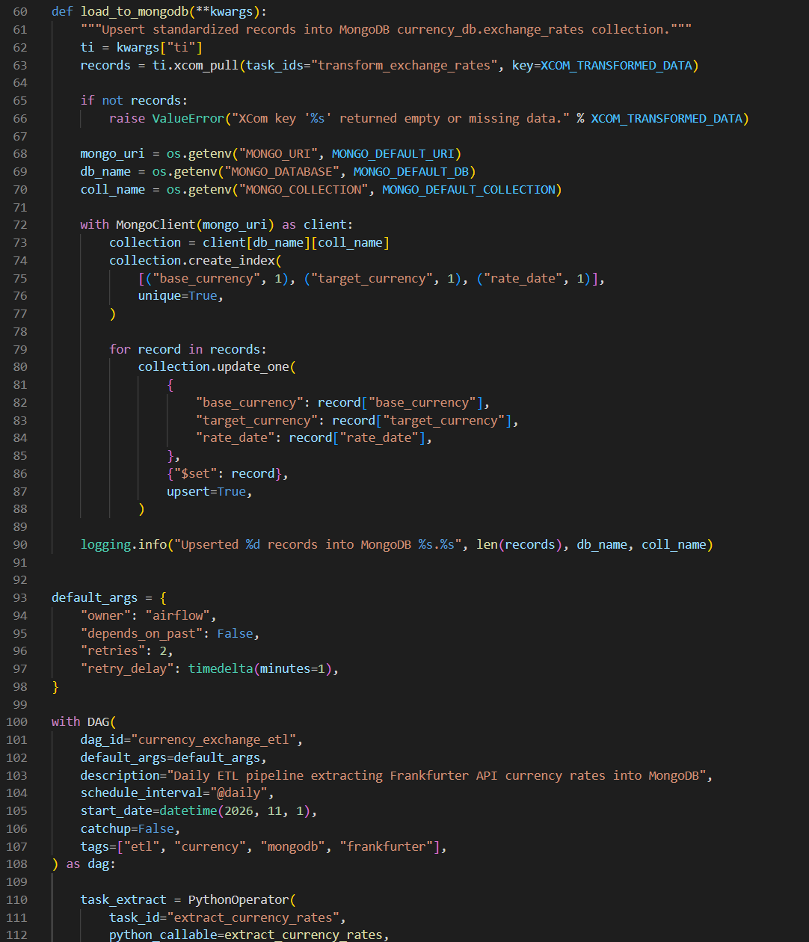

Step 4: Environment Launch & Container Verification
Executing astro dev start builds the custom runtime image (installing specified Python libraries) and starts all project containers.
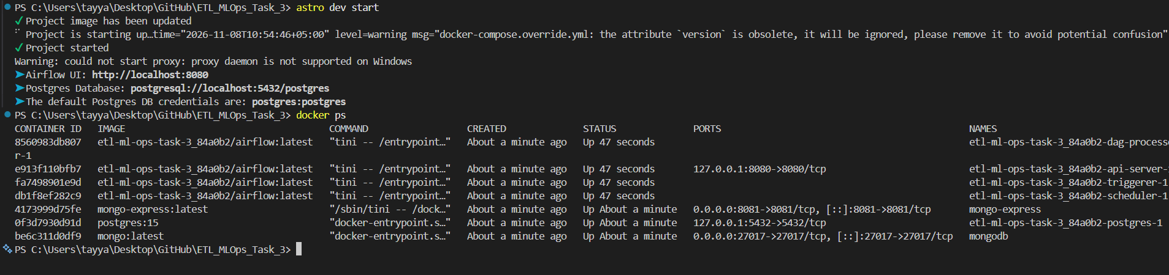

Step 5: DAG Execution in Airflow Web UI
Accessing the Airflow Web UI at http://localhost:8080, the DAG currency_exchange_etl was triggered manually. All three sequential tasks executed and completed with status success.
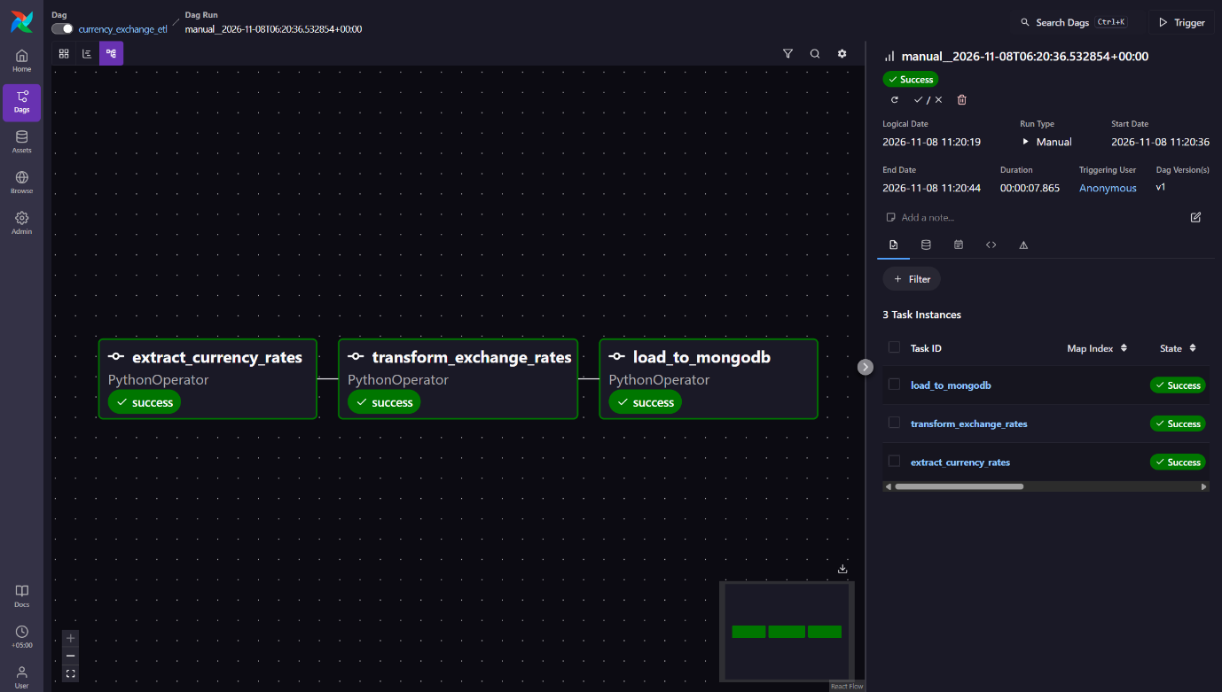

Step 6: Task Execution Logs
Inspecting task logs from the Airflow UI confirms task execution details, network connectivity, and upsert counts.
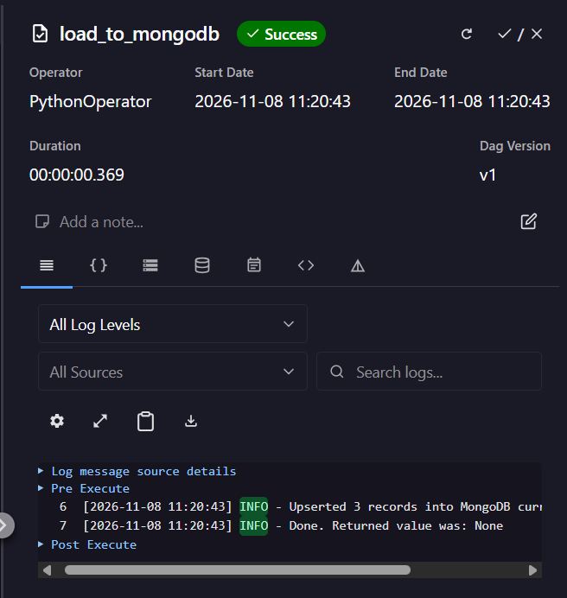

Step 7: Named XCom Data Transfer Verification
The assignment specifically requires Named XComs for inter-task communication. The XCom inspector confirms the storage of explicit keys and their corresponding structured JSON payloads.
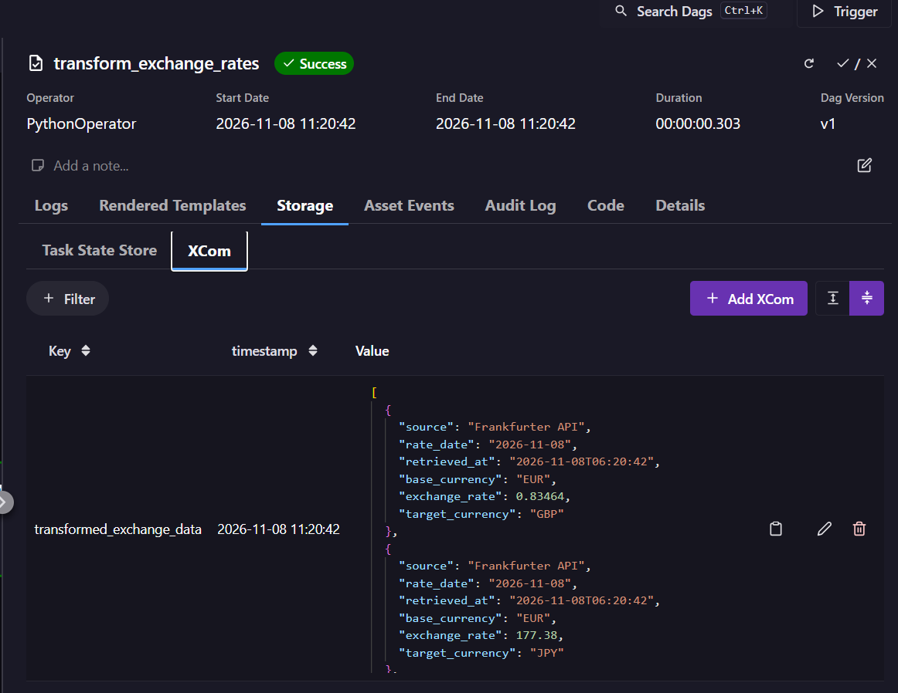

Step 8: Database Verification in Mongo Express
Navigating to Mongo Express at http://localhost:8081 allows administrative inspection of the MongoDB server status, active databases, and collections.
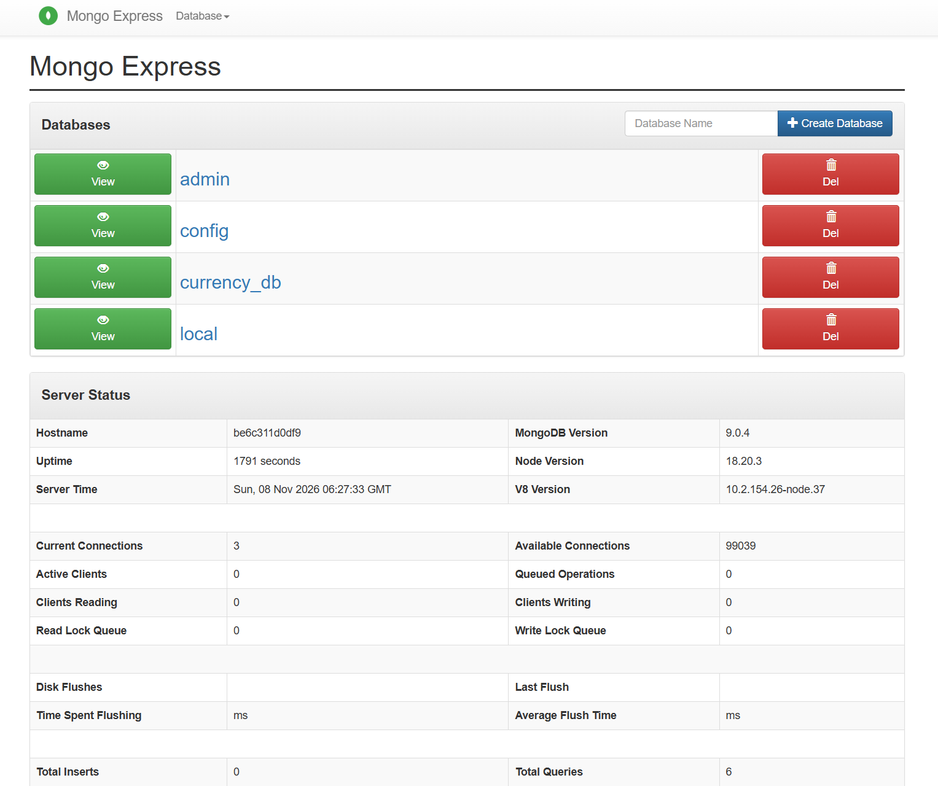

Step 9: Stored Document Schema Verification
Drilling into currency_db > exchange_rates displays the documents committed by the pipeline.
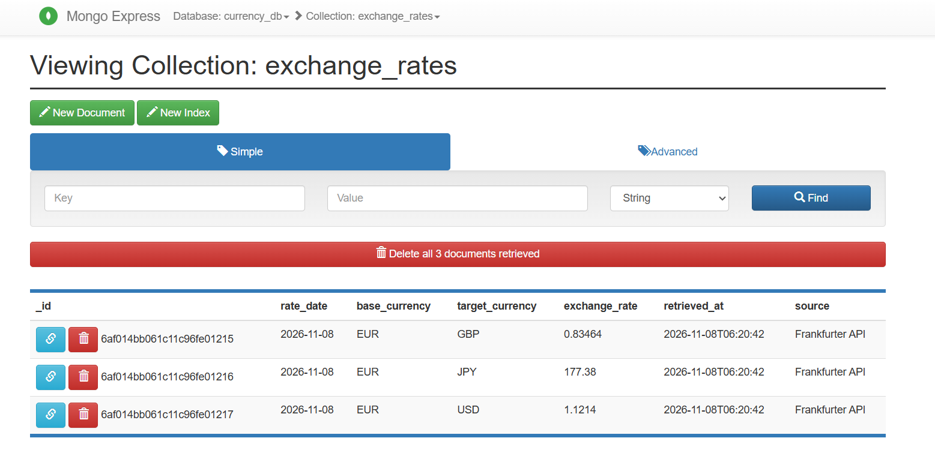

Conclusion & Operational Benefits
- Decoupled Architecture: Airflow orchestrates scheduling and task execution; MongoDB provides flexible document storage; Mongo Express provides a lightweight visual inspection interface.
- Idempotence: The load task enforces an index on (base_currency, target_currency, rate_date) and uses update_one(..., upsert=True). Multiple runs on the same date update existing entries without creating duplicate records.
- Failure Isolation: Each step executes in its own task boundary. API network interruptions fail fast at extraction without polluting downstream storage, and Named XComs provide full auditability into payloads between stages.

