DB LAB PHASE 2
MUHAMMAD TAYYAB NAWAZ L1S22BSSE0004
USAMA RASHEED L1S22BSSE0039

Q#1 ERD
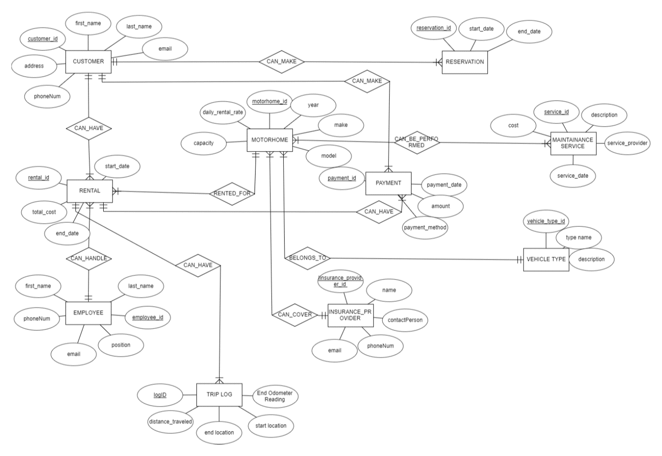

Q#2 RELATIONAL SCHEMA
