**Name: Tayyab Salman**

**Class: BSSC-5C**

**Reg. No. 124494**

**CS213 Advanced Programming**

**Lab No. 03**

**Getting started with R and building our first R application**

**29th September, 2017**

**Source Code**

**Code No. 01:**

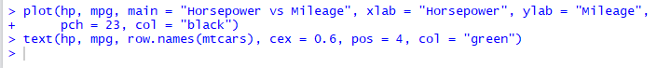

**Output No. 01:**

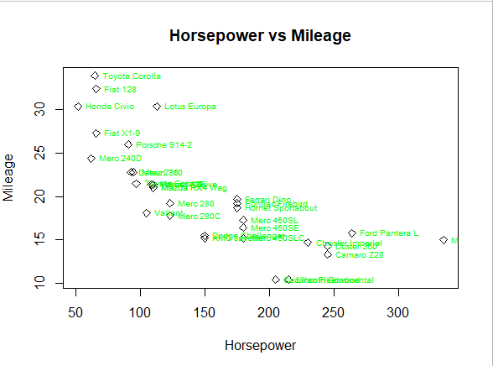

**Code No. 02:**

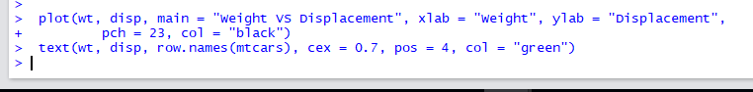

**Output No. 02:**

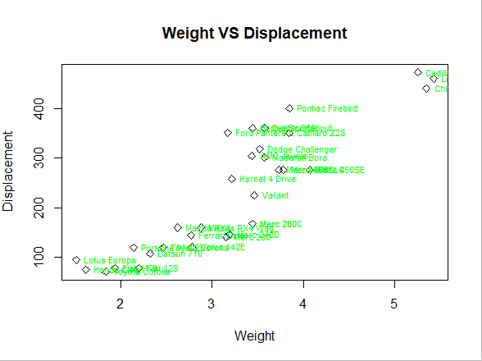

**Code No. 03:**

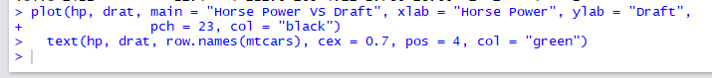

**Output No. 03:**

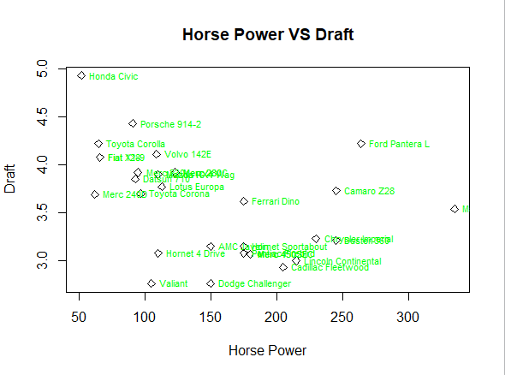

**Documentation (Comments)**

## Objectives:

* Get started with R and R Studio
* Get familiarized with R’s syntax and capabilities by building an application

**Comments:**

R is a language and environment for statistical computing and graphics. It is a [GNU project](http://www.gnu.org/) which is similar to the S language and environment which was developed at Bell Laboratories (formerly AT&T, now Lucent Technologies) by John Chambers and colleagues. R can be considered as a different implementation of S. There are some important differences, but much code written for S runs unaltered under R.

**GitHub**

<https://github.com/TayyabSalman/AP-Lab-No.-03>