**DBMS (Lab)**

**LAB-01**



**Submitted to**:

Ma’am Darakhshan Abdul Ghaffar

**Submitted by:**

Tayyaba Asif

2019-CE-5

**Date:** 23rd January,2022.

**Question No: 02**

Explore one additional tool for database models, run it on your machine and write your learning experience.

**Answer:**

**Tool explored:** MySQL Workbench

MySQL workbench is an open-source relational database. MySQL is a cross platform which means it runs on a number of different platforms such as Windows, Linux, and Mac OS etc. MySQL supports multiple storage engines with its own specifications. It has high performance as compared to the other database management systems. Its high performance is due to simplicity in design and support for multiple storage engines. It is a Visual Database designing and modelling access tool. This tool helps in the creation of new physical data models and modification of existing databases. The main purpose of MySQL workbench is to provide the interface to work with databases easily.

When you install MySQL Workbench following screen will be shown:

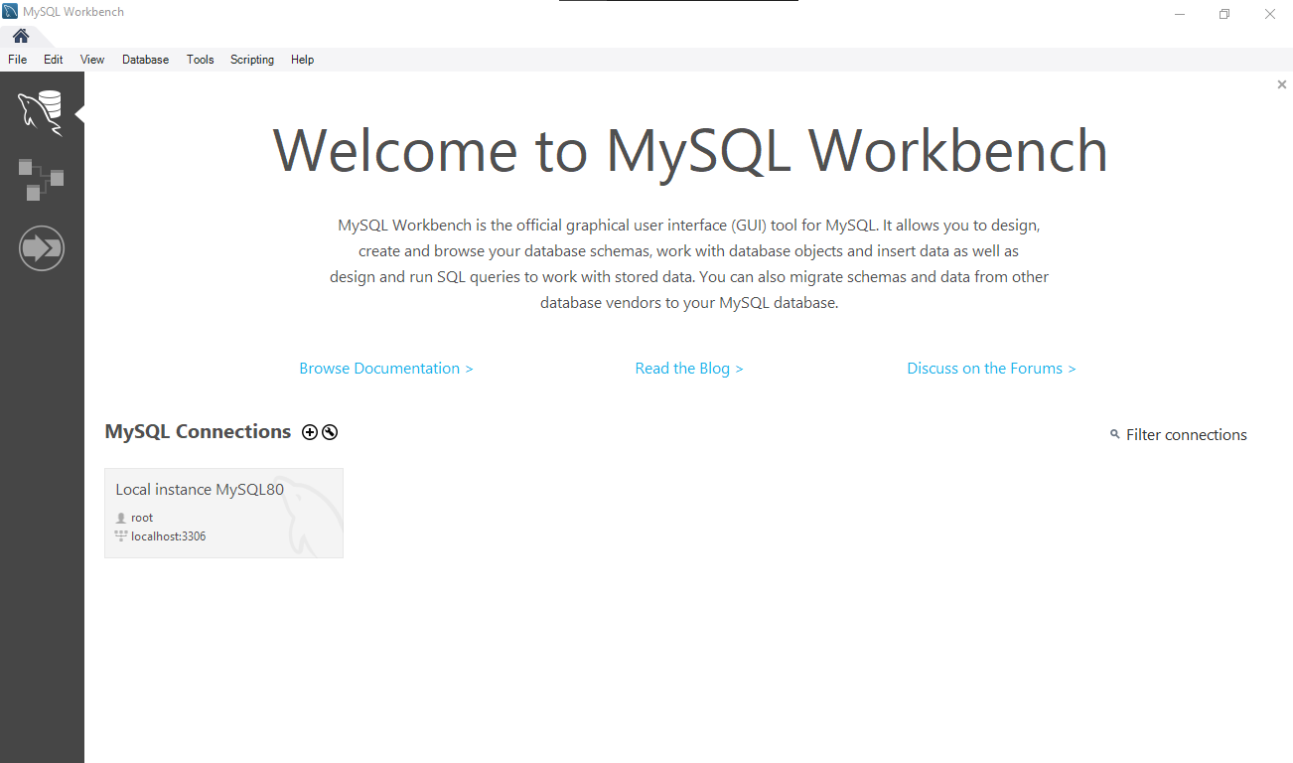

On this screen click on Local instance MySQL80. It will ask for username and password to connect to the server. After connecting it to the server following screen will appear.

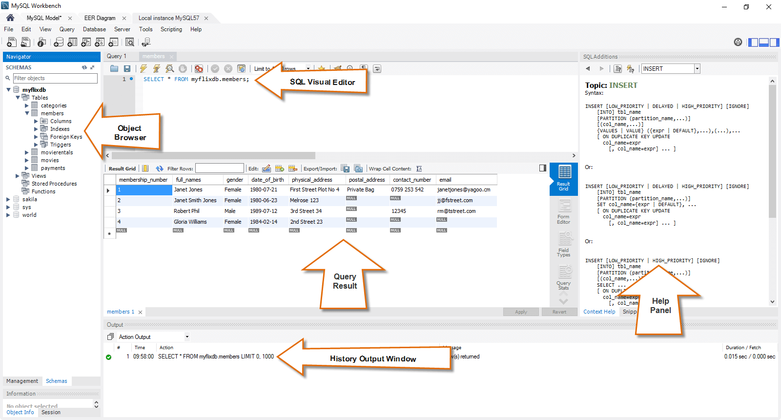

On this screen, you can write SQL queries on tables in SQL Visual Editor. On the left side there is a pane where you can see all the objects (tables, views, etc.) created in the database. Once you write the query, you can execute it from toolbar under the tab bar. After executing the query, query result will be displayed on the pane under the SQL Visual Editor. Here you can see all the data that was retrieved using the query from the table.

In MySQL Workbench, you can get help by simply typing your keyword in the help pane that is shown when you click on help menu in menu bar.

**How to create a new database model?**

1-you can click **File** and then **New Model** from the menu bar.

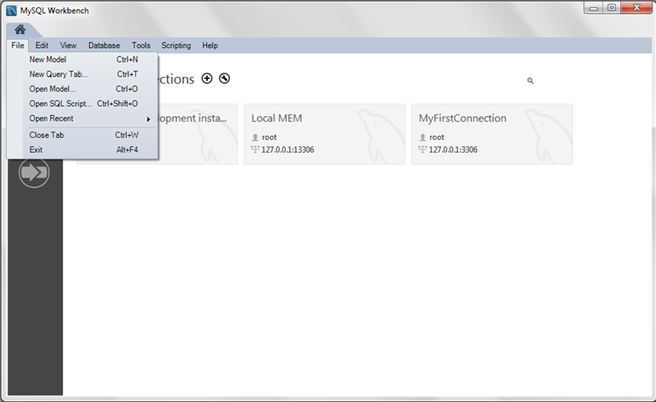

2-Click the + button on the right side of the **Physical Schemas** toolbar to add a new schema. The default schema name is new_schema1, which you can now change by modifying its **Name** field. Confirm this change in the **Physical Schemas** panel shown in the next figure. Now you are ready to add a table.

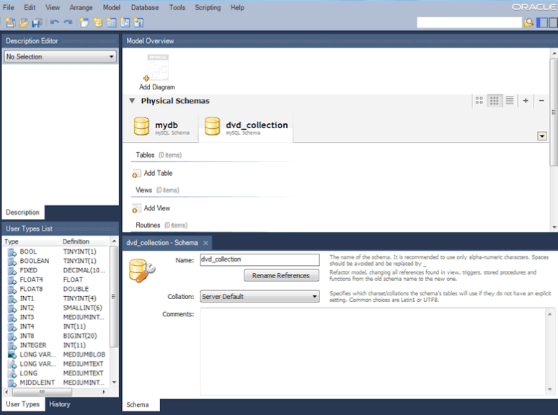

**3-** Double-click **Add Table** in the **Physical Schemas** section.

4- This will automatically load the table editor with the default table name table1.

5- Edit the **Table Name** field to change the table name.

6- Next, add columns to your table. Double-click a **Column Name** cell and the first field defaults to id column because (by default) MySQL Workbench appends id to the table name for the initial field.

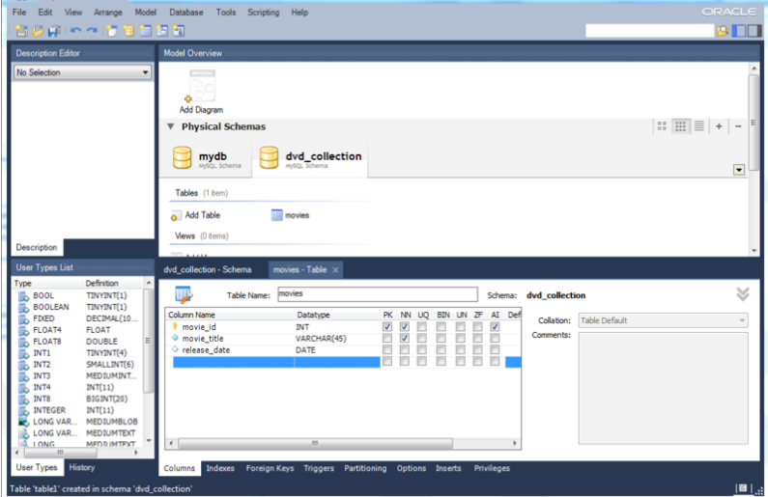

7- For a visual representation (EER diagram) of this schema, select **Model** and then **Create Diagram from Catalog Objects** to create the EER Diagram for the model. The next figure shows a new tab titled **EER Diagram**, which displays diagram representation of the movies table and columns.

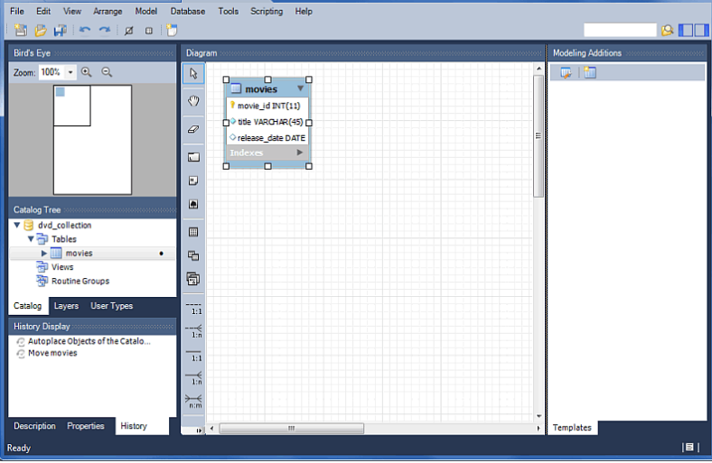

8- Save the model by choosing **File** and then **Save Model** from the menu, or click the Save Model to Current file icon on the menu toolbar.

This tool is very simple to download and use. The latest version that I have downloaded is **MySQL Workbench 8.0.28**. This tool can be downloaded from the following link:

<https://dev.mysql.com/downloads/installer/>