**Name:Faseeh Ur Rehman**

**RNO:L1F21BSCS0042**

**Name:Tayyeb Shehzad Butt**

**RNO:L1F21BSCS0019**

**Project Name**:

**Computer Science Online Learning platform Database**.

**Project Description**:

The Computer Science Online Learning Platform is a comprehensive and interactive system designed to provide a wide range of computer science courses to students and learners interested in advancing their knowledge and skills in various CS domains. The platform allows users to enroll in courses, access course materials, participate in discussions, and track their progress.

Key Features:

1. Course Enrollment: Users can browse the course catalog, view course details, and enroll in courses of interest.
2. Course Content Access: Enrolled users can access comprehensive course materials, including lesson materials, lecture videos, and additional resources.
3. Progress Tracking: Users can track their progress within enrolled courses, including completed modules, quizzes, and assignments.
4. Discussion Forum Participation: Users can participate in course-specific discussion forums to ask questions, engage in discussions, and share knowledge with other learners and instructors.
5. Quizzes and Assignments: The platform provides interactive quizzes and challenging assignments to assess users' understanding and knowledge retention.
6. Grading and Feedback: Instructors can grade assignments and provide constructive feedback to users, facilitating continuous learning and improvement.
7. User Profile Management: Users can create and manage their profiles, update their educational background, contact details, and view their course enrollment history.
8. Notifications and Announcements: The system sends notifications and announcements to users regarding course updates, upcoming deadlines, and important information related to their enrolled courses.
9. Search and Filter Courses: Users can search for specific courses based on keywords, topics, or instructors, and filter courses based on duration, difficulty level, or prerequisites.

ER Diagram

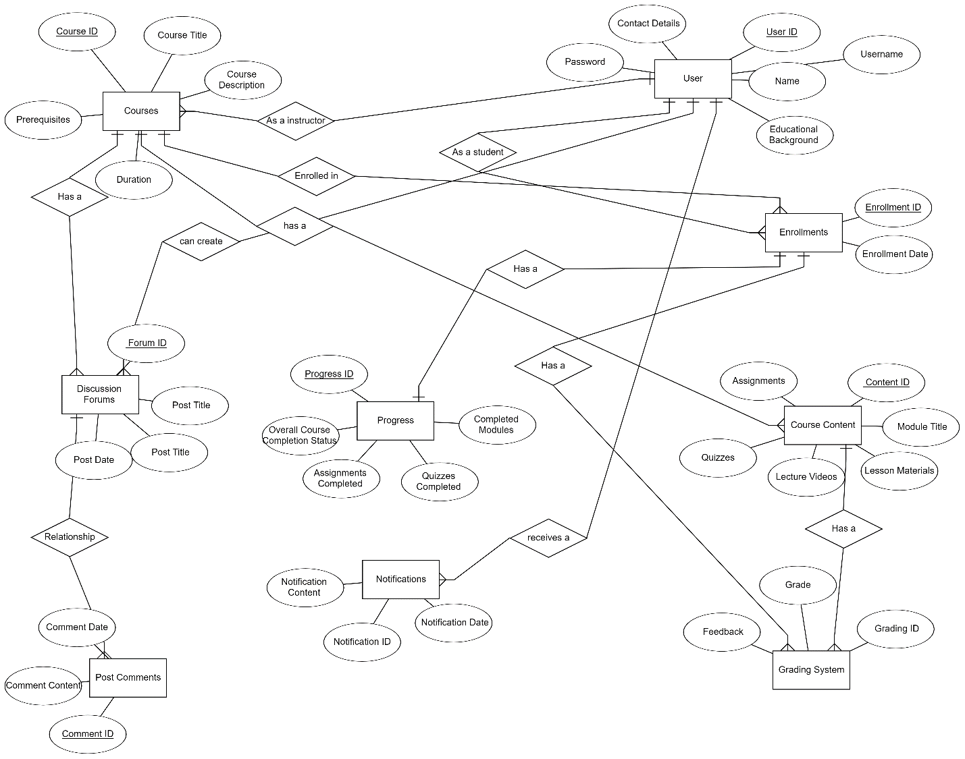

RELATIONAL SCHEMA:

