**MICROPROCESSOR SYSTEMS**

**ASSIGNMENT: 01**

**MUHAMMAD TAYYAB LATIF**

**366876**

**BEE 13-C**

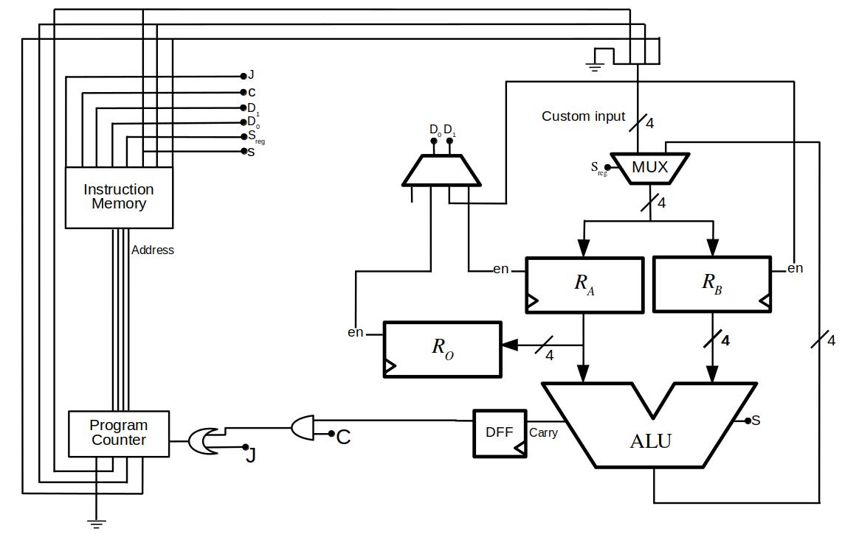

**BLOCK DIAGRAM**

**4-BIT MICROPROCESSOR**

A 4-bit microprocessor can process the data in 4-bit chunks. It is a very basic processor that can be used to perform some very simple and basic operations. The components involved are:

* ALU (Key component to perform operations)
* Registers
* Control Unit
* Clocks

**Working: -**

The working of a 4-bit processor can be explained in the following few basic steps:

* Fetching
* Decoding
* Execution
* Storing

**ARITHMETIC LOGIC UNIT (ALU)**

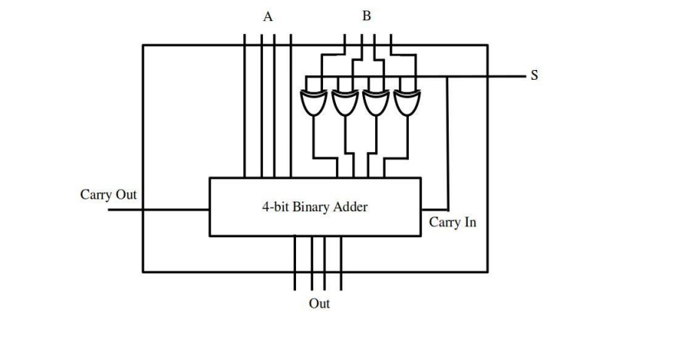

The arithmetic logic unit is a very important component in the 4-bit microprocessor system as it performs all the necessary arithmetic and logic tasks for data processing. It can perform the following types of operations:

* Addition
* Subtraction
* Multiplication
* Division
* AND
* OR
* NOT

**REGISTERS**

The register and its selection are an important part of the design of a 4-bit microprocessor system. Since we can only have a limited number of resistors, careful selection can make the system more effective and efficient. The registers are usually named A, B, C, and D in a 4-bit system.

**Working:**

The working of registers can be explained through the example that if the operation is to add, the control unit will send a signal to select the A register and the other signal to the B register. The contents of these two registers will be added using the ALU and the result will be stored in the third register C.

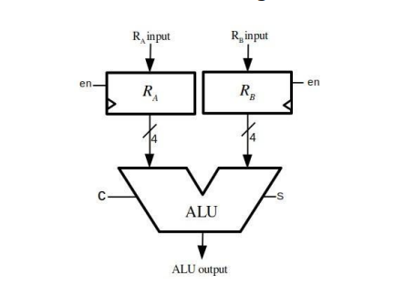

**SIMULATION MODEL**

**Components and working:**

* Multiplexer: The multiplexer is a component that selects one of several inputs and directs it to a single output. In a microprocessor, the multiplexer is used to select the source of data that will be processed by the ALU.
* Decoder: The decoder is a component that takes a binary input and activates one of several output lines based on the input value. In a microprocessor, the decoder is used to select the appropriate instruction from memory based on the binary value in the program counter.
* Registers (A, B, C): They will be used to store the data that will be processed by the microprocessor.
* ALU
* Logic gates: Logic gates are electronic components that perform Boolean logic operations on binary data. In a microprocessor, logic gates are used to perform operations such as AND, OR, and NOT
* Program counter: The program counter is a register that keeps track of the memory address of the current instruction being executed. It is incremented by 1 each time an instruction is executed, which allows the microprocessor to move to the next instruction in the program.
* Instruction decoder

**HOW WILL THE MICROPROCESSOR WORK: -**

1. The program counter is initialized to the starting memory address of the program.

2. The decoder selects the instruction from memory based on the binary value in the program counter.

3. The data required for the instruction is loaded from memory into the appropriate registers.

4. The multiplexer selects the appropriate source of data, and the ALU performs the required arithmetic or logical operation.

5. The result is stored in the appropriate register.

6. The program counter is incremented by 1, and the process repeats for the next instruction.

By repeating this process for each instruction in the program, the 4-bit microprocessor will perform a wide range of computations. We will keep in mind all this information and join these components in the correct order to make our microprocessor.

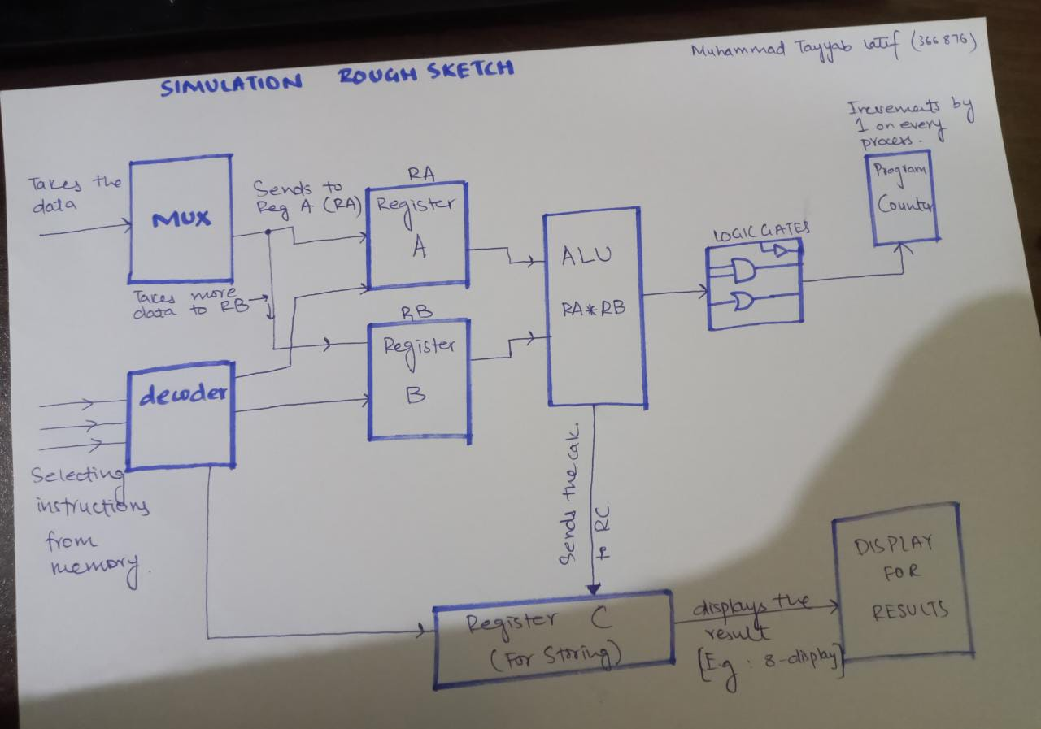

**TEST CODE FOR UNDERSTANDING (with instructions used)**

L1: **LDI** RA, 1; *RA= 1*

**LDI** RB, 2; *RB= 2*

**ADD** RA, RB; *RA = 1+2=3*

RC=RA; *RC=RA=3* ***MOV***

**SUB** RA, RB; *RA=3-2*

RC=RA; *RC=RA=1* ***MOV***

**JMP** L1