AI Skin Analysis
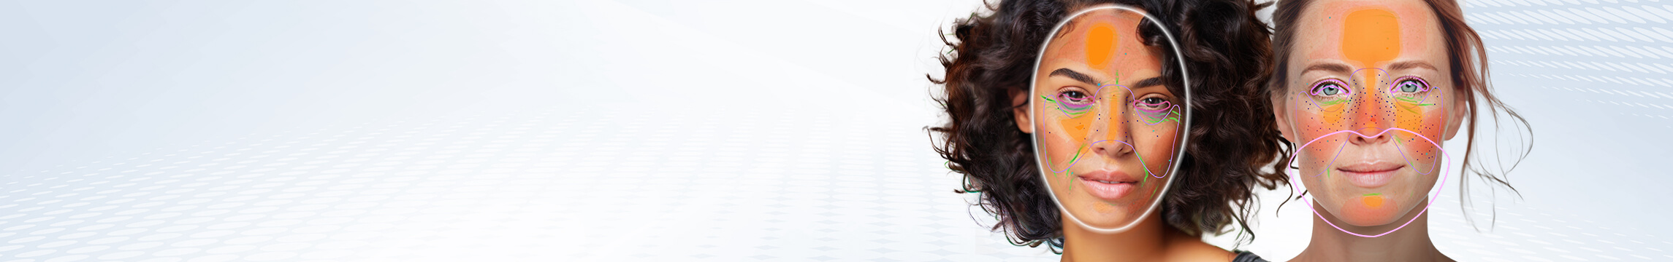 AI skincare analysis technology harnesses the power of artificial intelligence to analyze various aspects of the skin, from texture and pigmentation to hydration and pore size, with remarkable precision. By eAI Skin Analysis
 AI skincare analysis technology harnesses the power of artificial intelligence to analyze various aspects of the skin, from texture and pigmentation to hydration and pore size, with remarkable precision. By employing advanced algorithms and machine learning, AI skin analysis can offer personalized recommendations and skincare routines tailored to an individual's unique skin type and concerns.
This not only enhances the effectiveness of skincare products but also empowers users to make informed decisions about their skincare regimen. With the integration of AI skin analysis, individuals can now embark on a journey towards healthier, more radiant skin, guided by data-driven insights and the promise of more effective skincare solutions.

Integration Guide

How to Take Photos for AI Skin Analysis
- Take a selfie facing forward
  - Just one clear shot, looking straight into the camera. Leave your hair down so it falls over your chest, and make sure you're staring directly ahead for that front-on view.
  - Instead, use the JS Camera Kit to take a photo. Just leave your hair down so it falls over your chest. Don't tie it up.

Workflow
Skin Analysis API Usage Guide This guide explains how to upload an image and create a skin analysis task using the File API and AI Task API.

Step 1: Resize your source image
Resize your photo to fit the supported dimensions - up to 4096 pixels on the long side and at least 480 pixels on the short side for SD, or up to 4096 pixels on the long side and at least 1080 pixels on the short side for HD. See details in File Specs & Errors

Step 2: Upload File Metadata via File API
- Image Requirements
  - See details in File Specs & Errors
Send a POST request to initialise the file upload:
curl --request POST \
--url https://yce-api-01.makeupar.com/s2s/v2.0/file/skin-analysis \
--header 'Authorization: Bearer YOUR_API_KEY' \
--header 'Content-Type: application/json' \
--data '{
"files": [
{
"content_type": "image/png",
"file_name": "skin_analysis_01_3dbd1b6683.png",
"file_size": 547541
}
]
}'
- 
Important: Simply calling the File API does not upload your file. You must additionally upload the file to the URL provided in the File API response. That URL is your upload destination, make sure the file is successfully transferred there before proceeding.
Warning: Please note that, you will get an 500 Server Error / unknown_internal_error or 404 Not Found error when using AI APIs if you do not upload the file to the URL provided in the File API response.

Step 3: Retrieve Upload URL and File ID
The response includes:
- requests.url – Pre-signed URL for image upload.
- file_id – Identifier for creating an AI task.
Example Response:
{
"status": 200,
"data": {
"files": [
{
"content_type": "image/png",
"file_name": "skin_analysis_01_3dbd1b6683.png",
"file_id": "SaGaqpDgKwFrVBgMpQMA3HY0LeqdT9/13W5TOD8/u/FfjK3xgCQ+hRt9MJXBFaud",
"requests": [
{
"method": "PUT",
"url": "https://yce-us.s3-accelerate.amazonaws.com/demo/ttl30/...signature...",
"headers": {
"Content-Length": "547541",
"Content-Type": "image/png"
}
}
]
}
]
}
}


Step 4: Upload Image to Pre-signed URL
Use the provided requests.url and headers:
curl --location --request PUT 'https://yce-us.s3-accelerate.amazonaws.com/demo/ttl30/...signature...' \
--header 'Content-Type: image/png' \
--header 'Content-Length: 547541' \
--data-binary @'./skin_analysis_01_3dbd1b6683.png'


Step 5: Create AI Task
Use the file_id from Step 2 to create a skin analysis task:
curl --request POST \
--url https://yce-api-01.makeupar.com/s2s/v2.0/task/skin-analysis \
--header 'Authorization: Bearer YOUR_API_KEY' \
--header 'Content-Type: application/json' \
--data '{
"src_file_id": "SaGaqpDgKwFrVBgMpQMA3HY0LeqdT9/13W5TOD8/u/FfjK3xgCQ+hRt9MJXBFaud",
"dst_actions": ["wrinkle", "pore", "texture", "acne"],
"miniserver_args": {
"enable_mask_overlay": true,
"enable_dark_background_hd_pore": true,
"color_dark_background_hd_pore": "3D3D3D",
"opacity_dark_background_hd_pore": 0.4
// Additional parameters omitted for brevity
},
"format": "json"
}'
Once the upload is complete, you can select any skin concerns to analyze using your file ID or image file url. Please refer to the Inputs & Outputs.
Subsequently, calling POST 'task/skin-analysis' with the File ID or image file url executes the enhance task and obtains a task_id. Please be advised that simultaneous use of SD and HD skin concern parameters is NOT supported.
- Use an Existing Public Image URL Instead of uploading, you may supply a publicly accessible image URL directly when initiating the AI task.
Example Response:
{
"status": 200,
"data": {
"task_id": "SaGaqpDgKwFrVBgMpQMA3HY0LeqdT9_13W5TOD8_u_GPi6NqQ3dhlmN-6ntFwhzT"
}
}


Step 6: Poll Task Status
Retrieve task results using the task_id:
curl --request GET \
--url https://yce-api-01.makeupar.com/s2s/v2.0/task/skin-analysis/<YOUR_TASK_ID> \
--header 'Authorization: Bearer YOUR_API_KEY' \
--header 'Content-Type: application/json'
This task_id is used to monitor the task's status through polling GET 'task/skin-analysis' to retrieve the current engine status. Until the engine completes the task, the status will remain 'running', and no units will be consumed during this stage.
Processed results are retained for 24 hours after completion.- No need for short-interval polling.- Flexible polling intervals within the 24-hour window.
Important: Polling is still required to check task status, as execution time is not guaranteed.
The task will change to the 'success' status after the engine successfully processes your input file and generates the resulting image. You will get an url of the processed image and a dst_id that allow you to chain another AI task without re-upload the result image.
Your units will only be consumed in this case. If the engine fails to process the task, the task's status will change to 'error' and no unit will be consumed. When deducting units, the system will prioritize those nearing expiration. If the expiration date is the same, it will deduct the units obtained on the earliest date.

Step 7: Interpret Results
The response includes:
- ui_score – User-friendly score.
- raw_score – Raw analysis score.
- mask_urls – URLs for detection masks.
Example Response:
{
"status": 200,
"data": {
"results": {
"output": [
{
"type": "texture",
"ui_score": 68,
"raw_score": 57.33,
"mask_urls": ["https://yce-us.s3-accelerate.amazonaws.com/...texture_output.jpg"]
},
{
"type": "pore",
"ui_score": 92,
"raw_score": 95.34,
"mask_urls": ["https://yce-us.s3-accelerate.amazonaws.com/...pore_output.jpg"]
}
// Additional results omitted for brevity
]
},
"task_status": "success"
}
}

Debugging Guide
Warning: Please be advised that simultaneous use of SD and HD skin concern parameters is NOT supported. Attempting to deviate from these specifications will result in an InvalidParameters error.
- If you mix using HD and SD skin concerns, you will get an error as following:
{
"status": 400,
"error": "cannot mix HD and SD dst_actions",
"error_code": "InvalidParameters"
}
- If you misspell a skin concern or sending unknown skin concerns, you will get an error as following:
{
"status": 400,
"error": "Not available dst_action abc123",
"error_code": "InvalidParameters"
}


Real-world examples:
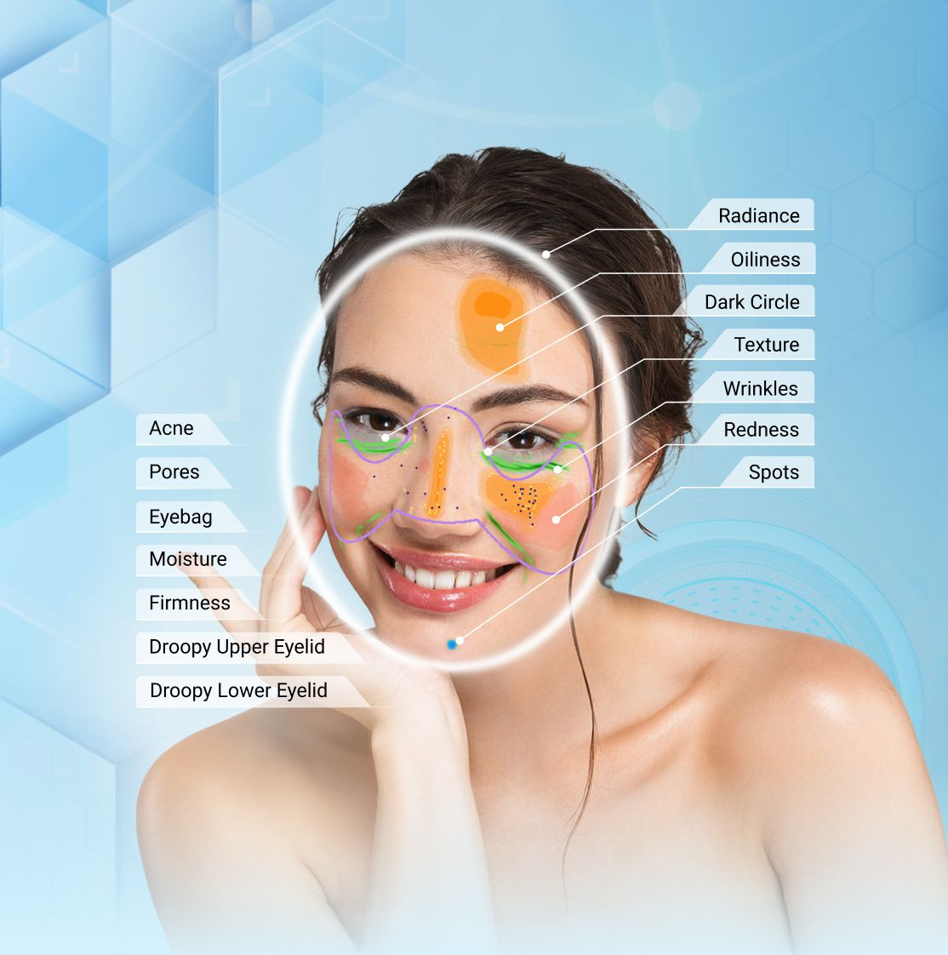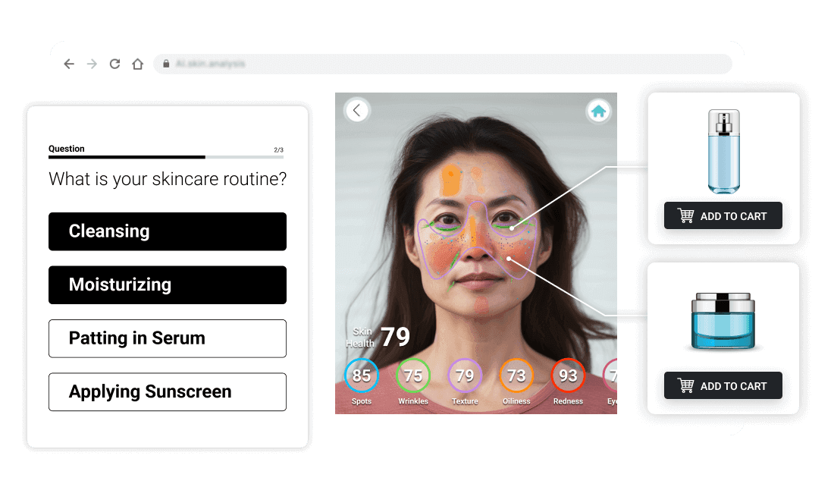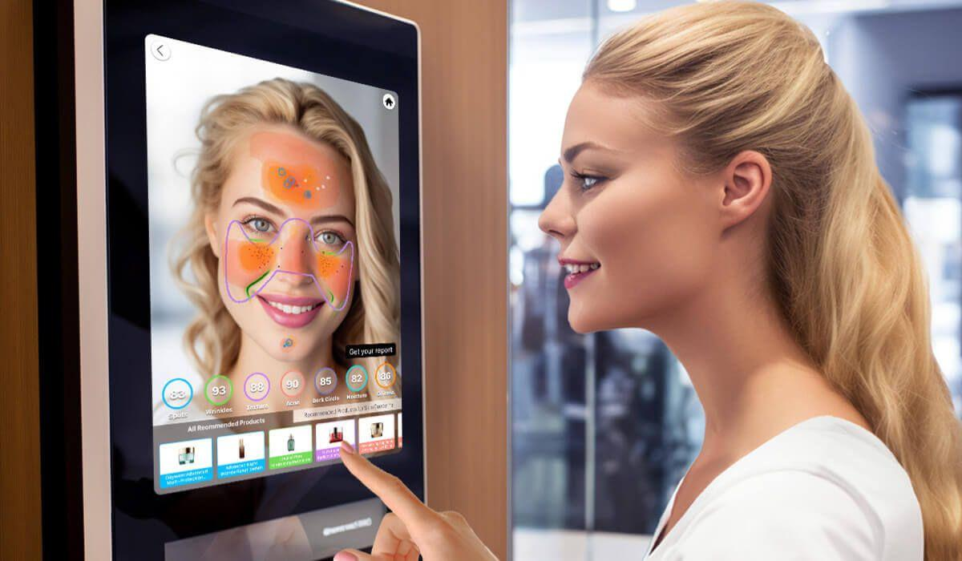

Inputs & Outputs

Input Paramenter Description
There are two options for controlling the visual output of AI Skin Analysis results: either generate multiple images, with each skin concern displayed as an independent mask, or produce a single blended image using the enable_mask_overlay parameter. By default, the system outputs multiple masks, giving you full control over how to blend each skin concern mask with the image.
- Default: enable_mask_overlay false 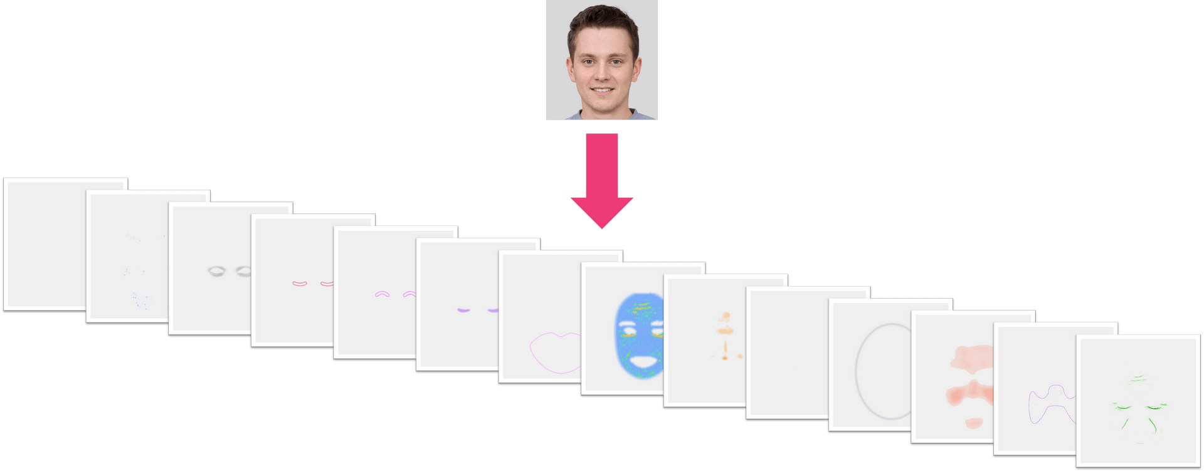
- Set enable_mask_overlay to true 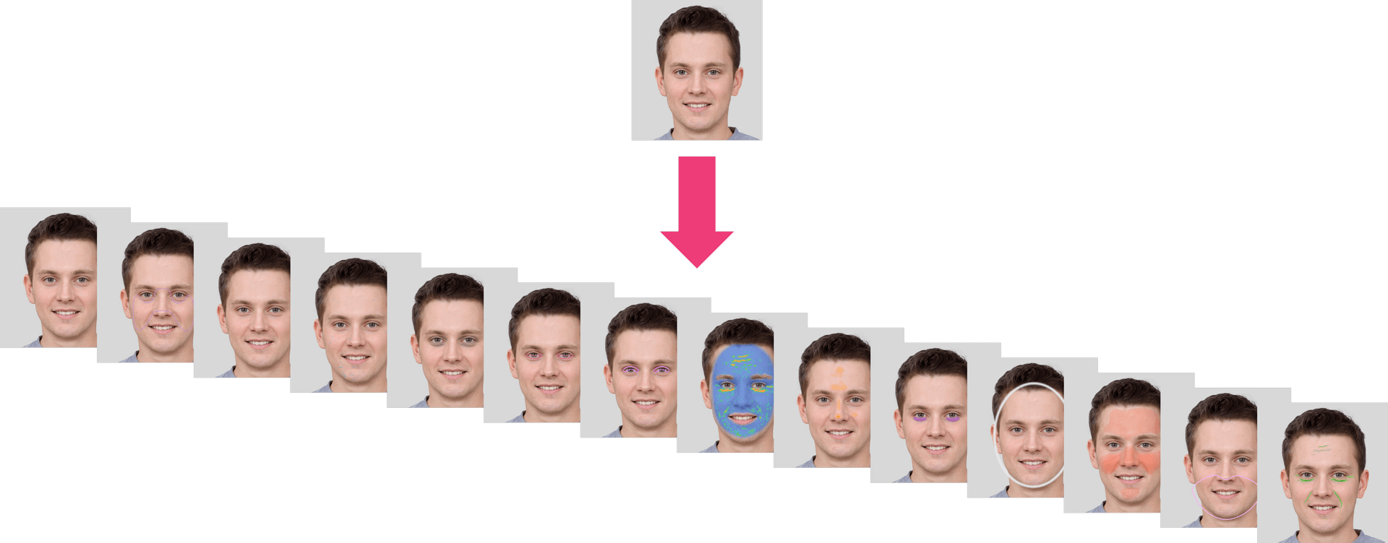

Output ZIP Data Structure Description
The system provides a ZIP file with a 'skinanalysisResult' folder inside. This folder contains a 'score_info.json' file that includes all the detection scores and references to the result images.
The 'score_info.json' file contains all the skin analysis detection results, with numerical scores and the names of the corresponding output mask files.
The PNG files are detection result masks that can be overlaid on your original image. Simply use the alpha values in these PNG files to blend them with your original image, allowing you to see the detection results directly on the source image.

File Structure in the Skin Analysis Result ZIP
- HD Skincare ZIP
  - skinanalysisResult
    - score_info.json
    - hd_acne_output.png
    - hd_age_spot_output.png
    - hd_dark_circle_output.png
    - hd_droopy_lower_eyelid_output.png
    - hd_droopy_upper_eyelid_output.png
    - hd_eye_bag_output.png
    - hd_firmness_output.png
    - hd_moisture_output.png
    - hd_oiliness_output.png
    - hd_radiance_output.png
    - hd_redness_output.png
    - hd_texture_output.png
    - hd_pore_output_all.png
    - hd_pore_output_cheek.png
    - hd_pore_output_forehead.png
    - hd_pore_output_nose.png
    - hd_wrinkle_output_all.png
    - hd_wrinkle_output_crowfeet.png
    - hd_wrinkle_output_forehead.png
    - hd_wrinkle_output_glabellar.png
    - hd_wrinkle_output_marionette.png
    - hd_wrinkle_output_nasolabial.png
    - hd_wrinkle_output_periocular.png
- SD Skincare ZIP
  - skinanalysisResult
    - score_info.json
    - acne_output.png
    - age_spot_output.png
    - dark_circle_v2_output.png
    - droopy_lower_eyelid_output.png
    - droopy_upper_eyelid_output.png
    - eye_bag_output.png
    - firmness_output.png
    - moisture_output.png
    - oiliness_output.png
    - pore_output.png
    - radiance_output.png
    - redness_output.png
    - texture_output.png
    - wrinkle_output.png
- JSON Data Structure (score_info.json)
  - "all": A floating-point value between 1 and 100 representing the general skin condition. A higher score indicates healthier and more aesthetically pleasing skin condition.
  - "skin_age": AI-derived skin age relative to the general population distribution across all age groups.
  - Each category contains:
    - "raw_score": A floating-point value ranging from 1 to 100. A higher score indicates healthier and more aesthetically pleasing skin condition.
    - "ui_score": An integer ranging from 1 to 100. The UI Score functions primarily as a psychological motivator in beauty assessment. We adjust the raw scores to produce more favorable results, acknowledging that consumers generally prefer positive evaluations regarding their skin health. This calibration serves to instill greater confidence in users while maintaining the underlying beauty psychology framework.
    - "output_mask_name": The filename of the corresponding output mask image.
  - Categories and Descriptions
    - HD Skincare:
      - "hd_redness": Measures skin redness severity.
      - "hd_oiliness": Determines skin oiliness level.
      - "hd_age_spot": Detects age spots and pigmentation.
      - "hd_radiance": Evaluates skin radiance.
      - "hd_moisture": Assesses skin hydration levels.
      - "hd_dark_circle": Analyzes the presence of dark circles under the eyes.
      - "hd_eye_bag": Detects eye bags.
      - "hd_droopy_upper_eyelid": Measures upper eyelid drooping severity.
      - "hd_droopy_lower_eyelid": Measures lower eyelid drooping severity.
      - "hd_firmness": Evaluates skin firmness and elasticity.
      - "hd_texture": Subcategories[whole]; Analyzes overall skin texture.
      - "hd_acne": Subcategories[whole]; Detects acne presence.
      - "hd_pore": Subcategories[forehead, nose, cheek, whole]; Detects and evaluates pores in different facial regions.
      - "hd_wrinkle": Subcategories[forehead, glabellar, crowfeet, periocular, nasolabial, marionette, whole]; Measures the severity of wrinkles in various facial areas.
    - SD Skincare:
      - "wrinkle": General wrinkle analysis.
      - "droopy_upper_eyelid": Measures upper eyelid drooping severity.
      - "droopy_lower_eyelid": Measures lower eyelid drooping severity.
      - "firmness": Evaluates skin firmness and elasticity.
      - "acne": Evaluates acne presence.
      - "moisture": Measures skin hydration.
      - "eye_bag": Detects eye bags.
      - "dark_circle_v2": Analyzes dark circles using an alternative method.
      - "age_spot": Detects age spots.
      - "radiance": Evaluates skin brightness.
      - "redness": Measures skin redness.
      - "oiliness": Determines skin oiliness.
      - "pore": Measures pore visibility.
      - "texture": Analyzes overall skin texture.
  - Sample score_info.json of HD Skincare

{
"hd_redness": {
"raw_score": 72.011962890625,
"ui_score": 77,
"output_mask_name": "hd_redness_output.png"
},
"hd_oiliness": {
"raw_score": 60.74365234375,
"ui_score": 72,
"output_mask_name": "hd_oiliness_output.png"
},
"hd_age_spot": {
"raw_score": 83.23274230957031,
"ui_score": 77,
"output_mask_name": "hd_age_spot_output.png"
},
"hd_radiance": {
"raw_score": 76.57244205474854,
"ui_score": 79,
"output_mask_name": "hd_radiance_output.png"
},
"hd_moisture": {
"raw_score": 48.694559931755066,
"ui_score": 70,
"output_mask_name": "hd_moisture_output.png"
},
"hd_dark_circle": {
"raw_score": 80.1993191242218,
"ui_score": 76,
"output_mask_name": "hd_dark_circle_output.png"
},
"hd_eye_bag": {
"raw_score": 76.67280435562134,
"ui_score": 79,
"output_mask_name": "hd_eye_bag_output.png"
},
"hd_droopy_upper_eyelid": {
"raw_score": 79.05348539352417,
"ui_score": 80,
"output_mask_name": "hd_droopy_upper_eyelid_output.png"
},
"hd_droopy_lower_eyelid": {
"raw_score": 79.97175455093384,
"ui_score": 81,
"output_mask_name": "hd_droopy_lower_eyelid_output.png"
},
"hd_firmness": {
"raw_score": 89.66898322105408,
"ui_score": 85,
"output_mask_name": "hd_firmness_output.png"
},
"hd_texture": {
"whole": {
"raw_score": 66.3921568627451,
"ui_score": 75,
"output_mask_name": "hd_texture_output.png"
}
},
"hd_acne": {
"whole": {
"raw_score": 59.92677688598633,
"ui_score": 76,
"output_mask_name": "hd_acne_output.png"
}
},
"hd_pore": {
"forehead": {
"raw_score": 79.59770965576172,
"ui_score": 80,
"output_mask_name": "hd_pore_output_forehead.png"
},
"nose": {
"raw_score": 29.139814376831055,
"ui_score": 58,
"output_mask_name": "hd_pore_output_nose.png"
},
"cheek": {
"raw_score": 44.11081314086914,
"ui_score": 65,
"output_mask_name": "hd_pore_output_cheek.png"
},
"whole": {
"raw_score": 49.23978805541992,
"ui_score": 67,
"output_mask_name": "hd_pore_output_all.png"
}
},
"hd_wrinkle": {
"forehead": {
"raw_score": 55.96956729888916,
"ui_score": 67,
"output_mask_name": "hd_wrinkle_output_forehead.png"
},
"glabellar": {
"raw_score": 76.7251181602478,
"ui_score": 75,
"output_mask_name": "hd_wrinkle_output_glabellar.png"
},
"crowfeet": {
"raw_score": 83.4361481666565,
"ui_score": 78,
"output_mask_name": "hd_wrinkle_output_crowfeet.png"
},
"periocular": {
"raw_score": 67.88706302642822,
"ui_score": 72,
"output_mask_name": "hd_wrinkle_output_periocular.png"
},
"nasolabial": {
"raw_score": 74.03312683105469,
"ui_score": 74,
"output_mask_name": "hd_wrinkle_output_nasolabial.png"
},
"marionette": {
"raw_score": 71.94477319717407,
"ui_score": 73,
"output_mask_name": "hd_wrinkle_output_marionette.png"
},
"whole": {
"raw_score": 49.64699745178223,
"ui_score": 65,
"output_mask_name": "hd_wrinkle_output_all.png"
}
},
"all": {
"score": 75.75757575757575
},
"skin_age": 37
}
  - 
Sample score_info.json of SD Skincare

{
"wrinkle": {
"raw_score": 36.09360456466675,
"ui_score": 60,
"output_mask_name": "wrinkle_output.png"
},
"droopy_upper_eyelid": {
"raw_score": 79.05348539352417,
"ui_score": 80,
"output_mask_name": "droopy_upper_eyelid_output.png"
},
"droopy_lower_eyelid": {
"raw_score": 79.97175455093384,
"ui_score": 81,
"output_mask_name": "droopy_lower_eyelid_output.png"
},
"firmness": {
"raw_score": 89.66898322105408,
"ui_score": 85,
"output_mask_name": "firmness_output.png"
},
"acne": {
"raw_score": 92.29713000000001,
"ui_score": 88,
"output_mask_name": "acne_output.png"
},
"moisture": {
"raw_score": 48.694559931755066,
"ui_score": 70,
"output_mask_name": "moisture_output.png"
},
"eye_bag": {
"raw_score": 76.67280435562134,
"ui_score": 79,
"output_mask_name": "eye_bag_output.png"
},
"dark_circle_v2": {
"raw_score": 80.1993191242218,
"ui_score": 76,
"output_mask_name": "dark_circle_v2_output.png"
},
"age_spot": {
"raw_score": 83.23274230957031,
"ui_score": 77,
"output_mask_name": "age_spot_output.png"
},
"radiance": {
"raw_score": 76.57244205474854,
"ui_score": 79,
"output_mask_name": "radiance_output.png"
},
"redness": {
"raw_score": 72.011962890625,
"ui_score": 77,
"output_mask_name": "redness_output.png"
},
"oiliness": {
"raw_score": 60.74365234375,
"ui_score": 72,
"output_mask_name": "oiliness_output.png"
},
"pore": {
"raw_score": 88.38014125823975,
"ui_score": 84,
"output_mask_name": "pore_output.png"
},
"texture": {
"raw_score": 80.09742498397827,
"ui_score": 76,
"output_mask_name": "texture_output.png"
},
"all": {
"score": 75.75757575757575
},
"skin_age": 37
}

File Specs & Errors

Supported Formats & Dimensions
AI Feature | Supported Dimensions | Supported File Size | Supported Formats
SD Skincare | long side <= 4096, short side >= 480 | < 10MB | jpg/jpeg/png
HD Skincare | long side <= 4096, short side >= 1080 | < 10MB | jpg/jpeg/png
Warning: It is your resposibility to resize input images based on the Supported Dimensions of HD or SD Skincare before runing AI Skin Analysis. It is highly recommended to use portrait rather than landscape aspect ratio as input.

Suggestions for How to Shoot:
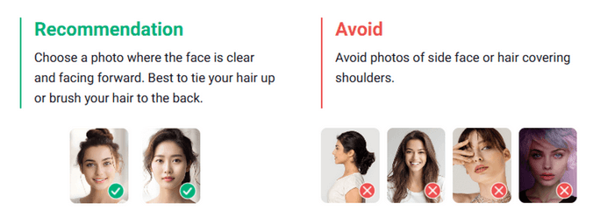

Get Ready to Start Skin Analysis Instructions
- Take off your glasses and make sure bangs are not covering your forehead
- Make sure that you’re in a well-lit environment
- Remove makeup to get more accurate results
- Look straight into the camera and keep your face in the center

Photo requirement
We will check the image quality to ensure it is suitable for AI Skin Analysis. Please make sure the face occupies approximately 60–80% of the image width, without any overlays or obstructions. The lighting should be bright and evenly distributed, avoiding overexposure or blown-out highlights. The pose should be front-facing, neutral, and relaxed, with the mouth closed and eyes open.
You should fully reveal your forehead and brush your fringe back or tie your hair to ensure the best quality. It is recommended that you remove your spectacles for optimal AI Skin Analysis performance, although this is not mandatory.
Warning: The width of the face needs to be greater than 60% of the width of the image.
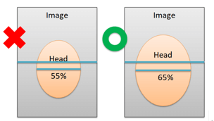

Error Codes
Error Code | Description
error_below_min_image_size | Input image resolution is too small
error_exceed_max_image_size | Input image resolution is too large
error_src_face_too_small | The face area in the uploaded image is too small. The width of the face needs to be greater than 60% of the width of the image.
error_src_face_out_of_bound | The face area in the uploaded image is out of bound
error_lighting_dark | The lighting in the uploaded image is too dark

Environment & Dependency
Sample Code Language / Tool | Recommended Runtime Versions
cURL | - bash >= 3.2  - curl >= 7.58 (modern TLS/HTTP support)  - jq >= 1.6 (robust JSON parsing)
Node.js (JavaScript) | Node >= 18 (for global fetch)
JavaScript | - Chrome / Edge >= 80  - Firefox >= 74  - Safari >= 13.1
PHP | PHP >= 7.4 (for modern TLS/compat), ext-curl (recommended) or allow_url_fopen=On + ext-openssl, ext-json
Python | Python >= 3.10 (for f-strings), requests >= 2.20.0
Java | Java 11+ (for HttpClient), Jackson Databind >= 2.12.0

JS Camera Kit

Overview
The JavaScript Camera Kit provides a complete in-browser camera solution designed for high-accuracy face-based imaging tasks. It includes:
- Camera permission handling
- Real-time face detection
- Automatic face quality validation (lighting, pose, angle, distance)
- Guided capture UI
- Multi-step capture flows for advanced hair/face tasks
- Support for both base64 and blob output formats
The module is particularly optimized for AI-driven image analysis, such as AI Skin Analysis (SD/HD), AI Face Tone Analysis, and hair-related analysis.

Download the JS Camera Kit
Include the JS Camera Kit SDK via CDN:
https://plugins-media.makeupar.com/v2.2-camera-kit/sdk.js
Once loaded, the SDK installs a global YMK object.

Quick Start Example
The following sample demonstrates:
- Loading the JS Camera Kit SDK
- Implementing window.ymkAsyncInit
- Initializing the module
- Opening the camera
- Receiving captured images
<!DOCTYPE html>
<html lang="en">
<head>
<meta charset="UTF-8" />
<meta name="viewport" content="width=device-width, initial-scale=1.0" />
<title>Camera Kit Sample</title>
</head>

<body>
<script>
window.ymkAsyncInit = function() {
YMK.addEventListener('loaded', function() {
/* Module fully loaded and ready */
});

YMK.addEventListener('faceDetectionCaptured', function(capturedResult) {
/* Display all captured images */
const container = document.getElementById('captured-results');
container.innerHTML = '';

for (const image of capturedResult.images) {
const img = document.createElement('img');
img.src = typeof image.image === 'string'
? image.image
: URL.createObjectURL(image.image);

container.appendChild(img);
}
});
};

function openCameraKit() {
YMK.init({
faceDetectionMode: 'skincare',
imageFormat: 'base64',
language: 'enu',
});
YMK.openCameraKit();
}
</script>

<!-- Load SDK -->
<script>
window.addEventListener('load', function() {
(function(d) {
const s = d.createElement('script');
s.type = 'text/javascript';
s.async = true;
s.src = 'https://plugins-media.makeupar.com/v2.2-camera-kit/sdk.js';
d.getElementsByTagName('script')[0].parentNode.insertBefore(s, null);
})(document);
});
</script>

<button onClick="openCameraKit()">Open Camera Kit</button>

<div id="YMK-module"></div>

<h3>Captured Results:</h3>
<div id="captured-results"></div>
</body>
</html>


Prerequisites
You must define the asynchronous initialization entry point:
<script>
window.ymkAsyncInit = function() {
YMK.init(); // default settings
};
</script>
Additional requirements:
Requirement | Description
Browser | Must support getUserMedia
HTTPS | Required on most browsers for webcam access
<div id="YMK-module"> | Mandatory mount point for the UI

Integration Guide

Step 1 — Initialize the Module
Call YMK.init() before calling YMK.openCameraKit():
YMK.init({
faceDetectionMode: 'skincare',
imageFormat: 'base64',
language: 'enu'
});

Supported Detection Modes
Mode | Description
makeup | Standard camera mode for virtual cosmetic try-on
skincare | Standard skin analysis mode, close-up face capture
hdskincare | HD Skin capture using webcams with ≥ 2560px width
shadefinder | Skin Tone Analysis front-face capture
facereshape | AI Face Reshape capture
hairlength | Full hair-length capture (from a distance)
hairfrizziness | 3-phase capture: front, right-turn, left-turn
hairtype | Same 3-phase multi-angle capture flow
ring | Hand capture for ring try‑on
wrist | Wrist capture for watch or bracelet try‑on
necklace | Selfie capture for necklace try-on
earring | Selfie capture for earring try-on

Step 2 — Add Event Handlers
Event examples:
YMK.addEventListener('faceQualityChanged', function(q) {
console.log('Quality updated:', q);
});
See the full Events List below.

Step 3 — Open Camera Kit
YMK.openCameraKit();
This automatically:
- Shows the UI
- Opens webcam
- Begins real-time face quality monitoring
- Automatically captures when conditions are acceptable

Step 4 — Receiving Captured Result
Captured images arrive via:
YMK.addEventListener('faceDetectionCaptured', function(result) {
console.log(result.images);
});


Step 5 — Close Module
YMK.close();


API Reference

YMK.init(args)
Configures module appearance, detection mode, language, and capture format.
Arguments
args.faceDetectionMode
Detection flow to use.
Values: "makeup" | "skincare" | "hdskincare" | "shadefinder" | "facereshape" | "hairlength" | "hairfrizziness" | "hairtype" | "ring" | "wrist" | "necklace" | "earring" Default: "skincare"

args.width
Pixel width of module container. Default:
- 360 (screens ≥ 500px)
- screen width (screens < 500px)
Allowed: 300–1920

args.height
Pixel height of module container. Default:
- 480 (screens ≥ 500px)
- min(screen.height, innerHeight) for smaller screens
Allowed: 300–1920

args.language
UI language.
Available: "chs", "cht", "deu", "enu", "esp", "fra", "jpn", "kor", "ptb", "ita" Default: "enu"

args.imageFormat
Format returned via faceDetectionCaptured.
"base64" or "blob" Default: "base64"

args.disableCameraResolutionCheck
Allow running even if webcam does not meet required resolution.
Default: false

Other API Methods
YMK.openCameraKit()
Opens the module and begins detection.

YMK.addEventListener(eventName, callback)
Registers event callbacks.
Returns: EventListenerIdentifier

YMK.removeEventListener(id)
Removes listener by identifier.

YMK.isLoaded()
Returns whether livestream or photo is drawn on canvas.
Returns: boolean

YMK.pause()
Pauses the webcam stream.

YMK.resume(restartWebcam = false)
Resumes webcam after pause.

YMK.getInfo()
Returns current module info:
{
"fps": 30
}

YMK.close()
Closes module and camera.

Events Reference
Lifecycle Events
Event | Description
opened | Module opened
loading | Loading progress (0–100)
loaded | Camera stream loaded onto canvas
closed | Module closed

Camera Events
Event | Description
cameraOpened | Webcam opened
cameraClosed | Webcam closed
cameraFailed | Permission denied or no webcam  Error code:  * "error_resolution_unsupported"  * "error_permission_denied"  * "error_access_failed"

faceQualityChanged
Fires continuously during detection.
{
"hasFace": true,
"position": "good",
"frontal": "good",
"lighting": "ok"
}
- Field Descriptions
Field | Values | Meaning
hasFace | true/false | Whether face is detected
position | "good", "notgood", "toosmall", "outofboundary" | Face distance/size quality
frontal | "good", "notgood" | Whether user is facing forward
lighting | "good", "ok", "notgood" | Lighting strength
Necklace/Earring
Field | Values | Meaning
hasFace | true/false | Whether face is detected
pose | "good", "notgood" | Face pose quality
size | "good", "notgood" | Face size quality
Wrist/Ring
Field | Values | Meaning
hasFace | true/false | Whether face is detected
position | "good", "notgood" | Hand position quality
pose | "good", "notgood" | Hand pose quality

Minimum Recommended Quality
const minQuality = {
hasFace: true,
area: "good",
frontal: "good",
lighting: "ok"
};

faceDetectionStarted User enters detection UI.

faceDetectionCaptured This event is fired after all required face quality validation checks have passed and the Camera Kit has successfully completed the capture workflow. Depending on the selected faceDetectionMode, the event may contain one or multiple captured images (e.g., multi-angle capture for hair modes).
Callback Arguments capturedResult — Object The result object containing all successfully captured images and metadata.
Field Definitions mode — string Indicates the active faceDetectionMode used for capturing. Possible values include: "makeup" | "skincare" | "hdskincare" | "shadefinder" | "facereshape" | "hairlength" | "hairfrizziness" | "hairtype" | "ring" | "wrist" | "necklace" | "earring" This value corresponds directly to the configuration set in YMK.init({ faceDetectionMode }).
images — Array A list of one or more captured images. Each entry represents a single capture phase, especially relevant for multi-phase modes (e.g., hair analysis).
ImageObject Structure
Field | Type | Description
phase | integer | The zero-based index representing the capture step.  Examples:  • Skincare = 0  • Hair frizziness sequence = 0 (front), 1 (right turn), 2 (left turn)
image | string or Blob | The captured image.  • Base64 string if args.imageFormat = "base64"  • Binary Blob if args.imageFormat = "blob"
width | integer | Pixel width of the captured image.
height | integer | Pixel height of the captured image.

Notes
- The number of images varies depending on faceDetectionMode.
  - Example: "hairfrizziness" and "hairtype" typically produce three images.
- Image resolution may differ from device to device. The actual pixel size depends on:
  - The user's webcam maximum resolution
  - The constraints and recommended settings for the selected mode
- All images are guaranteed to meet the minimum face quality requirements before this event is dispatched.

Configuration Notes
Quality Requirements
- Ensure correct distance
- Ensure frontal face angle
- Provide sufficient lighting (avoid shadows)
Multi-Phase Capture Modes like hairtype or hairfrizziness require:
- Front face
- Turn right
- Turn left
Ensure event handling is in place.

Create a new file.
To upload a new file, you'll first need to use the File API. It will give you a URL – use that URL to upload your file. Once the upload is finished, you can use the file_id from the same response to start using our AI features.
Authorizations:
BearerAuthenticationV2

Request Body schema: application/json

required
files  required | Array of objects

Responses
200 Successful retrieval of file upload information
400 Invalid request parameters
401 Invalid API Key or Inactive API Key or Expired API Key
post/s2s/v2.0/file/skin-analysis

Request samples
- Payload
- curl
- Node.js
- JavaScript
- PHP
- Python
- Java
Content type
application/json
Copy
Expand allCollapse all
{
- "files": [
  - {}
- ]
}

Response samples
- 200
- 400
- 401
Content type
application/json
Copy
Expand allCollapse all
{
- "status": 200,
- "data": {
  - "files": []
- }
}

Run a Skin Analysis task.
Once you start an AI task, you need to keep polling at given polling_interval to check its status until it shows either success or error because if you don't, the task will time out and when you try to check the status later, you'll get an InvalidTaskId error even if the task did finish successfully and your units will still be consumed.
Authorizations:
BearerAuthenticationV2

Request Body schema: application/json

required
Any of Run task with src file urlRun task with src file ID
src_file_url  required | string  Url of the file to run task. The url should be publicly accessible.
dst_actions  required | Array of strings (RunSkincareTaskDstActions)  Items Enum: "hd_wrinkle" "hd_pore" "hd_texture" "hd_acne" "hd_oiliness" "hd_radiance" "hd_eye_bag" "hd_age_spot" "hd_dark_circle" "hd_droopy_upper_eyelid" "hd_droopy_lower_eyelid" "hd_firmness" "hd_moisture" "hd_redness" "hd_tear_trough" "hd_skin_type" "wrinkle" "pore" "texture" "acne" "oiliness" "radiance" "eye_bag" "age_spot" "dark_circle_v2" "droopy_upper_eyelid" "droopy_lower_eyelid" "firmness" "moisture" "redness" "tear_trough" "skin_type"  The actions for Skin Analysis. There are 2 types of features: HD and SD. You can choose one or more features, either all in SD or all in HD. Note: HD and SD features cannot be mixed. HD features:  - hd_redness: Measures skin redness severity.  - hd_oiliness: Determines skin oiliness level.  - hd_age_spot: Detects age spots and pigmentation.  - hd_radiance: Evaluates skin radiance.  - hd_moisture: Assesses skin hydration levels.  - hd_dark_circle: Analyzes the presence of dark circles under the eyes.  - hd_eye_bag: Detects eye bags.  - hd_droopy_upper_eyelid: Measures upper eyelid drooping severity.  - hd_droopy_lower_eyelid: Measures lower eyelid drooping severity.  - hd_firmness: Evaluates skin firmness and elasticity.  - hd_texture: Analyzes overall skin texture.  - hd_acne: Detects acne presence.  - hd_pore: Detects and evaluates pores in different facial regions (forehead, nose, cheek, whole).  - hd_wrinkle: Measures the severity of wrinkles in various facial areas (forehead, glabellar, crowfeet, periocular, nasolabial, marionette, whole).  - hd_tear_trough: Detects tear trough.  - hd_skin_type: Evalutate skin type.  SD features:  - wrinkle: General wrinkle analysis.  - droopy_upper_eyelid: Measures upper eyelid drooping severity.  - droopy_lower_eyelid: Measures lower eyelid drooping severity.  - firmness: Evaluates skin firmness and elasticity.  - acne: Evaluates acne presence.  - moisture: Measures skin hydration.  - eye_bag: Detects eye bags.  - dark_circle_v2: Analyzes dark circles.  - age_spot: Detects age spots.  - radiance: Evaluates skin brightness.  - redness: Measures skin redness.  - oiliness: Determines skin oiliness.  - pore: Measures pore visibility.  - texture: Analyzes overall skin texture.  - tear_trough: Detects tear trough.  - skin_type: Evalutate skin type.
miniserver_args | object (RunSkincareTaskMiniserverArgs)
format | string  Enum: "json" "zip"  Response format of the analysis results. Default is 'zip'. - zip: Results will be packaged as a downloadable ZIP file containing a skinanalysisResult folder with score_info.json and all detection result images. The response will include a URL to download the ZIP file. - json: Results will be returned directly in the response body as JSON format. Note: The response schema differs between format=json and format=zip.

Responses
200 Successful execution of Skin Analysis task
400 Failed execution of task
401 Invalid API Key or Inactive API Key or Expired API Key
429 Too many requests within a given amount of time
post/s2s/v2.0/task/skin-analysis

Request samples
- Payload
- curl
- Node.js
- JavaScript
- PHP
- Python
- Java
Content type
application/json
Example
Run task with src file urlRun task with src file ID
Run task with src file url
Copy
Expand allCollapse all
{
- "src_file_url": "https://example.com/selfie.jpg",
- "dst_actions": [
  - "hd_wrinkle",
  - "hd_pore",
  - "hd_texture",
  - "hd_acne"
- ],
- "miniserver_args": {
  - "enable_mask_overlay": true,
  - "enable_dark_background_hd_pore": true,
  - "color_dark_background_hd_pore": "3D3D3D",
  - "opacity_dark_background_hd_pore": 0.4,
  - "enable_dark_background_hd_wrinkle": true,
  - "color_dark_background_hd_wrinkle": "3D3D3D",
  - "opacity_dark_background_hd_wrinkle": 0.4,
  - "enable_dark_background_hd_acne": true,
  - "color_dark_background_hd_acne": "3D3D3D",
  - "opacity_dark_background_hd_acne": 0.4,
  - "enable_dark_background_hd_texture": true,
  - "color_dark_background_hd_texture": "3D3D3D",
  - "opacity_dark_background_hd_texture": 0.4,
  - "enable_dark_background_hd_oiliness": true,
  - "color_dark_background_hd_oiliness": "3D3D3D",
  - "opacity_dark_background_hd_oiliness": 0.2,
  - "enable_dark_background_hd_age_spot": true,
  - "color_dark_background_hd_age_spot": "3D3D3D",
  - "opacity_dark_background_hd_age_spot": 0.2,
  - "enable_dark_background_hd_redness": true,
  - "color_dark_background_hd_redness": "3D3D3D",
  - "opacity_dark_background_hd_redness": 0.2,
  - "enable_dark_background_hd_firmness": true,
  - "color_dark_background_hd_firmness": "3D3D3D",
  - "opacity_dark_background_hd_firmness": 0.1
- },
- "format": "zip"
}

Response samples
- 200
- 400
- 401
Content type
application/json
Copy
Expand allCollapse all
{
- "status": 200,
- "data": {
  - "task_id": "grH0CvsgXuAIHLUzD0V1Ol34hoet3R1tvdbtiVHrDb6_UqCLKIejAIajwxrhOAfe"
- }
}

Check a Skin Analysis task status.
Authorizations:
BearerAuthenticationV2

path Parameters
task_id  required | string  Example: grH0CvsgXuAIHLUzD0V1Ol34hoet3R1tvdbtiVHrDb6_UqCLKIejAIajwxrhOAfe  ID of task to check

Responses
200 Successful check of Skin Analysis task status
400 Invalid task id
401 Invalid API Key or Inactive API Key or Expired API Key
500 The task has no response in the expected time
get/s2s/v2.0/task/skin-analysis/{task_id}

Request samples
- curl
- Node.js
- JavaScript
- PHP
- Python
- Java
Copy
curl --request GET \
--url https://yce-api-01.makeupar.com/s2s/v2.0/task/skin-analysis/grH0CvsgXuAIHLUzD0V1Ol34hoet3R1tvdbtiVHrDb6_UqCLKIejAIajwxrhOAfe \
--header 'Authorization: Bearer <access_token for v1, API Key for v2>'

Response samples
- 200
- 400
- 401
- 500
Content type
application/json
Example
Response when format=zip (success)Response when format=json (success)
Response when format=zip (success)
Task completed successfully. Results are packaged as a ZIP file.
Copy
Expand allCollapse all
{
- "status": 200,
- "data": {
  - "task_status": "success",
  - "results": "https://example.com/sample-result-url"
- }
}

Create a new file V2.1.
To upload a new file, you'll first need to use the File API. It will give you a URL – use that URL to upload your file. Once the upload is finished, you can use the file_id from the same response to start using our AI features.
Authorizations:
BearerAuthenticationV2

Request Body schema: application/json

required
files  required | Array of objects

Responses
200 Successful retrieval of file upload information
400 Invalid request parameters
401 Invalid API Key or Inactive API Key or Expired API Key
post/s2s/v2.1/file/skin-analysis

Request samples
- Payload
- curl
- Node.js
- JavaScript
- PHP
- Python
- Java
Content type
application/json
Copy
Expand allCollapse all
{
- "files": [
  - {}
- ]
}

Response samples
- 200
- 400
- 401
Content type
application/json
Copy
Expand allCollapse all
{
- "status": 200,
- "data": {
  - "files": []
- }
}

Run a Skin Analysis V2.1 task.
Once you start an AI task, you need to keep polling at given polling_interval to check its status until it shows either success or error because if you don't, the task will time out and when you try to check the status later, you'll get an InvalidTaskId error even if the task did finish successfully and your units will still be consumed.
Authorizations:
BearerAuthenticationV2

Request Body schema: application/json

required
Any of Run task with src file urlRun task with src file ID
src_file_url  required | string  Url of the file to run task. The url should be publicly accessible.
dst_actions  required | Array of strings (RunSkincareTaskDstActions)  Items Enum: "hd_wrinkle" "hd_pore" "hd_texture" "hd_acne" "hd_oiliness" "hd_radiance" "hd_eye_bag" "hd_age_spot" "hd_dark_circle" "hd_droopy_upper_eyelid" "hd_droopy_lower_eyelid" "hd_firmness" "hd_moisture" "hd_redness" "hd_tear_trough" "hd_skin_type" "wrinkle" "pore" "texture" "acne" "oiliness" "radiance" "eye_bag" "age_spot" "dark_circle_v2" "droopy_upper_eyelid" "droopy_lower_eyelid" "firmness" "moisture" "redness" "tear_trough" "skin_type"  The actions for Skin Analysis. There are 2 types of features: HD and SD. You can choose one or more features, either all in SD or all in HD. Note: HD and SD features cannot be mixed. HD features:  - hd_redness: Measures skin redness severity.  - hd_oiliness: Determines skin oiliness level.  - hd_age_spot: Detects age spots and pigmentation.  - hd_radiance: Evaluates skin radiance.  - hd_moisture: Assesses skin hydration levels.  - hd_dark_circle: Analyzes the presence of dark circles under the eyes.  - hd_eye_bag: Detects eye bags.  - hd_droopy_upper_eyelid: Measures upper eyelid drooping severity.  - hd_droopy_lower_eyelid: Measures lower eyelid drooping severity.  - hd_firmness: Evaluates skin firmness and elasticity.  - hd_texture: Analyzes overall skin texture.  - hd_acne: Detects acne presence.  - hd_pore: Detects and evaluates pores in different facial regions (forehead, nose, cheek, whole).  - hd_wrinkle: Measures the severity of wrinkles in various facial areas (forehead, glabellar, crowfeet, periocular, nasolabial, marionette, whole).  - hd_tear_trough: Detects tear trough.  - hd_skin_type: Evalutate skin type.  SD features:  - wrinkle: General wrinkle analysis.  - droopy_upper_eyelid: Measures upper eyelid drooping severity.  - droopy_lower_eyelid: Measures lower eyelid drooping severity.  - firmness: Evaluates skin firmness and elasticity.  - acne: Evaluates acne presence.  - moisture: Measures skin hydration.  - eye_bag: Detects eye bags.  - dark_circle_v2: Analyzes dark circles.  - age_spot: Detects age spots.  - radiance: Evaluates skin brightness.  - redness: Measures skin redness.  - oiliness: Determines skin oiliness.  - pore: Measures pore visibility.  - texture: Analyzes overall skin texture.  - tear_trough: Detects tear trough.  - skin_type: Evalutate skin type.
miniserver_args | object (RunSkincareTaskMiniserverArgs)
format | string  Enum: "json" "zip"  Response format of the analysis results. Default is 'zip'. - zip: Results will be packaged as a downloadable ZIP file containing a skinanalysisResult folder with score_info.json and all detection result images. The response will include a URL to download the ZIP file. - json: Results will be returned directly in the response body as JSON format. Note: The response schema differs between format=json and format=zip.
pf_camera_kit | boolean

Responses
200 Successful execution of Skin Analysis task
400 Failed execution of task
401 Invalid API Key or Inactive API Key or Expired API Key
429 Too many requests within a given amount of time
post/s2s/v2.1/task/skin-analysis

Request samples
- Payload
- curl
- Node.js
- JavaScript
- PHP
- Python
- Java
Content type
application/json
Example
Run task with src file urlRun task with src file ID
Run task with src file url
Copy
Expand allCollapse all
{
- "src_file_url": "https://example.com/selfie.jpg",
- "dst_actions": [
  - "hd_wrinkle",
  - "hd_pore",
  - "hd_texture",
  - "hd_acne"
- ],
- "miniserver_args": {
  - "enable_mask_overlay": true,
  - "enable_dark_background_hd_pore": true,
  - "color_dark_background_hd_pore": "3D3D3D",
  - "opacity_dark_background_hd_pore": 0.4,
  - "enable_dark_background_hd_wrinkle": true,
  - "color_dark_background_hd_wrinkle": "3D3D3D",
  - "opacity_dark_background_hd_wrinkle": 0.4,
  - "enable_dark_background_hd_acne": true,
  - "color_dark_background_hd_acne": "3D3D3D",
  - "opacity_dark_background_hd_acne": 0.4,
  - "enable_dark_background_hd_texture": true,
  - "color_dark_background_hd_texture": "3D3D3D",
  - "opacity_dark_background_hd_texture": 0.4,
  - "enable_dark_background_hd_oiliness": true,
  - "color_dark_background_hd_oiliness": "3D3D3D",
  - "opacity_dark_background_hd_oiliness": 0.2,
  - "enable_dark_background_hd_age_spot": true,
  - "color_dark_background_hd_age_spot": "3D3D3D",
  - "opacity_dark_background_hd_age_spot": 0.2,
  - "enable_dark_background_hd_redness": true,
  - "color_dark_background_hd_redness": "3D3D3D",
  - "opacity_dark_background_hd_redness": 0.2,
  - "enable_dark_background_hd_firmness": true,
  - "color_dark_background_hd_firmness": "3D3D3D",
  - "opacity_dark_background_hd_firmness": 0.1
- },
- "format": "zip",
- "pf_camera_kit": true
}

Response samples
- 200
- 400
- 401
Content type
application/json
Copy
Expand allCollapse all
{
- "status": 200,
- "data": {
  - "task_id": "grH0CvsgXuAIHLUzD0V1Ol34hoet3R1tvdbtiVHrDb6_UqCLKIejAIajwxrhOAfe"
- }
}

Check a Skin Analysis V2.1 task status.
Authorizations:
BearerAuthenticationV2

path Parameters
task_id  required | string  Example: grH0CvsgXuAIHLUzD0V1Ol34hoet3R1tvdbtiVHrDb6_UqCLKIejAIajwxrhOAfe  ID of task to check

Responses
200 Successful check of Skin Analysis task status
400 Invalid task id
401 Invalid API Key or Inactive API Key or Expired API Key
500 The task has no response in the expected time
get/s2s/v2.1/task/skin-analysis/{task_id}

Request samples
- curl
- Node.js
- JavaScript
- PHP
- Python
- Java
Copy
curl --request GET \
--url https://yce-api-01.makeupar.com/s2s/v2.1/task/skin-analysis/grH0CvsgXuAIHLUzD0V1Ol34hoet3R1tvdbtiVHrDb6_UqCLKIejAIajwxrhOAfe \
--header 'Authorization: Bearer <access_token for v1, API Key for v2>'

Response samples
- 200
- 400
- 401
- 500
Content type
application/json
Example
Response when format=zip (success)Response when format=json (success)
Response when format=zip (success)
Task completed successfully. Results are packaged as a ZIP file.
Copy
Expand allCollapse all
{
- "status": 200,
- "data": {
  - "task_status": "success",
  - "results": "https://example.com/sample-result-url"
- }
}
mploying advanced algorithms and machine learning, AI skin analysis can offer personalized recommendations and skincare routines tailored to an individual's unique skin type and concerns.
This not only enhances the effectiveness of skincare products but also empowers users to make informed decisions about their skincare regimen. With the integration of AI skin analysis, individuals can now embark on a journey towards healthier, more radiant skin, guided by data-driven insights and the promise of more effective skincare solutions.

Integration Guide

How to Take Photos for AI Skin Analysis
- Take a selfie facing forward
  - Just one clear shot, looking straight into the camera. Leave your hair down so it falls over your chest, and make sure you're staring directly ahead for that front-on view.
  - Instead, use the JS Camera Kit to take a photo. Just leave your hair down so it falls over your chest. Don't tie it up.

Workflow
Skin Analysis API Usage Guide This guide explains how to upload an image and create a skin analysis task using the File API and AI Task API.

Step 1: Resize your source image
Resize your photo to fit the supported dimensions - up to 4096 pixels on the long side and at least 480 pixels on the short side for SD, or up to 4096 pixels on the long side and at least 1080 pixels on the short side for HD. See details in File Specs & Errors

Step 2: Upload File Metadata via File API
- Image Requirements
  - See details in File Specs & Errors
Send a POST request to initialise the file upload:
curl --request POST \
--url https://yce-api-01.makeupar.com/s2s/v2.0/file/skin-analysis \
--header 'Authorization: Bearer YOUR_API_KEY' \
--header 'Content-Type: application/json' \
--data '{
"files": [
{
"content_type": "image/png",
"file_name": "skin_analysis_01_3dbd1b6683.png",
"file_size": 547541
}
]
}'
- 
Important: Simply calling the File API does not upload your file. You must additionally upload the file to the URL provided in the File API response. That URL is your upload destination, make sure the file is successfully transferred there before proceeding.
Warning: Please note that, you will get an 500 Server Error / unknown_internal_error or 404 Not Found error when using AI APIs if you do not upload the file to the URL provided in the File API response.

Step 3: Retrieve Upload URL and File ID
The response includes:
- requests.url – Pre-signed URL for image upload.
- file_id – Identifier for creating an AI task.
Example Response:
{
"status": 200,
"data": {
"files": [
{
"content_type": "image/png",
"file_name": "skin_analysis_01_3dbd1b6683.png",
"file_id": "SaGaqpDgKwFrVBgMpQMA3HY0LeqdT9/13W5TOD8/u/FfjK3xgCQ+hRt9MJXBFaud",
"requests": [
{
"method": "PUT",
"url": "https://yce-us.s3-accelerate.amazonaws.com/demo/ttl30/...signature...",
"headers": {
"Content-Length": "547541",
"Content-Type": "image/png"
}
}
]
}
]
}
}


Step 4: Upload Image to Pre-signed URL
Use the provided requests.url and headers:
curl --location --request PUT 'https://yce-us.s3-accelerate.amazonaws.com/demo/ttl30/...signature...' \
--header 'Content-Type: image/png' \
--header 'Content-Length: 547541' \
--data-binary @'./skin_analysis_01_3dbd1b6683.png'


Step 5: Create AI Task
Use the file_id from Step 2 to create a skin analysis task:
curl --request POST \
--url https://yce-api-01.makeupar.com/s2s/v2.0/task/skin-analysis \
--header 'Authorization: Bearer YOUR_API_KEY' \
--header 'Content-Type: application/json' \
--data '{
"src_file_id": "SaGaqpDgKwFrVBgMpQMA3HY0LeqdT9/13W5TOD8/u/FfjK3xgCQ+hRt9MJXBFaud",
"dst_actions": ["wrinkle", "pore", "texture", "acne"],
"miniserver_args": {
"enable_mask_overlay": true,
"enable_dark_background_hd_pore": true,
"color_dark_background_hd_pore": "3D3D3D",
"opacity_dark_background_hd_pore": 0.4
// Additional parameters omitted for brevity
},
"format": "json"
}'
Once the upload is complete, you can select any skin concerns to analyze using your file ID or image file url. Please refer to the Inputs & Outputs.
Subsequently, calling POST 'task/skin-analysis' with the File ID or image file url executes the enhance task and obtains a task_id. Please be advised that simultaneous use of SD and HD skin concern parameters is NOT supported.
- Use an Existing Public Image URL Instead of uploading, you may supply a publicly accessible image URL directly when initiating the AI task.
Example Response:
{
"status": 200,
"data": {
"task_id": "SaGaqpDgKwFrVBgMpQMA3HY0LeqdT9_13W5TOD8_u_GPi6NqQ3dhlmN-6ntFwhzT"
}
}


Step 6: Poll Task Status
Retrieve task results using the task_id:
curl --request GET \
--url https://yce-api-01.makeupar.com/s2s/v2.0/task/skin-analysis/<YOUR_TASK_ID> \
--header 'Authorization: Bearer YOUR_API_KEY' \
--header 'Content-Type: application/json'
This task_id is used to monitor the task's status through polling GET 'task/skin-analysis' to retrieve the current engine status. Until the engine completes the task, the status will remain 'running', and no units will be consumed during this stage.
Processed results are retained for 24 hours after completion.- No need for short-interval polling.- Flexible polling intervals within the 24-hour window.
Important: Polling is still required to check task status, as execution time is not guaranteed.
The task will change to the 'success' status after the engine successfully processes your input file and generates the resulting image. You will get an url of the processed image and a dst_id that allow you to chain another AI task without re-upload the result image.
Your units will only be consumed in this case. If the engine fails to process the task, the task's status will change to 'error' and no unit will be consumed. When deducting units, the system will prioritize those nearing expiration. If the expiration date is the same, it will deduct the units obtained on the earliest date.

Step 7: Interpret Results
The response includes:
- ui_score – User-friendly score.
- raw_score – Raw analysis score.
- mask_urls – URLs for detection masks.
Example Response:
{
"status": 200,
"data": {
"results": {
"output": [
{
"type": "texture",
"ui_score": 68,
"raw_score": 57.33,
"mask_urls": ["https://yce-us.s3-accelerate.amazonaws.com/...texture_output.jpg"]
},
{
"type": "pore",
"ui_score": 92,
"raw_score": 95.34,
"mask_urls": ["https://yce-us.s3-accelerate.amazonaws.com/...pore_output.jpg"]
}
// Additional results omitted for brevity
]
},
"task_status": "success"
}
}

Debugging Guide
Warning: Please be advised that simultaneous use of SD and HD skin concern parameters is NOT supported. Attempting to deviate from these specifications will result in an InvalidParameters error.
- If you mix using HD and SD skin concerns, you will get an error as following:
{
"status": 400,
"error": "cannot mix HD and SD dst_actions",
"error_code": "InvalidParameters"
}
- If you misspell a skin concern or sending unknown skin concerns, you will get an error as following:
{
"status": 400,
"error": "Not available dst_action abc123",
"error_code": "InvalidParameters"
}


Real-world examples:


Inputs & Outputs

Input Paramenter Description
There are two options for controlling the visual output of AI Skin Analysis results: either generate multiple images, with each skin concern displayed as an independent mask, or produce a single blended image using the enable_mask_overlay parameter. By default, the system outputs multiple masks, giving you full control over how to blend each skin concern mask with the image.
- Default: enable_mask_overlay false 
- Set enable_mask_overlay to true 

Output ZIP Data Structure Description
The system provides a ZIP file with a 'skinanalysisResult' folder inside. This folder contains a 'score_info.json' file that includes all the detection scores and references to the result images.
The 'score_info.json' file contains all the skin analysis detection results, with numerical scores and the names of the corresponding output mask files.
The PNG files are detection result masks that can be overlaid on your original image. Simply use the alpha values in these PNG files to blend them with your original image, allowing you to see the detection results directly on the source image.

File Structure in the Skin Analysis Result ZIP
- HD Skincare ZIP
  - skinanalysisResult
    - score_info.json
    - hd_acne_output.png
    - hd_age_spot_output.png
    - hd_dark_circle_output.png
    - hd_droopy_lower_eyelid_output.png
    - hd_droopy_upper_eyelid_output.png
    - hd_eye_bag_output.png
    - hd_firmness_output.png
    - hd_moisture_output.png
    - hd_oiliness_output.png
    - hd_radiance_output.png
    - hd_redness_output.png
    - hd_texture_output.png
    - hd_pore_output_all.png
    - hd_pore_output_cheek.png
    - hd_pore_output_forehead.png
    - hd_pore_output_nose.png
    - hd_wrinkle_output_all.png
    - hd_wrinkle_output_crowfeet.png
    - hd_wrinkle_output_forehead.png
    - hd_wrinkle_output_glabellar.png
    - hd_wrinkle_output_marionette.png
    - hd_wrinkle_output_nasolabial.png
    - hd_wrinkle_output_periocular.png
- SD Skincare ZIP
  - skinanalysisResult
    - score_info.json
    - acne_output.png
    - age_spot_output.png
    - dark_circle_v2_output.png
    - droopy_lower_eyelid_output.png
    - droopy_upper_eyelid_output.png
    - eye_bag_output.png
    - firmness_output.png
    - moisture_output.png
    - oiliness_output.png
    - pore_output.png
    - radiance_output.png
    - redness_output.png
    - texture_output.png
    - wrinkle_output.png
- JSON Data Structure (score_info.json)
  - "all": A floating-point value between 1 and 100 representing the general skin condition. A higher score indicates healthier and more aesthetically pleasing skin condition.
  - "skin_age": AI-derived skin age relative to the general population distribution across all age groups.
  - Each category contains:
    - "raw_score": A floating-point value ranging from 1 to 100. A higher score indicates healthier and more aesthetically pleasing skin condition.
    - "ui_score": An integer ranging from 1 to 100. The UI Score functions primarily as a psychological motivator in beauty assessment. We adjust the raw scores to produce more favorable results, acknowledging that consumers generally prefer positive evaluations regarding their skin health. This calibration serves to instill greater confidence in users while maintaining the underlying beauty psychology framework.
    - "output_mask_name": The filename of the corresponding output mask image.
  - Categories and Descriptions
    - HD Skincare:
      - "hd_redness": Measures skin redness severity.
      - "hd_oiliness": Determines skin oiliness level.
      - "hd_age_spot": Detects age spots and pigmentation.
      - "hd_radiance": Evaluates skin radiance.
      - "hd_moisture": Assesses skin hydration levels.
      - "hd_dark_circle": Analyzes the presence of dark circles under the eyes.
      - "hd_eye_bag": Detects eye bags.
      - "hd_droopy_upper_eyelid": Measures upper eyelid drooping severity.
      - "hd_droopy_lower_eyelid": Measures lower eyelid drooping severity.
      - "hd_firmness": Evaluates skin firmness and elasticity.
      - "hd_texture": Subcategories[whole]; Analyzes overall skin texture.
      - "hd_acne": Subcategories[whole]; Detects acne presence.
      - "hd_pore": Subcategories[forehead, nose, cheek, whole]; Detects and evaluates pores in different facial regions.
      - "hd_wrinkle": Subcategories[forehead, glabellar, crowfeet, periocular, nasolabial, marionette, whole]; Measures the severity of wrinkles in various facial areas.
    - SD Skincare:
      - "wrinkle": General wrinkle analysis.
      - "droopy_upper_eyelid": Measures upper eyelid drooping severity.
      - "droopy_lower_eyelid": Measures lower eyelid drooping severity.
      - "firmness": Evaluates skin firmness and elasticity.
      - "acne": Evaluates acne presence.
      - "moisture": Measures skin hydration.
      - "eye_bag": Detects eye bags.
      - "dark_circle_v2": Analyzes dark circles using an alternative method.
      - "age_spot": Detects age spots.
      - "radiance": Evaluates skin brightness.
      - "redness": Measures skin redness.
      - "oiliness": Determines skin oiliness.
      - "pore": Measures pore visibility.
      - "texture": Analyzes overall skin texture.
  - Sample score_info.json of HD Skincare

{
"hd_redness": {
"raw_score": 72.011962890625,
"ui_score": 77,
"output_mask_name": "hd_redness_output.png"
},
"hd_oiliness": {
"raw_score": 60.74365234375,
"ui_score": 72,
"output_mask_name": "hd_oiliness_output.png"
},
"hd_age_spot": {
"raw_score": 83.23274230957031,
"ui_score": 77,
"output_mask_name": "hd_age_spot_output.png"
},
"hd_radiance": {
"raw_score": 76.57244205474854,
"ui_score": 79,
"output_mask_name": "hd_radiance_output.png"
},
"hd_moisture": {
"raw_score": 48.694559931755066,
"ui_score": 70,
"output_mask_name": "hd_moisture_output.png"
},
"hd_dark_circle": {
"raw_score": 80.1993191242218,
"ui_score": 76,
"output_mask_name": "hd_dark_circle_output.png"
},
"hd_eye_bag": {
"raw_score": 76.67280435562134,
"ui_score": 79,
"output_mask_name": "hd_eye_bag_output.png"
},
"hd_droopy_upper_eyelid": {
"raw_score": 79.05348539352417,
"ui_score": 80,
"output_mask_name": "hd_droopy_upper_eyelid_output.png"
},
"hd_droopy_lower_eyelid": {
"raw_score": 79.97175455093384,
"ui_score": 81,
"output_mask_name": "hd_droopy_lower_eyelid_output.png"
},
"hd_firmness": {
"raw_score": 89.66898322105408,
"ui_score": 85,
"output_mask_name": "hd_firmness_output.png"
},
"hd_texture": {
"whole": {
"raw_score": 66.3921568627451,
"ui_score": 75,
"output_mask_name": "hd_texture_output.png"
}
},
"hd_acne": {
"whole": {
"raw_score": 59.92677688598633,
"ui_score": 76,
"output_mask_name": "hd_acne_output.png"
}
},
"hd_pore": {
"forehead": {
"raw_score": 79.59770965576172,
"ui_score": 80,
"output_mask_name": "hd_pore_output_forehead.png"
},
"nose": {
"raw_score": 29.139814376831055,
"ui_score": 58,
"output_mask_name": "hd_pore_output_nose.png"
},
"cheek": {
"raw_score": 44.11081314086914,
"ui_score": 65,
"output_mask_name": "hd_pore_output_cheek.png"
},
"whole": {
"raw_score": 49.23978805541992,
"ui_score": 67,
"output_mask_name": "hd_pore_output_all.png"
}
},
"hd_wrinkle": {
"forehead": {
"raw_score": 55.96956729888916,
"ui_score": 67,
"output_mask_name": "hd_wrinkle_output_forehead.png"
},
"glabellar": {
"raw_score": 76.7251181602478,
"ui_score": 75,
"output_mask_name": "hd_wrinkle_output_glabellar.png"
},
"crowfeet": {
"raw_score": 83.4361481666565,
"ui_score": 78,
"output_mask_name": "hd_wrinkle_output_crowfeet.png"
},
"periocular": {
"raw_score": 67.88706302642822,
"ui_score": 72,
"output_mask_name": "hd_wrinkle_output_periocular.png"
},
"nasolabial": {
"raw_score": 74.03312683105469,
"ui_score": 74,
"output_mask_name": "hd_wrinkle_output_nasolabial.png"
},
"marionette": {
"raw_score": 71.94477319717407,
"ui_score": 73,
"output_mask_name": "hd_wrinkle_output_marionette.png"
},
"whole": {
"raw_score": 49.64699745178223,
"ui_score": 65,
"output_mask_name": "hd_wrinkle_output_all.png"
}
},
"all": {
"score": 75.75757575757575
},
"skin_age": 37
}
  - 
Sample score_info.json of SD Skincare

{
"wrinkle": {
"raw_score": 36.09360456466675,
"ui_score": 60,
"output_mask_name": "wrinkle_output.png"
},
"droopy_upper_eyelid": {
"raw_score": 79.05348539352417,
"ui_score": 80,
"output_mask_name": "droopy_upper_eyelid_output.png"
},
"droopy_lower_eyelid": {
"raw_score": 79.97175455093384,
"ui_score": 81,
"output_mask_name": "droopy_lower_eyelid_output.png"
},
"firmness": {
"raw_score": 89.66898322105408,
"ui_score": 85,
"output_mask_name": "firmness_output.png"
},
"acne": {
"raw_score": 92.29713000000001,
"ui_score": 88,
"output_mask_name": "acne_output.png"
},
"moisture": {
"raw_score": 48.694559931755066,
"ui_score": 70,
"output_mask_name": "moisture_output.png"
},
"eye_bag": {
"raw_score": 76.67280435562134,
"ui_score": 79,
"output_mask_name": "eye_bag_output.png"
},
"dark_circle_v2": {
"raw_score": 80.1993191242218,
"ui_score": 76,
"output_mask_name": "dark_circle_v2_output.png"
},
"age_spot": {
"raw_score": 83.23274230957031,
"ui_score": 77,
"output_mask_name": "age_spot_output.png"
},
"radiance": {
"raw_score": 76.57244205474854,
"ui_score": 79,
"output_mask_name": "radiance_output.png"
},
"redness": {
"raw_score": 72.011962890625,
"ui_score": 77,
"output_mask_name": "redness_output.png"
},
"oiliness": {
"raw_score": 60.74365234375,
"ui_score": 72,
"output_mask_name": "oiliness_output.png"
},
"pore": {
"raw_score": 88.38014125823975,
"ui_score": 84,
"output_mask_name": "pore_output.png"
},
"texture": {
"raw_score": 80.09742498397827,
"ui_score": 76,
"output_mask_name": "texture_output.png"
},
"all": {
"score": 75.75757575757575
},
"skin_age": 37
}

File Specs & Errors

Supported Formats & Dimensions
AI Feature | Supported Dimensions | Supported File Size | Supported Formats
SD Skincare | long side <= 4096, short side >= 480 | < 10MB | jpg/jpeg/png
HD Skincare | long side <= 4096, short side >= 1080 | < 10MB | jpg/jpeg/png
Warning: It is your resposibility to resize input images based on the Supported Dimensions of HD or SD Skincare before runing AI Skin Analysis. It is highly recommended to use portrait rather than landscape aspect ratio as input.

Suggestions for How to Shoot:


Get Ready to Start Skin Analysis Instructions
- Take off your glasses and make sure bangs are not covering your forehead
- Make sure that you’re in a well-lit environment
- Remove makeup to get more accurate results
- Look straight into the camera and keep your face in the center

Photo requirement
We will check the image quality to ensure it is suitable for AI Skin Analysis. Please make sure the face occupies approximately 60–80% of the image width, without any overlays or obstructions. The lighting should be bright and evenly distributed, avoiding overexposure or blown-out highlights. The pose should be front-facing, neutral, and relaxed, with the mouth closed and eyes open.
You should fully reveal your forehead and brush your fringe back or tie your hair to ensure the best quality. It is recommended that you remove your spectacles for optimal AI Skin Analysis performance, although this is not mandatory.
Warning: The width of the face needs to be greater than 60% of the width of the image.


Error Codes
Error Code | Description
error_below_min_image_size | Input image resolution is too small
error_exceed_max_image_size | Input image resolution is too large
error_src_face_too_small | The face area in the uploaded image is too small. The width of the face needs to be greater than 60% of the width of the image.
error_src_face_out_of_bound | The face area in the uploaded image is out of bound
error_lighting_dark | The lighting in the uploaded image is too dark

Environment & Dependency
Sample Code Language / Tool | Recommended Runtime Versions
cURL | - bash >= 3.2  - curl >= 7.58 (modern TLS/HTTP support)  - jq >= 1.6 (robust JSON parsing)
Node.js (JavaScript) | Node >= 18 (for global fetch)
JavaScript | - Chrome / Edge >= 80  - Firefox >= 74  - Safari >= 13.1
PHP | PHP >= 7.4 (for modern TLS/compat), ext-curl (recommended) or allow_url_fopen=On + ext-openssl, ext-json
Python | Python >= 3.10 (for f-strings), requests >= 2.20.0
Java | Java 11+ (for HttpClient), Jackson Databind >= 2.12.0

JS Camera Kit

Overview
The JavaScript Camera Kit provides a complete in-browser camera solution designed for high-accuracy face-based imaging tasks. It includes:
- Camera permission handling
- Real-time face detection
- Automatic face quality validation (lighting, pose, angle, distance)
- Guided capture UI
- Multi-step capture flows for advanced hair/face tasks
- Support for both base64 and blob output formats
The module is particularly optimized for AI-driven image analysis, such as AI Skin Analysis (SD/HD), AI Face Tone Analysis, and hair-related analysis.

Download the JS Camera Kit
Include the JS Camera Kit SDK via CDN:
https://plugins-media.makeupar.com/v2.2-camera-kit/sdk.js
Once loaded, the SDK installs a global YMK object.

Quick Start Example
The following sample demonstrates:
- Loading the JS Camera Kit SDK
- Implementing window.ymkAsyncInit
- Initializing the module
- Opening the camera
- Receiving captured images
<!DOCTYPE html>
<html lang="en">
<head>
<meta charset="UTF-8" />
<meta name="viewport" content="width=device-width, initial-scale=1.0" />
<title>Camera Kit Sample</title>
</head>

<body>
<script>
window.ymkAsyncInit = function() {
YMK.addEventListener('loaded', function() {
/* Module fully loaded and ready */
});

YMK.addEventListener('faceDetectionCaptured', function(capturedResult) {
/* Display all captured images */
const container = document.getElementById('captured-results');
container.innerHTML = '';

for (const image of capturedResult.images) {
const img = document.createElement('img');
img.src = typeof image.image === 'string'
? image.image
: URL.createObjectURL(image.image);

container.appendChild(img);
}
});
};

function openCameraKit() {
YMK.init({
faceDetectionMode: 'skincare',
imageFormat: 'base64',
language: 'enu',
});
YMK.openCameraKit();
}
</script>

<!-- Load SDK -->
<script>
window.addEventListener('load', function() {
(function(d) {
const s = d.createElement('script');
s.type = 'text/javascript';
s.async = true;
s.src = 'https://plugins-media.makeupar.com/v2.2-camera-kit/sdk.js';
d.getElementsByTagName('script')[0].parentNode.insertBefore(s, null);
})(document);
});
</script>

<button onClick="openCameraKit()">Open Camera Kit</button>

<div id="YMK-module"></div>

<h3>Captured Results:</h3>
<div id="captured-results"></div>
</body>
</html>


Prerequisites
You must define the asynchronous initialization entry point:
<script>
window.ymkAsyncInit = function() {
YMK.init(); // default settings
};
</script>
Additional requirements:
Requirement | Description
Browser | Must support getUserMedia
HTTPS | Required on most browsers for webcam access
<div id="YMK-module"> | Mandatory mount point for the UI

Integration Guide

Step 1 — Initialize the Module
Call YMK.init() before calling YMK.openCameraKit():
YMK.init({
faceDetectionMode: 'skincare',
imageFormat: 'base64',
language: 'enu'
});

Supported Detection Modes
Mode | Description
makeup | Standard camera mode for virtual cosmetic try-on
skincare | Standard skin analysis mode, close-up face capture
hdskincare | HD Skin capture using webcams with ≥ 2560px width
shadefinder | Skin Tone Analysis front-face capture
facereshape | AI Face Reshape capture
hairlength | Full hair-length capture (from a distance)
hairfrizziness | 3-phase capture: front, right-turn, left-turn
hairtype | Same 3-phase multi-angle capture flow
ring | Hand capture for ring try‑on
wrist | Wrist capture for watch or bracelet try‑on
necklace | Selfie capture for necklace try-on
earring | Selfie capture for earring try-on

Step 2 — Add Event Handlers
Event examples:
YMK.addEventListener('faceQualityChanged', function(q) {
console.log('Quality updated:', q);
});
See the full Events List below.

Step 3 — Open Camera Kit
YMK.openCameraKit();
This automatically:
- Shows the UI
- Opens webcam
- Begins real-time face quality monitoring
- Automatically captures when conditions are acceptable

Step 4 — Receiving Captured Result
Captured images arrive via:
YMK.addEventListener('faceDetectionCaptured', function(result) {
console.log(result.images);
});


Step 5 — Close Module
YMK.close();


API Reference

YMK.init(args)
Configures module appearance, detection mode, language, and capture format.
Arguments
args.faceDetectionMode
Detection flow to use.
Values: "makeup" | "skincare" | "hdskincare" | "shadefinder" | "facereshape" | "hairlength" | "hairfrizziness" | "hairtype" | "ring" | "wrist" | "necklace" | "earring" Default: "skincare"

args.width
Pixel width of module container. Default:
- 360 (screens ≥ 500px)
- screen width (screens < 500px)
Allowed: 300–1920

args.height
Pixel height of module container. Default:
- 480 (screens ≥ 500px)
- min(screen.height, innerHeight) for smaller screens
Allowed: 300–1920

args.language
UI language.
Available: "chs", "cht", "deu", "enu", "esp", "fra", "jpn", "kor", "ptb", "ita" Default: "enu"

args.imageFormat
Format returned via faceDetectionCaptured.
"base64" or "blob" Default: "base64"

args.disableCameraResolutionCheck
Allow running even if webcam does not meet required resolution.
Default: false

Other API Methods
YMK.openCameraKit()
Opens the module and begins detection.

YMK.addEventListener(eventName, callback)
Registers event callbacks.
Returns: EventListenerIdentifier

YMK.removeEventListener(id)
Removes listener by identifier.

YMK.isLoaded()
Returns whether livestream or photo is drawn on canvas.
Returns: boolean

YMK.pause()
Pauses the webcam stream.

YMK.resume(restartWebcam = false)
Resumes webcam after pause.

YMK.getInfo()
Returns current module info:
{
"fps": 30
}

YMK.close()
Closes module and camera.

Events Reference
Lifecycle Events
Event | Description
opened | Module opened
loading | Loading progress (0–100)
loaded | Camera stream loaded onto canvas
closed | Module closed

Camera Events
Event | Description
cameraOpened | Webcam opened
cameraClosed | Webcam closed
cameraFailed | Permission denied or no webcam  Error code:  * "error_resolution_unsupported"  * "error_permission_denied"  * "error_access_failed"

faceQualityChanged
Fires continuously during detection.
{
"hasFace": true,
"position": "good",
"frontal": "good",
"lighting": "ok"
}
- Field Descriptions
Field | Values | Meaning
hasFace | true/false | Whether face is detected
position | "good", "notgood", "toosmall", "outofboundary" | Face distance/size quality
frontal | "good", "notgood" | Whether user is facing forward
lighting | "good", "ok", "notgood" | Lighting strength
Necklace/Earring
Field | Values | Meaning
hasFace | true/false | Whether face is detected
pose | "good", "notgood" | Face pose quality
size | "good", "notgood" | Face size quality
Wrist/Ring
Field | Values | Meaning
hasFace | true/false | Whether face is detected
position | "good", "notgood" | Hand position quality
pose | "good", "notgood" | Hand pose quality

Minimum Recommended Quality
const minQuality = {
hasFace: true,
area: "good",
frontal: "good",
lighting: "ok"
};

faceDetectionStarted User enters detection UI.

faceDetectionCaptured This event is fired after all required face quality validation checks have passed and the Camera Kit has successfully completed the capture workflow. Depending on the selected faceDetectionMode, the event may contain one or multiple captured images (e.g., multi-angle capture for hair modes).
Callback Arguments capturedResult — Object The result object containing all successfully captured images and metadata.
Field Definitions mode — string Indicates the active faceDetectionMode used for capturing. Possible values include: "makeup" | "skincare" | "hdskincare" | "shadefinder" | "facereshape" | "hairlength" | "hairfrizziness" | "hairtype" | "ring" | "wrist" | "necklace" | "earring" This value corresponds directly to the configuration set in YMK.init({ faceDetectionMode }).
images — Array A list of one or more captured images. Each entry represents a single capture phase, especially relevant for multi-phase modes (e.g., hair analysis).
ImageObject Structure
Field | Type | Description
phase | integer | The zero-based index representing the capture step.  Examples:  • Skincare = 0  • Hair frizziness sequence = 0 (front), 1 (right turn), 2 (left turn)
image | string or Blob | The captured image.  • Base64 string if args.imageFormat = "base64"  • Binary Blob if args.imageFormat = "blob"
width | integer | Pixel width of the captured image.
height | integer | Pixel height of the captured image.

Notes
- The number of images varies depending on faceDetectionMode.
  - Example: "hairfrizziness" and "hairtype" typically produce three images.
- Image resolution may differ from device to device. The actual pixel size depends on:
  - The user's webcam maximum resolution
  - The constraints and recommended settings for the selected mode
- All images are guaranteed to meet the minimum face quality requirements before this event is dispatched.

Configuration Notes
Quality Requirements
- Ensure correct distance
- Ensure frontal face angle
- Provide sufficient lighting (avoid shadows)
Multi-Phase Capture Modes like hairtype or hairfrizziness require:
- Front face
- Turn right
- Turn left
Ensure event handling is in place.

Create a new file.
To upload a new file, you'll first need to use the File API. It will give you a URL – use that URL to upload your file. Once the upload is finished, you can use the file_id from the same response to start using our AI features.
Authorizations:
BearerAuthenticationV2

Request Body schema: application/json

required
files  required | Array of objects

Responses
200 Successful retrieval of file upload information
400 Invalid request parameters
401 Invalid API Key or Inactive API Key or Expired API Key
post/s2s/v2.0/file/skin-analysis

Request samples
- Payload
- curl
- Node.js
- JavaScript
- PHP
- Python
- Java
Content type
application/json
Copy
Expand allCollapse all
{
- "files": [
  - {}
- ]
}

Response samples
- 200
- 400
- 401
Content type
application/json
Copy
Expand allCollapse all
{
- "status": 200,
- "data": {
  - "files": []
- }
}

Run a Skin Analysis task.
Once you start an AI task, you need to keep polling at given polling_interval to check its status until it shows either success or error because if you don't, the task will time out and when you try to check the status later, you'll get an InvalidTaskId error even if the task did finish successfully and your units will still be consumed.
Authorizations:
BearerAuthenticationV2

Request Body schema: application/json

required
Any of Run task with src file urlRun task with src file ID
src_file_url  required | string  Url of the file to run task. The url should be publicly accessible.
dst_actions  required | Array of strings (RunSkincareTaskDstActions)  Items Enum: "hd_wrinkle" "hd_pore" "hd_texture" "hd_acne" "hd_oiliness" "hd_radiance" "hd_eye_bag" "hd_age_spot" "hd_dark_circle" "hd_droopy_upper_eyelid" "hd_droopy_lower_eyelid" "hd_firmness" "hd_moisture" "hd_redness" "hd_tear_trough" "hd_skin_type" "wrinkle" "pore" "texture" "acne" "oiliness" "radiance" "eye_bag" "age_spot" "dark_circle_v2" "droopy_upper_eyelid" "droopy_lower_eyelid" "firmness" "moisture" "redness" "tear_trough" "skin_type"  The actions for Skin Analysis. There are 2 types of features: HD and SD. You can choose one or more features, either all in SD or all in HD. Note: HD and SD features cannot be mixed. HD features:  - hd_redness: Measures skin redness severity.  - hd_oiliness: Determines skin oiliness level.  - hd_age_spot: Detects age spots and pigmentation.  - hd_radiance: Evaluates skin radiance.  - hd_moisture: Assesses skin hydration levels.  - hd_dark_circle: Analyzes the presence of dark circles under the eyes.  - hd_eye_bag: Detects eye bags.  - hd_droopy_upper_eyelid: Measures upper eyelid drooping severity.  - hd_droopy_lower_eyelid: Measures lower eyelid drooping severity.  - hd_firmness: Evaluates skin firmness and elasticity.  - hd_texture: Analyzes overall skin texture.  - hd_acne: Detects acne presence.  - hd_pore: Detects and evaluates pores in different facial regions (forehead, nose, cheek, whole).  - hd_wrinkle: Measures the severity of wrinkles in various facial areas (forehead, glabellar, crowfeet, periocular, nasolabial, marionette, whole).  - hd_tear_trough: Detects tear trough.  - hd_skin_type: Evalutate skin type.  SD features:  - wrinkle: General wrinkle analysis.  - droopy_upper_eyelid: Measures upper eyelid drooping severity.  - droopy_lower_eyelid: Measures lower eyelid drooping severity.  - firmness: Evaluates skin firmness and elasticity.  - acne: Evaluates acne presence.  - moisture: Measures skin hydration.  - eye_bag: Detects eye bags.  - dark_circle_v2: Analyzes dark circles.  - age_spot: Detects age spots.  - radiance: Evaluates skin brightness.  - redness: Measures skin redness.  - oiliness: Determines skin oiliness.  - pore: Measures pore visibility.  - texture: Analyzes overall skin texture.  - tear_trough: Detects tear trough.  - skin_type: Evalutate skin type.
miniserver_args | object (RunSkincareTaskMiniserverArgs)
format | string  Enum: "json" "zip"  Response format of the analysis results. Default is 'zip'. - zip: Results will be packaged as a downloadable ZIP file containing a skinanalysisResult folder with score_info.json and all detection result images. The response will include a URL to download the ZIP file. - json: Results will be returned directly in the response body as JSON format. Note: The response schema differs between format=json and format=zip.

Responses
200 Successful execution of Skin Analysis task
400 Failed execution of task
401 Invalid API Key or Inactive API Key or Expired API Key
429 Too many requests within a given amount of time
post/s2s/v2.0/task/skin-analysis

Request samples
- Payload
- curl
- Node.js
- JavaScript
- PHP
- Python
- Java
Content type
application/json
Example
Run task with src file urlRun task with src file ID
Run task with src file url
Copy
Expand allCollapse all
{
- "src_file_url": "https://example.com/selfie.jpg",
- "dst_actions": [
  - "hd_wrinkle",
  - "hd_pore",
  - "hd_texture",
  - "hd_acne"
- ],
- "miniserver_args": {
  - "enable_mask_overlay": true,
  - "enable_dark_background_hd_pore": true,
  - "color_dark_background_hd_pore": "3D3D3D",
  - "opacity_dark_background_hd_pore": 0.4,
  - "enable_dark_background_hd_wrinkle": true,
  - "color_dark_background_hd_wrinkle": "3D3D3D",
  - "opacity_dark_background_hd_wrinkle": 0.4,
  - "enable_dark_background_hd_acne": true,
  - "color_dark_background_hd_acne": "3D3D3D",
  - "opacity_dark_background_hd_acne": 0.4,
  - "enable_dark_background_hd_texture": true,
  - "color_dark_background_hd_texture": "3D3D3D",
  - "opacity_dark_background_hd_texture": 0.4,
  - "enable_dark_background_hd_oiliness": true,
  - "color_dark_background_hd_oiliness": "3D3D3D",
  - "opacity_dark_background_hd_oiliness": 0.2,
  - "enable_dark_background_hd_age_spot": true,
  - "color_dark_background_hd_age_spot": "3D3D3D",
  - "opacity_dark_background_hd_age_spot": 0.2,
  - "enable_dark_background_hd_redness": true,
  - "color_dark_background_hd_redness": "3D3D3D",
  - "opacity_dark_background_hd_redness": 0.2,
  - "enable_dark_background_hd_firmness": true,
  - "color_dark_background_hd_firmness": "3D3D3D",
  - "opacity_dark_background_hd_firmness": 0.1
- },
- "format": "zip"
}

Response samples
- 200
- 400
- 401
Content type
application/json
Copy
Expand allCollapse all
{
- "status": 200,
- "data": {
  - "task_id": "grH0CvsgXuAIHLUzD0V1Ol34hoet3R1tvdbtiVHrDb6_UqCLKIejAIajwxrhOAfe"
- }
}

Check a Skin Analysis task status.
Authorizations:
BearerAuthenticationV2

path Parameters
task_id  required | string  Example: grH0CvsgXuAIHLUzD0V1Ol34hoet3R1tvdbtiVHrDb6_UqCLKIejAIajwxrhOAfe  ID of task to check

Responses
200 Successful check of Skin Analysis task status
400 Invalid task id
401 Invalid API Key or Inactive API Key or Expired API Key
500 The task has no response in the expected time
get/s2s/v2.0/task/skin-analysis/{task_id}

Request samples
- curl
- Node.js
- JavaScript
- PHP
- Python
- Java
Copy
curl --request GET \
--url https://yce-api-01.makeupar.com/s2s/v2.0/task/skin-analysis/grH0CvsgXuAIHLUzD0V1Ol34hoet3R1tvdbtiVHrDb6_UqCLKIejAIajwxrhOAfe \
--header 'Authorization: Bearer <access_token for v1, API Key for v2>'

Response samples
- 200
- 400
- 401
- 500
Content type
application/json
Example
Response when format=zip (success)Response when format=json (success)
Response when format=zip (success)
Task completed successfully. Results are packaged as a ZIP file.
Copy
Expand allCollapse all
{
- "status": 200,
- "data": {
  - "task_status": "success",
  - "results": "https://example.com/sample-result-url"
- }
}

Create a new file V2.1.
To upload a new file, you'll first need to use the File API. It will give you a URL – use that URL to upload your file. Once the upload is finished, you can use the file_id from the same response to start using our AI features.
Authorizations:
BearerAuthenticationV2

Request Body schema: application/json

required
files  required | Array of objects

Responses
200 Successful retrieval of file upload information
400 Invalid request parameters
401 Invalid API Key or Inactive API Key or Expired API Key
post/s2s/v2.1/file/skin-analysis

Request samples
- Payload
- curl
- Node.js
- JavaScript
- PHP
- Python
- Java
Content type
application/json
Copy
Expand allCollapse all
{
- "files": [
  - {}
- ]
}

Response samples
- 200
- 400
- 401
Content type
application/json
Copy
Expand allCollapse all
{
- "status": 200,
- "data": {
  - "files": []
- }
}

Run a Skin Analysis V2.1 task.
Once you start an AI task, you need to keep polling at given polling_interval to check its status until it shows either success or error because if you don't, the task will time out and when you try to check the status later, you'll get an InvalidTaskId error even if the task did finish successfully and your units will still be consumed.
Authorizations:
BearerAuthenticationV2

Request Body schema: application/json

required
Any of Run task with src file urlRun task with src file ID
src_file_url  required | string  Url of the file to run task. The url should be publicly accessible.
dst_actions  required | Array of strings (RunSkincareTaskDstActions)  Items Enum: "hd_wrinkle" "hd_pore" "hd_texture" "hd_acne" "hd_oiliness" "hd_radiance" "hd_eye_bag" "hd_age_spot" "hd_dark_circle" "hd_droopy_upper_eyelid" "hd_droopy_lower_eyelid" "hd_firmness" "hd_moisture" "hd_redness" "hd_tear_trough" "hd_skin_type" "wrinkle" "pore" "texture" "acne" "oiliness" "radiance" "eye_bag" "age_spot" "dark_circle_v2" "droopy_upper_eyelid" "droopy_lower_eyelid" "firmness" "moisture" "redness" "tear_trough" "skin_type"  The actions for Skin Analysis. There are 2 types of features: HD and SD. You can choose one or more features, either all in SD or all in HD. Note: HD and SD features cannot be mixed. HD features:  - hd_redness: Measures skin redness severity.  - hd_oiliness: Determines skin oiliness level.  - hd_age_spot: Detects age spots and pigmentation.  - hd_radiance: Evaluates skin radiance.  - hd_moisture: Assesses skin hydration levels.  - hd_dark_circle: Analyzes the presence of dark circles under the eyes.  - hd_eye_bag: Detects eye bags.  - hd_droopy_upper_eyelid: Measures upper eyelid drooping severity.  - hd_droopy_lower_eyelid: Measures lower eyelid drooping severity.  - hd_firmness: Evaluates skin firmness and elasticity.  - hd_texture: Analyzes overall skin texture.  - hd_acne: Detects acne presence.  - hd_pore: Detects and evaluates pores in different facial regions (forehead, nose, cheek, whole).  - hd_wrinkle: Measures the severity of wrinkles in various facial areas (forehead, glabellar, crowfeet, periocular, nasolabial, marionette, whole).  - hd_tear_trough: Detects tear trough.  - hd_skin_type: Evalutate skin type.  SD features:  - wrinkle: General wrinkle analysis.  - droopy_upper_eyelid: Measures upper eyelid drooping severity.  - droopy_lower_eyelid: Measures lower eyelid drooping severity.  - firmness: Evaluates skin firmness and elasticity.  - acne: Evaluates acne presence.  - moisture: Measures skin hydration.  - eye_bag: Detects eye bags.  - dark_circle_v2: Analyzes dark circles.  - age_spot: Detects age spots.  - radiance: Evaluates skin brightness.  - redness: Measures skin redness.  - oiliness: Determines skin oiliness.  - pore: Measures pore visibility.  - texture: Analyzes overall skin texture.  - tear_trough: Detects tear trough.  - skin_type: Evalutate skin type.
miniserver_args | object (RunSkincareTaskMiniserverArgs)
format | string  Enum: "json" "zip"  Response format of the analysis results. Default is 'zip'. - zip: Results will be packaged as a downloadable ZIP file containing a skinanalysisResult folder with score_info.json and all detection result images. The response will include a URL to download the ZIP file. - json: Results will be returned directly in the response body as JSON format. Note: The response schema differs between format=json and format=zip.
pf_camera_kit | boolean

Responses
200 Successful execution of Skin Analysis task
400 Failed execution of task
401 Invalid API Key or Inactive API Key or Expired API Key
429 Too many requests within a given amount of time
post/s2s/v2.1/task/skin-analysis

Request samples
- Payload
- curl
- Node.js
- JavaScript
- PHP
- Python
- Java
Content type
application/json
Example
Run task with src file urlRun task with src file ID
Run task with src file url
Copy
Expand allCollapse all
{
- "src_file_url": "https://example.com/selfie.jpg",
- "dst_actions": [
  - "hd_wrinkle",
  - "hd_pore",
  - "hd_texture",
  - "hd_acne"
- ],
- "miniserver_args": {
  - "enable_mask_overlay": true,
  - "enable_dark_background_hd_pore": true,
  - "color_dark_background_hd_pore": "3D3D3D",
  - "opacity_dark_background_hd_pore": 0.4,
  - "enable_dark_background_hd_wrinkle": true,
  - "color_dark_background_hd_wrinkle": "3D3D3D",
  - "opacity_dark_background_hd_wrinkle": 0.4,
  - "enable_dark_background_hd_acne": true,
  - "color_dark_background_hd_acne": "3D3D3D",
  - "opacity_dark_background_hd_acne": 0.4,
  - "enable_dark_background_hd_texture": true,
  - "color_dark_background_hd_texture": "3D3D3D",
  - "opacity_dark_background_hd_texture": 0.4,
  - "enable_dark_background_hd_oiliness": true,
  - "color_dark_background_hd_oiliness": "3D3D3D",
  - "opacity_dark_background_hd_oiliness": 0.2,
  - "enable_dark_background_hd_age_spot": true,
  - "color_dark_background_hd_age_spot": "3D3D3D",
  - "opacity_dark_background_hd_age_spot": 0.2,
  - "enable_dark_background_hd_redness": true,
  - "color_dark_background_hd_redness": "3D3D3D",
  - "opacity_dark_background_hd_redness": 0.2,
  - "enable_dark_background_hd_firmness": true,
  - "color_dark_background_hd_firmness": "3D3D3D",
  - "opacity_dark_background_hd_firmness": 0.1
- },
- "format": "zip",
- "pf_camera_kit": true
}

Response samples
- 200
- 400
- 401
Content type
application/json
Copy
Expand allCollapse all
{
- "status": 200,
- "data": {
  - "task_id": "grH0CvsgXuAIHLUzD0V1Ol34hoet3R1tvdbtiVHrDb6_UqCLKIejAIajwxrhOAfe"
- }
}

Check a Skin Analysis V2.1 task status.
Authorizations:
BearerAuthenticationV2

path Parameters
task_id  required | string  Example: grH0CvsgXuAIHLUzD0V1Ol34hoet3R1tvdbtiVHrDb6_UqCLKIejAIajwxrhOAfe  ID of task to check

Responses
200 Successful check of Skin Analysis task status
400 Invalid task id
401 Invalid API Key or Inactive API Key or Expired API Key
500 The task has no response in the expected time
get/s2s/v2.1/task/skin-analysis/{task_id}

Request samples
- curl
- Node.js
- JavaScript
- PHP
- Python
- Java
Copy
curl --request GET \
--url https://yce-api-01.makeupar.com/s2s/v2.1/task/skin-analysis/grH0CvsgXuAIHLUzD0V1Ol34hoet3R1tvdbtiVHrDb6_UqCLKIejAIajwxrhOAfe \
--header 'Authorization: Bearer <access_token for v1, API Key for v2>'

Response samples
- 200
- 400
- 401
- 500
Content type
application/json
Example
Response when format=zip (success)Response when format=json (success)
Response when format=zip (success)
Task completed successfully. Results are packaged as a ZIP file.
Copy
Expand allCollapse all
{
- "status": 200,
- "data": {
  - "task_status": "success",
  - "results": "https://example.com/sample-result-url"
- }
}

AI Hair Type Detection

AI Hair Type Detection
Imagine having an AI hair expert in your pocket. Our tech dives into your hair's texture, thickness, and curl pattern, picking from ten unique curl shapes and sorting them into nine clear types, from Straight to Super Kinky. You get a full hair profile, and brands can use those insights to deliver spot-on product recommendations and tips just for you.

Integration Guide

How to Take Photos for AI Hair Type Detection
- Take 3 Photos from left, front facing to right.
  - Just snap three quick selfies. One facing straight ahead, one turning about 45 degrees to the left, and one turning 45 degrees to the right. We're trying to catch the full look of your hair from all sides. Make sure your whole face and the upper boundary of your hair are clearly visible in each photo. Your face should take up around 50% to 80% of the image width. Not too small, not too close. That way, it's sharp enough for analysis. When you turn for the side shots, rotate your head left and right like you're saying 'no' (that's called yaw rotation). Keep your head level with no tilting up, down, or sideways. Skip any back or top-down angles because those wont work for us.
  - You can utilize the JS Camera Kit to snap photos. Make sure your hair is not tied up and let it hang in front of your chest. Turn your head to the right and hold still, and turn to the left to get 3 images to be analyzed.

How to Detect Hair Type by AI
- Using the /s2s/v1.1/file/hair-type-detection API, please upload the following assets:
  - Photos from the front, the right side, and the left side.
- Execute AI task /s2s/v1.0/task/hair-type-detection
Run the hair-type detection task by sending in three images: one from the front, one from the right side, and one from the left side. Use their file IDs as the source inputs for the AI.
- Polling to check the status of a task until it succeed or error
This task_id is used to monitor the task's status through polling GET 'task/hair-type-detection' to retrieve the current engine status. Until the engine completes the task, the status will remain 'running', and no units will be consumed during this stage.

Hair Type Classification
Category | Thumbnail | Hair Type Classification | Description
1 | 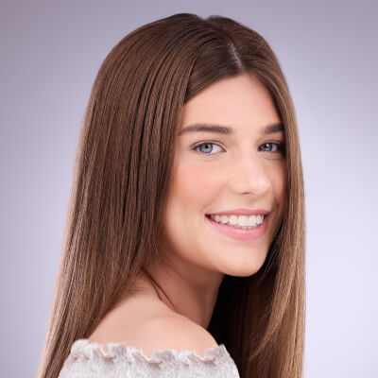 | Straight | This hair type is characterized by strands that lack natural curls and typically fall straight from the root to the tip
2A | 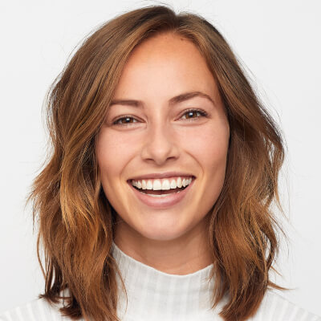 | Slight Wavy | This hair type features subtle, delicate waves with a smooth and tousled texture, but lacks volume at the roots
2B | 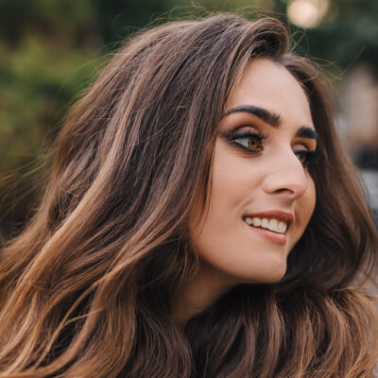 | Medium Wavy | This hair type that showcases natural S-shaped waves that typically begin in the middle of the hair shaft and delicately hug the head, creating a subtle and sophisticated dimension
2C |  | Thick Wavy | The waves in this hair type are characterized by a coarse texture and are shaped like the letter "S", starting at the root and continuing down the length of the hair. This hair type is prone to frizz
3A | 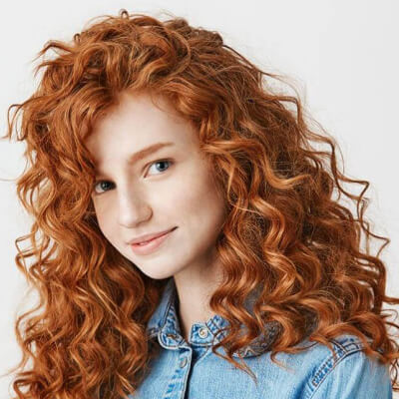 | Loose Curls | These curls are big, relaxed, and bouncy, and have a noticeable sheen from roots to ends
3B | 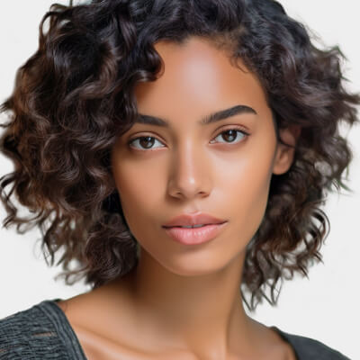 | Medium Curls | This hair type consists of coarse, springy ringlets that are prone to frizz
3C | 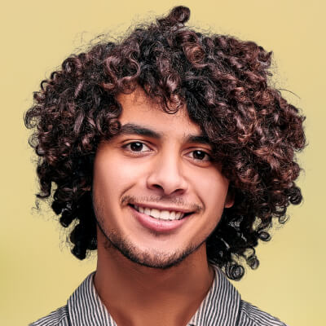 | Tight Curls | These curls boast a dense and compact corkscrew shape, lending them plenty of volume
4A | 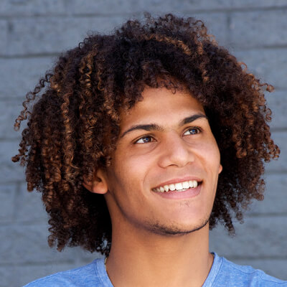 | Kinky Soft | This hair type is characterized by tightly packed, springy S-shaped coils
4B |  | Coily | Densely packed coils tightly wound into sharp, zigzag angles
4C | 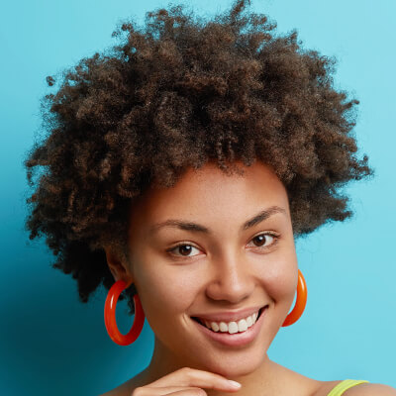 | Extremely Coily | This hair type is characterized by tight, fluffy coils that are more susceptible to breakage

Result Arguments
- mapping: result is a string showing the detected hair type category. Here lists all the possible result strings in an array:
["1 to 2a", "2a to 2b", "2b to 2c", "2c to 3a", "3a to 3b", "3b to 3c", "3c to 4a", "4a to 4b", "4b to 4c"]
- term: a one-to-one mapping string between hair type categories and their classifications. Here lists all the possible result strings in an array:
["Straight to Slight Wavy", "Slight to Medium Wavy", "Medium to Thick Wavy", "Thick Wavy to Loose Curls", "Loose to Medium Curls", "Medium to Tight Curls", "Tight Curls to Kinky Soft", "Kinky Soft to Coily", "Coily to Extremely Coily"]

Suggestions for How to Shoot
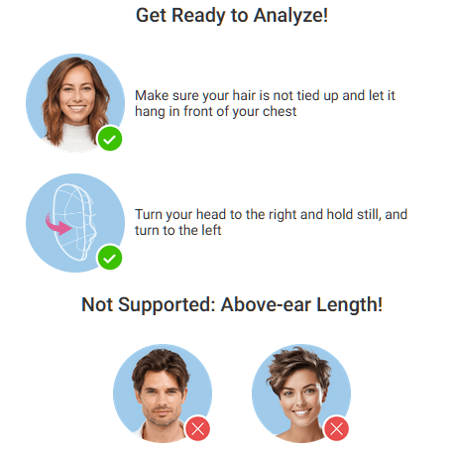


File Specs & Errors

Supported Formats & Dimensions
Type | Supported Dimensions | Supported File Size | Supported Formats
AI Hair Type Detection | The image must be at least 100 pixels wide and tall, and no more than 4096 pixels in either dimension. If one side of your image is longer than 1080 pixels, it will be resized automatically to fit within that limit for analysis. | < 10MB | jpg/png

Error Codes
Error Code | Description
error_mismatch_image_size | Make sure all your face photos (front, left, and right) are the same size
error_below_min_image_size | If your image is smaller than 100 pixels in width or height, it's too small to use
error_face_position_invalid | Your face needs to be fully visible in the image, without any parts cut off
error_face_position_too_small | The face in your photo is too small to analyze properly
error_face_position_out_of_boundary | Your face is either too large or partially outside the edges of the photo
error_insufficient_lighting | The lighting is too dim, which makes analysis difficult
error_face_angle_invalid | Your face angle isn't quite right. For front-facing shots, keep your head within 10 degrees of straight. For side-facing shots, the angle should be more than 15 degrees

Environment & Dependency
Sample Code Language / Tool | Recommended Runtime Versions
cURL | - bash >= 3.2  - curl >= 7.58 (modern TLS/HTTP support)  - jq >= 1.6 (robust JSON parsing)
Node.js (JavaScript) | Node >= 18 (for global fetch)
JavaScript | - Chrome / Edge >= 80  - Firefox >= 74  - Safari >= 13.1
PHP | PHP >= 7.4 (for modern TLS/compat), ext-curl (recommended) or allow_url_fopen=On + ext-openssl, ext-json
Python | Python >= 3.10 (for f-strings), requests >= 2.20.0
Java | Java 11+ (for HttpClient), Jackson Databind >= 2.12.0

JS Camera Kit

Overview
The JavaScript Camera Kit provides a complete in-browser camera solution designed for high-accuracy face-based imaging tasks. It includes:
- Camera permission handling
- Real-time face detection
- Automatic face quality validation (lighting, pose, angle, distance)
- Guided capture UI
- Multi-step capture flows for advanced hair/face tasks
- Support for both base64 and blob output formats
The module is particularly optimized for AI-driven image analysis, such as AI Skin Analysis (SD/HD), AI Face Tone Analysis, and hair-related analysis.

Download the JS Camera Kit
Include the JS Camera Kit SDK via CDN:
https://plugins-media.makeupar.com/v2.2-camera-kit/sdk.js
Once loaded, the SDK installs a global YMK object.

Quick Start Example
The following sample demonstrates:
- Loading the JS Camera Kit SDK
- Implementing window.ymkAsyncInit
- Initializing the module
- Opening the camera
- Receiving captured images
<!DOCTYPE html>
<html lang="en">
<head>
<meta charset="UTF-8" />
<meta name="viewport" content="width=device-width, initial-scale=1.0" />
<title>Camera Kit Sample</title>
</head>

<body>
<script>
window.ymkAsyncInit = function() {
YMK.addEventListener('loaded', function() {
/* Module fully loaded and ready */
});

YMK.addEventListener('faceDetectionCaptured', function(capturedResult) {
/* Display all captured images */
const container = document.getElementById('captured-results');
container.innerHTML = '';

for (const image of capturedResult.images) {
const img = document.createElement('img');
img.src = typeof image.image === 'string'
? image.image
: URL.createObjectURL(image.image);

container.appendChild(img);
}
});
};

function openCameraKit() {
YMK.init({
faceDetectionMode: 'hairtype',
imageFormat: 'base64',
language: 'enu',
});
YMK.openCameraKit();
}
</script>

<!-- Load SDK -->
<script>
window.addEventListener('load', function() {
(function(d) {
const s = d.createElement('script');
s.type = 'text/javascript';
s.async = true;
s.src = 'https://plugins-media.makeupar.com/v2.2-camera-kit/sdk.js';
d.getElementsByTagName('script')[0].parentNode.insertBefore(s, null);
})(document);
});
</script>

<button onClick="openCameraKit()">Open Camera Kit</button>

<div id="YMK-module"></div>

<h3>Captured Results:</h3>
<div id="captured-results"></div>
</body>
</html>


Prerequisites
You must define the asynchronous initialization entry point:
<script>
window.ymkAsyncInit = function() {
YMK.init(); // default settings
};
</script>
Additional requirements:
Requirement | Description
Browser | Must support getUserMedia
HTTPS | Required on most browsers for webcam access
<div id="YMK-module"> | Mandatory mount point for the UI

Integration Guide

Step 1 — Initialize the Module
Call YMK.init() before calling YMK.openCameraKit():
YMK.init({
faceDetectionMode: 'hairtype',
imageFormat: 'base64',
language: 'enu'
});

Supported Detection Modes
Mode | Description
makeup | Standard camera mode for virtual cosmetic try-on
skincare | Standard skin analysis mode, close-up face capture
hdskincare | HD Skin capture using webcams with ≥ 2560px width
shadefinder | Skin Tone Analysis front-face capture
facereshape | AI Face Reshape capture
hairlength | Full hair-length capture (from a distance)
hairfrizziness | 3-phase capture: front, right-turn, left-turn
hairtype | Same 3-phase multi-angle capture flow
ring | Hand capture for ring try‑on
wrist | Wrist capture for watch or bracelet try‑on
necklace | Selfie capture for necklace try-on
earring | Selfie capture for earring try-on

Step 2 — Add Event Handlers
Event examples:
YMK.addEventListener('faceQualityChanged', function(q) {
console.log('Quality updated:', q);
});
See the full Events List below.

Step 3 — Open Camera Kit
YMK.openCameraKit();
This automatically:
- Shows the UI
- Opens webcam
- Begins real-time face quality monitoring
- Automatically captures when conditions are acceptable

Step 4 — Receiving Captured Result
Captured images arrive via:
YMK.addEventListener('faceDetectionCaptured', function(result) {
console.log(result.images);
});


Step 5 — Close Module
YMK.close();


API Reference

YMK.init(args)
Configures module appearance, detection mode, language, and capture format.
Arguments
args.faceDetectionMode
Detection flow to use.
Values: "makeup" | "skincare" | "hdskincare" | "shadefinder" | "facereshape" | "hairlength" | "hairfrizziness" | "hairtype" | "ring" | "wrist" | "necklace" | "earring" Default: "skincare"

args.width
Pixel width of module container. Default:
- 360 (screens ≥ 500px)
- screen width (screens < 500px)
Allowed: 300–1920

args.height
Pixel height of module container. Default:
- 480 (screens ≥ 500px)
- min(screen.height, innerHeight) for smaller screens
Allowed: 300–1920

args.language
UI language.
Available: "chs", "cht", "deu", "enu", "esp", "fra", "jpn", "kor", "ptb", "ita" Default: "enu"

args.imageFormat
Format returned via faceDetectionCaptured.
"base64" or "blob" Default: "base64"

args.disableCameraResolutionCheck
Allow running even if webcam does not meet required resolution.
Default: false

Other API Methods
YMK.openCameraKit()
Opens the module and begins detection.

YMK.addEventListener(eventName, callback)
Registers event callbacks.
Returns: EventListenerIdentifier

YMK.removeEventListener(id)
Removes listener by identifier.

YMK.isLoaded()
Returns whether livestream or photo is drawn on canvas.
Returns: boolean

YMK.pause()
Pauses the webcam stream.

YMK.resume(restartWebcam = false)
Resumes webcam after pause.

YMK.getInfo()
Returns current module info:
{
"fps": 30
}

YMK.close()
Closes module and camera.

Events Reference
Lifecycle Events
Event | Description
opened | Module opened
loading | Loading progress (0–100)
loaded | Camera stream loaded onto canvas
closed | Module closed

Camera Events
Event | Description
cameraOpened | Webcam opened
cameraClosed | Webcam closed
cameraFailed | Permission denied or no webcam  Error code:  * "error_resolution_unsupported"  * "error_permission_denied"  * "error_access_failed"

faceQualityChanged
Fires continuously during detection.
{
"hasFace": true,
"position": "good",
"frontal": "good",
"lighting": "ok"
}
- Field Descriptions
Field | Values | Meaning
hasFace | true/false | Whether face is detected
position | "good", "notgood", "toosmall", "outofboundary" | Face distance/size quality
frontal | "good", "notgood" | Whether user is facing forward
lighting | "good", "ok", "notgood" | Lighting strength
Necklace/Earring
Field | Values | Meaning
hasFace | true/false | Whether face is detected
pose | "good", "notgood" | Face pose quality
size | "good", "notgood" | Face size quality
Wrist/Ring
Field | Values | Meaning
hasFace | true/false | Whether face is detected
position | "good", "notgood" | Hand position quality
pose | "good", "notgood" | Hand pose quality

Minimum Recommended Quality
const minQuality = {
hasFace: true,
area: "good",
frontal: "good",
lighting: "ok"
};

faceDetectionStarted User enters detection UI.

faceDetectionCaptured This event is fired after all required face quality validation checks have passed and the Camera Kit has successfully completed the capture workflow. Depending on the selected faceDetectionMode, the event may contain one or multiple captured images (e.g., multi-angle capture for hair modes).
Callback Arguments capturedResult — Object The result object containing all successfully captured images and metadata.
Field Definitions mode — string Indicates the active faceDetectionMode used for capturing. Possible values include: "makeup" | "skincare" | "hdskincare" | "shadefinder" | "facereshape" | "hairlength" | "hairfrizziness" | "hairtype" | "ring" | "wrist" | "necklace" | "earring" This value corresponds directly to the configuration set in YMK.init({ faceDetectionMode }).
images — Array A list of one or more captured images. Each entry represents a single capture phase, especially relevant for multi-phase modes (e.g., hair analysis).
ImageObject Structure
Field | Type | Description
phase | integer | The zero-based index representing the capture step.  Examples:  • Skincare = 0  • Hair frizziness sequence = 0 (front), 1 (right turn), 2 (left turn)
image | string or Blob | The captured image.  • Base64 string if args.imageFormat = "base64"  • Binary Blob if args.imageFormat = "blob"
width | integer | Pixel width of the captured image.
height | integer | Pixel height of the captured image.

Notes
- The number of images varies depending on faceDetectionMode.
  - Example: "hairfrizziness" and "hairtype" typically produce three images.
- Image resolution may differ from device to device. The actual pixel size depends on:
  - The user's webcam maximum resolution
  - The constraints and recommended settings for the selected mode
- All images are guaranteed to meet the minimum face quality requirements before this event is dispatched.

Configuration Notes
Quality Requirements
- Ensure correct distance
- Ensure frontal face angle
- Provide sufficient lighting (avoid shadows)
Multi-Phase Capture Modes like hairtype or hairfrizziness require:
- Front face
- Turn right
- Turn left
Ensure event handling is in place.

Create a new file.
To upload a new file, you'll first need to use the File API. It will give you a URL – use that URL to upload your file. Once the upload is finished, you can use the file_id from the same response to start using our AI features.
Authorizations:
BearerAuthenticationV2

Request Body schema: application/json

required
files  required | Array of objects

Responses
200 Successful retrieval of file upload information
400 Invalid request parameters
401 Invalid API Key or Inactive API Key or Expired API Key
post/s2s/v2.0/file/hair-type-detection

Request samples
- Payload
- curl
- Node.js
- JavaScript
- PHP
- Python
- Java
Content type
application/json
Copy
Expand allCollapse all
{
- "files": [
  - {}
- ]
}

Response samples
- 200
- 400
- 401
Content type
application/json
Copy
Expand allCollapse all
{
- "status": 200,
- "data": {
  - "files": []
- }
}

Run an Hair Type Detection task.
Once you start an AI task, you need to keep polling at given polling_interval to check its status until it shows either success or error because if you don't, the task will time out and when you try to check the status later, you'll get an InvalidTaskId error even if the task did finish successfully and your units will still be consumed.
Authorizations:
BearerAuthenticationV2

Request Body schema: application/json

required
Any of Run task with 3 angle src file urlsRun task with 3 angle src file IDs
src_file_urls  required | Array of strings = 3 items  The file URLs from upload file API. The file IDs for the sequence of source images are 'frontFace', 'rightFace', and 'leftFace'. Should provide either 'src_file_urls' or 'src_file_ids'.

Responses
200 Successful execution of the task
400 Failed execution of task
401 Invalid API Key or Inactive API Key or Expired API Key
429 Too many requests within a given amount of time
post/s2s/v2.0/task/hair-type-detection

Request samples
- Payload
- curl
- Node.js
- JavaScript
- PHP
- Python
- Java
Content type
application/json
Example
Run task with 3 angle src file urlsRun task with 3 angle src file IDs
Run task with 3 angle src file urls
Copy
Expand allCollapse all
{
- "src_file_urls": [
  - "https://example.com/selfie.jpg",
  - "https://example.com/selfie.jpg",
  - "https://example.com/selfie.jpg"
- ]
}

Response samples
- 200
- 400
- 401
Content type
application/json
Copy
Expand allCollapse all
{
- "status": 200,
- "data": {
  - "task_id": "grH0CvsgXuAIHLUzD0V1Ol34hoet3R1tvdbtiVHrDb6_UqCLKIejAIajwxrhOAfe"
- }
}

Check an Hair Type Detection task status.
Authorizations:
BearerAuthenticationV2

path Parameters
task_id  required | string  Example: grH0CvsgXuAIHLUzD0V1Ol34hoet3R1tvdbtiVHrDb6_UqCLKIejAIajwxrhOAfe  ID of task to check

Responses
200 Successful check of the task status
400 Invalid task id
401 Invalid API Key or Inactive API Key or Expired API Key
500 The task has no response in the expected time
get/s2s/v2.0/task/hair-type-detection/{task_id}

Request samples
- curl
- Node.js
- JavaScript
- PHP
- Python
- Java
Copy
curl --request GET \
--url https://yce-api-01.makeupar.com/s2s/v2.0/task/hair-type-detection/grH0CvsgXuAIHLUzD0V1Ol34hoet3R1tvdbtiVHrDb6_UqCLKIejAIajwxrhOAfe \
--header 'Authorization: Bearer <access_token for v1, API Key for v2>'

Response samples
- 200
- 400
- 401
- 500
Content type
application/json
Copy
Expand allCollapse all
{
- "status": 200,
- "data": {
  - "task_status": "running",
  - "error": "exceed_max_filesize",
  - "error_message": "string",
  - "results": {}
- }
}

