**Review of the Lab1**

1. One to one correpsondence
2. Role of IP
3. Run each command using t command and use of r and u command

**Lab2**

* 1. See segment:offset address or the logical adress of each instruction
  2. Word storage format--- Little endian notation vs big endian notation
  3. See the data/instruction in dump memory

U command shows one to one correpsondence between machine and assembly code

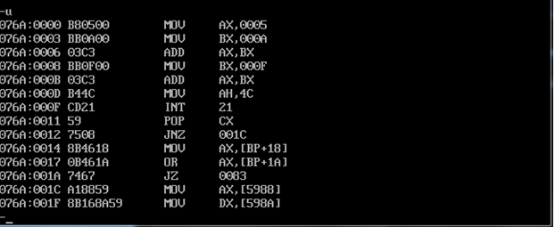

Intel processor use the little endian notation or format to store the data that is larger than one byte….. as in our program we want to store 5 in a word….then lower byte of a word is store at low byte and higher byte of a word is stored at the higher address.

But Motorola processor s uses the big endian format to store the word data ….that is higher byte a lower address and higher byte of a word is store at the lower address.

**Example1**: how 32bit word is store in Intel processor‘s memory eg **47A9B1B0h**

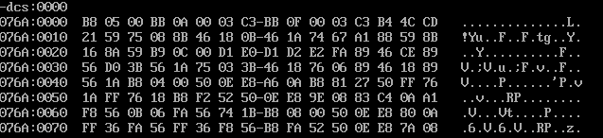

Example2: what is value at offset address **0000, 0004,0018** etc.