**Review of the Lab1**

1. One to one correpsondence
2. Role of IP
3. Run each command using t command and use of r and u command

**Review of the Lab2**

* 1. See segment:offset address or the logical adress of each instruction
  2. Word storage format--- Little endian notation vs big endian notation
  3. See the data/instruction in dump memory

**Lab3**

**Segmented memory Model: Overlapping**

1. **Partial overlapping**

Physical address of a memory location is unique while the logical address for a memory location is not unique: Example

P.A= 1256A is generated by the Logical address = 1256:000A , 1240:016A

In segmented memogy model:

* Seg:offset is needed to find the physical address
* Every offset is by default attached with segement to calculate the PA.

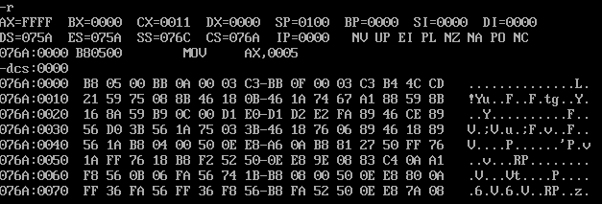

Starting Physical address of **Data Segement**: 075A0+0000 = 075A0h

Ending address of Data segment: 075A0 + FFFF = 1759Fh

Starting Physical address of **code Segement**: 076A0+0000 = 076A0h

Ending address of Data segment: 076A0 + FFFF = 1769F

See the difference between physical addresses of DS and CS = 076A0h – 075A0h = 100h

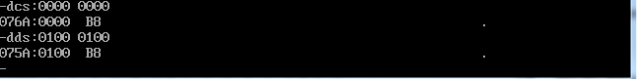

We have seen that there 128 or 100h byte difference between the DS and CS. Now look the first byte of the code segment through CS:0000 address and DS:0100….you will see both are pointing to the same memory location…. It show both segements are partically overlapped…

Edit this byte through CS and view it through CS and DS …you will see both contain same data….







Again resume the original contents then we will see the same contents will be place with same memory location.

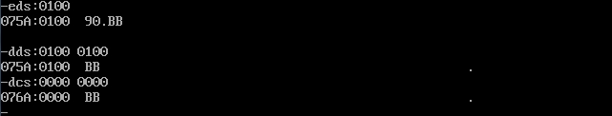

**B .Complete overlapping:**

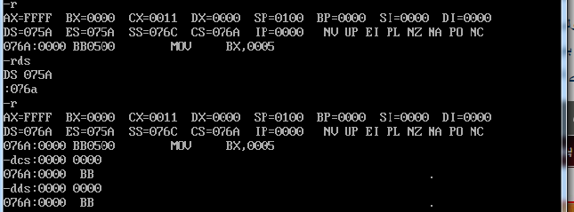

Exercise: declare variable and see their logical addresses